Social Protection Floor initiative




Workspace for the training on GESS

www.socialsecurityextension.org

As you are participating in the “Social Protection Floor Rapid Assessment, Costing and Design: From Tools and Methodology to practical Implementation”, we have created a workspace online on the GESS platform, to share the presentations made by the facilitators. The workspace also makes it possible for the facilitators and participants to share ideas, information and experiences discussed during the training.

To get access to this workspace:

- You need to first register to the platform. In order to do so, go to
www.socialsecurityextension.org, then click on the “sign up here” link in the registration box on the homepage as showed in picture 1 (see below).

Picture 1: GESS homepage

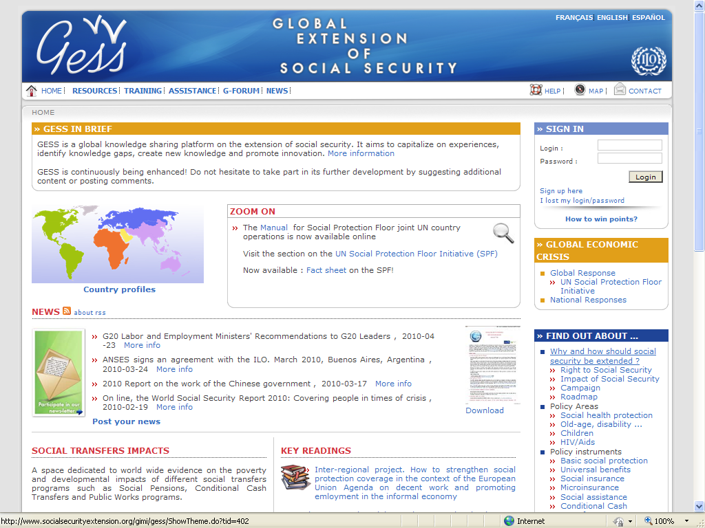
Access to generic info on the SPF initiative
Register to the platform

Once registered, you can:
- Access the “Rapid Assessment Private Space” (see picture 2 below). To access this private space, you need to send me an email with your login name, so that I can add you to the space members list. You can email me at bkk_intern6_sro.@ilo.org
- Once you submit your log in name, within 24 hours, you will be able to log in to the Rapid Assessment Private Workspace at http://www.socialsecurityextension.org/gimi/gess/ShowProjectPage.do?pid=1155

Picture 2: A private workspace for the participants of Rapid Assessment Training

- 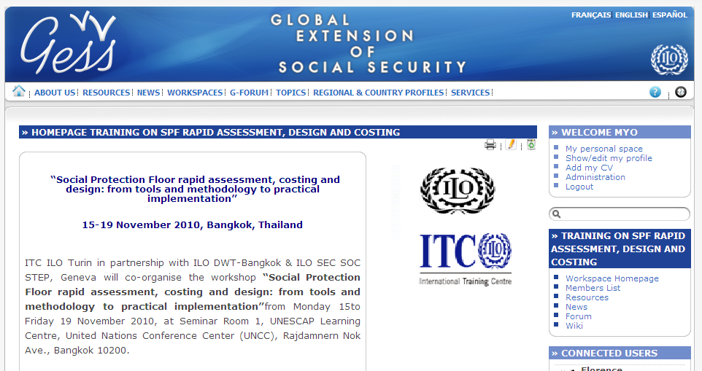
Private space

More about the GESS platform
GESS is a global knowledge sharing platform on the extension of social security and aims to facilitate the exchange of information and ideas, capture and document experiences, identify knowledge gaps, create new knowledge and promote innovation. To achieve this goal, GESS relies on the contributions of its users and the dialogue and exchange between them. It provides an international interdisciplinary knowledge sharing for the extension of social protection. GESS provides information and collaborative tools to all those working towards universal social protection coverage.

GESS is designed to be as interactive and user-driven as possible. In addition to providing information, it uses the wiki technology to allow for users’ participation. Almost all sections offer opportunities for users to get involved by posting news and comments, suggesting further resources, engaging in online discussions, adding questions and answers, inserting terms or definitions into the glossary etc.

How is GESS structured?
In order to facilitate easy access to relevant information and services for users coming from different backgrounds and searching for different pieces of information, the GESS content on social security is organized by topic (policy areas) and geographically.

How can you participate?

As already mentioned above, the platform relies on the contributions of its users and the dialogue and exchange between them. In the training, we will use this platform to share presentations and homework, etc.

You can also:
- Provide content on the implementation of the Social Protection Floor in your country,
- Upload your CV into the expert database, contributing to the creation of an online community on the extension of social protection.
- Add news and other resources you may wish to share!
- etc.

~ Welcome on GESS and hope to see you soon online! ~

