SPF in Cambodia National Social Protection Strategy (NSPS)

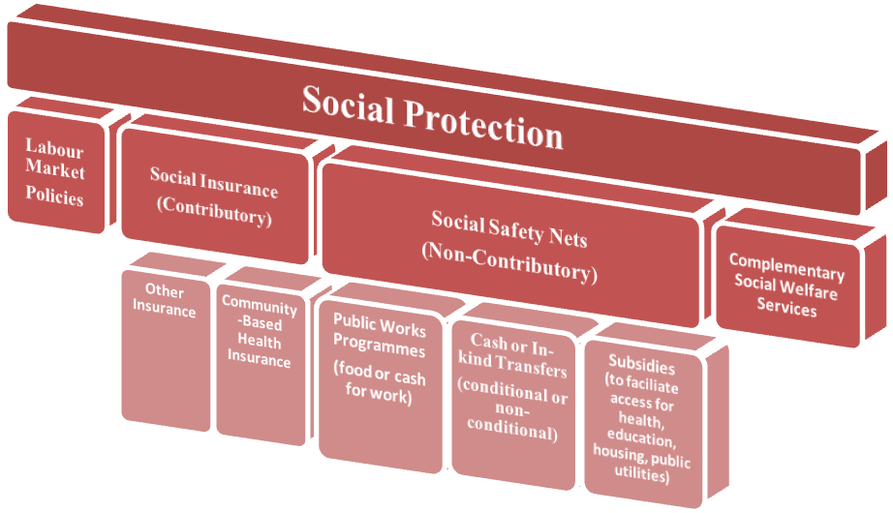
Scope of Cambodia NSPS

-

Social Protection for the Poor and Vulnerable

- Contributory and non-contributory schemes developed in parallel to ensure social protection for all.

Gradual Progression towards Comprehensive Social Protection

Rapid Assessment for Cambodia by Vathana
 | Demand side: accessibility of essential services through basic transfers in cash and in kind |  |  | Supply side: availability of essential services
Field & target groups | Legal coverage | Effective coverage | Adequacy of the benefit to ensure effective access | Level and quality of services available
Addressing the basic needs of the poor and vulnerable in situations of emergency and crisis
Emergency intervention during natural disaster  Targeted food distribution  Distribution of farm inputs | People living in flood- and drought-prone areas | % of people during emergencies receiving assistance including food, sanitation, water, shelter and other immediate response interventions within prescribed timeframes | Ratio of benefit to the loss of property during flood  Ratio of benefit to the loss of agricultural product and productive assets during flood and drought | Number of days to receive the first response
SOURCE OF INFORMATION? |  | ? | ? | Cambodian Red Cross  National Committee for Disaster Management
Reducing the poverty and vulnerability of children and mothers and enhancing their human development
Cash transfer for mother and child nutrition improvement  School-feeding  Outreach services and second-chance programmes for out-of-school youth and supporting social welfare services | Girls and women of reproductive age  Pregnant women  Small children (0-5)  Youth (15-24) | % of poor children who receive scholarships for primary and secondary education  Number of beneficiaries who benefit from take-home rations and school feeding  % of children under 2, pregnant women and nursing mothers who benefit from social transfers  % Pregnant women with 2 or more antenatal consultations with skilled health personnel | Enrollment rate  Amount of Scholarships (Cash or in-kind) related to average cost of attending schools (fees, transportation costs, opportunity cost …)  Assessment of hidden costs (opportunity costs, transportation costs …) | Teacher-pupil ratio  Number of children withdrawn from child labour  % progress in achievement of the national target on eliminating the worst form of child labour
SOURCE OF INFORMATION? | Population census | Education database
Addressing seasonal un- and underemployment and providing livelihood opportunities for the poor and vulnerable
Public work programme | All poor and near poor  Families with greater age dependency ratio  Landless and land poor | Number of days the rural poor are provided with work opportunities through labour-based PWP | Minimum wage rate  Average income during time of on-job training | Quality of training course, accreditation  Employer-Employee satisfaction  Worksite condition
SOURCE OF INFORMATION? |  | Cambodia socio economic survey
Promoting affordable health care for the poor and vulnerable
Health Equity Fund  Community-Based Health Insurance | All poor and near poor  Pregnant women  Small children (0-5)  People living with chronic illness | All poor and near poor | Ratio of benefit to the cost of treatment  % of benefit to the income-loss during treatment  Out of pocket payment as a percentage of total health expenditure | Doctor-patient ratio  Number of days that insurance scheme compensate to the expense of patients
SOURCE OF INFORMATION |  |  | Cambodian Socio Economic Survey | Ministry of Health
Improving social protection for special vulnerable groups
Social welfare services for special vulnerable groups  Old-age pension  Social transfer for people living with HIV and Tuberculosis  Rehabilitation programme for people with disability | Elderly  People living with disability  People living with chronic illness  Ethnic minorities  Orphans  Child labourers  Victims of violence, exploitation and abuse  Veterans  Families of migrants  Single mothers | % of people with disabilities who receive social protection services  % of elderly people who receive social protection services  % of people living with HIV who receive social protection services  % of TB patients who receive social protection services  % of Old People Association established  % of home care established  % of most excluded old people receive cash transfer | Average old age pension benefit level/ poverty line or minimum wage | N/A
SOURCE OF INFORMATION? |  |  |  | N/A
Overall coordination on the implementation of NSPS
INDICATOR(S) | All of the poor and vulnerable | All of the poor and vulnerable | % of people whose income is less than the national poverty line  % of people below the food poverty line  % of poor and vulnerable people who benefit from social safety nets  Prevalence of underweight (weight for age <2 SD) children < 5 years of age | Country’s social protection index ranking  Ranking on the Global Hunger Index  % of government budget allocated to social protection
SOURCE OF INFORMATION? |  |  | Cambodian Socio-Economic Survey  Demographic and Health Survey | ADB’s Social Protection Index  IFPRI’ Global Hunger Index  Cambodia Statistic Yearbook
Main Challenges:
- Social protection mainly in the form of crisis response – short-term safety nets – long-term vision needs to be nurtured and developed further
- Implementation of social protection programmes is often parallel to local government structure and programmes – results in perpetuation of low capacity and threatens sustainability – more management should be given to the government
- Targeting is ad-hoc and inaccurate
- Monitoring and evaluation is weak
- Limited coordination among social protection interventions has resulted in uneven coverage, duplication of efforts and lack of sustainability and overall impact.

Role of training tools in linking NSPS to SPF

