ILO Conclusions

This workshop arrived at the right moment:
- in some countries you may have a national social protection strategy in place and are looking at efficient ways to implement it;
- in some other countries you have started implementing nation wide universal social protection schemes and are seeking now for more coherence and efficiency.

This workshop was a great opportunity to enhance exchange between participants from different countries, and we see from the discussions and from the roadmaps you developed during the training that you all come back to your country with examples from Indonesia, Viet Nam, Cambodia, Thailand and Lao PDR.

The SPF concept and the staircase are well understood and have been even “nationalized” in many countries (Cf. Countries’ roadmaps) and the following “graphs”.

In Thailand:

And in Thai:
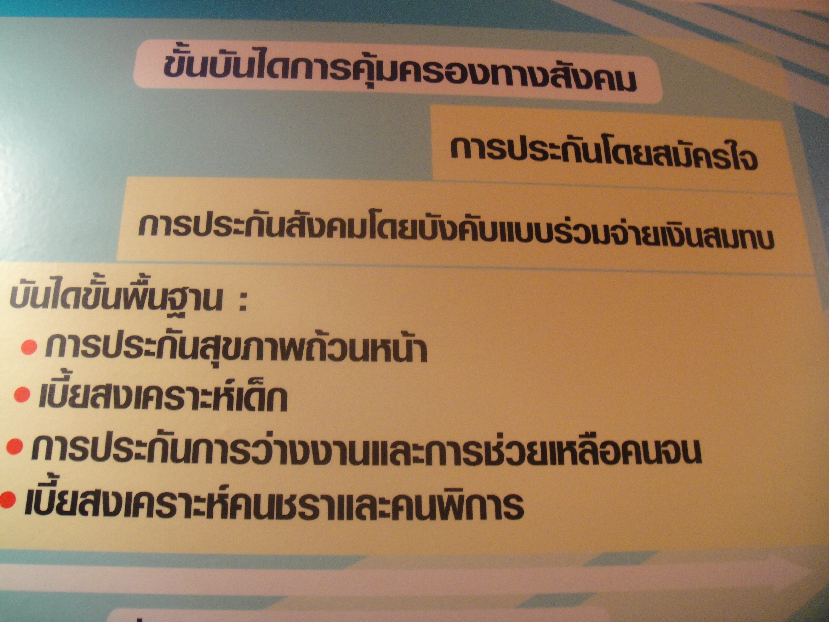

In Cambodia:

In Indonesia:
Most of you understand the need for the “rapid assessment” and that this methodology and tool can be used at different stages of the establishment of social protection mechanisms to increase coherence between mechanisms, understand which mechanisms are working best and which need improvements, to identify new policy priorities / orientations …

You have also understood the basic principles of the ILO-UNICEF costing tool and know that although it is not adapted to all specificities of the social protection programmes you are planning to establish it can help you to have a first rough idea of “how much all this is going to cost” and engage in a discussion with policy makers.

You have understood the different steps of the roadmap and where the tools and methods that were presented to you this week fit into this “chronogram”.

AWARENESS RAISING
NATIONAL SPF TASKFORCE, UN SPF TEAM SET UP
SP STOCKTACKING & MAPPING
PRELIMINARY ANALYSIS
PRIORITY AREAS FOR INTERVENTION
IDENTIFICATION OF POLICY OPTIONS
DESIGN & COSTING
FISCAL SPACE ANALYSIS – LT FINANCIAL SUSTAINABILITY
RECONSIDER DESIGN IN LIGHT OF FISCAL SPACE
LEGISLATION
IMPLEMENTATION
MONITORING, EVALUATION, COST-BENEFIT ANALYSIS, IMPACT
TIME

You are now going back to your countries with clear views on how to adapt and implement the assessment & costing tools and methods, and with the next steps in mind. The ILO and other UN agencies part of the SPF initiative will be happy to support you in this effort.

Thank you so much for your great and active participation all over the week. We wish you a safe trip back home. And we are looking forward to working with you again very soon!!

