Cross-cutting issue No1. Promotion of the SPF concept and inclusion of the SPF in the National Social Protection Strategy

- The example of Cambodia
- The example of Viet Nam
- The example of Thailand

Example of Cambodia – Integration in the NSPS

In Cambodia the National Social protection strategy is based on an assessment developed jointly by all development partners, under the coordination of the World Bank and World Food Programme. When the ILO started being involved in the development of this assessment, in January 2010, the Risk management framework of the World Bank was the main conceptual reference of this document. The ILO managed little by little to include the concept of the Social Protection floor and of the social security staircase.

The National Social Protection Strategy which was produced in parallel makes today a clear reference to the social protection floor (the comprehensive definition is quoted) and uses an adapted version of the social security staircase to explain the gradual progression towards comprehensive social protection.

Example of Viet Nam – Integration in the Implementation Plan of the NSPS

Following Mrs Bachelet’s visit to Viet Nam the Minister of Labour (MoLISA) recognized that the social protection floor approach should be used as a tool for implementation of the National social protection strategy for at least two reasons:

1- The social protection floor is in line with the principles and the approach of Viet Nam’s National Social Protection Strategy.

The National Social Protection Strategy’s principles of universality, solidarity, equitability, sustainability, promoting responsibility of individuals and concentrating supports to the poor converge with those guiding the implementation of the social protection floor worldwide.

More specifically the NSPS plans to reach universal health care coverage by 2014; to provide access to basic social services for all such as education, health care, accommodation, drinking water, electricity, information, sanitation and legal advice; to provide a minimum income to those in need. All these interventions are very close to that proposed under the SPF.

2- In addition to being relevant in the case of Viet Nam, the social protection floor concept will contribute to facilitate the implementation of the National Social Protection Strategy and make this strategy more efficient. It is therefore a great tool that should be used as a framework for the implementation of the strategy, and of course included as the umbrella of the NSPS implementation plan.

The social protection floor requires that the two dimensions of the floor, i.e. availability of services (or “supply”) and accessibility of services (or “demand”) are addressed simultaneously. Addressing simultaneously “supply” and “demand” issues requires that ministries, departments and implementing agencies work in a more coordinated way, and no longer in silos. This has therefore implications at the policy level and implementation level. It will however considerably increase the efficiency of the implementation of the NSPS.

The National Social Protection Strategy relies on three pillars:
- Active Labour Market Policies,
- Social Assistance, and
- Social Insurance.

The SPF offers a unique policy coherence framework in which all these pillars can be linked:
- By linking Social Assistance with contributory schemes (social security staircase);
- By linking access to social services with measures to increase employability (training, job placement such as PWPs, creation of new employment opportunities).

The social protection floor is a unique opportunity to develop integrated strategies to increase both social protection and increase inclusion in the labour market for all those working in the informal economy; it is both a precondition for the development of adapted labour market policies, and can contribute to increase their impact.

Example of Thailand – Using the SPF and the social security straircase as analysis framework for the developement of the social protection strategy

In Thailand, through the preparation of the 11th National Economic and Social Development Plan, the national plan on universal social welfare by 2017 and other policies, The Royal Thai Government has acknowledged the fragmentation of the existing social protection schemes and is considering the expansion of social welfare systems as a key tool to current challenges faced, notably the coverage of the informal economy and the reduction of inequalities.

Indeed, despite the implementation of the UCS (Universal Coverage Scheme) in 2001 and 500 Bath old age pension scheme in 2009, all Thai citizens still do not effectively benefit from basic adequate social protection.

Following the recent political unrest in Thailand, the Thai government has committed to mitigate social inequalities, through the Prime Minister's 5-point roadmap, the proposed plan of Construction of Welfare Society within B.E.2560 (2017). Social protection has also been identified as a theme of the 11th five-year National Economic and Social Development Plans.

Thailand is at the stage of visioning a broad strategy of social protection: the National Committee chaired by the Prime Minister recently drafted a national plan called “the National Plan on universal social welfare” by 2017. It focuses on 4 key components: social services, social assistance, social insurance and private provisions.
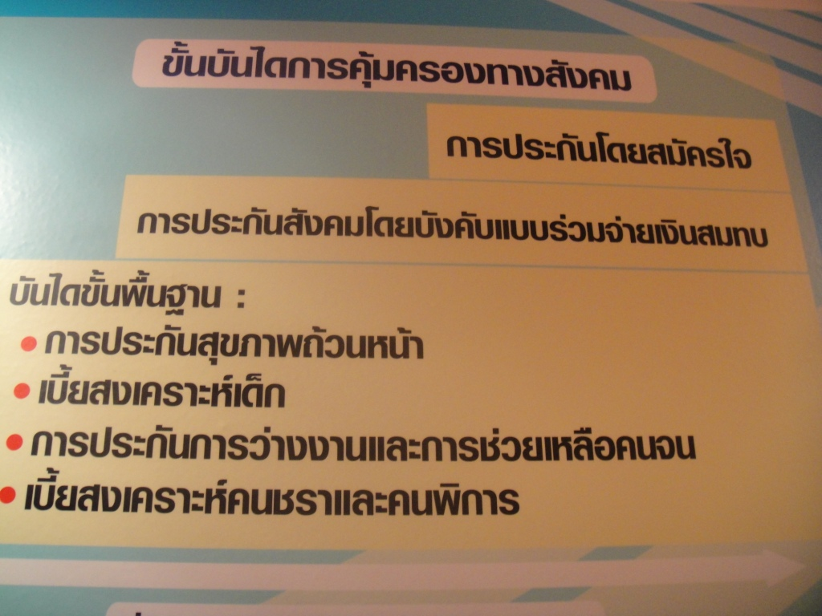
Thai version of the floor and social security staircase

A Development Cooperation Seminar will be organized on 5 November 2010 to discuss this draft strategy using the framework of the Social protection floor. Hosted by the Royal Thai Government (RTG) and the UN system it will provide a forum for dialogue between high-level government officials, international organizations, academia, employers and civil society to discuss and propose policy recommendations on
- Gaps and challenges ahead to ensure basic coverage and accessibility to available services of quality for All.
- How to ensure financial and institutional sustainability of the social protection system.

In the framework of the preparation of the next Partnership Framework with Thailand (UNPAF) – equivalent of the UNDAF, the enhancement of Thailand’s capacity in establishing the welfare society is being considered as key priority. A UN SPF Joint team, lead by the ILO, was created in April 2010. The team’s main objective is to promote a holistic and coherent vision of national social protection systems to contribute to close coverage gaps and reduce inequalities. The team will in the framework of the UNPAF include from next month members of the government (relevant ministries and institutions).

Discussion:
Based on these examples and your own experience:
- To what extend is the social protection floor concept already included in the policy debate, national social protection strategies and development frameworks in your country?
- Which concrete steps do you propose to push the SPF further on the agenda?

Present inclusion of the SPF in policy debate, NSPS, development frameworks | Concrete steps proposed

