Health Group (Target = the poor)
Mark the answer of underscore multiplies 0.1 in spider web. (e.g if the answer is 15=> mark 1.5)
Caution: Figures are spurious, just created for the exercise.
- In Indonesia, the Umbrella law # 40 on Social security was enacted in 2004. By implementing one of the provisions which is “Government regulation on social assistance for the poor and destitute” in 2005, for the first phase, the Government provided the poor and alike with health insurance costing around Rupiah 3.9 trillion. Given the fact that the total population of Indonesia is 230 million and of which 20 % are poor people, how many persons and what percentage of total poor are supposed to get health insurance legally?

=> Legal coverage: By law, the 100% of the persons who is defined as poor should be covered
1.1) 230 * 20% = 46 million
1.2) 100% persons are supposed to get health insurance

- In order to get health insurance, by law, you must register and fill the gaps in which is passive. Due to this delivery reluctance, only 23 million are registered for the insurance. (The number of poor is same as what you calculated above) To what level is this law effective? (Prove it by percentage)

=> Effectiveness: How effectively is the law actually covers the poor?
23 million / 46 million * 100 = 50%

- Only hospital care is covered. Out patient care is not covered. Hospital care equals to 50% of total health expenditure. What is the proportion of out of pocket payment in total health expenditure?
=>Adequacy: The package is only covering hospital care; they have to pay other extra things such as outpatient care (consultations, medicines …), under table payments, transport to access to hospital (Those sorts of data can be shown in Household survey)

Adequacy estimated = 50%

- In rural area, the total number of medical doctors including generalist and specialist is 5000 out of 50 million, total population. How many doctors per 10,000 persons are in rural area? And what is the ratio doctors to individuals? (Don’t believe the number!!)
=> Level and quality of services available; Supply
5000/50 million * 100 = 0.01%
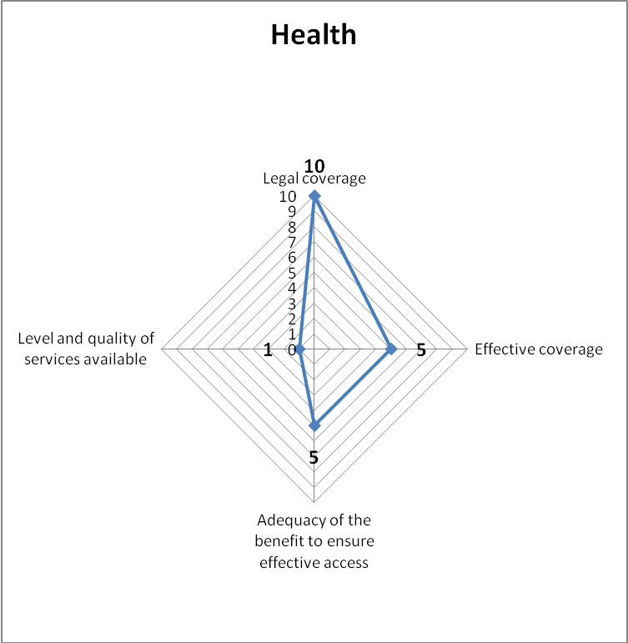

Cash transfers
- By Universal legal coverage in Thailand, persons who are 60 years and older are supposed to get 500 baht per month. Suppose total population is 65 million and the elderly (60 years and above) is 24 million. What proportion of the elderly should be covered by law?
=> Legal coverage: By law, the 100% of the elderly should be covered
100% persons are supposed to be covered

- Due to the scant amount comparing to today’s cost of living and delivery issues, the number of elderly who actually receive the cash is 16 million out of 24 million. What is the fraction of the elderly effectively gets the cash?
=> Effectiveness: How effectively is the law actually covers the elderly?

16 million/ 24milliono * 100 = 66.6 %

- People under poverty line gain 1500 Bath / month / person
Cash transfers for families who have children up to 3 gains 300 Bath
By "Employment guarantee scheme", working age population= 100 Bath / day up to 60 working days guaranteed during the year
The elderly gets 500 Bath / month
By above statement, on average how much cash a family including 1 elderly, 2 adults and 5 children will get per month? And what would be the ratio of adequacy?

=>Adequacy: the family only get 2,400 baht per month while the poor get 12,000 bath per month. Inadequacy!!!

2*500 (= ((100*60)/ 12 = 500) + 3*300+500=2,400 Bath / family / month
Poverty line = 12,000 Bath
Adequacy=2,400/12,000 * 100 = 20%

- Cash transfer
Budget cash transfer = 0.5% GDP … not much
Ask Hiroshi what should be the benchmark?
Benchmark = 3-5% of GDP for cash transfers + access to basic health care

