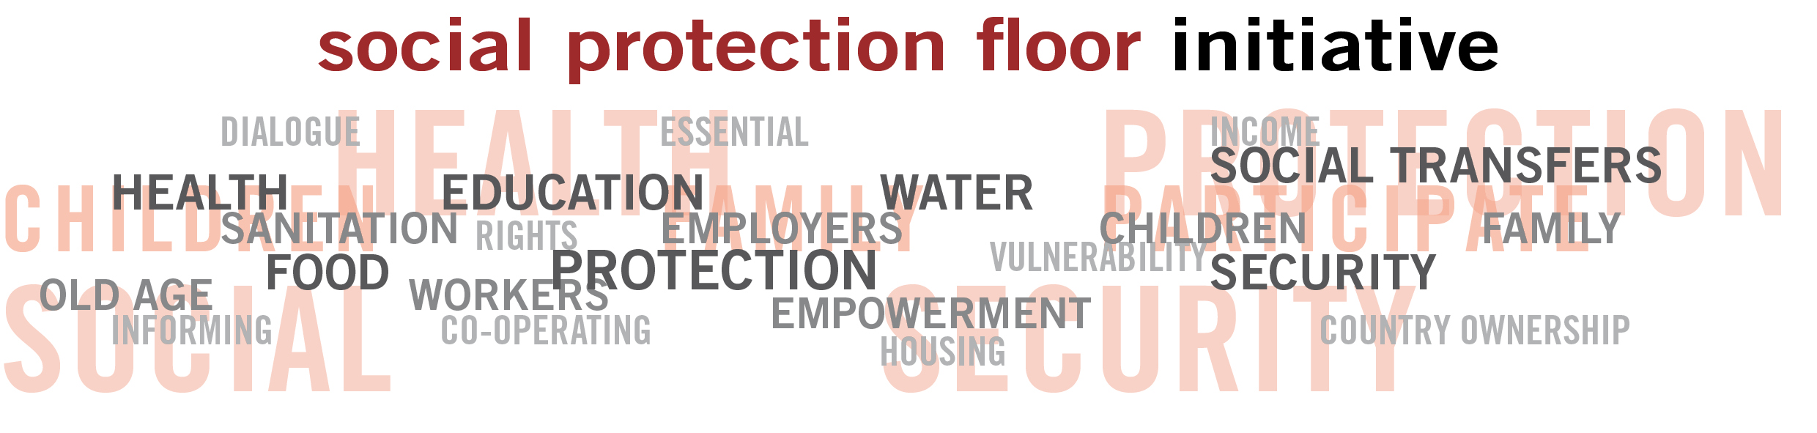



The Social Protection Floor-Initiative

21 November
Brunei

PROGRAMME

Sunday, 21 November 2010
Time | Agenda item
9:00 -9:15 | Introduction and objective
9:15-10:30 | - Expectations from participants  - Introduction to the topic: Who wants to be a protectionnaire?
10:30-11:00 | Coffee Break
11:00-12:30 | - The Social Protection Floor: Concept, country experiences (with a focus on the elderly)  - Presentation (UNESCAP,ILO)  - Discussion
12:30 – 14:00 | Lunch
14:00 – 15:45 | - Sharing of country experiences and approaches to implement the SPF-Initiative  - World Café on key issues and policy options (the SPF and Ageing, delivery issues, etc.)
15:45 – 16:00 | Coffee Break
16:00 – 17:00 | - Way forward: discussion on national follow-up actions
17:00 – 17:15 | - Conclusion remarks

