Thailand Social Protection Joint Team Meeting
Social Protection Floor initiative

July 21, 2011

Venue: ILO Meeting Room, 10th Floor

Time: 14.15 – 16.15

Present:
- UNESCO: Rachel Mc Carthy
- UNRCO: Mrs. Supavedee Chotikajan
- UNICEF: Mr. Andrew Claypole
- UNICEF: Mrs Chayanit Wangdee
- UNFPA: Mrs Viennarat Chuangwiwat
- UNFPA: Mr Adhi Wongkieo
- UNDP: Mr. Kwanpadh.Suddhi-Dhamakit
- UN Women : Ms. Ashley Burgin
- ILO: Mrs. Valerie Schmitt
- ILO: Mr. Seth Broekman
- ILO: Ms. Chayanich Thamparipattra
- ILO: Ms. Celine Felix
- ILO : Ms. Diane Taieb

Agenda of the Meeting
- Take stock of the situation
- Assessment and UNPAF Action Plan Processes
  - Minutes of meeting with MSHDS
  - Agreed Roadmap for Assessment and UNPAF
- Assessment content
  - TDRI report
  - Presentation of the pre-assessment
  - Key data/ info missing
  - Planning of bilateral consultations
- AOB/ Tour of the table

- Take stock of the situation
- The UNPAF process and the impact of the elections
The new government should appoint its cabinet at the end of August. This is strategic because the Welfare Society was a policy planned by the former Government, so the UN needs to wait for the new government to be appointed so as to be aware of the possible change in policy orientation. Although the Government is probably willing to implement a more inclusive social security system, the terminologies of the policy components may change.

- Budget considerations
Concerning the issue of pooling money within our team to carry out the assessment and costing of the Thai social security system, it was decided to transfer the money to ILO. An “I account” will be created in August. At that point, all agencies involved in the process will have to sign a form on the model of the one sent earlier by UNICEF.
Valerie raised an issue asking whether the money transferred by the different organizations was time-bounded. Given that ILO managed to negotiate an additional amount of money that can be used until the end of December 2011, that the creation of the account may take some time, and that most of the joint activities may occur from 2012 onwards, she asked if the other agencies would agree on the following organization: the ILO would use its own budget for the UNPAF until the end of December, and the budget granted by the agencies would be used in 2012. Most agencies agreed on that principle, as long as the money is transferred by the end of the year. Other agencies mentioned that they need to go back to their admin unit to check.

Follow-up:
- ILO to inform agencies on the advancement of the creation of the account
- Other agencies to inform ILO if any issue.
- Assessment and UNPAF Action Plan Process:

- Minutes of meeting with MSHDS

Jittima and Celine met on Tuesday 27 July with Khun Napa, Deputy Permanent Secretary of MSDHS (Co-Chair of our partnership on sand Khun Chinchai to discuss assessment and Action Plan. Khun Chinchai, who sits at the National Commission on Welfare Society informed that the TDRI Research on Towards Universal Welfare Society within 2017 was reviewed and finalized (in Thai). It was sent to the members of the National Commission who welcomed it but there was no follow-up. In order to push the new government to follow-up on the progressive construction of a universal social protection system, they welcomed the assessment exercise and agreed to co-organize the technical workshop on August 10. MSDH proposed to have Dr Somchai from TDRI to present the findings of the diagnosis part of his report.

- Agreed roadmap for assessment and UNPAF

Celine started to work on the pre-assessment matrix following the methodology developed within the social protection floor initiative.

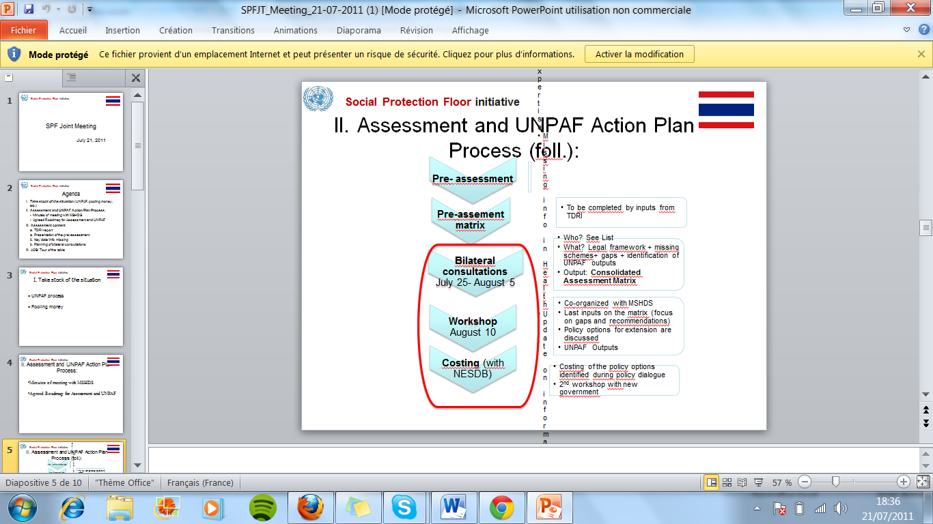 | - The first step of that assessment was the formalization of a pre-assessment based on a stocktaking of the schemes as compared to the Social Protection Floor. The pre-assessment is now ready. It will be completed with the information coming from data coming from the TDRI report.  - In the next two weeks, bilateral consultations with the Government and other stakeholders involved will be organized so as to discuss the pre-assessment and find other considerations that complement it (including expected assistance of the UN in the next 5 years). It is the opportunity to put different actors together, Governments, UN agencies, civil society…  - The 10th of August, a workshop will be organized in the form of a world café. It will be a one-day workshop gathering technical experts and will use the pre-assessment consolidated by bilateral consultations as base. The workshop will begin with a presentation on the findings of the report by TDRI (diagnosis part); this will be followed by a presentation on the SPF assessment methodology and recommendations emerging from the workshop. The idea of the workshop is to review the content of the assessment findings through discussions. Four tables will be organized, one on each guarantee of the Social Protection Floor (health, children, working age, the elderly). Everybody will have the possibility to sit at a table and review the gaps and the recommendations while giving his/ her opinion. For each table, a key person will be responsible for gathering all the information and ideas that emerged and synthetize it at the end of the day. The government would like 40 people as a maximum of attendees.  - The recommandations will thus be prioritized through a detailed costing of the schemes with financial projections.

Based on the gaps and recommendations that will be finalized at the end of this process outputs of the UNPAF will be formalized.

- Assessment content
  - The TDRI report

- How to present to TDRI report as compared to the assessment?
TDRI provided a very good diagnostic of the social security situation but as the political context has changed following the recent election the recommendations are less pertinent. Furthermore, the options in the report for enhancing social protection in Thailand were not fully in line with the UN social protection floor four guarantees. It was therefore decided that during the 10th August workshop, we will ask Dr Somchai from TDRI to make a presentation focusing on the diagnosis part of the report.

A meeting with TDRI will be organized next Monday so as to get more information on their report. UNICEF, UNFPA and the ILO will be part of that meeting, together with Khun Chinchai from MSDHS.

- Should we translate the TDRI report in English?
The TDRI report consists of 6 chapters:
- Explanation of the social security concept, the UCS ambition and the 4 pillars of social security,
- Stocktaking of the system and gaps in the current system,
- Recommendations to improve the current system,
- Estimations of the budget currently dedicated by the Government for the social security scheme,
- Proposal of four alternative programs of the current scheme,
- How to make this system sustainable? Analysis of ways to finance the new scheme, with taxes for example.
The UN agencies agreed in principle that the first 3 chapters should be translated. UN agencies attending the TDRI meeting will check that a translation has not yet been planned by TDRI.

  - Presentation of the pre-assessment

The pre-assessment matrix prepared by Celine was distributed to all participants of the meeting. It is organized by guarantee:
- Guarantee 1 : Health Social Protection,
- Guarantee 2 : Income security for the children, they are organized in 3 issues, minimum income, access to education, nutrition.
- Guarantee 3 : Income security for the working age,
- Guarantee 4 : Income security for the elderly.

  - Key data/info missing
All the agencies were asked to provide their inputs, but many of them did not do it so far. Thus, a few key data is missing, and Celine asked for the agencies to send their inputs as soon as possible. In particular, the following information is missing:
- Guarantee 1 : health
Information expected from WHO
- Guarantee 2 : children
Many inputs were provided, but we may think of reformulating.
- Update on coverage of the informal economy
- Information on community-based programs At that point, a comment was made about the social security schemes that are provisioned at the subnational level. How should we take them into account? After a discussion, the conclusion was that community-based schemes and non-formal systems must be included if they constitute good experiences that could be considered for replication but their limits should be highlighted (if not legislated, not systemic, on demand basis rather than following concrete targeting criteria, etc.)
- Include programs and gaps at decentralized level :
Issues on decentralization need to be captured in the assessment at that point. It may be a good idea to go and see at least one provincial representative.

- Cross-cutting topics :
  - HIV sensitiveness
MSDHS in collaboration with MOPH and UNICEF organized a workshop this week on HIV sensitive social protection for children. This was a very useful meeting, during which much information was gathered for the pre assessment. ILO and UNICEF met with people from NGOs who ILO might meet during the bilateral consultations.
  - gender sensitiveness
UNWomen committed to send the Joint Team guidance on key questions to ask during the bilateral consultations to ensure that the assessment include gender sensitive issues.

Follow-up:
- Agencies to provide information mentioned above
- ILO (Chayanich and Celine) to meet with UNFPA on July 22

  - Bilateral consultations

They will be scheduled during the next two weeks. The objective of the consultations is to review the legal framework, to identify missing schemes, and to discuss the design gaps and implementation issues.
Beyond that, the goal is also to work on the UNPAF Action Plan by discussing possible outputs with our counterparts.

To do so, the UN agencies are asked to provide by July 22nd a list of people that should be met for the bilateral consultations. The objective is for each specialized agency to guide ILO towards the right persons in their area of specialty, and also come with ILO during the meeting since they are most able to identify the key issues in their area of expertise. ILO is developing a pager to explain briefly what we are trying to do on the assessment. The idea is to contact also organizations that we will not be able to meet so that they provide us with their inputs.
Concerning coverage of migrants, a very complete report has been published lately. Most of the gaps and update on migrations in Thailand may be found on the subject and ILO is in contact with the working group on migration to get further inputs.

  - Assessment in Thailand : Outputs

- Baseline and output for the UNPAF Action Plan :
Seth Broekman shared some initial observations on the draft UNPAF Action Plan. Even though an accurate formulation of output statements is required to ensure alignment with the outcome statements and to reflect the correct level of accountability, it was suggested to place more emphasis on the selection/formulation of the corresponding indicators. The indicators are crucial for providing feedback on areas of success and areas in which improvement may be required. A relevant question in this regard is: do we have the means (budget, access to data and time) to measure the proposed indicators?

At the end of the process, the action plan will be co-signed by the Ministry of Social Development and Human Security and the ILO as the coordinator of the UN Joint Team.

- AOB/ Tour of the table
- Community based-programs
The question is : to what extent these schemes are to be included ? If all community-based schemes are included, the matrix will be unreadable. At the same time, sometimes central and local governments provide huge funds from its regular budget to that kind of schemes if the groups are qualified. These are the community empowerment programs. The matrix should assess if those schemes are systemic and predictable and it may be identified as complementary programs that can be used as recommendations. A good idea would be to include at least one or two relevant examples of community-schemes that are working.

- The floor methodology
An important point to keep in mind: in the assessment, the four essential guarantees of the floor are used as benchmark. Higher levels of benefits are assessed towards the floor only (not other benchmarks such as ILO Convention 102). The gaps that are identified in that exercise refer to the floor.

Meeting adjourned at 16h15

