Meeting UN SPF team – minute of the meeting – Thursday 28 March from 8:00-11:00 at ILO meeting room on the 11th floor

- Assessment exercise : briefing on latest developments, finalization of the agenda for the launch of the assessment exercise, invitation letters, etc. (ILO, V Schmitt & Jittima)
Over the past five months the ILO has engaged in a number of bilateral meetings with high level policy makers in Thailand in order to (1) present the Assessment report and its main recommendations, (2) gain their support for the launch and (3) obtain their signatures on the acknowledgment part. Dr Somkiat, Permanent secretary of the Ministry of Labour, Mr Vichien, Permanent secretary of the MSDHS and Khun Suwanee, Deputy Secretary General of NESDB have agreed to prepare and sign specific acknowledgements that were included in the report.
During these five months we also gained support from the members of the Sub-committee on Policy and Planning (under the National Commission on Social Welfare). Under the leadership of Khun Chinchai, MSDHS, three meetings of the Sub-committee were organized and comprehensive comments provided by representatives from the Ministry of Labour (several departments), MSDHS, MOH, MOE, Bureau of Budget of the Ministry of Finance and NESDB. All these comments were included in the final version of the report.
The list of meetings is enclosed for your easy reference:
Date | Meeting | Result/expected result
02/11/2012 | ILO shared the report with Minister of Labour | Minister committed to support ILO’s work on the social protection floor and even to talk to the Prime Minister about the launch of the report
06/12/2012 | MSDHS organized an inter-ministerial meeting | MSDHS shared the report with the members of the Sub-committee on Policy and Planning (under the National Commission on Social Welfare) ; they discussed the recommendations
14/12/2012 | ILO shared the report with Minister of MSDHS | Minister committed to further study the report with his team; the report to be launched during a bigger event on social protection with the different ministers concerned by the report and possibly the PM
14/12/2012 | Meeting between ILO Director General and the Prime Minister | Social protection was one of the key thematic areas discussed by ILO’s Director General, Mr Guy Rider, and H.E. Prime Minister.
21/12/2012 | ILO shared the report with Deputy Permanent Secretary, MSDHS | Deputy PS is committed to support the final revision and technical validation of the assessment report with other ministries.
17/01/2013 | MSDHS organized an inter-ministerial meeting | The technical recommendations of the report were endorsed  Consolidated comments will be provided to the ILO by 17 or 18 January 2013.
24/01/2013 | ILO shared the report with Deputy Secretary General, SSO | Deputy SG committed to participate in the launch
25/01/2013 | ILO shared the report with Permanent Secretary, MSDHS | Permanent Secretary agreed to sign an acknowledgement on the report and to participate in the launch
08/02/2013 | ILO shared the report with Deputy SG NESDB | Permanent Secretary agreed to sign an acknowledgement on the report and to participate in the launch
12/02/2013 | MSDHS organized an inter-ministerial meeting | Meeting of the Sub-committee on Policy and Planning (under the National Commission on Social Welfare) ; final comments on the ABND
March 2013 | ILO | Finalization Thai and English versions including acknowledgements from NESDB, MSDHS, MOL  Publication process
26/03/2013 | UN SPF Team - MSDHS | Preparatory meeting of the launch
End of April | Launch of the ABND report | Launch of the report as part of a bigger conference on “Strengthening social protection as an investment in the national economic development plan” where we would invite H.E. Prime Minister to deliver her statement on SP and NEDP.

The Assessment report was translated in Thai by Khun Jittima, and both Thai and English version were sent on 27 March to the Printer. The ILO will share with UN SPF Team members the layout of both documents once they are ready. In the published version the Thai and English versions will be clubbed (back to back).
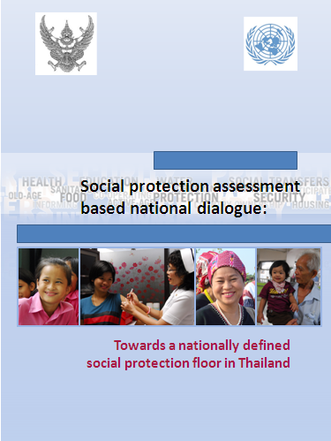 | The cover page of the report was designed by ILO and contains RTG and UN logos.  The members of the UN SPF Team approved the lay out of the cover page.

The launch will be organized from 2 to 9 May 2013 at the Government House, in the presence of the Prime Minister. The Agenda was presented to the UN SPF Team members and a few amendments were included; it was notably decided that the UNRC (Luc Stevens) would provide his remarks immediately after the Minister of MSDHS, and will focus on the UNPAF on social protection and Social Protection Assessment process and report. Also all speeches will be reduced (from 15 minutes to 10 minutes), except the speech of the Prime Minister which should remain 15 minutes long.
It was agreed that the Press conference should last 30 minutes instead of 20 minutes. However the relevance and the focus of a Press conference should be further discussed with the PM’s office. If the Press conference is attended by Policy makers (PM and ministers), journalists may aim at obtaining some commitments from the Government on the implementation of the recommendations of the assessment report; this may be a bit premature since the UN SPF team has not yet started the advocacy work for these recommendations; the Thai side should also be ready to answer tough questions. If the Press conference does not focus on the content of the report (but more broadly on social protection in general) it may be a lost opportunity for us and the visibility of our work. If the Press conference is at the technical level (Permanent secretaries and UN SPF team) we may have more opportunity to advocate for our recommendations. Instead of organizing a Press conference we may instead wish to invite the press and let them conduct interviews on an individual basis.
The invitation letters should be co-signed by UNRC and PS MSDHS.
What remains to be done before the launch?
- Finalization of the publication process (ILO)
- Invitation list and invitation letters (ILO), letters will be signed by UNRC and PS MSDHS
- Draft PM’s speech (ILO & PM Office)
- Prepare press briefing
  - 2 pager on assessment report (ILO), print 200 copies
  - UN SPF team brochure (ILO), reprint 200 copies
  - SPF Recommendation in English and Thai (finalize lay out, print 200 copies)
  - 2 pager on Child support grant (UNICEF), print 200 copies
  - 2 pager on LT care (ILO), print 200 copies
  - Other 2 pager related to key recommendations of the ABND report?
2) Briefing on latest developments regarding the proposed Child supports grant – (UNICEF, A. Claypole)
UNICEF briefed the meeting on some recent discussion with OPP at the MSDHS on policy analysis they are doing at the request of the Office of the Prime Minister in response to the RTG’s new population policy. Among other things, the population policy seeks to arrest the decline in the birth rate and improve the overall “quality” of the population through increased investment in children. At a recent meeting, the OPP briefed UNICEF on some of the strategies they are examining as possible suggestions to make to the PM’s Office. The strategies include introduction of paid maternity leave (even in the informal sector), the provision of maternity grants, the promotion of breast feeding, an allowance or “baby bonus” per new born such as used in Singapore, promotion and investment in early childhood development. UNICEF used the occasion of the discussion to brief OPP colleagues on the concept of Child Support Grants and the role they can be in enhancing human capital formation, particularly when paid to poor and marginalized children in the youngest age groups. The OPP report is being prepared and is expected to be ready in April. We should ensure that the relevant staff members from OPP are invited to the launch of the ABND report in May.
The NESDB is conducting a literature review on international experience of child support grants with UNICEF support. The report has been delayed due to competing priorities in NESDB but it is hoped it can be ready within the next few months.
The main work of UNICEF in 2013 on the child support grant will be to focus on advocacy for the concept and the recommendations emerging from the ABND report. Following some internal strategizing, UNICEF is trying to focus the advocacy message around a montly child support grant of 600 Baht for children of 0-6 years of age and targeted to the poorest segments of the population. As part of its advocacy campaign, UNICEF will produce a new video to take stock of the recommendations of the ABND and to provide more specific policy options.
3) Long term care system’s design (ILO, V. Schmitt and Viennarat & GIP SPSI, JC Dehaye)
One of the recommendations of the ABND report in Thailand is the design and establishment of a LT care system.
ILO mentioned that the LT care system’s design should be linked with measures to increase fertility rates and it offers a great opportunity for adopting a more holistic approach which would be at the cross roads of several policy areas: access to care for dependent people, development of employment opportunities in particular in rural areas, providing measures to encourage maternity (to reverse fertility decline) and enhance future productivity of children (feeding, stimulation, etc.), developing skills, and so on. Such a holistic approach should be supported by all UN agencies (not only one or two). The ILO encouraged other UN SPF Team members to participate more actively in LT care system’s design.
The ILO and the French association GIP SPSI have commissioned two experts from France to support the RTG in the development of a comprehensive LTCare system. The project started with a situation analysis which highlighted the importance of care provided by volunteers and the predominant place of hospitals in the organization of health care services. Although the design of the system is at a very preliminary stage, we already know that we should focus on all dimensions of LTCare, health care, social care and intermediate care (and not only the health care part). The traditional organization of care (based on volunteers and families) will need to be kept, even if the LTCare sector requires at the same time standardization and professionalization of some of the interventions. Also, coordination between actors (using for instance IT systems) should be reinforced, since today existing ministries and providers are working pretty much in isolation. The project will also develop a costing model of various policy options (using an adapted version of the RAP) and discuss several financing options. Preliminary cost estimates tend to show that the cost would be relatively low (0.1% GDP).
4) Education tool “Let’s learn about social protection” (ILO, V. Schmitt)
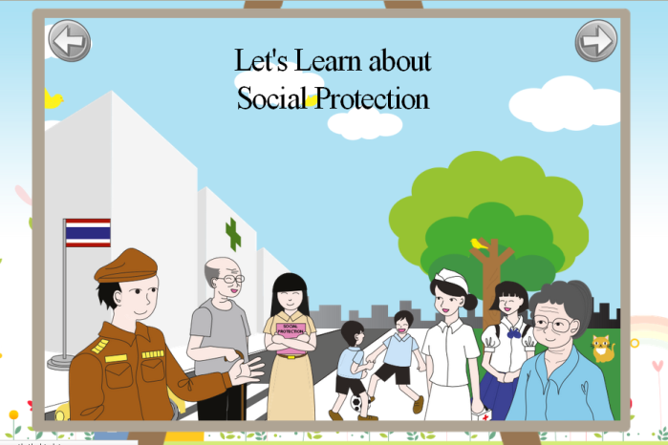
The tool is currently being developed and can be access through http://earth.thebigdot.com/ILO/.

Target group: children of 10-12 years of age and aims at raising awareness on the social protection floor.

We have requested a meeting with MOE to: a/ present the idea of the tool ; b/ ask for their support during the design stage, the testing phase (with real children) and subsequently the dissemination of the tool ; c/ request for MOE's tablets to facilitate the tests

We would like to set up a Co-creation environment to involve the young people at an early stage of project's development and to develop already a platform where the tool can be shared and tested and suggestions made. At a later stage we wish to use this network of young people as ambassadors of the tool. Having already a network of potential users would be an advantage when discussing with the ministry of education.

The tool will be part of a bigger Education on social protection project using social networks that will recreate the missing link between ILO/UN and young people.
a/ In the framework of this project students will have every month a new assignment on the technical area of social protection - examples: "this month you need to find and illustrate an example in your life related to social protection and explain it in a short video"; "this month we launch a drawing contest on maternity protection or work injury - the winner will have a visit of the hospital XXX by the hospital director"
b/ The social protection education tool could be used to trigger out the debate on social protection in the class room and across social networks
c/ The members of the network will not only be recipients of knowledge but providers of knowledge (lack of social protection is a problem that they face in their lives - they may have ideas and solutions) and vehicles to transfer and disseminate the knowledge to others
d/ A network of Thai volunteers to launch activities, discussions, and so on could be established

The Education tool is being developed by thebigdot
We plan to develop the bigger Education on social protection project using social networks in close collaboration with The Gras Foundation/Society Fresh
http://www.society-fresh.nl/?page_id=206

Main feedback from UN SPF Team colleagues:
- The tool as it is now would mainly target children of 10-12 years of age. If we are to use the tablets made available by the Ministry of Education the target should be 6-7 years of age. We may want to simplify the text to reach this target group and propose two tools, one which would be disseminated through the tablets (for 6-7 years old children) and one which would be available on line and target older children.
- It would be good to create linkages with the UNDP youth network which has developed an anticorruption advocacy campaign with students.
- The Ministry of Education has a group of teachers that is designing education and pedagogical tools; we should try to meet with them at our next meeting at the MOE (scheduled at the end of April).
AOB
FAO mentioned that following the creation of a social protection division at FAO they are more and more interested in getting involved in SP related activities.
Follow up activities (after the meeting):
- ILO will prepare the minutes of the meeting and post them on the GESS workspace + send them to all UN SPF Team members (done)
- ILO will send the revised agenda for the launch to all UNSPF team members
- ILO will organize the meeting with MOE and inform UNESCO

Minutes prepared by Valerie Schmitt, ILO (28 march 2013)

