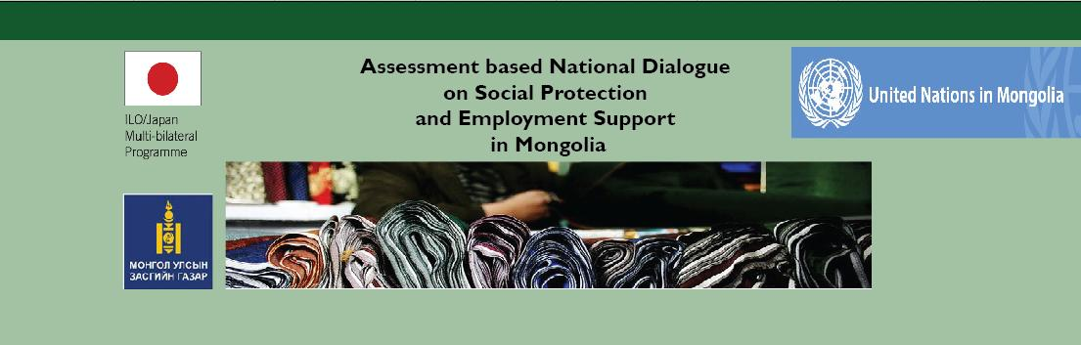

MINISTRY OF POPULATION
DEVELOPMENT & SOCIAL PROTECTION

Assessing the cost of a social protection floor in Mongolia: Introduction of final results and draft report
12 September 2014, Friday
Conference room, Puma Imperial hotel, Ulaanbaatar

Background
Mongolia has already in place a well ramified social security system, with a compulsory social insurance scheme, extended to herders, self-employed and informal workers on a voluntary basis. The country is also equipped with a mandatory social health insurance, a universal child allowance and a number of social welfare programmes, as well as recent laws to expand employment promotion and local development programmes. However, current development in Mongolia, overly dependent on the mining sector, may pose a threat on its sustained economic growth and continuity of its social policies. In addition, the administration and delivery of social security benefits and employment services across a very sparsely populated country remains challenging, leaving more than 80 per cent of herders, self-employed and informal economy workers with insufficient income security.
In this context, the government of Mongolia has measured the critical importance of strengthening social policies and establishing at least a social protection floor (SPF) to close urban and rural development disparities. The SPF is a set of basic social rights and services that each member of a society should enjoy. It promotes income security through a basic set of guarantees including:
(i) all residents have access to a nationally/provincially defined set of affordable essential health care services;
(ii) all children enjoy income security through transfers in kind or in cash ensuring access to nutrition, education and care;
(iii) all those in active age groups who cannot (or should not, in case of pregnancy) earn a sufficient income enjoy a minimum income security through social transfers in cash or in kind or employment guaranteed schemes ; and
(iv) all residents in old age and with disabilities have income security at least at the level of the nationally defined poverty line through pensions for old age and disability or transfers in kind.
On 5 September 2013, the Government, notably the Ministry of Population Development and Social Protection (MPDSP), and the United Nations Country Team for Mongolia launched the Assessment Based National Dialogue (ABND) on Social Protection and Employment support services.
The first step (September – December 2013) of the ABND consisted in: (i) mapping for each of the four guarantees of the SPF an inventory of existing social security, social protection and poverty alleviation programmes, (ii) identifying policy gaps and implementation issues, and (iii) preparing a number of recommendations for achieving at least a SPF in Mongolia (Second national dialogue on 5 December 2013).
Since last December 2013, a technical working group composed of experts and practitioners from MPDSP and Ministry of Labour, and the UN Working Group on Social Protection have converted the key recommendations into scenarios that can be further “costed”. These scenarios are specific social protection provisions that need to be introduced or further expanded to fill the gaps and guarantee at least a comprehensive social protection floor for all the population in Mongolia. The costs of these provisions is being calculated and projected over the 2014-2020 period using the ILO-UNICEF costing tool called the Rapid Assessment Protocol (RAP).
During the 3rd national dialogue which took place on the 2nd of May this year the methodology of RAP and its preliminary results were shared and discussed with all stakeholders. From May to September the finalization of costing, observation of fiscal space and writing ABND draft report was implemented.
Today’s forth national dialogue “Assessing the cost of a social protection floor in Mongolia: introducing final results and report” is to share with all stakeholders the final results of the costing of establishing a social protection floor and a draft of Report.
For more information on the ABND in Mongolia:
http://www.social-protection.org/gimi/gess/ShowProjectPage.do?pid=2287
Objective of the forth national dialogue
The forth national dialogue aims to:
- Explain the high and low scenarios and discuss the parameters of the proposed social protection measures;
- Present the final results of the RAP and discuss its assumptions;
- Discuss the affordability and financing of social protection measures; and
- Introduce the draft of the Final report on ABND in Mongolia.
Outputs
The forth dialogue will produce and validate the following outputs:
1. final results of the RAP to extend social protection and achieve at least a SPF in Mongolia is agreed;
2. a draft of final report of ABND is shared.

Participants
Around one hundred technical staff and directors from relevant government institutions, workers and employers’ organizations, UN agencies, civil society representatives and other development partners who are dealing with social protection and employment support policies and programmes are invited.
A proposed list of invitees is attached in Annex 1.
Place and time
Friday 12 September, from 9.00 am to 16.15 pm.
Conference room, Puma Imperial hotel, Ulaanbaatar

For more information
For more information, please contact:
ILO/Japan Project: Building and Promoting Social Protection and Employment Services for Vulnerable Groups in Mongolia, Learning from ASEAN
Ms. Bayartsetseg Bayarsaikhan, Administrative Assistant, ILO MAPS: bayarsaikhan@ilo.org
Ms. Baigalmaa Sanjjav, National Project Manager, ILO MAPS: sanjjav@ilo.org
Ms. Celine Peyron Bista, Chief Technical Advisor, ILO MAPS: bista@ilo.org

