Title  Country and union name | 

Main points
Summary
Summary


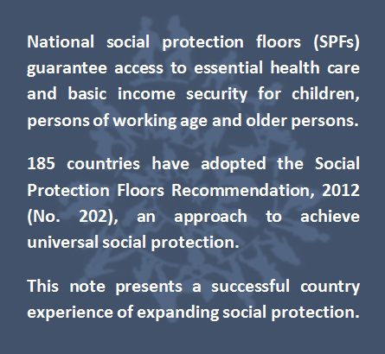
National social protection floors (SPFs) guarantee access to essential health care and basic income security for children, persons of working age and older persons.

185 countries have adopted the Social Protection Floors Recommendation, 2012 (No. 202), an approach to achieve universal social protection.

This note presents a successfull experience of a trade union initiative to promote social protection floors and fight for workers rights.
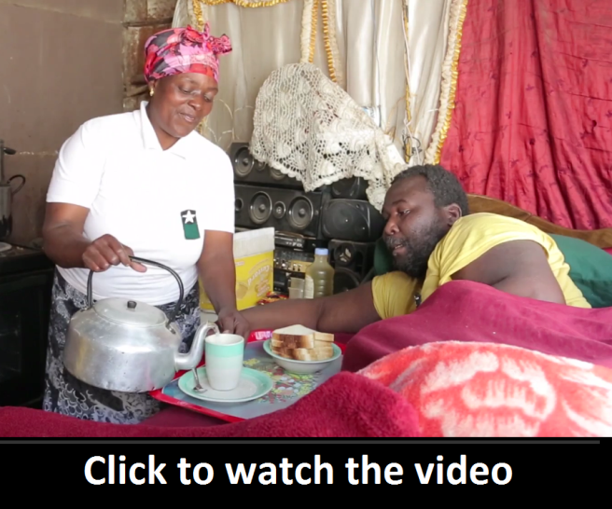
Social Protection in Action: Building Social Protection Floors Month Year
Main lessons learned
- A
- B
- C
- D
- E
1. Context
Text
Text
Text
Text
Text
Text
Text
Text
Text
Text
Text
Text
Text
Text
Text
Text
Text
Text
Text
Text
Text
Text
Text
Text
Text
Text
Text
Text
Text
Text
Text
Text
Text
Text
Text
Text
Text
Text
Text
Figure 1. xxxxx
Figure image
Source:
Text
Text
Text
Text
Text
Text
Text
Text
Text
Text
Text
Text
Text
Text
Text
Text
Text
Text
Text
Text
Text
Text
Text
Text
Text
Text
Text
Text
Text
Text
2. Description of the initiative
Text
Text
Text
Text
Text
Text
Figure 2. xxxxx
Figure image
Source:
Text
Text
Text
Text
Text
Text
Text
Text
Text
Text
Text
Text
3. What is the impact?
Text
Text
Text
Text
Text
Text
Text
Text
Text
Text
Text
Text
Text
Text
Text
Text
Text
Text
Text
Text
Text
Text
Text
Text
Text
Text
Text
4. What’s next?
Text
Text
Text
Text
Text
Text
Text
Text
Text
Text

REFERENCES  XXXXX |  |  | Building Social Protection Floors  Country Note Series Month Year  This note was produced by xxx of the xxx institution and xxxx of the ILO. It was reviewed by yyyy of the ILO.  The editor of the series is Isabel Ortiz, Director of the Social Protection Department, International Labour Organization (ILO).  For more information, contact: ortizi@ilo.org    www.social-protection.org
INTERNATIONAL LABOUR OFFICE  4, route des Morillons  1211 Genève 22  Switzerland |  | 
Follow us on:
       | www.facebook.com/SPplatform  www.linkedin.com/company/social-protection-platform  www.twitter.com/soc_protection  www.youtube.com/user/ILOTV

