html tags & styles for editing pages in gess (October 2010)

To add | type these html tags | you will see on the screen
1. HTML tags for changes within the text
arrows | <ul class="chip">  <li>text 1</li>  <li>text 2</li>  <li>text 3</li>  </ul> | text 1  text 2  text 3
bullet list | <ul>  <li>text</li>  <li>text</li>  </ul> | - text  - text
bold | <b>text</b> | text
italics | <i>text</i> | text
Underline | <u>text</u> | text
line spacing (double)  = creates a paragraph | <p>text</p> | text  text
line spacing (single) | text <br /> (only to set at the end of the text)
2. Creating links (URL, images, e-mail-addresses etc.)
image | <img src= "image URL path" alt=”” >  <img src=" http://www.ilo.org/gimi/pages/online/english/images/17442.PNG" alt=”” > | 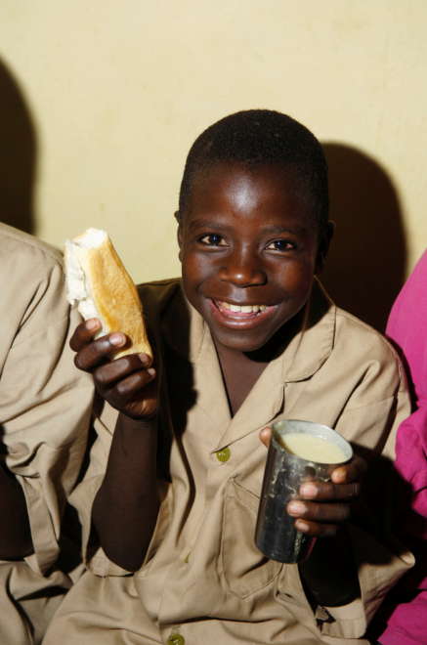
Links 1 (URL address)  website | <a href=”full URL address”>text</a>  Example:  <a href="http://www.ilo.org">ILO website</a> | ILO website
Links 2 (internal):  library resource  direct download of resource  workspace  wiki/theme/news page | (last part of the URL address)
 | <a href="RessShowRessource.do?ressourceId=17697">Growth and Poverty reduction strategy paper 2007< | Growth and Poverty reduction strategy paper 2007
 | <a href="RessFileDownload.do?ressourceId=17457">Argentina</a> | Argentina
 | <p><a href="ShowProjectPage.do?pid=1035">Workspace: Strengthening Social Protection in the Syrian Arab Republic</a></p> | Workspace: Strengthening Social Protection in the Syrian Arab Republic
 | <p><a href="ShowWiki.do?wid=278"> Health sector </a></p>  <p><a href="ShowTheme.do?tid=401">Right to social security</a></p>  <p><a href="ShowNews.do?nid=7307">The Minimum Living Standard (MLS) in Jiangsu province, China </a></p> | Health sector  Right to social security  The Minimum Living Standard (MLS) in Jiangsu province, China
Links 3 (external) | <a href="full URL address" target=”_blank”>text</a>  <a href="http://www.ilo.org" target="_blank">ILO website</a> | ILO website
e-mail address | Example: <a href=mailto:gess@ilo.org>Contact us</a> | Contact us [link to GESS e-mail]
Creating subheading, sub-sections, tables, columns, numerations etc.
horizontal line | <p>This is a paragraph</p>  <hr />
Numeration | <ol>  <li>âllo</li>  <li>âllo</li>  <li>âllo</li>  </ol> | - âllo  - âllo  - âllo
subtitles (e.g. for  flagship resources)  Example 1 (with one arrow)  Example 2 (without arrow)  Example 3 | <div class=gimi-subtitle>&nbsp;»&nbsp;A new funding mechanism: Global Social Trust (GST)</div>  <div class=gimi-subtitle>Colombia’s subsidized health insurance scheme</div>  <div class="theme-subtitle" style="line-height: 10px;">What is child-sensitive social protection?&nbsp;</div> | 
Editing the text in two columns  1. column  [tr=table row]  [td=table cell]  [p=paragraph] | <table cellpadding="10" border="0" width="100%">  <tr>  <td width="50%" valign="top">  <p>Firstly, we would… </p>
  Firstly, we would like to thank all participants of the user satisfaction survey for giving us your opinions on GESS and congratulate the winner of the prize draw for the book. | In light of the results, we will continue to work on improving GESS, especially making it easier for users to post their contributions on the platform.
2. column | </td>  <td width="50%" valign="top">  <p>In light of the results…</p>
Insert a table from word | It is possible to copy a table from word. Make sure that the table is not too large, so that it fits on a GESS page.
Insert expanding sub-sections  - sub-section  2. sub-section | <li onclick="$('#general').slideToggle('slow'); changeClass(this.id)" class="chipDown" id="01" style="cursor: pointer; color: rgb(52, 109, 191);"><strong>General</strong></li>  </ul>  <div style="display: none;" id="general">  <p><b>text</b></p>  <p><b>text</b></p>  </div>  <ul>  <li onclick="$('#poverty').slideToggle('slow'); changeClass(this.id)" class="chipDown" id="02" style="cursor: pointer; color: rgb(52, 109, 191);"><b><strong>Poverty</strong></b></li>  </ul>  <div style="display: none;" id="poverty">  <p><b>text</b></p>  <p><b>text</b></p>  </div> | 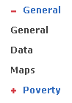  Note: if you use more than one expanding sub-section, please change the items marked in red as it is done in the example, and adapt the title of the sub-section
Creation of tabs | <div id="tabs">  <ul>  <li><a href="#tabs-3"><b>Demographic</b></a></li>  <li><a href="#tabs-4"><b>Economic</b></a></li>  <li><a href="#tabs-5"><b>Social</b></a></li>  </ul>  <div id="tabs-3">  <ul>Je suis suppos&eacute;e mettre un truc marrant!! heu.....45 6&nbsp; .... non, 3.1415<br />  J'adore le chocolat blanc ... mais en &eacute;t&eacute; ce n'est pas pratique, il fait trop chad</ul>  </div>  <div id="tabs-4">  <ul>Et si on allait &agrave; la plage??<br />  </ul>  </div>  <div id="tabs-5">  <ul>Vivement le week-end, j'suis naze.<br />  Comment &ccedil;a s'&eacute;crit?<br />  Comme tu l'entends<br />  <br />  <b>Jeu</b><br />  Qui a dit quoi?</ul>  </div>  </div> | 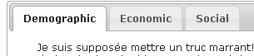  See for example the statistic page on GESS: ShowTheme.do?tid=10

Useful links:

** HTML online guide

http://www.w3schools.com/html/default.asp

To facilitate the HTML programming you can work with the Texteditor ++ program. You can convert your data into HTML format and work with it more easily.
Here the link for download:
http://www.editplus.com/download.html

Websites where different HTML styles are explained and demonstrated (like the accordion on Florence’s page: ShowWiki.do?wid=76)

** http://jqueryui.com/demos/

http://www.digitalia.be/software/slimbox2/

