www
International labour organisation, regional Office for SoUTH Asia, New Delhi
THE LIKELIHOOD OF ENROLMENT: EVIDENCE FROM HARYANA
An analysis of the first enrolment phase of ‘Rashtriya Swasthya Bima Yojna’
Nalini Gulati
Summer Intern (July-Oct 2008)

PREFACE

This paper is a culmination of my work during a three-month summer internship at the International Labour Organisation, Regional Office for South-Asia, under the supervision of Mr. Marc Soquet and Ms. Surina Rajan. The findings and analysis in this report are based on primary data collected in the district of Panipat, Haryana, through a household survey conducted in August-September 2008.
The study is focused on the enrolment phase of the “Rashtriya Swasthya Bima Yojna’- a voluntary health insurance scheme sponsored by the Central Government for Below Poverty Lines workers and their families. It seeks to determine the likelihood of enrolment of a BPL household in the scheme, based on socio-economic and demographic characteristics. It is based on the rationale that understanding the target group and what affects their propensity to enrol will enable better designed awareness programmes leading to wider outreach and hence, effective achievement of the scheme’s larger goals.

I thank Mr. Debi Prasad Mondal (Statistical Officer, ILO SRO-New Delhi) for technical inputs in design of the Questionnaire, District Rural Development Agency of Panipat, Haryana for organising the household survey and Mr. Anil Swarup (Director General, Labour Welfare, Government of India) for providing useful insights into the RSBY.

Date: 2ND October 2008 NALINI GULATI
Reading for MPhil. Economics
University of Oxford

1. BACKGROUND
1.1 Health Insurance for the poor in developing countries
The linkages between health status of the population and economic development are well established in the development literature. A major problem that persists in the developing world today is that the poor lack access to quality health-care facilities and the means to pay for such facilities. As a result, the poor constantly face the risk of loss of income and/or income earning capacities owing to sickness. Operating in such high risk exposure environments often proves to be welfare reducing and inefficient.
On the other hand, public spending in health care systems has been found to be insufficient. According to the WHO, Health expenditures in most countries have increased much beyond what the governments can afford, leading to a decline in government participation in health care financing. Most of the health care is financed through Out-Of-pocket (OOP) payments by individuals. This worsens the health status and economic condition of the most vulnerable, low-income groups of the society.
Within this framework, health insurance is increasingly being recognised as a viable health care financing option in developing countries. Providing health insurance cover to the poorest of poor is particularly challenging. However, successful implementation of such schemes is critical to the achievement of the goal of inclusive growth.
Extension of social security in the field of health to the poor and excluded populations in the informal economy and the rural sector is central to the STEP (Strategies and Tools against social Exclusion and Poverty) Program of ILO.
1.2 ‘Rashtriya Swasthya Bima Yojna’: Scheme design and salient features
RSBY is a Central Government health insurance scheme for BPL families in India. It aims to cover an estimated 60 million BPL families spread across 600 districts of the country, in a phased manner over the next 5 years (2008-09 to 2012-13). The main objective of the scheme is to protect the poor from major health shocks that involve hospitalisation.
Each BPL family (Household head, spouse and up to three dependants) is insured for a sum of Rs. 30,000 per annum for a nominal registration/renewal fee of Rs. 30. The annual premium is paid by the Central Government and the State Government in a 3:1 ratio, with the Central Government bearing any additional premium and administrative costs. The beneficiaries are entitled to more than 700 in-patient procedures, covering all pre-existing conditions and with minimum exclusions. Though OPD facilities are not a part of the scheme, OPD consultation is free.
Since the scheme targets the poorest of the poor in the country, it has been designed to a “cashless” and “paperless” scheme. This is in view of the inability of the target group to raise financial resources for medical care in the first place and then claim reimbursement from the insurance provider. This also does away with a great deal of documentation, which seems suitable for a scheme meant for a group consisting primarily of illiterate individuals.
A unique feature of the scheme that enables it to be cashless and paperless is the use of smart cards. No other scheme in the country that is meant to serve the poorest of the poor makes such widespread use of technology. The smart card, which is issued to the beneficiary, is to be used at hospitals each time the beneficiary makes use of the services. It enables inter-operationability in network hospitals and foolproof biometric identification of beneficiaries. It is mandatory for the empanelled hospitals to be equipped with hardware required to read and operate data on the smart cards.
The scheme differentiates itself from other such health insurance initiatives by addressing the needs of migratory workers that move from one part of the country to another in search of employment.
Finally, the RSBY provides business opportunities for all its key stakeholders – Insurance companies, Hospitals, Smart Card Service Providers and Intermediaries. There is an incentive for the private sector players to promote the scheme and insure its successful operation, since the RSBY is a source of potentially large revenues for them owing to the sheer volume of business. This Public-Private Partnership setup of the Scheme seems promising and sustainable.
2. OBJECTIVES OF THE STUDY AND MAJOR RESEARCH QUESTIONS
This paper aims to study the first enrolment phase of the RSBY carried out in April 2008 using empirical evidence from the state of Haryana, a state that is being looked upon as a forerunner in the implementation of RSBY. The focus is on studying the characteristics of the target group of the scheme and predicting the likelihood of enrolment of BPL households based on socio-economic and demographic features. The households are classified on the basis of various variables, and enrolment rates across categories are compared.
3. METHODOLOGY
3.1 Data sources
The results are based on a household data collected through a primary survey conducted at the district of Panipat, Haryana. The sample comprised 2% of the target BPL population of the district, with proportional representation of rural and urban cohorts and selected on a random basis. The Household survey includes a total of 1077 households representing 4457 individuals.
Data from the BPL Census 2007 at Panipat and various reports of the Labour department, Government of Haryana has also been used in certain parts of the analysis and to provide benchmarks for validating that the sample is a reasonably good representation of the population it has been selected from.
3.2 The survey questionnaire
The survey questionnaire includes sections on participation and use of scheme and household information such as demographics, health status and health care seeking behaviour, education, income, work status and so on. (Appendix)
3.3 Analysis
The statistical analysis was carried out using SPSS and EXCEL.
4. FINDINGS
The findings have been presented in three sections: the first section describes the sample BPL population, the second relates household characteristics to the propensity of enrolment and the third section uses a multiple regression model to further investigate the influence of a select group of characteristics on the outcome variable.
4.1 UNDERSTANDING THE TARGET GROUP
We look at the composition of the sample in terms of ten socio-economic and demographic variables: Income level, Income stability, Occupation, Work status, Education level, marital status, Gender, Age, House structure and rural/urban classification. Understanding the target BPL population of scheme is critical for its effective implementation and design of awareness programmes.
4.1.1 Income Level
The maximum proportion of the sample lies in the Rs. 10,000-Rs. 20,000 per annum income category.

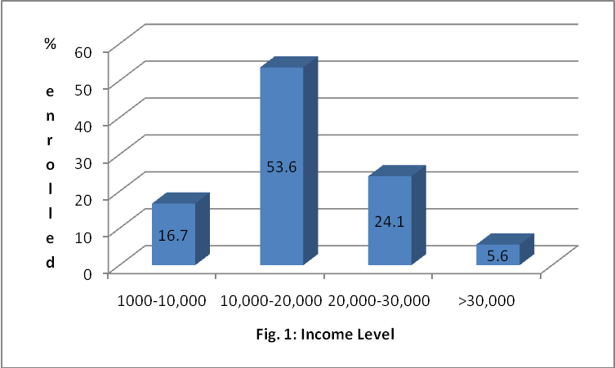
Ref. Table: A.1
4.1.2 Income Stability
A little above 60% of the target group claims to have income that is stable over the year.
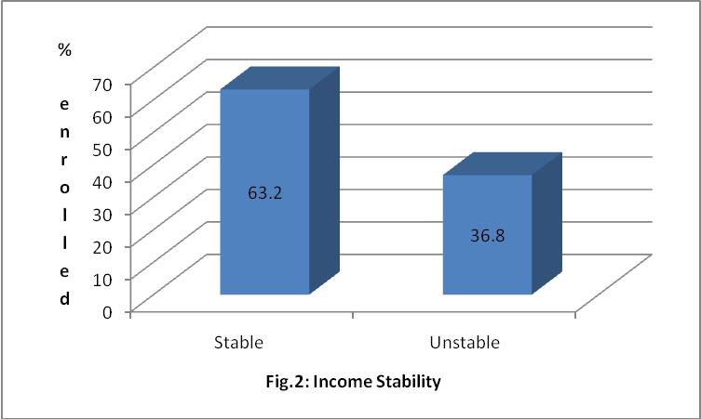
Ref. Table: A.2
4.1.3 Work Status
About 9% of the group is employed and a combined 35% is engaged in household work or is unemployed and looking for work. Thus, very high levels of unemployment are characteristic of the group.
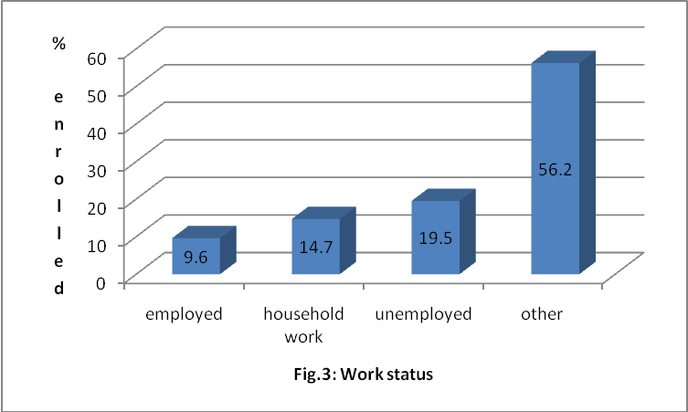
Ref. Table: A.3

4.1.4 Occupation
The single largest proportion of the employed group works as casual or other labour. A significant proportion is also employed as agricultural labour. Others are self-employed either in agriculture or non-agricultural activities.
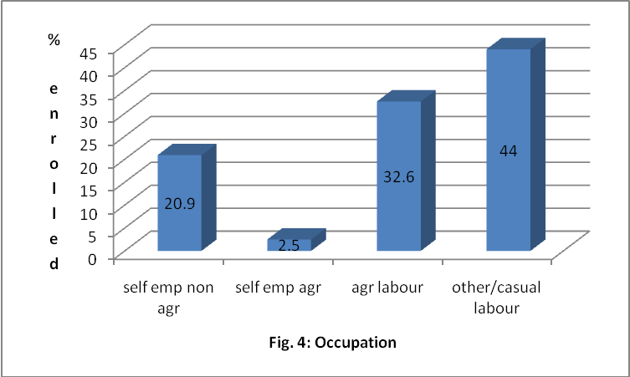
Ref. Table A.4
4.1.5 Education Level
Almost a half of the target population is illiterate and less than 15% is educated up to secondary or higher levels.
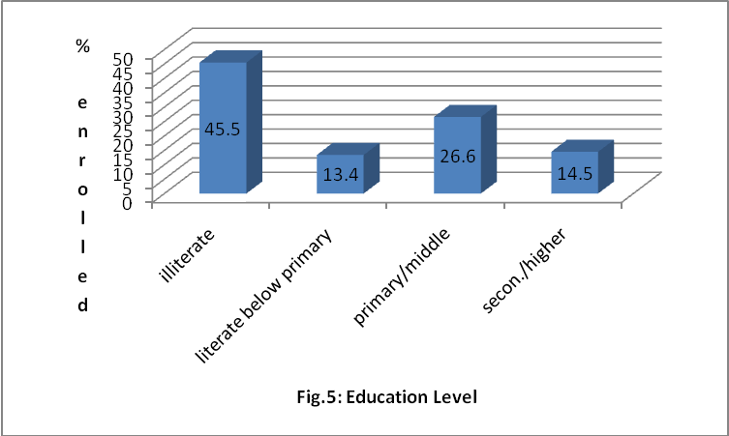
Ref. Table: A.5
4.1.6 Gender
About 80% of the household heads in the target population is male.
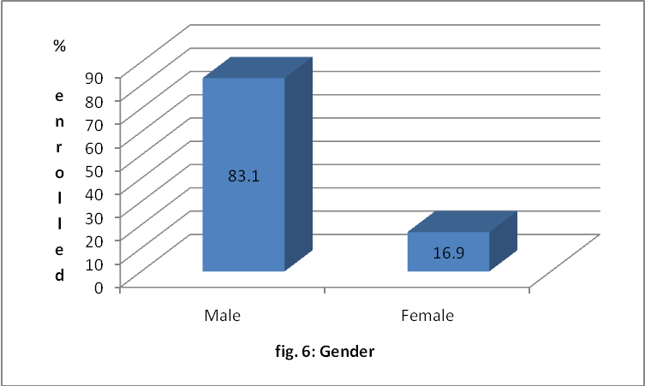
Ref. Table: A.6
4.1.7 Age group
Maximum number of household heads fall in the 31-54 age group category and the rest are almost equally divided in the under 30, 45-60 and above 60 groups.
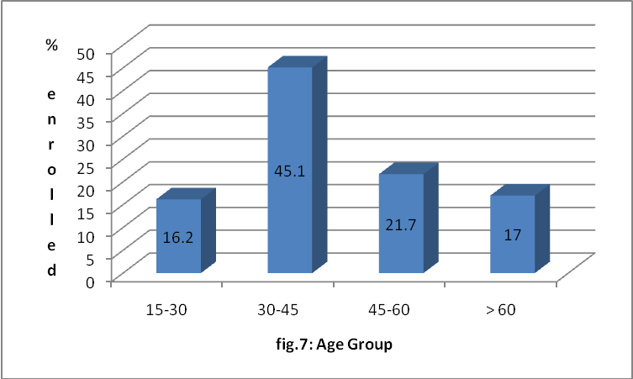
Ref. Table: A.7

4.1.8 Marital Status
A significant proportion of household heads in the sample is married.
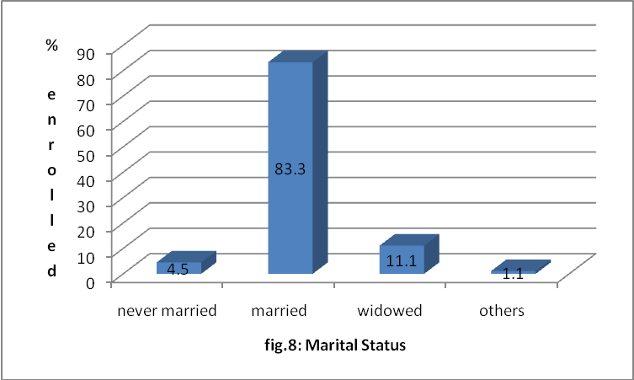
Ref. Table: A.8
4.1.9 Rural/Urban classification
A little more than half of the sample comprises rural households.
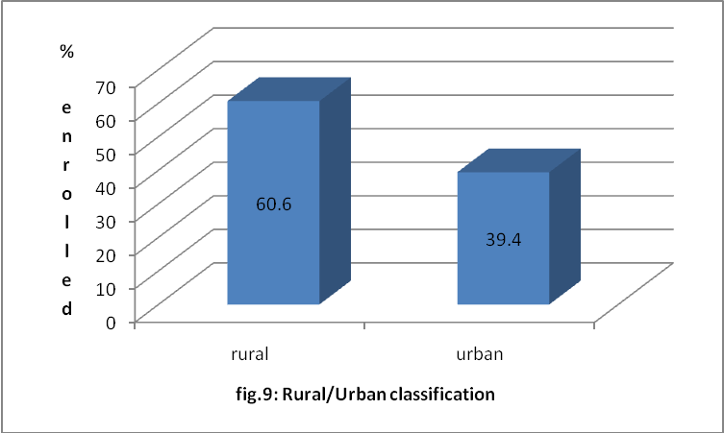
Ref. Table: A.9
4.1.10 Household structure
Only a third of the households live in pucca houses, while 65% lives in either semi-pucca or katcha structures.
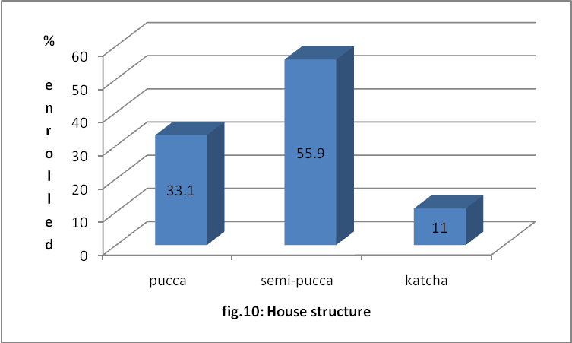
Ref. Table: A.10
A comparison of figures for certain key variables with the district figures from the BPL Survey 2007shows that the sample is a reasonably good representation of the BPL population that it has been selected from.
4.2 PROPENSITY TO ENROL: PREDICTING THE LIKELIHOOD OF ENROLMENT THROUGH SOCIO-ECONOMIC AND DEMOGRAPHIC CHARACTERISTICS
In the model used in this section, the dependent or outcome variable is enrolment that takes two values depending on whether the household is enrolled under the RSBY or not. A cross tabulation of each of the above characteristics is done with the enrolment variable to be able to observe and compare the enrolment rates in various categories of the target population, when classified on the basis of socio-economic and demographic features. Chi-square values are estimated in order to check which of the independent variables significantly influence the likelihood of enrolment of a household in the scheme.
4.2.1 Participation in RSBY
Roughly 60% of the sample is enrolled in RSBY. (District figures for Panipat as a whole show that there is 52% enrolment in RBSY.
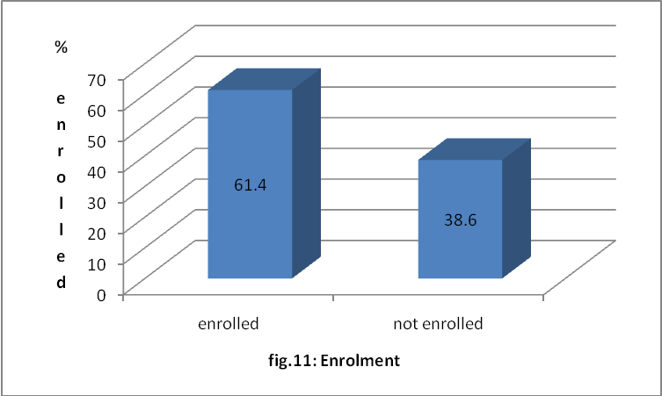
Ref. Table: A.11
4.2.2. Predictor variables
4.2.2.1 Income level
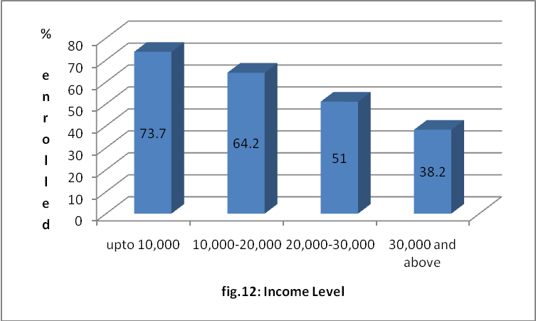
Ref. Table: A.12

Almost 80% of the lowest income category is enrolled under the scheme. This contrasts sharply with the highest income group wherein only about 40% is enrolled. There is a clear trend of decreasing enrolment with increasing income levels evident from the figure. This may mean that BPL households with relatively higher income are more satisfied with their current state of access to health care and means to finance the same. Thus, the need to be enrolled under a voluntary health insurance scheme such as the RBSY may be less pressing for higher income households. This also points towards the fact that the Rs. 30 required for registration under the scheme does not seem to be a deterring factor if the household perceives the scheme as beneficial and suited to its needs.
The Chi-square test shows that income as a predictor variable is significant to enrolment.
4.2.2.2 Income stability
A much larger percentage of households claiming to have income that is unstable over the year have enrolled for RSBY. The reasons behind this may be similar to the arguments of the “Income level” variable that the households with unstable income have a higher degree of insecurity and uncertainty, hence giving rise to the need to be covered by such government funded health insurance programmes.
Chi-square tests show that “income stability” is significant in its influence on enrolment.

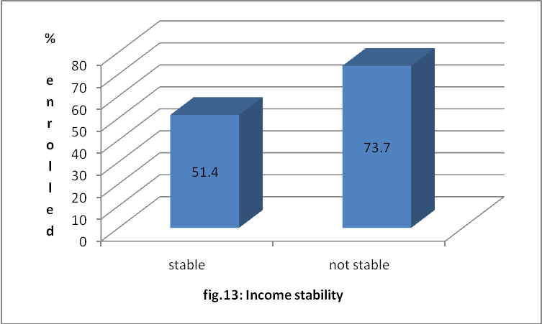
Ref. Table: A.13

4.2.2.3 Work Status
The unemployed group has shown the highest rates of enrolment under RSBY. The enrolment rates for the employed group are somewhat lower as compared to the unemployed group, but reasonably high in absolute terms. It is possible that those who are formally employed, particularly in urban areas, may already be receiving some kind of health care benefits or cover such as the ESI (a social security scheme that promulgates the Employee State Insurance Act 1948)
Just over a half of those engaged in household work are beneficiaries under the RSBY. There is hence, scope in that group and awareness programmes should be targeted at that group and designed in a way such that they effectively communicate the existence and benefits of the RSBY to them.
Chi-square tests show work status to have a significant influence on the likelihood of a household to be enrolled under the scheme.

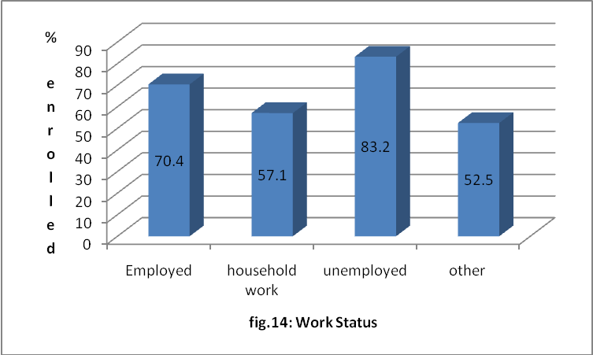
Ref. Table: A.14
4.2.2.4 Occupation
Those self-employed in agriculture or employed as labour in agriculture or other activities, all show an enrolment rate of about 70%. The figure highlights the low enrolment rates of household heads that are self-employed in agriculture.
Chi-square tests show that occupation is significant as a predictor variable of enrolment.
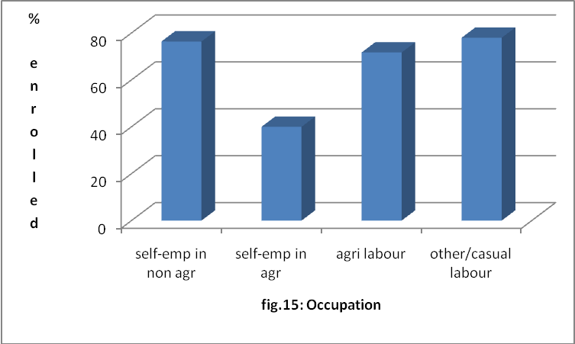Ref. Table A.15
4.2.2.5 Education Level
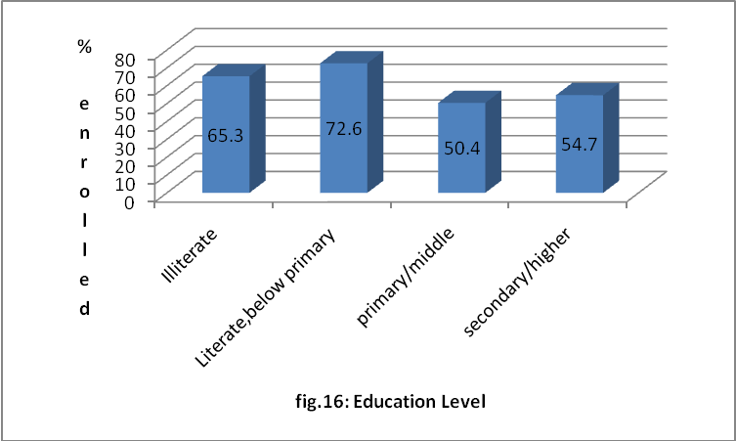
Ref. Table: A.16
Household heads educated up to primary or higher levels show unexpectedly low enrolment rates.
65% of the illiterate population is enrolled; however, it should be kept in mind that roughly half of the target group falls in this category pointing towards the large numbers that are still not a part of the scheme and need to be covered.
Chi square tests show education level to have a significant influence on enrolment.

4.2.2.6 Age group
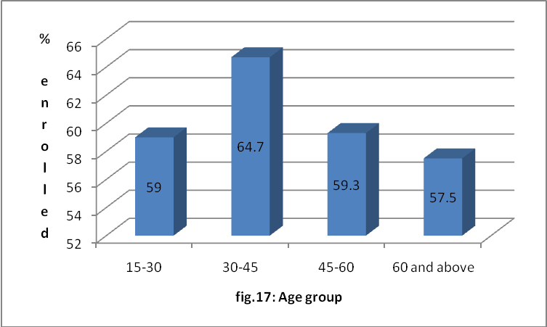
Ref. Table: A.17
There is not too much difference in the enrolment rates across age groups, the rate being in the range of 60%; which is in fact the enrolment rate for the sample. Chi square tests confirm that age group is not a significant factor in predicting enrolment in RSBY.

4.2.2.7 Rural/Urban Classification
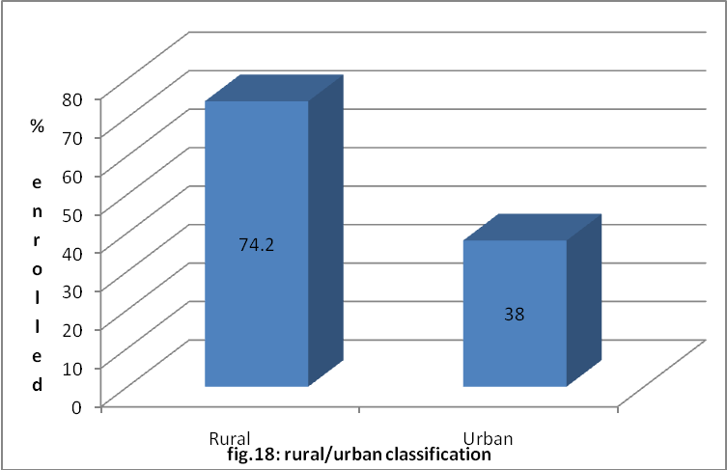
Ref. Table A.18
There is a glaring difference in the enrolment rates of urban and rural households-the rate of enrolment of rural households is almost twice that of urban households. Chi square tests also show rural/urban classification to be highly significant in predicting enrolment. There can be various arguments for explaining this trend- ‘word of mouth’ and ‘herd mentality’ seem to operate more effectively in rural areas, as means of spreading awareness. This factor turns out to be very important for a scheme such as the RSBY. The household survey conducted revealed that more people become interested in the scheme on hearing about people benefiting by being enrolled under the scheme, by way of cashless treatments at good hospitals.
Also, as mentioned in the “work status” section, more people in the urban areas are likely to be formally employed as labour and being already covered under one scheme or the other. It should also be pointed out that a large majority of urban workers are migratory. Even though the RSBY is designed to cater to the needs of migratory workers, the fact that the scheme is not yet operational in all parts of the country may be a deterring factor to this group. This is a problem that will get sorted out in the later phases of the scheme, and we can expect to see greater enrolment. It is also possible that this feature of the RSBY is not well known at this point and needs to be more widely publicised.

4.2.2.8 House Structure
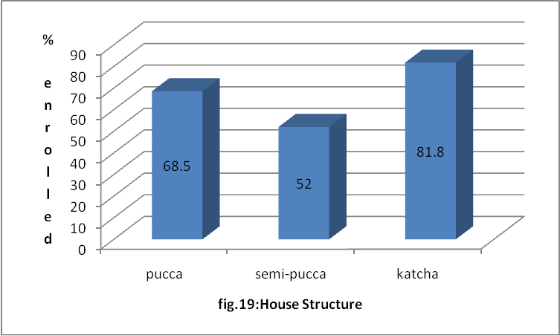
Ref. Table A.19
4.2.2.9 Gender
Households with male heads have somewhat higher rates of enrolment than female headed households. However, chi-square tests show that the gender factor is not a significant predictor of enrolment.

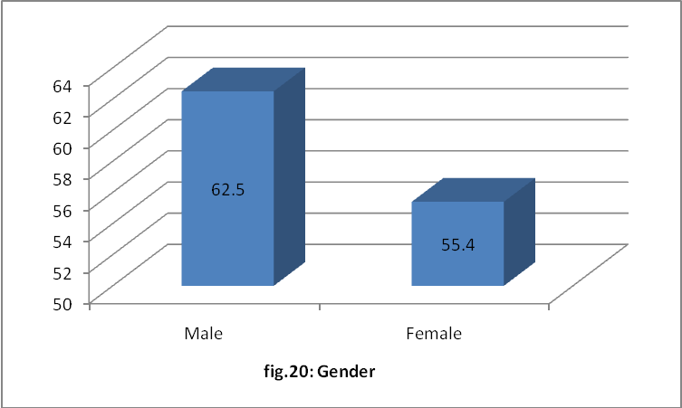
Ref. Table A.20

4.2.2.10 Marital Status
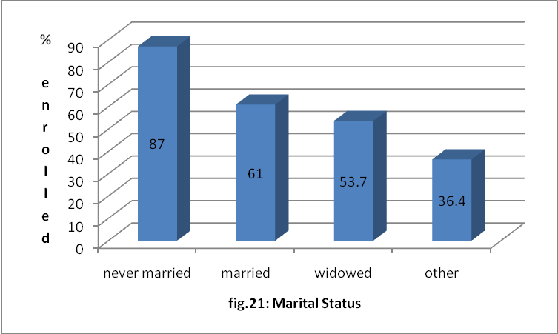
Ref. Table A.21
4.3 MULTIPLE REGRESSION ANALYSIS
Based on the above analysis, we choose the following predictor variables for Logistic regression: Education, Work status, Age Group, Income level and Rural/Urban.
The regression model used in this section is as follows:
y=α+ β ₁x₁+ β₂x₂+......+
; Where y is the dependent variable i.e. enrolment. It is a binary variable that can take only two values, depending on whether the household is enrolled under the scheme or not. Since the dependent variable is binary, we use a Logistic Regression Model. α is the constant of the model, β represents coefficients of the explanatory variables.
N=939

A chi-square value = 164.286 and p<.001 indicate that the model is significant.

The multivariate analysis accounts for collinearity among the independent variables and hence, gives the influence of each predictor variable on the dependent variable adjusted for the indirect influence of other factors.
For each of these categorical variables, the first category has been taken as the reference category.
The rural/urban classification continues to be a significant factor. Being employed also has a significant influence on enrolment.
Education that turned out to be a significant factor in the univariate analysis of the previous section is now showing a p value that is not significant. This means that education on its own does not particularly help in predicting the likelihood of the household to enrol, but it is correlated with other independent variables that do have a direct influence on our dependent variable. For instance, bivariate correlation between education and income level shows a significant relationship between the two. The level of education may also be a proxy for work status, which itself was seen to be a significant predictor.
Age group turned out to be insignificant in the previous section’s analysis but has been included in the multiple regression model owing to the general association of age with propensity to fall sick and hence, the need for health insurance. However, the p-values associated with the “age group” group in the model as well, confirms that for our sample, age of the household head is not a significant predictor of the likelihood of enrolment.
For the “income level” variable, the highest and the next to highest categories of income turn out to be significant, with the lowest income group as reference. This means that income becomes a deciding factor for enrolment only for households falling in the Rs. 20,000 or higher income categories. There is not too much difference in the propensity to enrol between the “up to Rs. 10,000” and the “Rs. 10,000-Rs.20,000” category, for our sample.
5. SUMMARY AND CONCLUSIONS
Applications to implementation of scheme and awareness programmes

The RSBY comes across as a scheme with the potential of alleviating the health status of the poorest of the poor and hence making a significant contribution to the larger goal of inclusive growth. It also involves a huge amount of public spending in health hence, addressing concerns regarding rising OOP expenditure in health care.
An analysis of the target group shows that high levels of illiteracy and abysmally low employment rates are characteristic of the group. Majority of the population works as casual labour. These points towards the poor state of access to financial resources for health care as well as access to quality health care facilities that the group must have. The group characteristics reflect the enormity of the challenge of providing health insurance cover to the target population and also the importance of improving their health indicators.
Regarding participation in the scheme, the enrolment rates in the sample as well as the district as a whole, are commendable considering that this is the first enrolment phase of the scheme. This indicates that the scheme has been well-designed and is suited to address the needs and requirements of its target population. Enrolment rates in the later phases of the scheme are expected to be much higher based on the fact that every time a member of the enrolled households benefits by way of cashless treatment at a quality health care centre/hospital, a number of the non-enrolled become interested in the scheme. Thus, word of mouth publicity of the benefits of the scheme is playing an important role in generating awareness.
About 0.5% of the sample has used their smart cards in the six months of enrolment of the scheme. The preliminary response of the beneficiaries regarding use of the scheme has been positive, with most of them claiming to have no difficulties in availing benefits. The respondents have expressed satisfaction with the level of treatment and medical facilities provided to them, and intend to renew the scheme next year. District figures show that the largest proportion of the users of smart cards has undergone cashless general surgery in the empanelled hospitals. A number of these have also been treated for infectious diseases, respiratory disorders and orthopaedic problems.
Although the scheme is being widely publicised in the State, more needs to be done in that area. There seems to be a need to re-design and strengthen awareness and promotion programmes because a number of household heads that are not enrolled in the scheme cite lack of awareness that the scheme exists as the reason for not participating. A large proportion of the non-enrolled also say that they knew the scheme existed but did not fully understand the procedures involved and the benefits of the scheme. Thus, equal emphasis should be placed on these aspects in awareness programmes.
Survey revealed that some people enrolled under the scheme are not aware of the fact that the scheme is now operational. Interestingly, the survey became a means of conveying that to people, a lot of who responded to questions regarding their use of the scheme by saying that they did not know they could start using their card. Special attention needs to be paid to ensure wide publicity of these aspects at least in the early phases of the scheme roll-out.

Comparison of enrolment rates across various categories of households classified on the basis of socio-economic and demographic factors combined with the study that revealed which of these factors are actually significant in the likelihood of enrolment, indicates which particular sections of the target group need to be focused on while implementation and promotion of the scheme. The major findings of this part of the analysis were as follows: Firstly, there is a lot of difference in the enrolment rates of rural and urban areas. Some possible reasons for this trend have been pointed out earlier, such as the fact that the urban population is more prone to migration and even though the scheme caters to the needs of migratory workers, it is not yet operational in all states. There is scope for further exploring this result and focusing on promoting the scheme in urban areas. Secondly, education level of the household head does not have a direct influence on the likelihood to enrol in the scheme. However, education is correlated with other factors, for instance income levels that do have a direct influence on our outcome variable. Thirdly, income turned out to be a significant predictor of the likelihood to enrol and the enrolment rates are lower in higher income groups. Finally, age, which is generally considered an important factor in an individual’s decision to participate in a health insurance scheme, did not turn out to be significant in our sample.

Age, gender, work status, occupation, education, marital status are those of the head of the households in the sample

