INTERNATIONAL LABOUR ORGANIZATION

DEVELOPMENT COOPERATION PROJECT DOCUMENT

On-demand country advisory services to improve synergies between social protection and Public Finance Management



Country: |  | On demand services to countries
ILO Responsible Official: |  | Shahrashoub Razavi
Time frame: |  | 44 months
Budget requested: |  | 4,871,154 Eur
Resource partner: |  | EC DEVCO – GLO19/19/EUR
 | EXECUTIVE SUMMARY

Over the past decade, social protection has become recognized as a central element for achieving sustainable and inclusive development, including through goals 1, 3, 5, 8, 10 and 16 of the 2030 Agenda for Sustainable development. As a result, an increasing number of countries and development actors have launched activities in this area of work. However, it is technically complex to design and implement social protection systems that are well-performing, coherent, well-coordinated with related policy-areas, financially sustainable and in line with international principles and standards, in particular as regards their orientation towards achieving universal social protection. Systems need to be tailored to country contexts and build on existing structures and institutions, to ensure simultaneously their financial, technical and political feasibility: there are no one-size-fits all solutions.
Both governments and development partners often resort to recruiting external expertise for the highly technical work on the various branches of social protection and different steps in the delivery chain. However, the solutions proposed do not always bring about the desired impact since many contractors provide suggestions for certain highly specialized technical areas but fail to take sufficiently into consideration the bigger pictures and country context, including political economy factors and institutional capacities at country level. In this situation, there is typically significantly asymmetry of information between contractors and government-led SP institutions and government institutions often lack capacities to procure, monitor and use technical advisory services to their best advantage. The added value of the project consists in, on the one hand providing advisory based on international standards and good practices, not for profit and free of vested interests and, on the other in strengthening the internal capacities of government institutions to better understand how to commission and use social protection related services.
Under “Approach 2”, for which the ILO is the implementing agency, the project thus will provide to a minimum of 10 countries on-demand cutting-edge technical advisory services that take a holistic and systemic approach in three interconneted areas of technical expertise, as defined in the Action document:
1.- Ensuring sustainable financing for comprehensive social protection for all in need of such protection. This includes estimating costs and impacts of different programme design options, carrying out analysis of fiscal space and various strategies to expand investment in social protection and engaging with Ministries of Finance on the choice and implementation of realistic financing strategies.
2.- Ensuring efficient and effective spending of funds including by analysing programme delivery chains and administrative arrangements to maximize efficiency and effectiveness of the use of funds when designing and implementing social protection programmes.
3.- Improving shock-resilience by providing technical advisory services for improving responsiveness of programmes in times of shock or crisis, both regarding financing but also regarding administrative and implementation capacities.
Countries will be selected through a minimum of 2 calls for proposals based on a defined set of criteria including relevance to the programme, expected impact and results and operational efficiency, among others. The global component of the Action will complement the “Approach 2” component and will ensure the documentation and sharing of experiences and knowledge generated in delivering support to all countries where the Action is implemented.
The COVID-19 pandemic constitutes an unprecedented challenge for the whole world with significant immediate as well as longer term social and economic implications. Social protection systems play an important role during the current COVID-19 crisis in facilitating access to affordable health services and in mitigating the social and economic repercussions of the crisis both at households levels by providing basic income security and at the macro level by stabilizing aggregate demand and contributing to macro economic stability. The above objectives and planned actions have therefore become all the more relevant in the current global state of emergency. Countries are announcing new measures to adapt and upscale their social protection programmes or introduce measures to support the population cope with the effects of the COVID-19 pandemic. It is therefore important to maintain and expand the fiscal space and delivery capacity of social protection systems during this crisis. The programme therefore decided to accelerate the process of selecting approach 2 countries and to focus the first call on supporting countries to respond to and recover from COVID-19.

1. BACKGROUND AND JUSTIFICATION

Background
In the context of the EU financed Action “Improving synergies between social protection and Public Finance Management” (DCI-HUM/2018/041-579) implemented jointly by ILO (lead agency), UNICEF and the Global Coalition for Social Protection Floors (GCSPF), eight countries have been pre-selected. In these eight countries, the programme will engage over a three-year period to strengthen social protection systems, particularly as regards their financing (approach 1). In addition, the programme aims to provide medium-term technical advisory services across a range of areas relevant to build efficient, sustainable and equitable social protection systems in line with the New European Consensus on Development.
The present document elaborates in more detail the modalities of this Global Facility for on-demand country advisory services described in section 1.13.4 of the Action document (approach 2).

Around the world, structural transformations resulting from population ageing, globalization, labour migration, automatization and climate change pose challenges to the adequacy and financial and economic sustainability of existing social protection systems. In this context, social protection is more crucially important to help workers and employers navigate the macro-structural transformations as well as more frequent individual life and work transitions including from school to work, labour mobility, active ageing, and from the informal to the formal economy, and enable them to seize new opportunities. The ILO Centenary Declaration adopted in June 2019 expresses a global consensus on the importance of social protection systems for helping people cope with the above transformations, for ensuring growth is inclusive and for enabling a life in dignity. Yet, significant coverage gaps remain (see fig 1. below), with significant regional variations as well as significant differences between men and women (see fig. 2 below).

Figure 1 Effective social protection coverage, selected contingencies, global and regional estimates by area, 2016

Source: ILO, World Social Protection Database, based on SSI; ILOSTAT; national sources.
Figure 2 Share of men and women of working age contributing to a pension scheme and share of men and women in pensionable age receiving a pension (contributory and non-contributory), selected countries, latest available data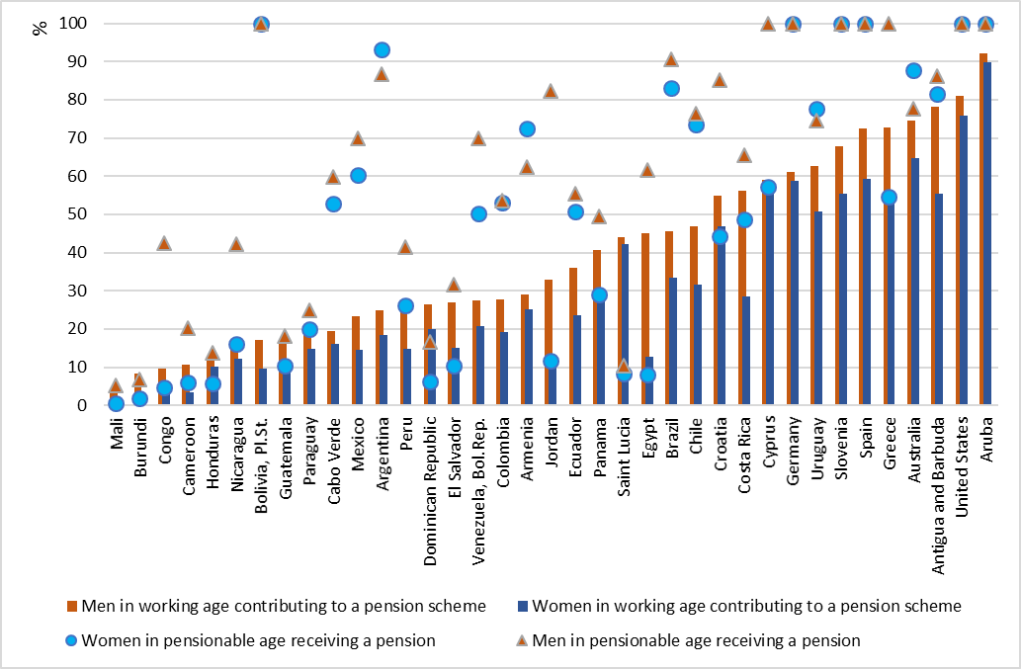
Source: ILO World Social Protection Database, based on SSI; ILOSTAT; national sources.

As shown in figure 3, coverage gaps are highly correlated with expenditure on social protection: countries that spend more on social protection have higher coverage and countries that underinvest in social protection cannot reach high levels of population coverage.
Figure 3 Government expenditure on social protection linked to SDG indicator 1.a.2 and social protection coverage SDG indicator 1.3.1 (both excluding health), latest available data
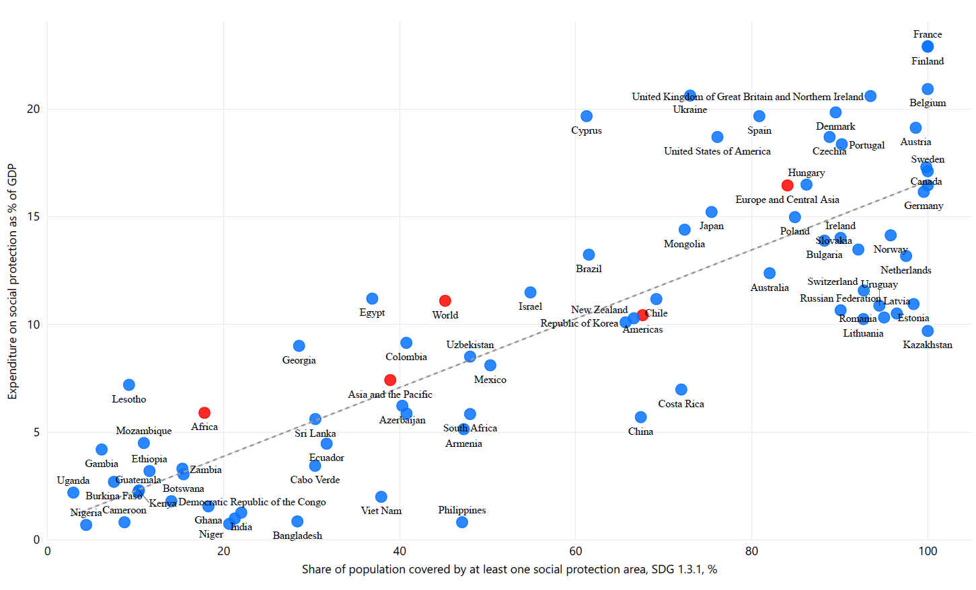
Source: ILO, World Social Protection Database, IMF.

However, it is not just a question of how much is being spent but also how the funds are being used. The programme therefore offers support to countries and development agencies in three interconnected areas of technical expertise:
1.- Ensuring sustainable financing for comprehensive social protection for all. This includes estimating costs and impacts of different options for programme design, carrying out analysis of fiscal space and various strategies to expand investment in social protection and engaging with Ministries of Finance on the choice and implementation of realistic financing strategies.
2.- Ensuring efficient and effective spending of funds by analysing programme delivery chains and administrative arrangements, as well as establishing monitoring mechanisms, to maximize efficiency and effectiveness of the use of funds when designing and implementing social protection programmes.
3.- Improving shock-resilience by providing technical advisory services for improving responsiveness of programmes in times of shock or crisis, both regarding financing but also regarding administrative and implementation capacities.

Problem Analysis
At national level, coherent social protection policy making requires coordination across different policy areas as responsibilities for social protection programmes are spread across various sectors. It is therefore important to consider social protection systems as a whole, rather than limiting interventions to individual schemes and programmes. In addition, social protection systems need to be designed ensuring coherence with other policy areas related to social protection. The starting point for creating coherence is thus a holistic, multidisciplinary analysis of the strengths and weaknesses of the existing system in the context of employment, education, health, budgetary and economic policies. Such analysis is crucial for the designing, planning and implementation of social protection programmes and the social protection system as a whole. Such analysis is also complex, requiring actuarial, statistical, legal, financial, policy design, social, economic and public administration expertise. The increasing use of new technologies is posing additional challenges for countries to keep pace with latest developments.

Many countries lack capacities in these highly specialized areas and revert to external expertise, e.g. from the UN system or bilateral development agencies to request for support in their efforts of strengthening their social protection system. With the 2008/09 global economic and financial crisis and the adoption of the 2030 Agenda for Sustainable Development, social protection has attracted much more attention as a key driver of sustainable and inclusive development. As a result, governments requests for technical advisory services are expanding towards UN agencies or donors who contract out a large part of their activities, and towards an increasing number of actors providing such support, but that is not necessarily aligned with international social security standards and principles. The market for these services is intransparent and the quality of services provided varies considerably, in particular since most actors come with a specific mandate and partial perspective but hardly any provider can offer the combination of multi-disciplinary support outlined above. The field is therefore not easy to navigate for new-comers or outsiders of the domain leading to inefficiencies in terms of time and energy spent on procurement processes or contracting of services and to outcomes where provided services do not meet needs. At the same time, the EU budget support actions do not yet sufficiently tap into the developmental potential of investing in social protection systems as budget support to the social sector, and social protection in particular, remains at modest levels. Therefore, increasing EU budget support for strengthened social protection systems could send a strong signal to countries regarding the importance of increased investment into these sectors.

Through the “Approach 2” of the Action on creating synergies between social protection financing and social protection, the programme offers an efficient, effective, transparent and responsive mechanism through which countries and EU delegations can access needed social protection technical advisory services of high quality, that is aligned with international social security standards and conducive of achieving the SDGs, and based on successful country experiences and practices.

Stakeholders and Target Groups
Direct target groups of the project are governments and EU delegations in need of technical assistance in the areas outlined above 1) sustainable financing, 2) effective implementation and 3) improving shock-responsiveness of their social protection schemes and programmes. The indirect target group is the population, in particular poor and vulnerable groups who will benefit from better-managed, more accessible, more gender- and disability-sensitive and more sustainable social protection systems in their countries.
Relevant stakeholders include:
- Relevant sector ministries with the general mandate on social protection and/or responsible for certain flagship programmes and/or responsible for coordination and policy coherence, including e.g. Ministry of Labour, Ministry of Health, Ministry of Finance, Ministry of Planning, Ministry of Children, women, family and social affairs, Ministry of Agriculture among others.
Central level government is important for overall policy formulation, setting priorities and developing a strategic vision for the extension of social protection as well as adopting and enforcing the related legal framework. In the context of the project, they are a key target audience for explaining the need for investing in social protection.
- Regional and local government entities responsible for social protection programme administration and/or delivery of both contributory and non-contributory social protection programme and schemes.
Lower administrative levels and programme administrators can provide administrative data and important information on what works well and what can be improved in the delivery of social protection programmes. They often share responsibility for the implementation or oversight of the schemes and programmes, are more aware of realities and needs of the population, and as such need to be involved in reform decisions to ensure their buy-in for a smooth implementation process. Otherwise, resistance to change can jeopardize reform projects. Local administrations also play a crucial role in the monitoring of social protection programmes’ performance and funding, and thus it will be important to reinforce data, tools and capacities for more effectively carrying out these tasks.
- National statistical offices are crucial partners to obtain necessary data for assessing social protection needs, coverage levels and coverage gaps as well as general social-economic and demographic data. Low capacities, lack of tools, and dispersion of data across many social protection actors challenge the monitoring of the social protection system’s efficiency. There is a need across countries to strengthen the management information systems of social protection programme, and their interoperability, as well as national statistical offices’ capacities to coordinate data collection and consolidation.
- Social partners are key stakeholders in that they finance social protection systems through their taxes and contributions. As such, they should be involved in decision-making on social protection systems. From the perspective of contributors or recipients, they can also provide important information on the functioning of the system, accessibility of programmes and on population needs, and provide suggestions on ways to improve compliance or administrative processes and tools.
- UN agencies and donors (including EU delegations) working on social protection and social inclusion are important partners. In many countries, in particular low-income countries, the social sector is influenced and partially funded by development partners. They are important stakeholders as a source of information and capitalization of practices, in light of the need for coordinating activities and as contributing financially.
- IMF provides short term recommendations on social spending based on three criteria: fiscal sustainability, spending efficiency and spending adequacy. However, the short term recommendations can put at risk the long-term aspirations/policies of the country and can have negative consequences on social protection systems; “short-term gains” through reforms to achieve fiscal surplus can lead to “long-term pain” in terms of higher poverty and inequality. Through the project the ILO and EU will try to advocate for taking due consideration to equity and social sustainability principles to increase the effectiveness and sustainability of the reform programmes suggested by the IMF.
- Civil society and non-government organizations representing beneficiaries play an important role in providing information on the realities of the persons and stakeholders they represent, in particular vulnerable groups, women, people with disability, elderly, migrant workers, among others. In many countries, the delivery system relies also on the civil society organizations activities; this is the case of the social mutualist movement in implementing national social health insurance schemes in several West African countries. The civil society are also partners for advocacy and awareness raising activities, in this sense the partnership with the Global Coalition for Social Protection Floors (GCSPF) in the framework of the Action.

ILO Comparative Advantage
As the UN agency with the official and holistic mandate on social protection, the long-standing experience and as a standard-setting agency with a large number and diversity of highly qualified social protection experts, the ILO is uniquely placed to provide social protection advisory services across the full ranges of needed areas of expertise: policy and legal framework, financing, statistical work, implementation, monitoring, coverage of different groups along the life cycle, coverage for different life cycle risks.
ILO’s combines technical expertise with a strong process-orientation based on participatory national dialogue and consensus-building as well as internationally adopted normative framework that makes ILO stand out compared to other actors, including UN Agencies, that do not benefit from this close relationship with workers’ and employers’ representatives.
ILO technical advisory services are unique in three respects:
1.- ILO pays as much attention to the delivery process as to technical excellence, including all relevant stakeholders through a participatory process called national dialogue which enhances understanding for social protection issues and facilitates consensus-building on key reform measures.
2.- In this participatory process, the ILO places a strong emphasis on building local capacities in the course of service delivery. This includes both inviting local experts to hands-on training as well as conducting training as a core element of services delivery. The ILO plays a pivotal role in the SPIAC-Board and development of the ISPA tools, referring to its experience and guides on several key issues such as assessment of systems, extension to informal economy, financing, unemployment protection, legal setting, and migrant workers.
3.- As a standard-setting organization and as the organization with the mandate to work on social protection, the ILO has a unique combination of in-house experts working with a holistic and systemic perspective.

Supported by those strengths, ILO took the lead to launch the Global partnership on universal social protection in 2016, joined by the World Bank and now an increasing number of development partners and countries. Recently, the ILO Global social protection week, gathering over 500 participants in Geneva, illustrated again the leading role of the ILO on social protection.

Project Contribution to National Development Plans, EU budget support operation, UNDAF/UNSDCF, SDG
In the selection of country requests, the facility will respond as a priority to proposals that have strong national social protection frameworks, documenting strong political will to extend social protection. Other key criteria for selecting proposals will be their full alignment with national development plans, UNDAFs / UNSDF and their contribution to achieving the SDGs. The project will prioritize requests from EU delegations with concrete programming needs for budget support on social protection.

2. PROJECT STRATEGY

Introduction
The objective of this component of the Action aims to ensure that EU delegations and countries have access to quality social protection advisory services that provide integrated support upon request for any aspect regarding the planning, design, financing and implementation of social protection systems, programmes or delivery mechanisms, which are well coordinated across sectors and support the achievements of ongoing and planned EU budget support programmes and /or inspire future EU budget support programmes in the area of social protection. The project therefore offers technical advisory services to countries and EU delegations in line with the three strategic objectives of the EU Action on Creating Synergies between Public Finance Management and Social Protection:
1.- Ensuring sustainable financing for comprehensive social protection for all. This includes estimating costs and impacts of different programme design options, carrying out analysis of fiscal space, identifying innovative financing options, and various strategies to expand investment in social protection and engaging with Ministries of Finance on the choice and implementation of realistic financing strategies..
2.- Ensuring efficient and effective spending of funds by analysing programme delivery chains. administrative arrangements, setting spending monitoring tools, at local and national levels, to maximize efficiency and effectiveness of the use of funds when designing and implementing social protection programmes and schemes.
3.- Improving shock-resilience by providing technical advisory services for improving responsiveness of programmes in times of shock or crisis, both regarding financing but also regarding administrative and implementation capacities.
For the delivery of these services, the programme draws on the long-standing expertise of the ILO Social Protection department, which includes a team of specialist posted in the regions and countries, thereby ensuring quality and compliance with international principles and standards as depicted in the figure below:

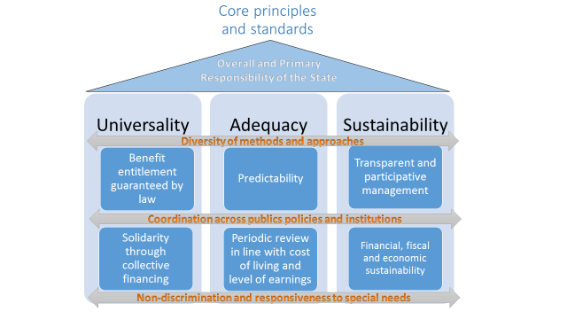
Apart from these substantial principles anchored in ILO standards, process-wise, the technical advisory services will be focussed on the following principles:
- A participatory approach that builds consensus among stakeholders;
- Thorough analysis that builds a strong evidence base and development of tools;
- Action oriented research that provides concrete recommendations for improving the social protection systems, programmes and delivery modalities with a specific focus on gender, disability, new technologies and shock-responsiveness.
Equally, a strong focus will be placed on the restitution of finding and planning of next steps so as to ensure uptake of recommendations and maximize impact.
The project will provide services upon request. Countries will be selected based on a set of criteria including relevance for the overall programme (including its contribution to achieving SDGs related to social protection), demonstrated political will, technical quality and overall coherence of the proposal. In order to facilitate a selection process that best meet these criteria, countries and EU delegations will be asked to submit their requests in response to calls for proposals. The first call will be launched upon approval of the related documents by the operational committee (tentatively: April 2020) and will be focused on COVID-19 social protection responses. A second call for proposals will be launched no later than 9 months following the approval of the first round of proposals. Depending on the number of requests received and subject to budget availability, a third call would be organized no later than 9 months after the approval of proposals from the second call. In total, with the available budget, it is expected that 10 countries will receive support (depending on the nature and financial implications of the requests).
Where needed, the ILO will support EU delegations and countries to elaborate the scope, timeframe, cost and nature of the request. The deadline for submission of requests will be 6 weeks after the launch of the call (four weeks for the first call) and the proposals should be selected through the operational committee within 6 weeks after submission (, 2 weeks for the first call; depending also on the volume of proposals received). For the selected countries, the EU delegations, the government and the ILO will elaborate detailed proposals that will further specify the objectives, planned activities, methodology, work plan, profile of experts, the proposed institutions to be entrusted with or be included in the activity as well as the budget allocation for the action. Based upon approval of the request by the Operational Committee, an agreement will be signed between the government and the ILO that details services to be provided as well as the related costs paid by the action. The detailed description of the selection modality and criteria will refer to the standard operating procedures available as a separate document that will constitute the terms of reference of each call. Similarly the project will develop templates for preparing the proposals. The ILO will either directly deliver the advisory services or through subcontractors that will be backstopped by the ILO to ensure high quality support. The Global Facility will advertise its services and actively encourage countries in the process of social protection reforms to seek support from the facility.
A strong management unit at ILO headquarters will ensure a smooth process for launching the call for submitting requests, the selection process and the delivery of services. The global cross-country component of the EU Action will document country experiences and lessons learnt, including through a revision and updating of existing tools and models based on the country cases. (An overview of potential services offered is provided in Annex B)

Narrative Theory of Change: from Intervention to Results (A Theory of Change Visualisation is attached as Annex A)
The project aims to drive change through the following logic:
IF countries and EU delegations receive the technical services that they need (request) and
IF these services are delivered in a timely manner and of high quality and
IF these services are developed through a holistic and participatory approach that involved all relevant stakeholders and
IF these services take into consideration the political, financial and technical feasibility of proposed actions

THEN national stakeholders will have a solid evidence base and reinforce capacities to take informed decisions and
THEN reform options will be adopted that are politically, financially and technically viable and in conformity with ILO Social Security standards, and
THEN reform options will enjoy buy-in and ownership by relevant stakeholders

SO THAT agreed measures are implemented leading to better managed, more sustainable and gender-sensitive social protection schemes and programmes resulting in an extension of social protection, reduction in poverty and inequality and more inclusive development and the progressive achievement of the SDGs on social protection.

This theory of change presupposes that governments and programme administrations are indeed interested to work towards universal social protection and therefore willing to take the necessary action and commit the necessary resources.

Expected results (see also Logframe Annex C)

    - End-of-Project Outcome
Outcome 1: A minimum of 10 countries receive on-demand high quality, gender-responsive, disability-inclusive technical advisory services that are relevant and produce technically, financially and politically feasible recommendations on how to improve the national social protection system, programmes or delivery mechanisms

Output 1: Selection of a minimum of 10 countries through a minimum of two calls for proposals, based on criteria of relevance and sound operations
Activities:
    - Launch and dissemination of the calls for proposals
    - Organisation of selection of requests through the operational steering committee
    - Support services to develop the proposals

Output 2: Delivery of technical advisory services of high quality that are gender-responsive and disability-inclusive are delivered in the 10 selected countries
Activities in the 10 countries:
    - A multidisciplinary technical team is composed to deliver the services in line with the request
    - A process for participatory implementation of the advisory services is established, to the extent possible drawing on existing consultation or dialogue structures
    - The evidence base is created to address the request, including information and data on gender, disability, shock-responsiveness, costs, financing and digitalization
    - Different scenarios to improve the social protection system, programme or delivery mechanisms (in line with the request) are identified and elaborated - coherence and coordination within and beyond the social protection system is ensured.
    - The scenarios are analysed regarding a selection of parameters in line with the request, e.g. costs, financing sources, political economy implications, institutional capacity, technical feasibility, impact (on poverty, inequality, GDP growth, formalization and other systemic changes) and taking into consideration implications regarding their effects on gender, disability, shock-responsiveness and potential of using new technologies in their implementation
    - Findings are disseminated so that national stakeholders, including social partners are well-informed about social protection needs and possible actions to address them
    - Technical advisory services delivered are summarized in an outcome document (country report, strategy, roadmap, draft policy, etc.) and the results are entered in ILO’s Results monitoring tool
    - Framework and tools for monitoring progress in implementing the project outcomes (country report, strategy, roadmap, draft policy, etc.) and progress in extending social protection are established; the Results monitoring tool is updated
    - Technical advisory services are backstopped by responsible sub-regional Decent Work Team and relevant HQ specialist(s)

    - Impact
By selecting countries that demonstrate strong political will to move towards universal social protection, the programme increases the likelihood that governments and administrations will follow up on the findings produced by the project. If they do, then they will improve their social protection systems along the following aspects:
    - Improved financial sustainability
    - Improved evidence base regarding needs, costs, coverage
    - Improved effective coverage
    - Improved administration, delivery and monitoring capacity
This in turn, will lead to reducing poverty and inequality (SDG 1 and 10) and potentially trigger a virtuous cycle of development, of improved health (SDG 3), transition to the formal economy and improved income and productivity, which in turn will lead to higher tax collection and potentially further investments in social spending.
Improving the design, administration and delivery will also have impact on SDG 16 in terms of creating effective, accountable and inclusive institutions at all levels.

    - Assumptions
Management assumptions:
- The selected projects are able to attract and retain high quality and specialized staff and/or consultant to carry out the work
- The projects are able to facilitate consensus-building among key stakeholders
Implementation assumptions:
- Needed data and information are available at country level and will be shared
- Political will to improve coordination and coherence internally (across sectors) and externally (across related policy areas) exists demonstrated for example by delegating the relevant and sufficiently high-level persons to coordination meetings and bodies.
- Government, programme administrations and other relevant actors will follow-up on and implement the recommended actions
- The necessary resources will be committed to implementing the agreed actions
- There is demand for the advisory services and technical assistance, both from partner countries and EU Delegations
Development assumptions
- The project suggests recommendations that will lead to an extension of social protection coverage and adequacy, through increased fiscal space or improved governance
- Macro- economic and political conditions will be favourable to trigger a virtuous cycle of improved coverage, improved productivity, higher tax revenues, higher wages, and more resources for social protection
Sustainability assumptions
- Government, programme administrations and other relevant actors will follow-up on and implement the recommended actions
- Trained staff will continue to work in the social protection system of the country
- Continued or increased political will and financial commitment for additional investments in social protection

    - Stakeholder Ownership and Sustainability of Results
Description of stakeholder involvement in the elaboration of the proposal
The adoption of a participatory process based on wide consultations with relevant stakeholders will be a key criterion in selecting country requests. As a minimum, the proposal should be discussed with relevant line ministries, government representatives from regional and local government, administrations of existing social protection schemes, social partners, women and people with disability’s associations and representative organizations of the informal economy.
Ownership in the implementation process
National ownership and consensus-building are a key objective, and element of success, throughout the project implementation. This is particularly important for sound analysis of social protection needs and for identifying appropriate solutions since different stakeholders are involved in the different implementation steps and can share first-hand experience on what works and what does not. This information is not available elsewhere and can only be obtained from stakeholders directly. At the same time, involving the stakeholders right from the start (identification of objectives and data collection) as well as throughout (discussion of reform measures and findings) will generate ownership of the findings. This will make follow-up action more likely as well as generating acceptance for needed change, thus facilitating the implementation.
Sustainability of results
The programme approach of creating synergies between public finance management and social protection is itself a sustainability strategy since it emphasizes the importance of ensuring that social policies are designed on the basis of a solid and sustainable financing framework. Similarly, analysing simultaneously the political, financial and technical/institutional viability of different policy options will increase adoption rate and sustainability. The participatory approach of training national staff during the delivery of technical services and when carrying out the diagnostic of the social protection system will build the capacity for periodic updating of analytical reports and planning tools for evidence based decision-making.

    - Risk Analysis

Risk | Risk  Level | Likeli hood | Mitigation strategies
The selected projects are unable to attract and retain high quality and specialized staff and/or consultant to carry out the work. | H | Medium | This Action will follow standard ILO recruitment processes which are competitive and merit-based. Staff at ILO Social Protection Department are available for backstopping if needed.
Consensus cannot be reached because opposing views of key stakeholders cannot be overcome | L | Low | The dialogue methodology of the project and strong focus on evidence-based problem solving will facilitate consensus-building.
Needed data and information is not available at country level | L | High | Where data is missing, the projects will work with assumptions and will provide guidance on improving data collection and compilation of social protection statistics
The macro-economic and political context is not favourable to the extension of social protection. | M | Low | In certain regions of the world, countries are increasingly being exposed to climate change, insecurity, and political orientations that may hamper future development of social protection systems
Political will to improve coordination and coherence internally (across sectors) and externally (across related policy areas) is lacking | L | Low | Demonstration of political will is one of the selection criteria to respond to requests for technical assistance since no impact can be achieved if there is no political willingness to mobilize the required resources and to take the necessary action.
Government, programme administrations and other relevant actors do not follow-up on and implement the recommended actions | H | Medium | By building on existing structures, careful feasibility analysis and ensuring political willingness, the Action will maximize the likelihood that recommendations will be followed up on.
Political decision making in the partner country is slow and cumbersome, national partners and stakeholders change constantly and in case of government changes following elections, there is a risk that one has to start from square one again. | M | Medium | To the extent possible, the Action will proceed through wide national dialogue and consensus-building across the entire political spectrum and secure progress achieved through written agreements and Memoranda of Understanding. The evidence-based approach will make working across difference government easier since the findings on coverage gaps or financing gaps will not be different before and after the elections.
Demand for the advisory services and technical assistance, both from partner countries and EU Delegations is limited. | L | Low | A pro-active strategy will be adopted at the beginning of the Action to ensure that EUDs, and partner countries and development partners are aware of the available services. This includes a communication strategy coupled with efforts to network with key stakeholders.  Regional meetings and events will be used to advertise these services.  During implementation, a monitoring mechanism will be put in place at Unit B3 level, to activate corrective Actions if needed to stimulate demand.
EUDs are not well aware on how to potentiate the programmatic links between social protection and the sector policies being supported through budget support contracts. | M | Medium | Policy advice and technical assistance will be designed in such a way as to focus particularly on the articulation between social protection and social/other policies in general.

3. MONITORING

At the start of the implementation phase, the project manager will be responsible to set up a permanent internal, technical and financial monitoring system to track progress at each level of the logical hierarchy of the project – the activities, outputs, outcomes and impacts. Implementation monitoring will take place to ensure effective operations, i.e. continuous monitoring of activities, outputs and the flow of resources to ensure their strategic orientation towards intended project results. The workplan is the most important element for monitoring project implementation. The project manager will also ensure that individual country workplans are set up and monitoring frameworks. Baselines and targets will be set for relevant indicators listed in the logframe according to each country and policy contexts. This will entail elaborating additional monitoring tools such as performance plans, responsibility matrix, resource plans, monitoring matrix etc. Monitoring tools will be selected as appropriate for each of the country advisory services to be delivered, in line with the specific nature and implementation modality of that request.
The monitoring matrix of each selected country request will identify information needs and related sources and how data will be collected, keeping in mind also information needs of the planned evaluation acivities.

4. INSTITUTIONAL FRAMEWORK AND IMPLEMENTATION ARRANGEMENTS

  - Institutional Framework
As laid down in the Action document, the ILO is the agency with the “responsibility to manage the technical assistance facility to be established for the execution of on-demand support of Approach 2”. The ILO will therefore manage the process of launching the call, facilitate the selection of requests by the operational steering committee, and provide assistance to countries to develop well-articulated, precise and achievable proposals. As provided in the agreement, the Operational Committee will consist of five persons with voting rights, three from the European Commission and two from the ILO, and will sit in variable composition depending on the geographical location of the proposed activity. Each of the Operational Committee must include one member representing each of the following groups: DEVCO B3, one ILO Social Protection Department technical expert, one EU geographical unit, one EU Delegation in the region, one representative of a regional/Decent Work Team ILO office. To the extent possible, members of the Operational Committee will aim at taking their decisions by consensus, by keeping an option to decide by simple majority voting of all statutory OC members, if requested by one member.

  - Partnerships and implementation Arrangements (if applicable)
At country level, the ILO will work in close collaboration with the EU delegation. Depending on the countries selected, the ILO will enter into partnerships or implementation agreements with actors as needed for a successful implementation of the activities. In all cases, the ILO will pursue a participatory approach and consult with and involve relevant stakeholders throughout the project implementation.

5. KNOWLEDGE AND COMMUNICATION

The communication and visibility plan are submitted as a separate document.

6. MANAGEMENT ARRANGEMENTS

In order to ensure efficient management of the project, different roles and responsibilities are assigned to the project staff and ILO staff overseeing the project:
Project manager: Responsible for the day-to-day management of the project, including
- Communication with EU, the operational committee and other project partners
- Supervision of junior staff and consultants
- Overall coordination and secondary backstopping of technical services delivery
- Liaison with field specialists
- Organizing and coordinating resources, management of contracts and funds
- Technical work
- Ensuring timely action, quality and effectiveness of outputs
- Facilitate the selection of requests by the operational committee
- Drafting, coordination and compilation of reports
Technical experts (P3, various technical fields of work, number of work months depending on nature of work required): Responsible to carry out on-demand technical advisory services
Support staff: Responsible for carrying out administrative tasks
Head of Flagship programme and ILO responsible official: Responsible for overall direction and decision-making;

7. EVALUATION

The project will fully participate in the foreseen joint evaluation plan developed for the action: evaluability review, a joint independent mid-term evaluation under the leadership of the EU and a joint independent final evaluation under the leadership of the ILO. The ILO will conduct evaluations of the Action in line with its evaluation policy, rules and procedures. For the approach 2 component, a selection of 4-5 countries will be included for in-depth analysis (i.e. country missions) in the final evaluation under the leadership of the ILO. All country support activities will be included in the evaluation through desk studies and interviews.

8. FUNDING

  - Budget Narrative
The budget contains the following main items of expenditure:
- Staff performing the following functions (charged at standard costs):
- carry out the overall coordination, management and administration of project activities
- backstopping of 10 country technical advisory services
- implementation of some of the technical advisory services (different areas of expertise)
- Technical backstopping missions
- Activities to be financed as part of the technical advisory services, including workshops and trainings and subcontracts of consultants or services

Annexes

Annex A: Sample Theory of Change visualisation (see PRODOC section 2.2)

Annex B: List of technical advisory services offered under the programme

Annex C: Logical Framework

Annex D: Budget

Annex A: Theory of Change Visualisation

Assumptions
Governments and EU delegations submit relevant requests

Sphere of action/ « control »

Sphere of influence
Government actors and SP programmes
Workers

Sphere of interest

Impact
Development objective
Extended social protection coverage and strengthened systems leads to a reduction in poverty, vulnerability and inequality
First order outcomes
Services provide the needed evidence-base for informed decision-making

2nd order outcomes

Agreed measures are implemented so that social protection schemes are better managed, more sustainably financed and better address the needs of the population

Outcomes

Outputs

On-demand technical advisory services focussing on sustainable social protection financing delivered to a minimum of 10 countries that meet the following criteria:
- Participatory
- Gender-responsive
- Disability-inclusive
- Shock-responsiveness

ILO

Assumptions
Action will be taken in line with the services provided

Employers

First order outcomes
Reform options are identified that are politically, financially and technically feasible

Workers

Assumptions Actions will produce positive results for SP coverage

First order outcomes
Stakeholders reach consensus on priority measures to be taken

Civil Society Actors

Annex B: List of Technical Advisory Services

- Assessment-Based National Dialogue involving all relevant stakeholders
- Drafting of social protection law/strategy
- Ratification of ILO Standards
- Social protection expenditure review (SPER) and costing of social protection scenarios
- Fiscal space analysis and financing
- Participating in the development and implementation of a financing strategy for social protection (with Ministry of Finance, IMF, EU and other DPs)
- Working with parliamentarians and other stakeholders to influence the budget increase for social protection
- Engaging constituents as “agents of change” and building their knowledge and skills to enable effective national dialogue process and facilitate a culture of social protection.
- Feasibility studies, design / reform of scheme/programme parameters
- Developing social protection programme roadmaps/ implementation strategies.
- Actuarial analysis
- Investment policy and management structure analysis
- Drafting scheme regulations/by-laws
- Working with parliamentarians to support adoption of new legal framework
- Case management and social care is integrated into SP programmes
- Establishment of an inter-ministerial social protection coordination body.

- Strengthen or establish social protection information system
- Strengthen or establish effective and inclusive social accountability, complaints and appeal mechanisms
- Regular M&E mechanisms established for programme course correction
- Integrated delivery mechanisms (e.g. single window)
- Strengthen institutional capacities, e.g. national identification system
- Decentralized coordination and communication mechanisms to administer social protection activities
- Strengthening staff capacities particularly social welfare workers
- Assessment of social protection systems taking into consideration humanitarian and emergency contexts (e.g. climate change mitigation and adaptation, refugees, etc.)
- Support the development of data collection systems to be used in the event of a crisis
- Integration of humanitarian response mechanisms into national social protection systems and vice versa promoting use of national mechanisms for humanitarian responses
- Strengthening financial capacities (contingency funding) for shock-responsive social protection systems.
- Defining and utilizing analytical tools to assess operational effectiveness and efficiency of national social protection systems (CODI and other ISPA tools)
- Definition and application of results and impact assessment tools/ methods
- Facilitating south-south learning and exchange of experiences on social protection system design and implementation.
- Development and update of good practices guides, tools, databases etc.
- Support the development of national statistical authorities and develop capacities on social protection statistics

- Increasing leadership and promoting partnerships on advancing universal social protection
- Increasing awareness and strengthening capacities of DPs regarding the design and implementation of social protection systems (and floors), including knowledge on financing and public finance management.
- Establishing effective coordination mechanisms for development actors’ initiatives
- Promoting financing for social protection through papers, pledging conferences and multi-stakeholder national and global funds
- Supporting nationally led and owned social protection initiatives
Strategy Development
Programme Design
Programme Implementation

Shock-responsive SP

Evidence & knowledge management

Partnerships

Cross-cutting capacity building at country level and through global and regional training facilities
Annex C: Logical Framework
See separate document

Annex D Budget

