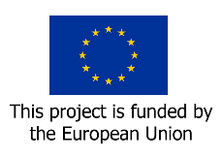
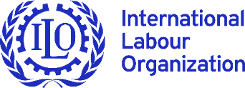
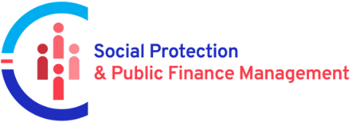

Final Report
March 2022 – June 2023

EU/ILO Programme on Improving Synergies between Social Protection and Public Finance Management
Project Code (GLO/19/53/EUR)

VIET NAM



June 2023
Project title: EU/ILO Programme on Improving Synergies between Social Protection and Public Finance Management
Country: Viet Nam
Report type (pick one): Final report
Reporting period: From March 2022 to June 2023

Linkages:
Sustainable Development Goal: implement nationally appropriate social protection systems and measures for all, including floors, and by 2030 achieve substantial coverage of the poor and the vulnerable
UNDAF Outcome: UN-Viet Nam Coorperation Framework, Outcome 1: Inclusive Social Development

Preparation and Review
Report prepared by: Andre Gama, 04/07/2023
Report reviewed by: Markus Ruck, 05/07/2023
Report approved by: Ingrid Christensen, 07/07/023

Contents
1 Executive Summary 4
2 Basic Information 5
3 Summary outputs 6
4 Summary outcomes 8
4.1 Achievement of the project outcomes 9
5 Narrative Report: Managing for Results 9
5.1 Results summary 9
5.2 Monitoring, evaluations, and other reviews including with implementing partners and EU Delegations 12
5.3 Main challenges, risks and corrective action 12
5.4 Opportunities and corresponding strategy adjustments 13
5.5 Specific interventions related to public finance management 13
5.6 Complementarity with the EU Delegation’s interventions and on-going and future Budget Support Programmes 13
5.7 Synergies with other social protection interventions and strategic partnerships with other development partners 14
5.8 Overall budget analysis 14
5.9 Lessons learned and good practices 15
5.10 Visibility & Communication 15
5.11 Conclusions and Recommendations 16
Annexe 1 : Project risk register 18
Annexe 2: Knowledge products of the project 20
Annexe 3: Communication and visibility 21
Annexe 4: Emerging good practice 25

Executive Summary
The “Expanding fiscal space towards a more gender-sensitive social protection system in Viet Nam” project was developed jointly by the ILO Country Office for Viet Nam and the EU Delegation in Viet Nam between December 2021 and February 2022, and started on 14 March 2022.

In the first months of implementing the project, emerging risks and opportunities presented themselves, both with an ability to influence the project’s implementation and impact.

With regards to the risk, the ILO team in charge of the project observed, in the first half of 2022, a slowing down of the momentum at the Government level with regard to the potential introduction of the Multi-Tiered Child Benefit through the new revision of the Social Insurance Law.

With respect to the opportunities, the Government of Viet Nam, in April 2022, requested the ILO to lead and coordinate the UN support to the revision of Party Resolution 15 on Social Policies. Party Resolution 15 is the only legal document in Viet Nam that oversees the whole of the social protection system (as well as additional policy branches), and thus presents a unique and valuable channel to promote comprehensive and coordinated reform to the whole system.

ILO proposed an adjustment of the project and its activities, in order to overcome these risks and take advantages of these opportunities in a way that better aligns with national stakeholders’ priorities, and best leverages the projects activities into effective, transformative and long-lasting impact. The prodoc revision was endorsed in July 2022, to ensure that the project keeps a focus on promoting gender responsive social protection, whilst expanding its focus and investment on issues related to public finance management.

Following this revision, the project focused, under Outcome 1, on addressing the Government’s request for support to the development of an accounting system for social protection and social policies, which enables a better measurement and projection of social budgets in the country, thus equipping social protection policy makers with stronger tools to advocate for increased fiscal space for social protection with other stakeholders.

Under this outcome, the ILO entered into a UN to UN Agreement with the United Nations University – Maastricht Economic and Social Research Institute on Innovation and Technology (UNU-MERIT) to support MOLISA to:
- Develop a framework for the measurement of expenditure in social protection programmes and social policies. A set of social budgeting tables was developed, which enables to clearly distinguish between expenditure for social protection and social policies in Vietnam in the period 2012-2022. This framework has been completed and endorsed by the Government.
- Collect all data on expenditure of social protection and social policies in the 2012-2022 period. Based on the framework described above, the following step consisted of collecting national data (on social protection and social policy expenditure – managed by the Ministry of Finance), with a view to allow room for further collection of expenditure at subnational level at later stages.
- Develop a joint MOLISA-ILO report on social expenditure in Viet Nam, including the projection of expenditure for social protection and social policies in Vietnam to 2030 and 2045.

Under Outcome 2, the activities focused on promoting dialogue and capacity building on issues related to gender equality in social protection. In particular, the project supported the Viet Nam Women Union (VWU) to:
- Develop a Training package on gender perspectives in social protection in Viet Nam. This training package focuses on strengthening general knowledge of ILS on social protection and gender issues. The package also presents suggestions regarding the role VWU staff at all levels (national and subnational) can play in advocating for gender sensitive and gender responsive social protection.
- Organize two consultations at grassroot level (one with VWU at the provincial level, one with VWU at the district levels) on the draft training materials. More than 30 VWU staff reviewed and provided feedback.
- Organize 2 pilot training courses for more than 100 trainees who are VWU staff at the central and grassroot level in over 20 provinces and cities in Vietnam.
- Conduct a survey on the current status of the maternity benefit in the current social security system. More than 200 respondents participated in the survey.
- Develop a report and a Policy Brief on Situation of Maternity benefits in Viet Nam. The report and Policy Brief identified key coverage gaps of the maternity benefit for women in Viet Nam, including the discussion on the overall working trajectory of women during maternity, the limitations and constrains they are facing during the maternity period, and identified the possible options for expanding maternity protection towards universal coverage.
- Collaborate with VGCL and VCCI in organizing consultations with workers and employers to discuss the ongoing social protection reforms in the country, with a focus on promoting a more gender-responsive social protection system.

Although the project experienced some delays in the beginning due to the reprogramming and adjustment, most of the committed results have been achieved. Some conclusions are as follows:

- The overall project was very relevant, timely and fully in line with the needs and expectations of the national stakeholders, ILO and the donor.
- Overall, the project has been very effective and has achieved its overall objective. The project contributed to support the people in Viet Nam, especially those at risk of being left behind, to benefit from inclusive, gender responsive, disability-sensitive, equitable, affordable and quality social services and social protection systems, will have moved further out of poverty in all its dimensions and will be empowered to reach their full potential.
- The impact of the project has been to promote and accelerate the transition towards an inclusive, gender responsive and integrated social protection system, which increases the coverage expansion of the SP system for more people especially those at risk of being left behind.
- The Project has had a strong intervention on public finance management, through providing evidence-based analysis and capacity building on social budgeting and development of a framework for the measurement of expenditure in social protection programmes and social policies in Viet Nam. These outputs are essential to enable stakeholders in Viet Nam to advocate for increased fiscal space for social protection.
- The project has had a strong impact on gender equality. The Gender training package for policy advocacy in Social Protection, which will be institutionalized/deployed by the Viet Nam Women Union, will significantly increase VWU’s internal capacity building system, benefiting thousands of VWU staff at central and local level. This will in turn contribute to improving the quality of policy advocacy towards gender-responsive social protection policy in Viet Nam at all levels.

Basic Information

Countries covered: | Viet Nam
Donor: | European Commission, DG for International Cooperation, Development Cooperation Instrument
Budget: | 165,850
Administrative unit: | ILO Hanoi
P&B Outcome: | <Linked to P&B Outcome>
DWCP outcome: | VNM 151
Start date: | 14 March 2022
End date: | 30 June 2023
Project Duration in months: | 15 months

Summary outputs

OUTPUT DELIVERY
Output |  | Output status |  | Output summary
Outcome 1: Improved design and financing of gender sensitive social protection systems
1.1 | FORMTEXT An official definition of what programmes and policies in Viet Nam are classified as Social Protection Programmes and Social Policies is agreed and endorsed by the relevant stakeholders | On schedule | FORMTEXT Technical assistance focused on providing evidence-based analysis and capacity building on social budgeting. A framework for the measurement of expenditure in social protection programmes and social policies Viet Nam has been finalized and endorsed by the Government  The joint MOLISA-ILO report on social expenditure in Viet Nam, including the projection of expenditure for social protection and social policies in Vietnam to 2030 and 2045 has been finalized and endorsed by MOLISA.
1.5 | FORMTEXT <Enter output title> | <please select> | FORMTEXT
Outcome 2: 2. Capacity developed and knowledge shared about gender sensitive social protection systems in general, and the MTCB in particular
2.1 | FORMTEXT Government and social partners' capacity on gender sensitive social protection systems in general, and the MTCB in particular, are improved | On schedule | FORMTEXT A Gender training package for policy advocacy in Social Protection has been finalized and piloted. The training materials were endorsed by VWU and is being replicated in the VWU internal system.
2.5 | FORMTEXT <Enter output title> | <please select> | FORMTEXT

OUTPUTS: Overall delivery assessment
☒ | Highly satisfactory  Implementation of almost all (>80%) outputs is on schedule as envisaged in the implementation plan and almost all (>80%) indicator milestones have been met. | ☐ | Satisfactory  Implementation of the majority (60-80%) of outputs is on schedule as envisaged in the implementation plan and the majority (60-80%) of indicator milestones have been met.
☐ | Unsatisfactory  Some (40-60%) outputs are being implemented on schedule as envisaged in the implementation plan and/or only some (40-60%) indicator milestones have been met. | ☐ | Very unsatisfactory  Few (<40%) outputs are being implemented on schedule as envisaged in the implementation plan and/or only a few (<40%) indicator milestones have been met.

Justification of self-assessment:

Although there are some adjustments on the focus and activities, in general the project has been implemented successfully. Activities have contributed to the development of a more effective, efficient and gender-sensitive social protection system in Viet Nam. Adjustments to the project have slightly delayed implementation, but increased alignment with national priorities and impact.

Summary outcomes
OUTCOME ACHIEVEMENT
Indicator | Baseline  (before project start) | Target (end-of-project goal) | Outcome summary
Outcome 1: Improved design and financing of gender sensitive social protection systems
FORMTEXT Status and content of the New Party Resolution on Social Policies | FORMTEXT NA | FORMTEXT The explicit addressing of gender equality and fiscal space is included in the new resolutio | FORMTEXT The new framework for measurement of SP expenditure and the Report on social protection expenditure in Viet Nam are essential to enable stakeholders in Viet Nam to advocate for increased fiscal space for social protection.
FORMTEXT | FORMTEXT | FORMTEXT | FORMTEXT
FORMTEXT | FORMTEXT | FORMTEXT | FORMTEXT
Outcome 2: Capacity developed and knowledge shared about gender sensitive social protection systems in general, and the MTCB in particular
FORMTEXT Number of organizations, and stakeholders trained and consulted about gender sensitive social protection systems, in particular the MTCB | FORMTEXT 2 | FORMTEXT 7 | FORMTEXT Improving gender responsiveness and sensitivityin the new resolution, such as possible introduction of child benefits and the universal coverage of maternity cash benefits will contribute to narrow down the gender gaps of the country social protection  The new Gender training package for policy advocacy in Social Protection will be institutionalized by the VWU, which will reach full impacts when it is used in the VWU’s internal capacity building system, benefiting thousands of VWU staff at central and local level. This will in turn contribute to improve the quality of policy advocacy towards gender-responsive social protection policy in Viet Nam.

Achievement of the project outcomes

OUTCOME: Overall outcome summary
☒ | Highly probable  Almost all (>80%) reporting period milestones have been met. Based on the indicators and risk assessment, it is highly probable all outcomes will be achieved by the end of the project. | ☐ | Probable  The majority (60-80%) of reporting period milestones have been met. Based on the indicators and risk assessment, it is probable the majority of outcomes will be achieved.
☐ | Low probability  Some (40-60%) reporting period milestones have been met. Progress is being made on the outcomes but based on the indicators and risk assessment only some outcomes will be achieved. | ☐ | Improbable  Few (<40%) reporting period milestones have been met. Limited progress is being made on the outcomes and based on the indicators and risk assessment only a few outcomes will be achieved.

Justification of self-assessment:

Overall, the project has been very effective and has achieved its overall objective. The project contributed to support the people in Viet Nam, especially those at risk of being left behind, to benefit from inclusive, gender responsive, disability-sensitive, equitable, affordable and quality social services and social protection systems, will have moved further out of poverty in all its dimensions and will be empowered to reach their full potential.

Narrative Report: Managing for Results

Results summary

Briefly outline the outcomes achieved in the project, highlighting how project outputs led to (initial or more substantive) outcome changes during the project lifespan.

In outcome 1, the outputs created by the project are expected to provide evidence for the new Party Resolution give direction for an improved and expanded fiscal space for social protection. The new framework for measurement of SP expenditure and the Report on social protection expenditure in Viet Nam are essential to enable stakeholders in Viet Nam to advocate for increased fiscal space for social protection.

In outcome 2, the gender training package for policy advocacy will be an important tool for Viet Nam Women’s Union (VWU) to build capacity of its staff at central and sub-national levels to actively participate in the policy discussion and dialogues on promoting gender equality in social protection in Viet Nam.

The project develops a human voice story about a VWU leader’ story about how her understanding about gender responsive social protection grew through ILO-VWU joint work, how her capacity has increased to the point that now she is able to lead a training to be rolled out through thousands of VWU representatives throughout the country, allowing what started as an ILO policy level collaboration to reach and have an impact at the grassroot (town, village, commune) level, and have a sustained impact on VWU capacity to advocate for more gender responsive social protection at all levels. The story was posted in ILO social media, and has been shown several time during the International Symposium: Strengthening Synergies with Public Finance Management for Achieving Universal Social Protection.

The project generated a report and a Policy Brief on Situation of Maternity benefits in Viet Nam. The report and Policy Brief has identified key coverage gaps of the maternity benefit for women in Viet Nam, including the discussion on the overall working trajectory of women during the maternity, the limitations and constrains they are facing during the maternity period, and identify the possible options for expanding maternity protection towards universal coverage. This will be used in coming advocacy towards an universal maternity benefits in Viet Nam.

Based on the achievement of outcomes explain how the project is likely to contribute towards the overall development objective.

The New Resolution on Social Policies for 2023-2030 with vision to 2045 will be the overarching framework for Viet Nam to reform its social protection system. The impact of the project has been to strengthen to accelerate the transition towards an inclusive, gender responsive and integrated social protection system, which increase the coverage expansion of the SP system for more people, especially those at risk of being left behind.

At the same time, outcome 2 contributed to the improved capacity on advocacy and dialogue towards a more gender responsive social protection, which lead to reach the overall development objectives through promoting more effective, efficient and gender sensitive social protection systems

Describe how the project has contributed to the achievement of national development strategies (e.g. DWCP, UNDAF, SDGs, etc.) and other development frameworks (e.g. SDG, etc.)

By the full achievement of two outcomes, the project contributed to support the people in Viet Nam, especially those at risk of being left behind, to benefit from inclusive, gender responsive, disability-sensitive, equitable, affordable and quality social services and social protection systems, will have moved further out of poverty in all its dimensions and will be empowered to reach their full potential. These results are committed under Priority 2 of the Decent Work Country Programme (DWCP) for Viet Nam, 2022-2026, and Output 1.3 of One Strategic Framework for Sustainable Development Cooperation between the UN and GOVN (2022-2026). Therefore the project is fully relevant with the DWCP and the UNDAF, as well as the national development strategy.

Self-evaluation results:

Relevance
The overall project was very relevant, timely and was fully in line with the needs and expectations of the national stakeholders, ILO and the donor.
The project contributes to country priority 2 of the Decent Work Country Programme (DWCP) for Viet Nam, 2022-2026. The project was also coherent with other work been carried out by the ILO country office and in the region such as the ILO/IA Project Inclusive Growth, Jobs and Social protection (new phase 2017-2022).
The Project supports One Strategic Framework for Sustainable Development Cooperation between the UN and GOVN (2022-2026), specifically the Outcome 1: Inclusive Social Development.

Effectiveness
Overall, the project has been very effective and has achieved its overall objective. The project has contributed to the new draft of Party Resolution on Social Policies in the 2023-2030 with vision to 2045, in which it contains a number of legislative reforms to promote a rights-based system and concrete policy options for coverage expansion and including number of element that advance Gender equality in social protection, including the possible universal expansion of maternity benefits and introduction of child benefits.
A Gender training package for policy advocacy in Social Protection has been finalized and piloted in Viet Nam. The training materials will be an important tool for Viet Nam Women’s Union (VWU) to build capacity of its staff at central and sub-national levels to actively participate in the policy discussion and dialogues on promoting gender equality in social protection in Viet Nam

Sustainability
The impact of the project has been to strengthen to accelerate the transition towards an inclusive, gender responsive and integrated social protection system, which increase the coverage expansion of the SP system for more people especially those at risk of being left behind. The New Resolution on Social Policies for 2023-2030 with vision to 2045 will be the overarching framework for Viet Nam to reform its social protection system.
Moreover, advanced gender equality contents in the new resolution, such as possible introduction of child benefits and the direction towards universal coverage of maternity cash benefits will contribute to narrow down the gender gaps of the country social protection system and improving the life of millions of women in Viet Nam.
The new Gender training package for policy advocacy in Social Protection will be institutionalized by the Viet Nam Women Union, which will reach full impacts when it is used in the VWU’s internal capacity building system, benefiting thousands of VWU staff at central and local level. This will in turn contribute to improve the quality of policy advocacy towards gender-responsive social protection policy in Viet Nam.

Monitoring, evaluations, and other reviews including with implementing partners and EU Delegations

Outline efforts made to involve a broad range of stakeholders in M&E, including the role played by the EU Delegation, constituents and implementing partners. Highlight efforts to support the implementation of the EU programmation and interventions.

The project is implemented as part of the EU/ILO/UNICEF programme on "Improving synergies between Social Protection and Public Financial Management". The project activities are fully compliant with the procedures, rules and regulations of the EU and ILO. Activities are monitored by ILO and the implementing partners (ILSSA and VWU. The project informs routinely the SP&PFM Programme global management, and EU Delegation in Vietnam on deliverables and milestones achieved, and has discussed thoroughly all challenges and successes of the project so far with both parties.

Explain the process/method for collecting information regarding outcomes and challenges mentioned in this report.

The project work with implementing partners and other stakeholders to request the provision of sex-disaggregated data for monitoring the impact and informing policy adjustments on gender equality. In particularly, VSS is responsible to provide sex disaggregated data on social insurance, MOLISA Department of Social Assistance is responsible to provide data on social assistance, ILSSA is responsible to update on process of drafting the new Resolution and VWU is responsible to provide update on the gender issues. Besides the project records and monitor the number of workshops, dialogues, participants and products

If any evaluations were carried out, briefly describe how findings and recommendations were addressed by the intervention.

An evaluation in on going

Main challenges, risks and corrective action

The most challenging risk was the slowing down of the momentum at the Government level with regards to the potential introduction of the Multi-Tiered Child Benefit through the new revision of the Social Insurance Law. The Project has timely analysed and proposed reprogramming which helped to continue to achieve the overall development objective of the project while increasing alignment with national priorities.

Besides, in the beginning of 2022 when the project started, the COVID-19 pandemic affected the activities of ILO, the Government and other sectors in many ways.

- Technical meetings and workshops: The project has been developing a number of background studies and in-depth analysis on a desk-basis. These have been used for capacity building workshops and consultations using Zoom.
- Mission: The project has been delivering most activities online or in the duty station that do not require travels.

After resuming face-to-face meetings and missions, the project has been continuously facing potential risks of absence of participants, resource persons or ILO officials when they are diagnosed covid-positive or hospitalized in the last minute.

Opportunities and corresponding strategy adjustments

With the request from the Government for the ILO to lead UN technical support to the development evidence-based knowledge on social protection in order to support the revision of the implementation of Resolution No. 15-NQ/TW and develop the New Resolution on Social Policies in Vietnam 2022-2030 with vision to 2045, the project has timely requested adjustments and reprogramming of activities to address this request.

In November 2022, the Ministry of Labour, Invalids and Social Affairs (MOLISA), as part of their response to the ILO’s Global Campaign to promote the ratification of Convention No. 102, requested the support to review existing laws and policy framework taking international standards, particularly ILO Convention No 102, into account. The project has collaborated with the ILO/IA project to provide supports to draft the Report on “ Assessment of the social security legislation for the ratification of the Social Security (Minimum Standards) Convention, 1952”.

Specific interventions related to public finance management

Within outcome 1, output 1.1, the ILO provided technical support with focus on providing evidence-based analysis and capacity building on social budgeting. This is essential to enable stakeholders in Viet Nam to advocate for increased fiscal space for social protection under the new Resolution on Social Policies.

The project entered in a UN to UN Agreement with the United Nations University – Maastricht Economic and Social Research Institute on Innovation and Technology (UNU-MERIT) to support MOLISA to develop a draft framework for the measurement of expenditure in social protection programmes and social policies. A set of social budgeting table has been developed, which enables to clearly distinguish between expenditure for social protection and social policies in Vietnam in the period 2012-2022.

Also under output 1.1, the project supported MOLISA to collect all data on expenditure of social protection and social policies. The support initially focuses on collecting national data (expenditure managed by Ministry of Finance) but also allow room for further collection of expenditure decentralized managed at sub-national level. The project also support to develop a joint MOLISA-ILO report on social expenditure in Viet Nam, including the projection of expenditure for social protection and social policies in Vietnam to 2030 and 2045.

These outputs are expected to provide evidence for the new Party Resolution give direction for an improved financing of the new social protection system. The new framework for measurement of SP expenditure and the Report on social protection expenditure in Viet Nam are essential to enable stakeholders in Viet Nam to advocate for increased fiscal space for social protection

Complementarity with the EU Delegation’s interventions and on-going and future Budget Support Programmes

The SP Team in Viet Nam has kept close contact with the EU delegation, and discussed in detail the changes to the PRODOC implemented, and respective adjustment of focus of the project based on risks and opportunities described.

The EU Delegation expressed strong support and interest in the ILO activities under the programme, and expressed how the feedback from the project is helping to shape the EU plan for Development and Cooperation in Viet Nam for the coming years, which is still being finalized.

The EU interventions on the space of SP in Viet Nam are currently quite limited, limiting the scope for complementarities. However, the programme has helped the EU Delegation assess how to best expand its focus on SP in Viet Nam, something that should be expressed in future EUD activities in the country

Synergies with other social protection interventions and strategic partnerships with other development partners

The project was implemented under the framework of the overall work the ILO is undertaking in Viet Nam over the past years in the areas of Social Protection and Informality. This includes the ongoing Irish-Aid Partnership Programme. The goal of this Programme in Viet Nam is to improve the linkage between the contributory and tax–funded systems, through assessments and dialogues to develop the SI and SA schemes within the framework of a multi-tiered system. The Programme also has a strong gender focus and has co-funded the Gender Impact Assessment of the SI system. Therefore, there are strong synergies between the two projects, and resource pooling for specific activities can be considered to magnify the impact of both projects.

This project was also be implemented in coordination with the UN Joint Programme (UNJP) 2020-2022 in Viet Nam in the first half of 2022. The project benefited not only from the ILO’s technical expertise in the field of social protection and its crosscutting thematic expertise, which is essential for developing integrated solutions, but can also be built on the crosscutting, high-quality technical expertise of the UNJP agencies, namely UNICEF, UNFPA and UNDP. The ILO leadership and significant involvement in the UN joint work on Social Protection in Viet Nam, especially the coordination of UN supports in development of the New Social Policies Resolution, enabled it to explore all available synergies between the different programmes, while guaranteeing that duplication of efforts does not take place.

The project activities have been coordinated with other UN agencies through the UN’s Result Group on Inclusive Growth and Social Protection. The project also benefited from coordination mechanisms with other development partners. This includes the ongoing ILO-World Bank collaboration on an actuarial assessment of the pension funds and development of policy options for extension of social protection coverage through a multi-tier social protection system.

Overall budget analysis
Present a brief budget summary, comparing actual and planned expenditure with previous forecasts and the approved budget. Also, highlight and explain over/under spending and efficiency gain.

Budget were utilized according to the plan. In the beginning, the project synergized with other on-going project such as ILO/IA and UNJP to be as cost efficient as possible. ILO Office in Hanoi
assumed full programmatic and financial accountability for the funds disbursed. The ILO Social Protection team in Hanoi administered the funds in accordance with ILO and UN/EU regulations, rules, directives and procedures.
Self-evaluation results:

Efficiency

Resources (funds, human resources, time, expertise etc.) been allocated strategically to achieve outcomes and have been used efficiently. In fact, savings achieved during the initial period of implementation due to cost-sharing arrangements and joint activities with other ILO’s projects may allow the implementation of additional activities.

Lessons learned and good practices
Prepare at least one good practice worth sharing with other projects - template Emerging Good Practices. Available in Annex 4.

The project was adjusted timely to address the risk of slowing momentum on social protection and making it more alighted with national priorities.
See further in Annex 4.

Visibility & Communication
The project regular updated status, activities and results of the project on the country page of the www.socialprotection-pfm.org website as well as the ILO Social Protection Country Page.

Furthermore, ILO made use of its Social Media channels in Viet Nam to share with wider audience news about publications and events developed with the project’s support. However since the third quarter of 2022, the ILO Viet Nam’s communication officer moved to work in the head quarter, social media channel has been silent for quite a long.

The project team also kept regular communication with the EU delegation to explore synergies on the communication and visibility area and discuss with the relevant stakeholders the preparation of joint communication materials such as press releases whenever relevant.

The project develop a human voice story about a VWU leader’ story about how her understanding about gender responsive social protection grew through ILO-VWU joint work, how her capacity has increased to the point that now she is able to lead a training to be rolled out through thousands of VWU representatives throughout the country, allowing what started as an ILO policy level collaboration to reach and have an impact at the grassroot (town, village, commune) level, and have a sustained impact on VWU capacity to advocate for more gender responsive social protection at all levels. The story was posted in ILO social media, and has been shown several time during the International Symposium: Strengthening Synergies with Public Finance Management for Achieving Universal Social Protection.

Conclusions and Recommendations

Conclusions and recommendation from the self-evaluation
Conclusions | 1. The overall project was very relevant, timely and was fully in line with the needs and expectations of the national stakeholders, ILO and the donor  2. Overall, the project has been very effective and has achieved its overall objective. The project contributed to support the people in Viet Nam, especially those at risk of being left behind, to benefit from inclusive, gender responsive, disability-sensitive, equitable, affordable and quality social services and social protection systems, will have moved further out of poverty in all its dimensions and will be empowered to reach their full potential.  3. The impact of the project has been to strengthen to accelerate the transition towards an inclusive, gender responsive and integrated social protection system, which increase the coverage expansion of the SP system for more people especially those at risk of being left behind.  4. The Project has a strong intervention on public finance management, through providing evidence-based analysis and capacity building on social budgeting and development of a framework for the measurement of expenditure in social protection programmes and social policies in Viet Nam. These outputs are essential to enable stakeholders in Viet Nam to advocate for increased fiscal space for social protection  5. The project has a strong impacts on gender equality. The Gender training package for policy advocacy in Social Protection will be institutionalized by the Viet Nam Women Union, which will reach full impacts when it is used in the VWU’s internal capacity building system, benefiting thousands of VWU staff at central and local level. This will in turn contribute to improve the quality of policy advocacy towards gender-responsive social protection policy in Viet Nam
Recommendations | - Continue the work on advocacy on expansion of fiscal space for social protection | Responsible entity: MOLISA, MOF, National Assembly
Recommendations |  | Priority (high, medium, low):  High
Recommendations |  | Resources (high, medium, low, NA):  High
Recommendations |  | Timeframe (long-, medium, short-term):  Short and medium
Recommendations | - Develop the trainers/resource person to deliver the Gender Training package. Institutionalize the Gender Training Package | Responsible entity: Viet Nam Women Union
Recommendations |  | Priority (high, medium, low): High
Recommendations |  | Resources (high, medium, low, NA): High
Recommendations |  | Timeframe (long-, medium, short-term):  Short-term

Annexe 1 : Project risk register

Risk Identified | Mitigating Measures | Additional risk response | Change | Impact
Political instability: Change in government position due to rotation which might affect the policies’ priorities. | Political stability is regularly assessed. There is no expectation of political changes that may affect the achievement of project objectives. | If different situations come up, the project will immediately assess arising risks again and flexibly adjust the implementation strategies and modalities whenever necessary. | No change in the total level of risk | Change in government which might affect the policies’ priorities.
Lessened political will to support social protection initiatives. | The ILO currently has active social protection activities and support to government. With the EU Fund the ILO will ensure continuity of these actions and any necessary advocacy to keep SP in the spotlight, within budget capacity. | Political support will be constantly sought, due to the nature of the project. As soon as there is any indication of a diminished interest, the ILO will strengthen its recommendations and provide the relevant guidance and flexibly adjust the implementation strategies and modalities whenever necessary. | No change in the total level of risk | The shock of the COVID-19 crisis has pushed SP back into all Government’s attention in the region, as a key component response measure. On the other hand, the current political will to social protection could subside in favour of attention to the economic recovery.
Recession or unstable growth | It is unlikely that social spending will reduce in the short-term so existing programs will not be affected. However, authorities might be conservative in the targets they set for the ongoing system reforms. The project will continue disseminating evidence generated over the project’s duration. | If different situations come up, the project will immediately assess arising risks again and flexibly adjust the implementation strategies and modalities whenever necessary. In particular, the project will closely monitor the impact of the COVID-19 crisis. | Increase in the total level of risk | Despite of its proximity to China, Viet Nam has shown notable capacity to contain the pandemic. When compared to other countries, its economy has also shown remarkable resilience. Still, the risk is not over and its hard to tell how things will develop in the short-term
Emergency operations of governments and other development partners in response to the COVID-19 postpone the project’s implementation | Continued close communication and openness to collaboration, but most important, flexibility depending on how the global, regional and country situations evolve. | The project will closely monitor the impact of the COVID-19 crisis in coordination with the governments and development partners to assess their priorities, and will flexibly adjust the implementation strategies and modalities whenever necessary. | No change in the total level of risk | The COVID-19 pandemic has created an unprecedented demand on country’s social systems as well as on development partners’ support. There is a risk key government partners will be overwhelmed with the magnitude of the situation and progress on non-urgent issues could be slow.

Annexe 2: Knowledge products of the project
List of knowledge products, technical reports and studies produced by the project. All documents listed here will be attached to the progress report and should be uploaded to the website www.socialprotection-pfm.org and the ILO social protection country page.

Title of the product or report | Type of product (working paper, brief, technical report, video, capacity building content, etc…) | Published/not published
Towards a Comprehensive Social Security System in Viet Nam Policy Recommendations for 2030, with a vision towards 2045 completed and submitted to the Government in preparation for the new Social Policy strategy for 2023-2030 with vision to 2045 | Technical Report | Not yet published
Strengthening Social Security In Viet Nam - The Case For Greater Coordination And Alignment” | Technical Report | Not yet published
Strengthening Social Policies in Viet Nam, joint UN Synthesis Report on Social Protection | Technical Report | Not yet published
Social Expenditure Review Viet Nam | Technical Report | Not yet published
Viet Nam Women Union – Guidelines for Policy Advocacy in Social protection | Training materials | Not yet published

Annexe 3: Communication and visibility
Include relevant documentation, photo, web link, multimedia or information that may contribute to a better understanding of project progress, and demonsrate good communication and visibility of the proejct.

Articles:

- Vietnam Women’s Union develops new training package for gender-responsive social protection

https://socialprotection-pfm.org/vietnam-womens-union-develops-new-training-package-for-gender-responsive-social-protection/

- the ILO support VWU to advocate for maternity cash benefits expansion

http://hpntuyenquang.org.vn/chinh-sach-phap-luat/hoi-lhpn-viet-nam-tiep-tuc-nghien-cuu-de-xuat-mo-rong-che-do-thai-san-1255.html

- ILO in collaboration with Viet Nam Confederation of Labour to consult of social policies and social protection reform

https://laodong.vn/cong-doan/tong-lien-doan-tap-huan-ve-chinh-sach-phap-luat-an-sinh-xa-hoi-1110036.ldo

- ILO collaboration with VCCI in communicating the reform of social policies and roles of employers

https://daklak.gov.vn/-/tap-huan-ve-chinh-sach-an-sinh-xa-hoi-va-vai-tro-cua-cac-doanh-nghiep

- Towards a sustainable Social Protection system in Viet Nam

http://www.congdoankh.org.vn/tin-chi-tiet/id/8191/Chinh-sach-phai-xay-dung-he-thong-an-sinh-xa-hoi-ben-vung

- The Social policies should target universal coverage

https://phutho.gov.vn/vi/chinh-sach-xa-hoi-huong-den-toan-dan-toan-dien

Pictures

Workshop: Review the 2012-2022 Social Policies and develop the new Resolution for Social Policies for 2023-2030 with vision to 2045
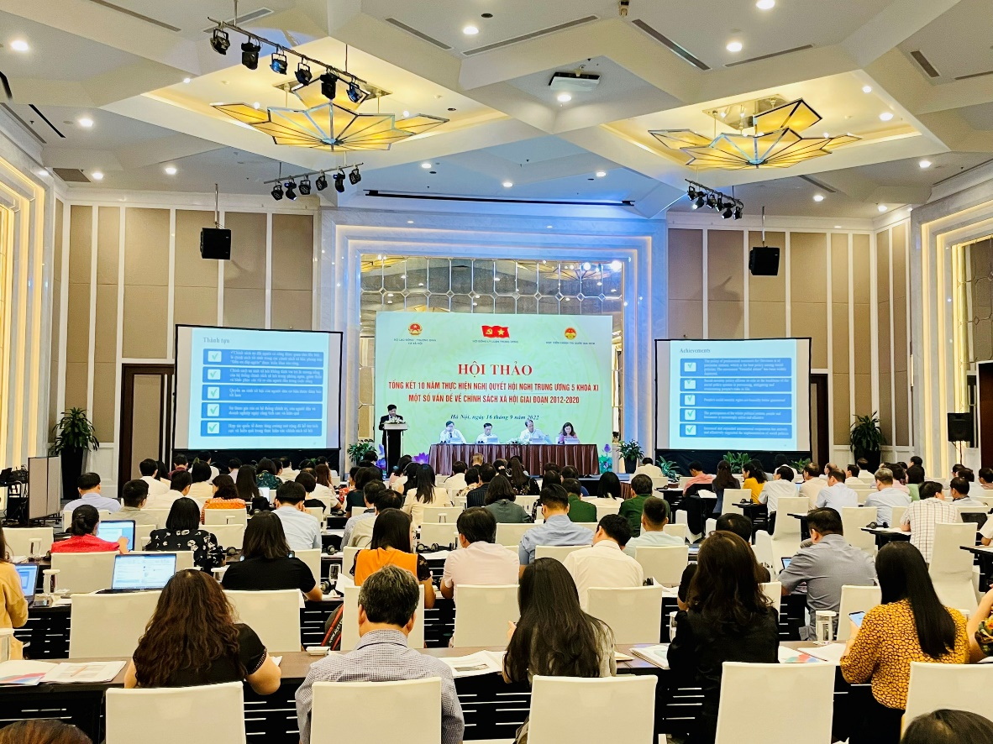
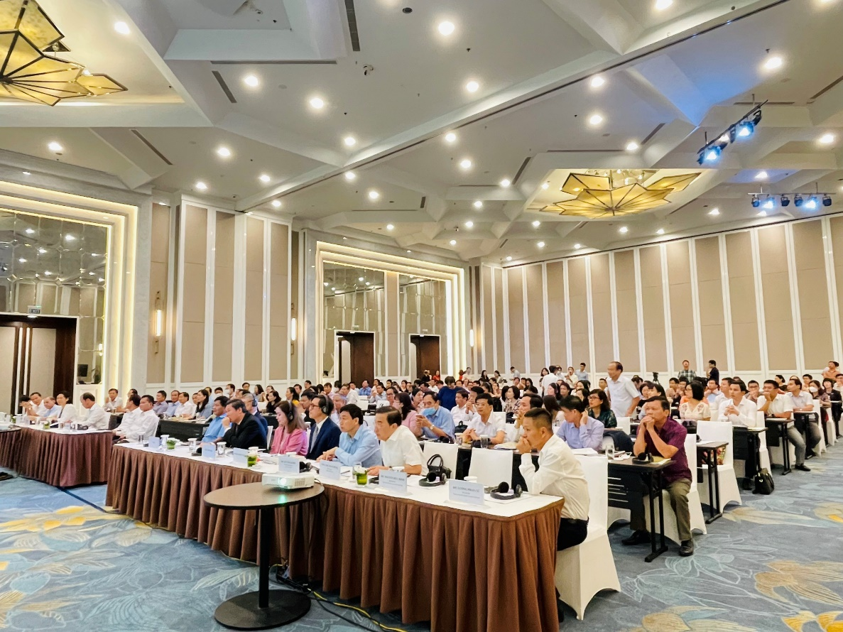

Consultation with workers on Social Policies Reforms

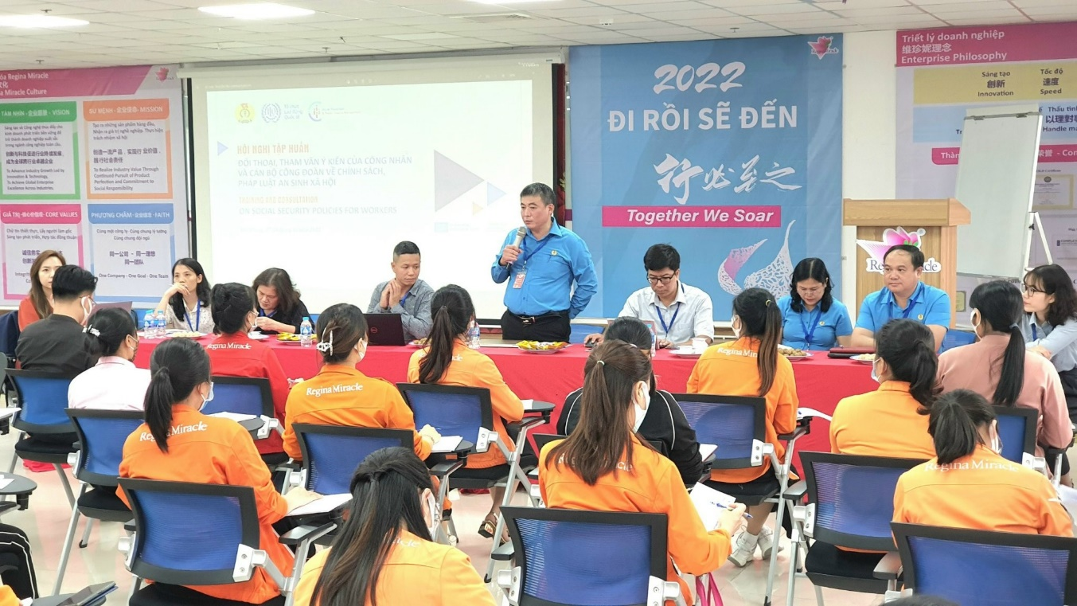
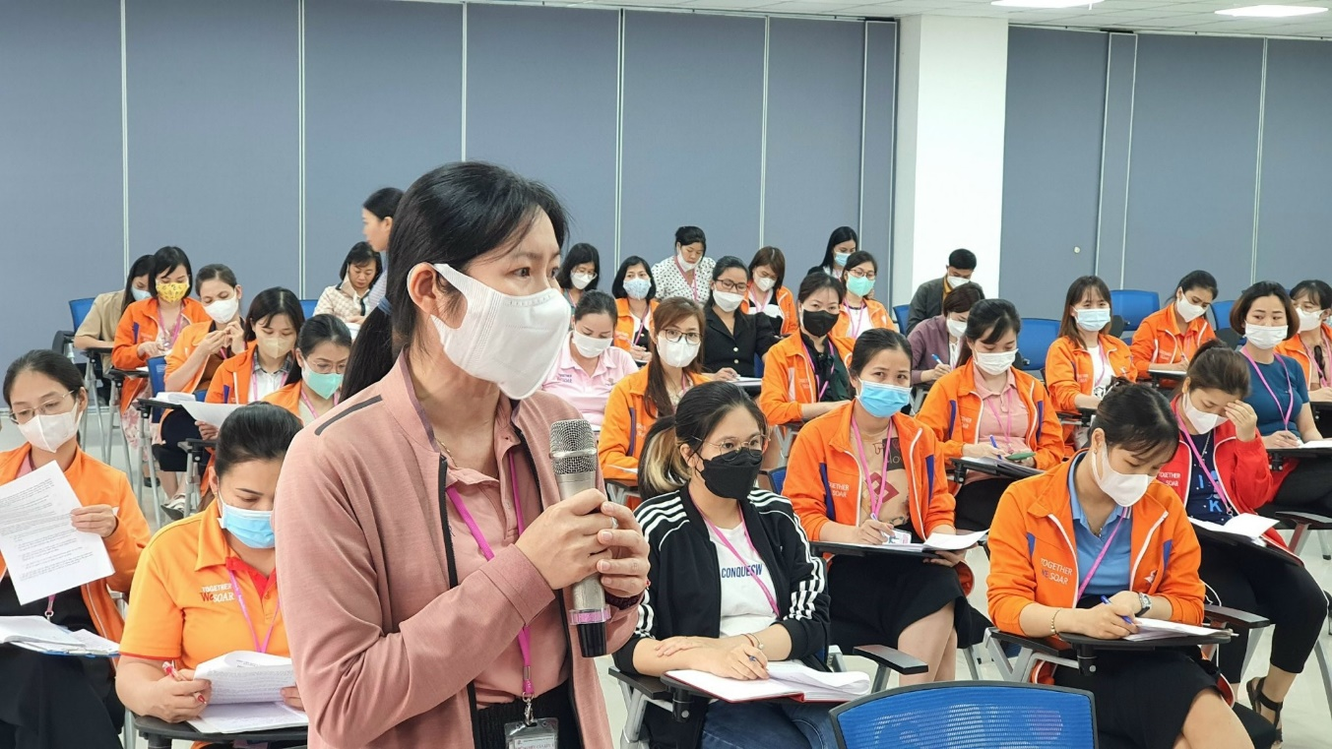

Viet Nam Women Union and the Gender Guidelines on Social Protection Advocacy

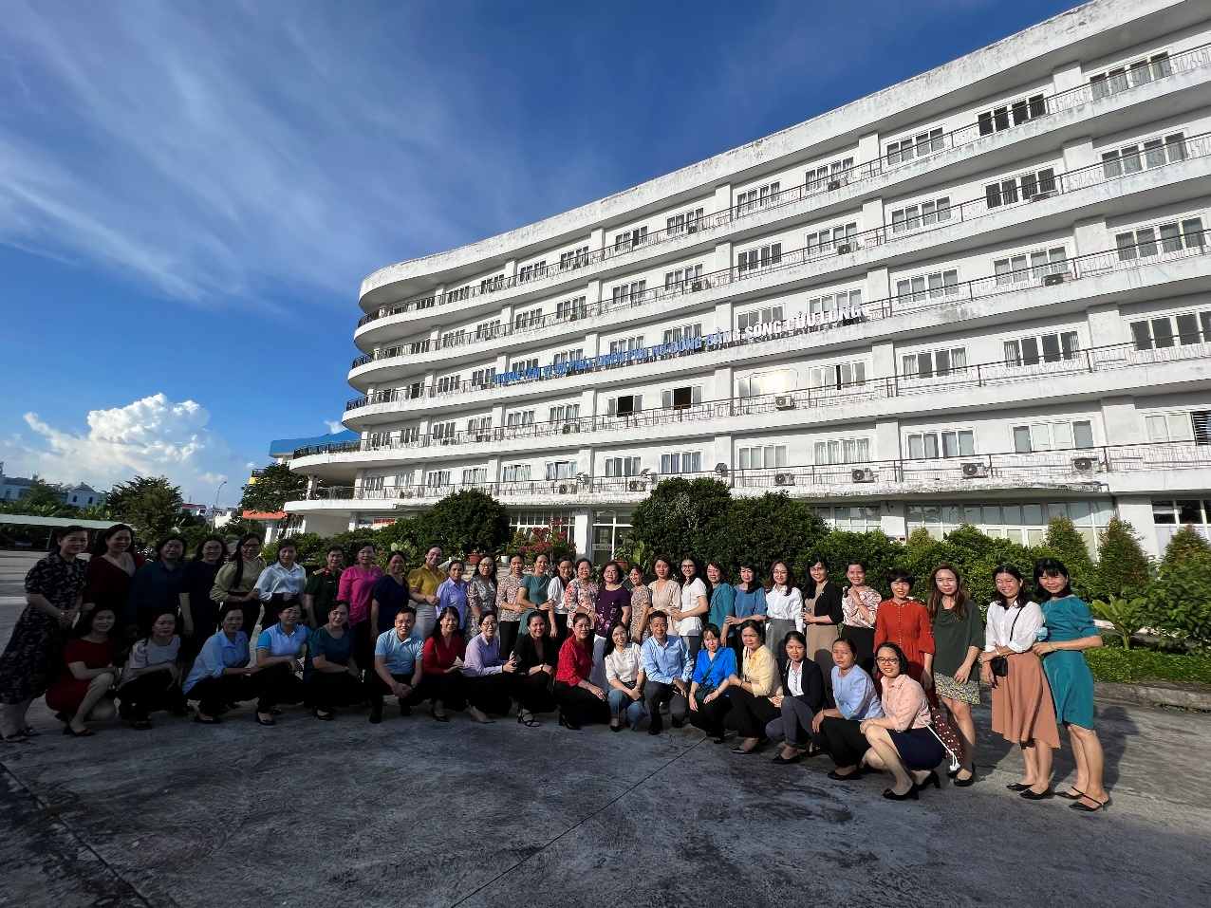

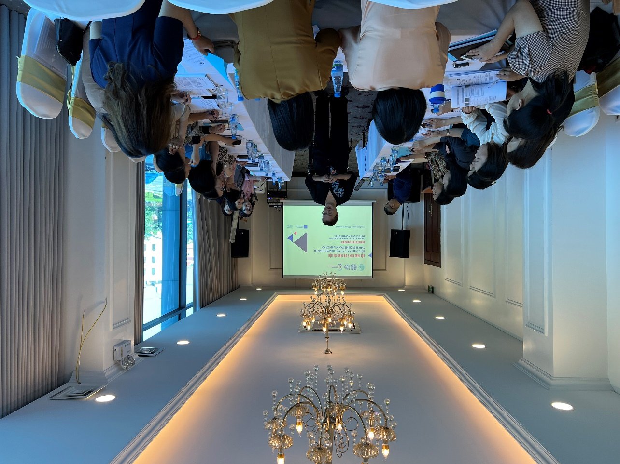

Annexe 4: Emerging good practice
Country
Title of the practice | Timely adjustment for increased alignment with national priorities
Summary – Briefly describe the good practice, including results and the support provided by the SP&PFM Programme (1 paragraph) | The project was adjusted timely to address the risk of slowing momentum on social protection and making it more alighted with national priorities.
Context - Describe relevant elements of the context and the preconditions of practice (the starting point) | The initial approach of the project was to strengthening gender-sensitive social protection in Viet Nam through a multi-tiered child benefit. In the first months of implementation of the project, emerging risks and opportunities have presented themselves, both with an ability to influence the project’s implementation and impact. With regards to the risk, the ILO team observed, in the first half of 2022, a slowing down of the momentum at the Government level with regards to the potential introduction of the Multi-Tiered Child Benefit through the new revision of the Social Insurance Law  With respect to the opportunity, the Government of Viet Nam, in April 2022, requested the ILO to lead and coordinate the UN support to the revision of Party Resolution 15 on Social Policies. Party Resolution 15 is the only legal document in Viet Nam that oversees the whole of the social protection system (as well as additional policy branches), and thus presents a unique and valuable channel to promote comprehensive and coordinated reform to the whole system.
Good practice – Present the practice/experience, explaining the actors involved, the innovative methods/working methodology, the step-by-step to achieve the results | ILO proposed an adjustment of the project and its activities, in order to overcome these risks and take advantages of these opportunities.  The Prodoc was revised to ensured that the project keeps its focus on promoting gender responsive social protection, whilst expanding its focus and investment on issues related to public finance management.
Main results – Briefly describe the results already achieved | The Prodoc revision was endorsed in July 2022. The activities were preprogrammed in a way that better aligns with national stakeholders’ priorities, and best leverages the projects activities into effective, transformative and long-lasting impact.  Through the revision, activities have been implemented effectively and timely.  Overall, the project has been very effective and has achieved its overall objective. The project has contributed to the new draft of Party Resolution on Social Policies in the 2023-2030 with vision to 2045, in which it contains a number of legislative reforms to promote a rights-based system and concrete policy options for coverage expansion and including number of elements that advance Gender equality in social protection, including the possible universal expansion of maternity benefits and introduction of child benefits.
Success factors – List the factors that contributed to the success of the practice (bullet points) | - Closely monitoring the evolvement in policy discussion and analyzing changes in Government priorities.  - Closely liaising with implementing partners  - Keep donor and ILO Socpro informed routinely  - Government’s acknowledgment of ILO ongoing contribution in the social protection as well as ILO coordination roles in UN social protection for a.  - Flexibility of the ILO team, including Hanoi team, Senior Social Protection Specialist at the ILO Regional Office for Asia and the Pacific, SP&PFM Programme and the Global Technical Facility of the Social Protection Department in ILO HQ,
Challenges – List the main existing challenges (bullet points) | - The intervention period is short. For areas like public finance management, it will take time for the Government to absorb proposed solutions
Lessons learned – Indicate up to 3 lessons learned from this experience that could be useful for other countries (more general than success factors) | - Closely monitoring the evolvement in policy discussion and analyzing changes in Government priorities
Next steps | - After the resolution on social policies was endorsed, the project continues to support the Government Action Plan to implement the new Resolution.

In the Vietnamese legal system, Party Resolutions supersede Laws and Decrees.
Based on the Implementation Plan
This is a self-assessment
Based on the M&E plan
Compare achievement against planned target as per indicator.
The national social protection and social care system is inclusive, coherent, and integrated, applying life-cycle, risk informed, resilient and gender-responsive approaches, focusing on meeting the needs of the most vulnerable people
https://www.ilo.org/hanoi/Whatwedo/Projects/WCMS_717414/lang--en/index.htm
Conclusions should synthesize the main findings into statements of merit and worth. As such, judgments need to be fair, impartial, and consistent with the findings
Recommendations should follow from conclusions; link to lessons learned; and describe a time-frame (short-, medium-, long-term), the degree of priority (high, medium, low), who is called upon to act and acknowledge whether there are any resource implications.
Use the existing project risk register for filling in this table
Outline any additional mitigating measures or any change in the planned mitigating strategy and provide a rationale
The change column summarizes any change in the identified risk as a result of the corrective/mitigating measures
Outline the impact on project objectives once the mitigating measures were put in place
In the Vietnamese legal system, Party Resolutions supersede Laws and Decrees.

