MODULE C

The objective of this Module is to make employers familiar with the classification and functioning of different social protection schemes and with the main branches of social security. The ILO's strategy for the extension of social protection coverage is introduced and an overview of the levels of social expenditures in middle and low-income countries is provided.

Key questions
- Which different forms of social protection programmes exist?
- How can different types of social protection schemes be integrated in a comprehensive social security system?
- What are the different branches of social security?
- What is the level of social expenditure in low and middle-income countries?

Which different forms of social protection programmes exist?

Based on their financing mechanisms, social protection schemes (or “social transfers schemes”) can be classified into two main groups: contributory and non-contributory schemes.

Figure 1: Overview of Social Transfer Schemes
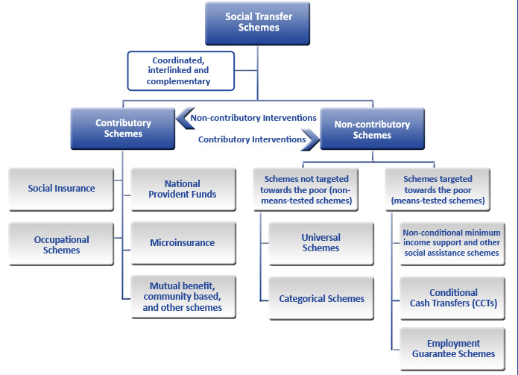

Contributory schemes are directly financed by their beneficiaries (protected persons and their employers) through the payment of contributions, which determines the entitlement to the benefits. In many cases they can be partly financed from taxes or other sources such as subsidies aimed at covering the deficit, supplanting contributions altogether, or covering only specific groups of contributors or beneficiaries. Contributory schemes include:

- Statutory social insurance scheme: the most common form of contributory social security schemes, statutory social insurance usually covers workers in formal wage employment and, in some countries, the self-employed. Contributions are usually shared between employers and employees;

- Occupational schemes: can be set up by employers or labour associations on a voluntary basis. The main objective of these plans is to top up, at least partially, the benefits provided by social insurance schemes;

- National provident funds: in the absence of social insurance, these schemes provide a certain level of protection by paying a lump sum to beneficiaries when particular contingencies occur (typically old age, invalidity or death);

- Micro-insurance schemes: created to address the priority needs of the people excluded from formal schemes, micro-insurance schemes have no compulsory participation. Members pay, at least partially, the contributions necessary to cover the benefits. These schemes can be run by mutual benefit organizations, NGOs, micro-finance institutions, or commercial insurers, which usually operate al local level.

Figure 2: Functioning of social insurance

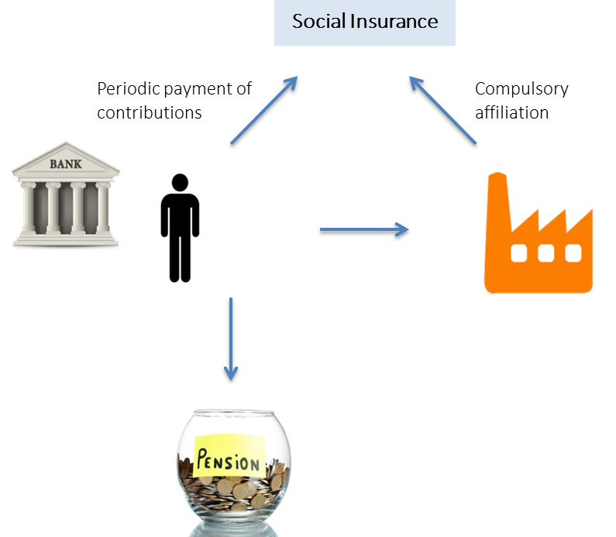

Conversely, non-contributory schemes normally require no direct contribution from beneficiaries or their employers as a condition of entitlement to benefits. Non-contributory schemes are usually financed through taxes or other state revenues, or, in certain cases, through external grants or loans. Non-contributory schemes encompass a wide range of schemes classified according to their target group.

Some non-contributory schemes are explicitly targeted towards people living in poverty, while others are available to larger groups of the population. The latter include:

- Universal schemes for all residents: providing benefits under the single condition of residence, such schemes are mostly put in place to guarantee access to health care. They are generally tax-financed, but may require a co-payment by users of health services sometimes with exemptions for the poorest.

- Categorical schemes: focus on specific groups of the population. The most frequent forms of categorical schemes are those that transfer income to the elderly above a certain age or children below a certain age. They may also include other types of conditions such as performing or accomplishing certain tasks. Categorical schemes are often referred to as “universal” if they cover all the people belonging to a certain broad category (such as “universal old-age pensions” covering all elderly men and women above a certain age threshold).

Figure 3: Categorical vs. universal schemes
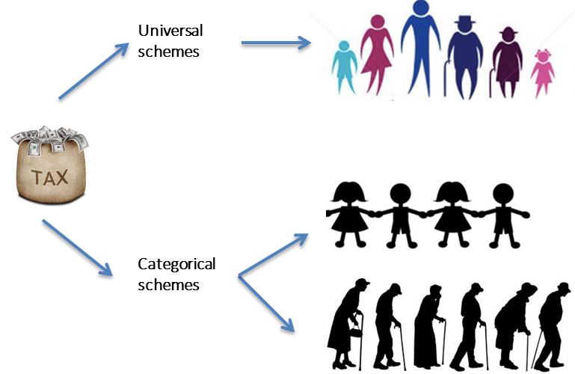

Non-contributory schemes targeted towards the poor (means-tested schemes) usually use a targeting mechanisms that ensures that these programmes cover only those people whose means (usually their assets or income) fall under a certain threshold. These schemes might vary in terms of methods of targeting employed, conditions required for beneficiaries to access benefits and inclusion of other interventions that are delivered on top of the actual income transfer itself. They include:
- (Non-conditional) minimum income support schemes: also often referred to as social assistance schemes, are schemes that provide cash benefits to the most vulnerable groups of the population. Such schemes may also provide or facilitate access to benefits in kind, such as access to health care and other social services. They are usually based on some form of means-test;

- Conditional cash transfers (CCTs): provide cash benefits to poor people subject to the condition that they fulfil specific “behavioural” requirements. This may mean they must ensure their children attend school regularly or that they utilize basic preventative nutrition and health-care services;

- Employment guarantee schemes: ensure access to a certain number of workdays per year to poor households, generally providing wages at a relatively low level (typically at the minimum wage level if this is adequately defined). Such programmes are one form of public employment programmes, which are often referred to as “public works” programmes. Some employment guarantee schemes employ a means-test, while others use self-targeting mechanisms based on the assumption that the low wages provided will attract only those with a genuine need.

For more info:
-Kenya: non contributory social protection
-Universal health protection: a right for everyone-everywhere
-Universal Pension extension in China

How can different types of social protection schemes be integrated in a comprehensive social security system?
In several countries two or more schemes may co-exist and provide benefits for similar contingencies to different groups of the population. This means that these schemes should not be mutually exclusive but rather complementary. To guarantee efficiency and effectiveness of the schemes, coordination and coherence among them is required. Fragmented and uncoordinated social protection programs might increase the likelihood that people fall into poverty, expand the coverage gap and induce exclusion errors.
In accordance with the ILO strategy for the extension of social protection coverage, social protection schemes should be gradually integrated within comprehensive social security systems, in line with national priorities, circumstances and resources.
The strategy for the extension of social security, formulated in the Resolution and Conclusions of the International Labour Conference in 2011 and further strengthened by ILO’s Social Protection Floors Recommendation, 2012 (No. 202), comprises two dimensions:
- Horizontal dimension: establishing and maintaining social protection floors as a fundamental element of national social security systems; and
- Vertical dimension: pursuing strategies for the extension of social security that progressively ensure higher levels of social security to as many people as possible, guided by ILO social security standards.

Figure 4: The two dimensions of the ILO’s strategy for the extension of social security coverage
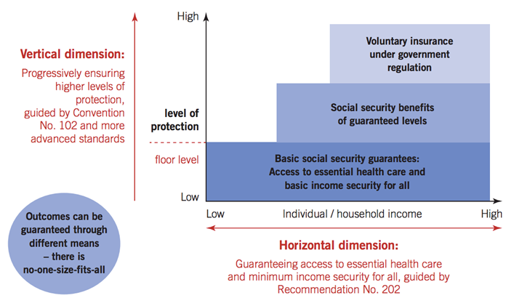

With the idea that ‘there is no one size fitting all’ this strategy can be pursued through different means and different combinations of schemes. In Thailand for instance the implementation of the social protection floor and the access to basic healthcare measures is guaranteed through a combination of employer-provided schemes (for civil servants), health insurance (for employees) and universal health care schemes.

Figure 5: The ILO’s strategy in practice – the social security staircase
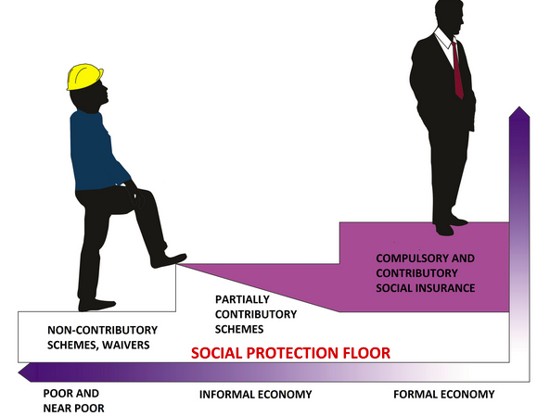
Box 1. Extension of social security coverage: the experience of China and Colombia

China: between 2009 and 2013, China tripled the number of people covered by the old-age pension system, making impressive progress in achieving its goal of universal coverage by 2020. Through a combination of contributory and non-contributory social pensions, in line with the Social Protection Floors Recommendation, 2012 (No. 202), China is moving toward the realization of universality of protection. Universal pensions, as part of social protection floors have proved to increase domestic consumption and demand, promote human development and social stability, all of which are fundamental for national development and economic growth.

For more info: Universal Health Protection in China, http://www.social-protection.org/gimi/gess/RessourcePDF.action?ressource.ressourceId=51765

Colombia: after two decades of development, the Colombian health insurance system exhibits very positive results. Based on the principle of "universality” the Colombian health system provides obligatory health insurance to everyone through a contributory plan for employees and self-employed workers with contributory capacity, and a subsidized (non-contributory) scheme for informal workers and low-income self-employed workers. The experience of Colombia shows that significant progress towards universal health protection is feasible and affordable for developing countries.

For more info: http://www.social-protection.org/gimi/gess/RessourcePDF.action?ressource.ressourceId=48019

What are the different branches of social security?
With the adoption of the Minimum Standard Convention in 1952, the ILO set up the minimum standards for each of the nine branches of social security. The adoption of this Convention is seen as a milestone in the history of social security and is one important element of guidance for countries in realizing the universal human right to social security.
Figure 6: Social security branches
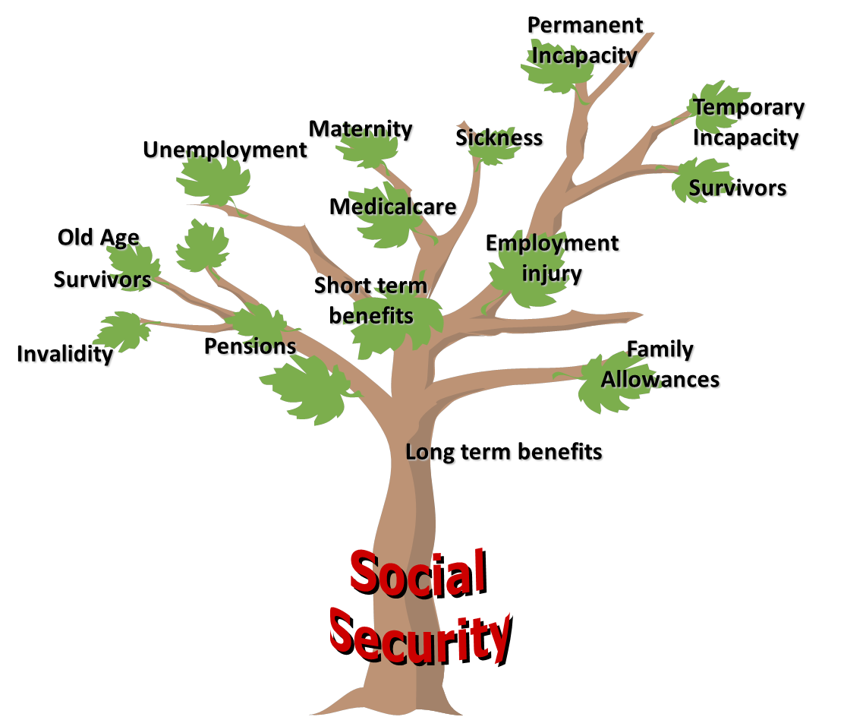

The branches of social security are aligned with the primary needs of individuals and are meant to address the main risks they are exposed to throughout their life-cycle. They are identified as follows:
- Healthcare→ access to healthcare is of fundamental importance for each individual and for the economy as a whole, due to its implications on productivity and employment. The main objective of social health protection policies is to achieve universal health coverage, by providing all the people in need with access to health infrastructure and services, thus reducing the burden of out-of-pocket expenditures. Access to healthcare facilities can be granted through either contributory (e.g. social insurance or private health insurance) or non-contributory schemes (e.g. conditional cash benefits or national health systems.

- Sickness benefits→ sickness benefits ensure income security in case of incapacity of work during ill health. Paid sick leave prevent the loss of productivity of workers: through sickness benefits workers are able to get in better health conditions more rapidly, are less likely to develop more serious forms of illness and disability and to spread diseases to other workers. Income replacement in case of sickness can equal a lump-sum or 100 per cent of the wages and it is financed through the same mechanisms as healthcare. Sick leave coverage generally excludes informal sector workers.

- Unemployment benefits → unemployment benefits provide (at least) partial income replacement for the loss of earnings resulting from temporary unemployment, enabling individuals to maintain decent living standards during this period. The majority of unemployment schemes, of contributory nature, are designed to cover only formal workers, thus leaving behind people employed in the informal sector, who however might end up being protected by social assistance schemes.

- Old age benefits → old-age pensions provide income security to people upon retirement. To prevent people to fall into poverty, it is of crucial importance that they are secured with a source of income to rely on throughout their all life. Where private transfers cannot guarantee income security after retirement, public pension schemes become the main source of income for old people. Old-age benefits can be delivered through contributory and/or non-contributory schemes, the latter being universal, means tested or pension tested. Despite many countries have made substantial efforts to ensure income security after retirement, a significant coverage gap still exists for informal sector workers.

- Employment injury benefits → in many countries protection against employment injuries represents the oldest branch of social security. By compensating employees of the loss of income resulting from work accidents or occupational diseases, employers’ guarantees secure working conditions for their workers. Employment injury benefits are mostly delivered through social insurance schemes or in some cases have a voluntary basis.

- Disability benefits → social protection schemes play a fundamental role in supporting persons with disabilities in case of loss of income or when they are in need of access to healthcare. Social protection measures aimed at re-integrating persons with disabilities in the labour market are as well important. Disability benefits can vary depending on the duration and degree of the disability. They comprise both in cash and in kind benefits and are generally financed through social insurance mechanisms.

- Maternity benefits → maternity benefits play the double role of ensuring income security and provide access to maternal healthcare in case of pregnancy. Maternity protection is of critical importance for the well-being of pregnant women and of their children. In many cases, the lack of maternity protection forces women, especially those in the informal economy, to go back to work prematurely, thus exposing at serious risks their lives and the lives of the new-born children. Most maternity schemes are anchored in social insurance and thus provided only to those people with some contributory capacity.

- Survivors’ benefits → survivors’ benefits are fundamental in supporting widows or children in case of death of the family’s breadwinner. By ensuring income security, survivors’ pensions protect the rest of the household from the risk to fall into poverty.

- Family benefits → family benefits are fundamental in addressing the needs of children, especially of those belonging to the most vulnerable groups of the society. These benefits not only ensure income security, but also are meant to secure decent living standards to all the children, by providing them with enough food, housing, education, care and any other necessary services. Due to the diversity of the needs addressed, child protection can be guaranteed through different instruments.

- Long-term care (LTC) → While not yet considered a standard branch of social security, an increasing number of countries address LTC needs through their social security system. LTC includes a set of services and support undertaken by professionals and informal care givers provided to people who are limited in their ability to function independently on a daily basis, over an extended period of time. Through LTC services patients are supported in Activities of Daily Living (ADLs), such as eating, bathing, dressing. Another category of LTC, called Instrumental Activities of Daily Living (IADLs), pertains to everyday tasks and includes: groceries shopping, cleaning and cooking. The purpose of LTC schemes is to ensure that a person with physical, functional or mental restrictions can maintain the highest possible quality of life, according to his or her preferences, and with the greatest possible degree of autonomy, participation and dignity. The services may be provided in different care settings, from day-care centres to the patients’ home.

For more info:
-Maternity protection makes business sense
-Employment and injury protection in Southern and Eastern Africa
-A Legacy of Rana Plaza: Making employment injury insurance a reality for all

What is the level of social expenditure in low and middle-income countries?
The case for social protection is compelling in our times. Social protection is both a human right and sound economic policy. By powerfully contributing to reducing poverty, exclusion, and inequality social protection also boosts economic growth and supports household income and thus domestic consumption.

Since the beginning of the twentieth century, significant progress has been made in extending social security coverage and building comprehensive social security systems. The number of areas covered by social protection programmes anchored in national legislation, has rapidly increased especially in European countries, large parts of the Americas, but also in Asia and the Pacific and in North Africa. Significant progress has also been made in the Middle East and sub-Saharan Africa.

It should be however kept in mind that the extension of legal coverage does not in itself ensure either the effective coverage of the population or improvements in the quality and level of benefits. In fact, the extension of effective coverage has significantly lagged behind that of legal coverage, due to problems in implementation and enforcement, a lack of policy coordination and weak institutional capacities for the effective delivery of benefits and services.

Moreover, it is often argued however that social protection is not affordable or that government expenditure cuts are inevitable during adjustment periods. Finding fiscal space for critical economic and social investments is however essential. It is important to understand at the outset that governments’ options in respect of revenue and spending vary widely across the globe. It is a matter of political choice: some countries opt to spend more or less, as part of their social contract. What is important is to invest efficiently in social protection programs that respond to the needs of the population. The levels of expenditures might therefore vary enormously between countries (See Figure 7).

Figure 7: Total public social protection expenditure in selected countries

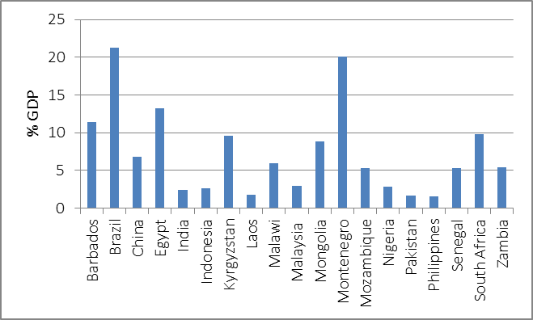
Source: ILO. 2014. World Social Protection Report 2014/2015. (Geneva, International Labour Office). Available at: http://www.ilo.ch/wcmsp5/groups/public/---dgreports/---dcomm/documents/publication/wcms_245201.pdf

Take-away message

- Social transfers are distributed through different types of social protection schemes including contributory and non-contributory schemes;

- Contributory schemes are directly financed by their beneficiaries (protected persons and their employers) through the payment of contributions; the most common form is social insurance schemes;

- Non-contributory schemes instead do not require direct contribution from beneficiaries or their employers as a condition of entitlement to receive benefits. They are divided into programs directly targeted towards the poor (conditional or non-conditional cash transfer / social assistance schemes and employment guarantee schemes) and into programs not specifically targeted towards the poor (universal and categorical schemes);

- To guarantee efficiency and enhance the implementation of effective national social security programs coordination among different schemes is required;

- In alignment with the ILO strategy, comprehensive social protection systems should guarantee at least a basic level of social security to all through nationally-defined social protection floors (horizontal dimension) and progressively provide higher levels of protection to as many people as possible (vertical dimension);

- The needs social protection programs address are embedded in the branches of social security: healthcare, old-age pensions, maternity benefits, survivors’ pensions, children and family benefits, employment injury benefits, disability benefits, sickness benefits, unemployment benefits;

- Levels of social protection expenditure vary. What is important is to invest efficiently in social protection programs that respond to the needs of the population.

