Communication and Visibility Strategy

Improving synergies between social protection
and
Public Finance Management

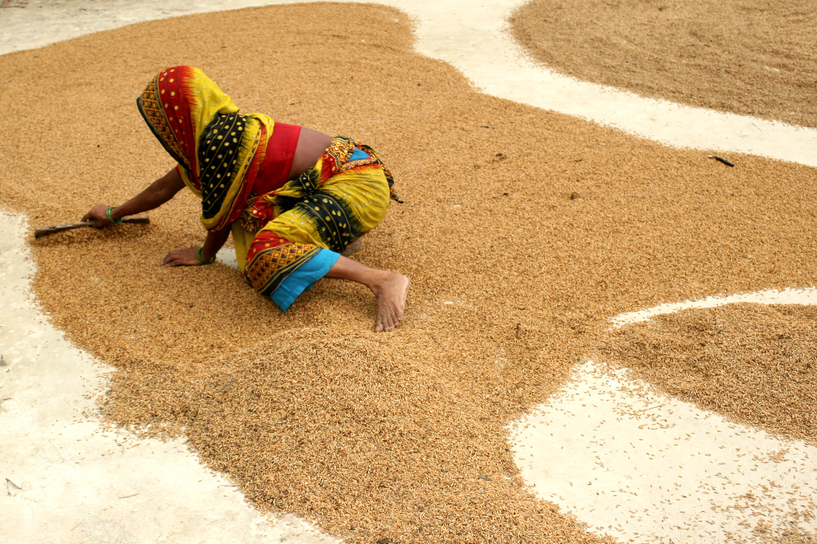
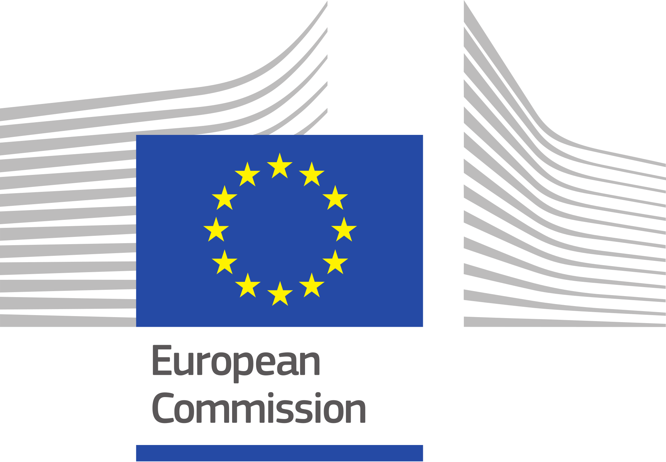

“The European Union is supporting the extension of Social Protection through a new initiative improving synergies between PFM and Social Protection”

“Fiscal space exists even in the poorest countries”

“Despite significant progress in the extension of social protection in many parts of the world, 55 per cent – as many as 4 billion people – are left unprotected”

“The extension of social protection coverage to those in the informal economy and facilitating their transition to the formal economy are key to promoting decent work and preventing poverty”

“2 out of 3 children are not covered by social protection across countries, and the coverage is lowest where child poverty is highest”​

“Lack of social protection leaves people vulnerable to poverty, inequality and social exclusion across the life cycle, thereby constituting a major obstacle to economic and social development”

“Social protection coverage gaps are associated with a significant underinvestment in social protection”

Context
The EU is financing an Action on Creating Synergies between Social Protection and Public Financial Management (DCI-HUM/2018/041-579, GLO/19/53/EUR) which is implemented April 2020-May2023. The Action has two components for country work: In component one, for which UNICEF, ILO and the Global Coalition for Social Protection Floors (GCSPF) are joint implementing partners, eight countries have been pre-selected for in-depth and longer term support. Under component two, implemented by the ILO, the programme provides on-demand technical advisory services to a limited number of additional countries and EU Delegations. The programme also has a global component that will carry out activities that are shared across countries, in particular knowledge management, training, research and communication and visibility activities. This document describes communication and visibility activities and products that will be produced for the overall action. Country projects can draw on these materials and customize them for their context.
The EU funded action is highly relevant for the Agenda 2030. It contributes primarily to the progressive achievement of SDGs 1: “No poverty” and 10: “Reduced inequalities”, but also promotes progress towards Goals 2 "Zero hunger", 3: “Good health and well-being", 5: “Gender equality”, 8: “Decent work and economic growth”, 16: “Peaceful and inclusive societies” and 17: "Partnerships for the goals". The communication and visibility (C&V) strategy of the programme is built around the importance of investing in social protection to achieve the SDGs and creating visibility for the programme.

Overview and approach
The Action has two sets of audiences, objectives and related communication channels. On the one hand, each country of both approach 1 and 2 will develop a communication and visibility plan to articulate clearly country-specific activities in communicating the objectives elaborated below. Each country will invest in communication and visibility accordingly and as per the guidelines provided by EU. The second communication interventions target the development community at large, including EU delegations and countries where the programme is not implemented but that could learn from the programme. A particular communication need relates to the dissemination of information regarding the call for proposals for the selection of approach 2 countries (see section 3.2 for more detail on this). Moreover, it will be important that the programme gives visibility to the Action’s interventions in supporting the response to the COVID-19 crisis.
The experiences and achievements of the Action will be shared through a number of channels. These include the Social Protection Platform www.socialprotection.org, as well as specific ILO, UNICEF, EU and GCSPFs country web pages consolidated into a Global Action dedicated website, linked to the ILO’s www.social-protection.org and www.ilo.org and UNICEF websites. In addition, a workspace compiling all the project’s documents and related information dedicated to the Action has been be set up on the ILO’s www.social-protection.org , that will remain private and serves internal communication needs among country and HQ teams involved in the programme. The project will also develop a “branding” for the Action that will give the programme a unique identity and make it more visible.
The global component of the Action will play an important role in following up on country activities, implementation and results to facilitate sharing and learning across countries and to bring together lessons learnt to make them accessible to a larger audience. Country experiences, including those developed in response to the COVID-19, and research findings will be documented and compiled in good practice guides, briefs and case studies, and shared with other countries to encourage peer-to-peer learning. The programme will encourage South-South cooperation and promote the participation of beneficiary countries of Approaches 1 and 2 in relevant regional activities. The implementing partners’ at national and regional levels will further enhance the dissemination of knowledge and experiences gained through the programme.
The ILO Global Flagship Programme on Building SPFs will provide an additional platform to enhance all communication and visibility efforts undertaken by the programme, while at the same time already providing a large number of knowledge products (e.g.: guides, tools, cross-country policy advice on priority thematic areas in the form of thematic & technical briefs) that can enhance the impact of the actions. The ILO provides a web of networks that will allow the programme to enhance its visibility, communication outreach and overall impact. For the dissemination of the programme’s communication and visibility products, the programme will build on the already existing regional and global partnerships like the UN SPF initiative, South-South Cooperation, The Global Business Network for SPFs, the Social Protection Inter-Agency Coordination Board (SPIAC-B), Social Protection Freedom and Justice for Workers network and the Universal Social Protection (USP2030) initiative.
In addition, globally, UNICEF will communicate about the programme through its global website: www.unicef.org with a link to the specific project website as well as its internal knowledge management platforms and its social media presence. UNICEF will also work with ILO in communicating about the EU funded action in various external and internal meetings to share information related to the Action with a wide range of stakeholders including through strong regional and country level social protection platforms.
All actions are going to be guided by the Communication and Visibility Manual for European Union External Action.

Communication Objectives

Overall objectives for the programme

Communication objectives in programme countries (1st set of interventions)

- Creating a culture of social protection by raising awareness of national stakeholders and the development community on the importance of investing in social protection to protect people and communities from poverty and to reduce inequalities;
- Enhancing the visibility of the Action and disseminating its products among national stakeholders and development partners at country level, in particular with a view to creating an evidence base to inform policy reforms and COVID-19 responses.
- Giving visibility to the commitment of the EU, ILO, UNICEF and GCSPF to support the countries to increase their financing for social protection through improved public finance management that would benefit the population and achieve the SDGs;
- Enhancing visibility to the commitment of the EU, ILO, UNICEF and GCSPF to support the countries to develop shock-responsive social protection systems through improved articulation between disaster risk management and social protection, including economic crisis such as the one caused by the COVID-19 pandemic ;

Communication objectives in non-programme countries, among development partners and the international community at large (2nd set of interventions)
- Enhancing the visibility of the Action among EU Member States, programme countries and non-programme countries, and the global community (notably through, the SPIAC B, USP2030 initiative, Multi-Stakeholder partnership and other networks) including its role in supporting the COVID-19 response and other potential crisis;
- Disseminating broadly the Action’s products among the development community and national stakeholders as a way of strengthening the knowledge sharing component, in particular in a South-South cooperation context, and promoting the EU, ILO, UNICEF and GCSPF approaches and expertise in strengthening social protection systems.
- Enhancing the visibility of the Action and of EU, ILO, UNICEF and GCSPF as agencies with expert advice on matters related to increasing domestic financing for social protection and building shock-responsive, gender-responsive, disability-inclusive social protection systems.

- Positioning the EU (EC DEVCO and EU MSs) as one of the main development actors promoting USP2030 and the 2030 Agenda on social protection, and one of the main contributors to increase domestic financing for social protection;
- Reinforcing internal communication with EU delegations to convince of the importance of budget support for social protection.
The communication plan in Annex A provides for each objective the details regarding the relevant target groups, communication tools and activities, timelines and indicators of success. More specifically communication will reinforce the three objectives of the EU action document and key messages will be aligned with them:
1) Highlighting the social and economic benefits of universal social protection coverage (general objective) and the importance of appropriate design and adequate financing of social protection systems in support of their efforts towards SDGs 1 and 10 (specific objective 1).
2) Emphasizing the importance of implementing and monitoring effective gender-sensitive and disability-inclusive social protection systems and programmes for all while ensuring financial sustainability and macroeconomic stability (specific objective 2).
3) Illustrating the benefits and the importance of shock-sensitive social protection programmes and systems adapted to the needs of those living in protracted fragility and crises, including forcibly displaced persons, and how these can help mitigate effects of shocks and support people’s adaptation to a new environment (specific objective 3).

Specific objective for Approach-2 country selection
Under Approach 2, the programme will launch a minimum of two calls for proposals to select a minimum of 10 countries that will receive on-demand technical support. The first call, launched on 20 April 2020, intended to collect needs for technical assistance from Government in building and implementing their response to the COVID-19 crisis. These calls need to be published to a well-targeted audience to ensure a sufficient number of relevant requests is submitted while avoiding an overload of responses with requests that are off-topic. The compilation of requests ties a lot of resources, especially when country team are already very involved in the COVID-19 response, and the programme needs to be careful not to raise too high expectations, as this could be a reputational risk. The key target audience for this call are EU delegations and partner countries with a strong interest to achieve progress towards universal social protection and related sustainable financing. The calls will be disseminated through the EU and ILO networks as well as inviting expression of interests through a targeted mailing list. A lesson learnt from the first call for proposals linked to the COVID-19 response is the need to reinforce communication and clarity towards the Governments on the role of the ILO and EU Delegations in the preparation and implementation of the proposals. Also, future calls will be published in English, French and Spanish.

Target groups of the programme’s communication and visibility activities
For the first set of interventions for the communication and visibility strategy, the target audience will be mainly:

- Policy actors. Communication and awareness raising seeks to serve them with the most recent knowledge and tools that will support decision making leading to the financing of social protection.

- Government actors: These include line ministries, social protection schemes and programmes, parliamentarians, local governments, economic and social councils etc. They need to be informed of the importance of social protection for sustainable development and where to find support for implementation, in particular the most recent technical knowledge and tools, in order to influence and support national decision-making processes leading to the financing of social protection and sound implementation, governance and delivery.

- Civil Society: In their role of active engagement in monitoring and advocating for increased investment in social protection, the programme can support them with the latest knowledge and collaborate with them in awareness-raising activities. They also play a key role in fostering an overall social protection culture whereby society are aware and claim their entitlements and the government as duty bearers understand and meet their obligations.

- Social partners: Workers and employers finance social protection systems through their contributions and taxes, as such they are a key stakeholder in social protection systems, and need to be aware of the positive effects investments in social protection can trigger as well as of the programme activities so that they can actively participate and influence policy change.

- General public. People are at the centre of the work of the Action. The objective is both to inform them on how the programme will benefit them but also how they can be involved with advocating for the extension of social protection.

- Journalists. They are an essential audience and channel through which to communicate about the programme, its impact and its main messages. Media can be a vector of change and will bring the messages to the other target groups.

For the second set of interventions for the communication and visibility strategy, the target audience will be mainly:

- Development partners. They need to be informed on the Action, the knowledge developed and its impact at country level with a view to informing the future design of social protection interventions. Communication about the Action will be continued among the SPIAC-B members.

- EU Delegations: They need to be made aware of the positive developmental effects investments in social protection can trigger and how both budget support as well as domestic resource mobilisation can contribute to inclusive development.

- EU Members States: They need to be aware of our activities so that we can seek synergies and enhance the impact of the overall programme.

- G20 Group: The project will contribute to the advocacy for universal social protection and greater financing for social protection.

Key Messages:
Below is a list of generic key messages developed at the outset of the programme. More specific key messages will be developed around different activities, events and for specific country contexts, in particular with respect to gender-responsiveness, disability-inclusiveness, shock-responsiveness and social protection financing. In particular, key messages will be elaborated around key findings of the country analytical work and research carried out.
- Social security is a human right and an investment with high returns in economic and social development;
- Social protection coverage gaps are associated with a significant underinvestment in social protection;
- Social protection also acts as an automatic stabilizer and has a multiplier effect by making a critical contribution to fostering people’s wellbeing, decent and productive employment, reducing economic insecurity, supporting entrepreneurship and sustainable enterprises, addressing income inequality, as well as boosting inclusive and sustainable growth;
- Social Protection interventions introduced in response to the COVID-19 crisis can and should be designed not just to alleviate immediate short term needs but also with a medium-term perspective of overall strengthening social protection systems.
- Equitable and sustainable universal social protection systems are important to reinforce the social contract and promote social justice, solidarity, cohesion, and peace;
- Social protection facilitates structural transformations as it liberates people from fear, breaks the vicious cycle of poverty and vulnerability, contributes to gender equality and women’s empowerment;
- The extension of social protection coverage to those in the informal economy can facilitate their transition to the formal economy
- Social protection is key to promoting decent work and preventing poverty;
- Lack of social protection leaves people vulnerable to poverty, inequality and social exclusion across the life cycle, thereby constituting a major obstacle to economic and social development;
- Civil society has a significant role to play in ensuring social accountability for social protection, including monitoring and generation of evidence on the impacts of social protection on the vulnerable individuals;

Communication tools and channels identified

The programme team will adapt and implement traditional and innovative communication tools and techniques. Combined together, these tools and techniques will allow a modern and tailored implementation of the Communication and Visibility Strategy. A break-down of the overall budget for 2020-2023 can be found in the Annex.

- Communication tools
- Leaflets, fact-sheets, and info-cards: they are easy to design, produce and distribute and can often be managed with a limited budget. They highlight key information in condensed way. They will be developed for the Global Action to reinforce the results under the second set of interventions, as well as at country level to be used as communication channelled for the first set of intervention. They can be printed in small quantities and often “in-house” so that they can be tailored for specific events and specific audiences; they are essentially a medium that people grab easily and keep for long in their office or home, so that the potential for recurrent consultation by the same person but also colleagues.
The programme will produce leaflets, fact sheets, info-cards and info-graphics on specific topics, national dialogue results, research findings, at global and national levels, and progress of the programme tailored specifically to the events where they will be distributed (e.g. conferences, SPIAC-B etc.). Those materials will be tailored to the audience of the first or second set of interventions respectively. For example, the programme will produce a compliation of key communication materials of the countries benefiting from the programme.
- Banners: they are a standard tool to highlight key information about an event or activity and to visualize the key stakeholders involved. Often printed in large format for better visualisation from afar and mounted on walls. They can easily be moved and re-used in many circumstances, either in the Delegation itself or at any other location. The programme will produce these to display at events and conferences where the programme is represented.
- Brochures: They are usually more complex to design and include both text and supporting tools, which can include tables, pictures, data, etc. UNICEF and ILO together with GCSPF will develop at least one joint cross-country brochure that documents the success of the programme regarding research findings and activities in approach 1 and 2 countries. The brochure will position results strategically to enter the global development discourse on social protection, the SDGs and development financing. This product will be widely shared, disseminated and communicating through various channels listed below.
- Folders, pens, bags notebooks and other meeting materials,: Folders are a useful way to gather hand-outs and event materials. All materials provided at workshops, seminar or public events can be compiled in such folders. The global component will provide a design template that all projects can use for their events as needed.
Similarly, gadgets such as pens or bags are useful items for event participants and create visibility for the programme as they continue circulating via participants in the project’s activities.
- Flash Drive: They are an efficient and practical way to store information, materials, etc. digitally, making information more accessible, easier to share and to disseminate. Being mindful of ecological considerations, the programme will limit distribution of these and focus on making information available on the website and distribute cards with the related QR codes.
- Press Releases, Press Clippings and Media Relations: Presence in the media is a key indicator in measuring impact and visibility of a brand or an institution. Despite the explosion of the number of news sources and media, the press remains a key channel to deliver information and share values and opinions about a topic or an institution. The media will be mobilized both at global and national level in order to contribute to the objectives of both set of interventions. The programme team will make sure that the efforts towards the press, including radio, TV and the mass media, be it by means of drafting press releases, by taking interviews with journalists and editors-in-chief, or by organizing press conference are handled with utmost care and prepared jointly with EU Delegations to ensure consistency of the messages.
- Website: The programme will develop a landing page for the Global Action, e.g. www.pfm4sp.org and build on existing ILO, UNICEF and SPIAC-B online platforms (www.social-protection.org and www.socialprotection.org, www.ilo.org and www.unicef.org) to ensure knowledge sharing and dissemination of programme findings, publications and tools applied and produced by the programme and results of the activities undertaken at national level as well as online training tools. Each priority country will develop a sub-page that will be linked to the website of the Global Action. The project team at the global level will ensure that the country pages are regularly updated and linked to the ILO country office’s websites.
- Audio-visual materials: Programme activities will be documented among others through the production of videos that will be shared through the social media channels mentioned above. The programme will moreover produce a flagship video that will present the Action, its objectives and planned interventions globally and in the eight countries, series of short thematic videos, visualizing the importance of the programme’s work, specifically focusing on various aspects around social protection, PFM, fiscal space, shock-sensitive social protection, disability, gender, etc. A final short feature film (5-10 min), summarizing the key elements of the programme will be produced.
- Documentation of experiences, research and publications: The research and country analytical work undertaken by the programme will be documented and published in joint EU/ILO/UNICEF/GC-SPF publications. When relevant for the advocacy work, key results of these researches will be presented through infographic supports, in particular the cross-cutting research. Knowledge and scientific evidence generated by the programme, including experiences in response to the COVID-19 crisis, may enrich existing good practices guides and the Compendium of country cases illustrating successful experiences of universal social protection as well as innovative practices to increase fiscal space and extend coverage to all.
An overview of technical specifications of the above items can be found in Annex B and a budget in Annex C.

- Communication channels
- Workshop, conferences, seminars, roundtables and public lectures: These events organized by the country projects but also the global component will also participate in events that gather people who share a common interest or objective. These events are a key opportunity to bring information, tools, data and expertise to practitioners and to position the programme’s objectives. Information will be disseminated through various ways, including presentations, publication of workshop/ conference/ background materials or life-streaming of events. Where events are organized by the programme, the project coordinator will pay careful attention to ensuring that these events are well-organized, facilitated and presentations are impactful. Visibility will be ensured through consistent use of EU and programme partner logos and materials, including the design templates of banners, leaflets, folders, presentations etc. produced by the global component.
At this point, two concrete events have been identified that the global component will organize: a launching event will take place in Brussels on a date still to determined with the EU delegations as key target audience to raise awareness about the new programme, its objectives, and the availability of on-demand technical support as well as about the importance of social protection for sustainable development in general. The launching event will also be the opportunity to highlight the Action’s support to the COVID-19 response at country level and globally. Secondly an international conference is planned towards the end of the project targeting social protection practitioners around the world from both the development community and governments to discuss pathways to universal social protection, related sustainable financing and the key findings from the programme in this endeavour.
- Social Media: The Action will set up a social media strategy, including Action-specific hashtags and twitter handles. Information will moreover be shared through already existing ILO, UNICEF, GCSPF and EU social media channels as well as through social media channels of like-minded partners (creating synergies). Channels that will receive particular attention is LinkedIn, YouTube, Facebook, Twitter, Medium. In addition, information can be disseminated through online platforms such as yammer, google drive, allowing the target groups to more easily share and store the information in a user-friendly and paperless format.
- Networking activities: The programme will support networking activities to create synergies in delivering messages and to increase the effectiveness of the programme objectives. Networking events can take place in various forms, such as lunch, dinner, cocktail reception or in relation to an event (e.g. social gathering after workshops). These events can be a valuable source for an informal exchange between counterparts and allow for brainstorming and valuable discussions beyond what workshops usually cater for.
- Internal Communication: The programme actions will be coordinated globally through communication platforms. A password protected programme workspace has been set up to share internally knowledge among project managers. In addition, a platform will be set up and a number of webinars will be organized to share knowledge on selected thematic areas (e.g. PFM, shock-sensitive social protection, etc.) among programme partners across countries and agencies. These will be open to all programme partners, including the EC. The programme will also regularly develop some information-sheet on the status of the implementation of the Global Action that EC-DEVCO can share with the EU Delegations and Member States. The flagship video on the Global Action will be an easy channel to present the Action to the EU Delegations, in addition to a two-pager leaflet.
- Media: National newspapers, TV and radio stations will be contacted and informed in line with implementing agencies’ media policy.

- Indicators of success
Through the above-mentioned communication and visibility channels and activities it is expected that:
- A higher awareness among the development community and priority countries’ stakeholders of the importance of investing in social protection and the need for increased social protection exists at country and global levels. It will be measured by the number of new members to the Call for Action on USP, number of government, social partners, and development partners’ statements that call for sustainable social protection systems.
- A high level of awareness of the activities, impact and outcomes of the programme is built among the different target groups. Qualitative assessment of participation in knowledge sharing activities and analysis of recommendations discussed in technical and policy documents at the national level will give some indication about the achievement of the programme and communication objectives.
- A higher level of visibility of the work carried out by the programme is achieved at the national and global level. Possible indicators will be the level of frequentation of the website, social media channels, number of press conference and appearing in the media at country and global level, number of downloads of reports and the number of participants in various activities.
- A good understanding of the Action by the EU Delegations directly involved in the Approach 1 and Approach 2, as well as other EU Delegations and EU Member States.
The communication plan in annex A contains a detailed list of indicators to measure success of C&V activities.

Annex A: Communication Plan:

Objective | Target Group | Key messages | Activities | Indicators | Timeline
Raising awareness on the importance of investing in social protection to protect people and communities from poverty and its associated vulnerabilities; | Community development and stakeholders of priority countries | Social security is a human right and an investment with high returns in economic and social development;  Well governed social protection systems prevent poverty, reduce inequality, social exclusion and economic insecurity, promote equal opportunities and gender and racial equality;  Social protection also acts as an automatic stabilizer and has a multiplier effect….; | - Develop and regularly update website and audio-visual materials, post them on social media for dissemination;  - Advocacy events including high-level conferences, press conference and interviews, post on social media:  -Roundtables, workshops, meetings;  - Disseminate research products & publications, and prepare key messages from these products, in particular the cross-country research. | Number of government, social partners and development partners’ statements  Website visits; Number of clicks on Audio-visual materials; download of publications; social media  Support for 8 country workshops, Number of workshop attendants (disaggregated by sex); Social media views | Website:  2020  Other activities, social media, press clips: ongoing  Audio-visual materials:  2022
x
Enhancing the visibility of the programme and its products among EU Member States, supported countries, and the global community (notably through, the SPIAC B, USP2030 initiative, Multi-Stakeholder partnership and other networks), including in the COVID-19 crisis response | Stakeholders  EU Member States  Development partners  Journalists | EU, ILO and UNICEF support countries in their efforts to build universal social protection systems that are financially sustainable  The European Union is supporting the extension of Social Protection through a new initiative improving synergies between PFM and Social Protection;  The extension of social protection coverage to those in the informal economy and facilitating their transition to the formal economy are key to promoting decent work and preventing poverty;  Universal social protection is key to sustained inclusive economic and social development, for individuals, communities and nations; | - Organize a launch event and final global conference in Brussels  - Organize some press conference and interviews, publish press releases, post in the social media  - Update the Action’s website (USP2030, social-protection.org)  - Organize high-level events and workshops at country level, post in the social media | 1 launch event in Brussels.  Launch events in four countries  1 final global conference  Support for 8 restitution events at country level  Number of press events  Number of EU Member States and development partners attending workshops and communication events;  USP2030 membership  Frequency of sharing programme content by other partners (EU MSs, development partners, etc.) | April 2020  2020  2023  2023  ongoing
Disseminating research and knowledge products as a way of strengthening the knowledge sharing component, in particular in a South-South cooperation context, and promote ILO, UNICEF, GCSPF, and the EU’s approaches and expertise. | Development community and national stakeholders
Giving visibility to the commitment of the EU, ILO, UNICEF and GCSPF to support the countries to increase their financing for social protection through improved public finance management that would benefit the population and achieve the SDGs | Development community. International financing institutions, Governments, especially Ministries of Finance, Planning and Economy | Universal social protection is key to sustained inclusive economic and social development, for individuals, communities and nations;  Social security is a human right and an investment with high returns in economic and social development  Social protection coverage gaps are associated with a significant underinvestment in social protection;  Countries need to create fiscal space and innovative financing mechanisms, improve PFM, for filling the gap to achieve universal social protection  Through enhanced solidarity both at national and international levels, it will be possible to mobilize the needed financing for social protection | - Bring evidence on the return on investing in social protection (global research product)  - Disseminate these evidences and prepare advocacy material (infographic, videos, social media posting, press release)  - Organize high level conferences, workshops on financing for social protection and PFM | One high-level panel in the final global conference  Number of country’s high level conferences  Number of Government officials’ statement | 2023  2021-2022  On-going
Enhancing visibility to the commitment of the EU, ILO, UNICEF and GCSPF to support the countries to develop shock-responsive social protection systems through improved articulation between disaster risk management and social protection, including economic crisis such as the one caused by the COVID-19 pandemic | Development and humanitarian partners  National stakeholders  EU Delegations  Journalists  Civil society | Robust and sustainable social protection systems are needed to recover from the COVID-19 crisis and prevent future shocks  Social protection also acts as an automatic stabilizer and accelerator of recovery in times of crisis  Emergency interventions should aimed also at strengthening social protection systems | - Disseminate the experiences of the COVID-19 response through country cases  - Post on the website and social medias stories about the Action’s support to those affected by the COVID-19  - Organize national workshops on the articulation between social protection and emergency responses | Number of documented experiences  Number of stories posted on the website | 2020-2021  2020-2021  2021-2022
Positioning the EU (EC DEVCO and EU MSs) as one of the main development actors promoting USP2030 and the 2030 Agenda on social protection, and one of the main contributors to the increase of domestic financing for social protection; | Policy actors  Government actors  Workers/Employers  Development partners  Journalists  Civil Society | Universal social protection is key to sustained inclusive economic and social development, for individuals, communities and nations;  Fiscal space exists even in the poorest countries; | - Organize press releases; produce  banners,  Fact-sheets,  Leaflets  Audio-visual materials;  - Organize workshops/  Conferences; press conference and interviews, post in the  social Media | Number of press releases;  Number of fact sheets disseminated;  View count of audio-visual materials;  Social media post views; | Branding and templates:  2020  Other activities:  ongoing
Enhancing the EU delegations understanding of the importance to increase budget support for social protection | EU Delegations  EU Member States | Social protection is a lubricant of change and investments made therein help navigate these transitions, liberate people from fear, break the vicious cycle of poverty and vulnerability, contribute to gender equality and women’s empowerment and in so doing, contribute to the inevitable transformation of our societies and economies;  Lack of social protection leaves people vulnerable to poverty, inequality and social exclusion across the life cycle, thereby constituting a major obstacle to economic and social development; | - Produce fact-sheets;  Leaflets;  Research and publications;  - Organize workshops/  Conferences; | Number of publications, workshops | Ongoing
Disseminating the call for proposals | EU delegations, governments, ILO offices | Countries that are committed to achieving universal protection and related sustainable financing can apply for on-demand technical support through a prescribed process | EU and ILO website, targeted mailing list | Number of site vistis / downloads  Number of relevant proposals received | April 2020  February 2021 (tentative)

Annex B: Technical specification of Communication and Visibility items
 | Items/tentative technical specifications | Tentative number of units
 | PRINT MEDIA
1 | Programme Factsheet  Specifications:  No. of pages: 1 (1 sheet); Language: English; Size: A4  Print: Colour (glossy) | 250
2 | Stand up banner  Specification:  Size: 2 x 0.8m; Print: Colour (glossy) | 4
3 | Country & Policy Briefs (10 – 12 briefs in total)  Specifications: | 600 (50 each)
  Size: A4, No. of pages: 4 (2 sheets folded)
  Print: Colour (glossy)
4 | Cross-country research study  Specifications:  Size: A4;  Print: (B&W) | 250
 | Visibility items
5 | Reusable Bag (fabric)  Size: 28 x 40 cm  Material: Fabric  Print: Colour | 250
6 | Pens with programme logo/design | 250
 | Video materials
7 | Trailer film about the programme  Specifications: 1-2 min. | 1
8 | Film about the programme based on the documentation from global and country activities  Specification: 5 – 10 min. | 1
9 | Animation film on key results/outcomes of the research study (investment case - impact analysis)  Specifications: 2-5 min. | 1
10 | Video on the ILO advisory services facility  Specification: 1-3 min | 1
 | Web & other design elements
11 | Domain-server with the programme website: | 1
12 | Design of project-logo | 1
13 | Website design and development | 1
 | Events (e.g.: Launching event, etc.)
14 | Launching Event in Brussels (20. April 2020) | 1
15 | Final dissemination and closing event (tentatively in 2023) | 1

Annex C: Communication and Visibility Budget

 | Items | Inception phase | ILO - 1st year | UNICEF - 1st year | ILO - 2nd year | UNICEF - 2nd year | ILO - 3rd year | UNICEF - 3rd year | Total
1 | Design of project logo |  | 1,000 |  |  |  |  |  | 1,000
2 | Design and set up of website |  | 18,000 |  | 3,000 |  | 3,000 |  | 24,000
3 | Design of publication templates (flyer, banner, posters, publications, powerpoint presentations, reusable bags, pens, etc.) |  | 2700 |  |  |  |  |  | 2,700
4 | Social Media (e.g.: boosting posts) |  | 300 |  | 300 |  | 300 |  | 900
5 | Video and photo materials and other forms of knowledge products |  | 5,000 |  | 5,000 | 4,000 | 7,000 | 8,962 | 29,962
6 | Launching Event in Brussels (20. April 2020) | 5,000 |  |  |  |  |  |  | 5,000
7 | Final dissemination and closing event – C&V activities |  |  |  |  |  | 6,000 |  | 6,000
 | Total |  |  |  |  |  |  |  | 69,562

