Cross-cutting issue No4. Beyond the floor: adapted contributory mechanisms for informal economy workers
- The example of Thailand
- The example of Viet Nam
- The example of Indonesia

Extending social insurance to Informal Economy Workers (contributory mechanism) in Thailand

In Thailand, informal economy workers that account for 24.3 million people (70% of the working population) and their families are covered for health care through the UCS (Universal Health Care Scheme) since 2001, but they lack adequate coverage for other benefits.

Background Information
- The 10th National and Social Development Economic Plan (2007-2011) includes the extension of social security to the informal labour as objective.
- Through the section 40 of the Social Security Act, B.E. 2533, the Social Security Office from the Ministry of Labour offers voluntary coverage for three benefits: maternity, invalidity and deaths.
- While the corresponding scheme has been available for more than 15 years, only 60 people (out of 24.3 million) have registered so far!!! Why this situation?

An un-attractive package ?

Contingency | Replacement rate/ lump sum
Maternity | 3000 baths = 100 USD
Invalidity | Medical expenses up to 1000 baths / month (33 USD) and 50% of the minimum wage for 15 years
Death | 100 times the minimum wage

According to several surveys of satisfaction the target population shows interest in being covered for injury benefits and old age. However none of these two benefits are included in the package!

During a recent event organized by UNFPA and the civil society, during which more than 100,000 representatives of the Informal Economy network in Thailand voiced their claims/revendications to the Prime Minister using the social network tool Facebook. It appeared that these benefits are not so attractive, as people may not use them on a regular basis. One representative said: “Could I contribute for a benefit I can enjoy while Alive?”
In line with this fundamental question the package will soon be reformed (Decree being discussed) and include an additional two benefits: sickness /injury and old age benefits.

An unaffordable package?

The contribution was calculated - without pooling risks with the formal sector workers, actuarial valuation is not clear – and fixed at an annual rate of 3,360 Baths a year (115 USD). Paying a one-time amount of 3,360 Baths is of course very difficult for most informal economy workers.

Under the present reform (Decree being discussed) the following modifications will be introduced:

- Monthly payment will be made possible,
- Payment mechanism will be eased by offering the possibility to pay in convenient stores (the so-called “7/11” which are small supermarkets opened all day and almost all night) – less opportunity costs,
- Social marketing (see for instance the following picture),
- A network of Social security officers will visit enterprises and beneficiaries to build trust …

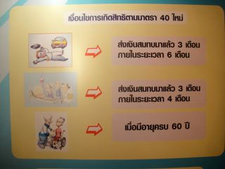

What is currently on the agenda?
- Should this scheme be voluntary or mandatory scheme (but in case it is mandatory … how to enforce it in the informal economy?)
- Legislative framework : Adoption of the Decree (being discussed at parliament at the moment)
- Introduce a subsidized old age savings account (the State would top up the amount saved by the worker)

Extending social insurance to Informal Economy Workers (contributory mechanism) in Viet Nam

In Viet Nam, the extension of Social security to employees of small enterprises and informal economy workers is made through a voluntary scheme and faces a number of challenges (ex: lack of incentives / mechanisms for attracting informal economy workers). The voluntary scheme was covering only about 65,000 workers in 2009, from small and medium enterprises and the informal economy; most of them were previously insured under the compulsory scheme, and willing to complete their contribution period on a voluntary basis to be entitled to the old age pension. The main reasons why the voluntary scheme does not attract more workers are the following: lack of communication and awareness raising, payment patterns and amounts which are not adapted and too high compared to the willingness to pay.

The extension of social health protection coverage is more successful with nearly 50 million persons covered so far:
- contributory affiliation of formal sector workers, and pensioners;
- automatic affiliation and subsidization of the premiums of certain categories of the population: the poor and vulnerable, ethnic minorities, children under 6 years old, socially assisted groups such as disable, elderly, job-less, etc. ;
- partial subsidization of the premiums for the near poor (with 50% of the premium subsidized by the government budget) as well as pupils and students (with 30 to 50% of the premium subsided by the government budget).

The government plans to extend coverage to self-employed in urban areas, farmers/ workers in agriculture/fishery/forestry, and others through a voluntary affiliation by 2014. There are however many doubts on the success of future implementation of the voluntary scheme for various reasons: the packages are not attractive enough; quality of care is perceived as poor; health insurance card holders are not treated with respect (as they don’t pay “cash” and as reimbursement mechanisms of the hospitals is very long); the premiums seem to be too high for the capacity to pay; there is also adverse selection problems since membership is voluntary; etc.
The benefit package varies according to the different target groups as well as the amount of premium (calculated on the basis of the salary or the minimum wage) and the sources of funding of the premium (employers and workers, social insurance scheme for pensioners and veterans, the State …).
The social health protection strategy was implemented through the enactment of the health insurance Law and the corresponding decrees of application.

Extending social insurance to Informal Economy Workers (contributory mechanism) in Indonesia

Extension of social protection to informal economy workers is done through two complementary strategies in Indonesia:

1- Social assistance

Indonesia has established some of the components of the social protection floor; access to health care is guaranteed to the poor through the subsidized scheme Jamkesmas which already covers 76.4 million people; other initiatives include conditional cash transfers for families with children that already cover 400,000 households and are meant to be extended or the Rice for the poor programme.

Although Jamkesmas covers today one third of the population there is apparently issues in the service delivery that reduces the impact of the scheme and effective access to quality health care. The other programmes mentioned are still scattered; they cover only a limited number of districts for instance.

There is however no consistent social protection floor strategy nor attempts to link these programs and initiatives with other strategies to reduce vulnerabilities of the poor (e.g., employment creation, skills development). All these schemes also face major issues in terms of mis-targeting of the poor.

2- Social insurance

In Indonesia, Jamsostek (the social insurance scheme for formal sector workers) has started implementing a scheme for informal economy workers and was covering around 150,000 persons in 2009 (cumulated number of 500,000).

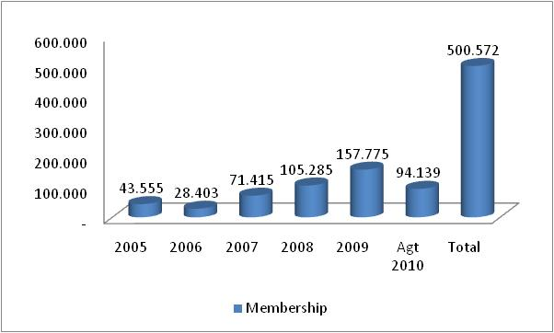

Members can choose one or more benefits among employment injury, death, old age, health care. The corresponding contributes rates are indicated in the image below.

This scheme faces however many challenges such as:
- awareness of people is low;
- marketing strategy is not appropriate (from group marketing to individual marketing);
- problem of availability and quality of health care services;
- un-adapted payment patterns (monthly) leading to suspension of entitlement of benefits & feeling of poor “delivery”;
- higher operational costs than under group insurance;
- design of the scheme (possibility to chose between benefits) leads to adverse selection issues (ex: moto-taxis who have a high risk of accidents and subscribe only work-injury insurance);
- although health care coverage would be the most needed it is not chosen because too expensive for the workers (no subsidies of the premiums);
- premiums for work injury are even higher than for the formal sector scheme, because incidence is higher;
- high turn over of membership, except for health care (because members see the “interest” of renewing membership when they chose health care coverage);
- delivery channels are not efficient (through associations / cooperatives and “branches”);
- difficult to define the cause of accidents given the working hours of IE workers (outside opening hours of Jamsostek).

There is therefore a need to use the lessons learned from this first attempt in order to design / develop and scale up adapted social protection schemes with greater chances of success.

In Indonesia it is also important to work not only at national level but also at provincial and local levels for the following reasons:

1- In the context of the decentralization process, many provinces and cities (e.g., Maluku, Solo) have a vision for the informal economy, are progressively improving working conditions of informal economy workers and “formalizing” their activities. They also have the willingness to expand social protection for all informal economy workers through adapted strategies.

In Solo for instance the street vendors received small shops from the municipality, and are working in clean and structured markets, they are also paying taxes (their resettlement was therefore a good financial operation for the municipality) and are more organized.

In Maluku the province is developing an integrated approach for the seaweed sector. This integrated approach includes: creating new business and employment opportunities for seaweed producers, vocational training to increase their productivity, better working conditions and components of the social protection floor.

2- Expanding social protection through top-down approaches is not effective; community based and local organizations should be increasingly used as an intermediary between national or provincial level programs and the target people (working in the informal economy). There is a need therefore to identify and work closely with these organizations that can be found at the local level; they can be of various natures: associations, cooperatives, micro-finance organizations, micro-insurance.

Discussion
Based on these examples and your own experience, could you please describe several issues you have been faced to in designing and implementing contributory social protection schemes for the informal economy, and propose ways to address these issues?

Issues in designing and implementing contributory schemes for IE workers | Ways to address them

