 |  | 

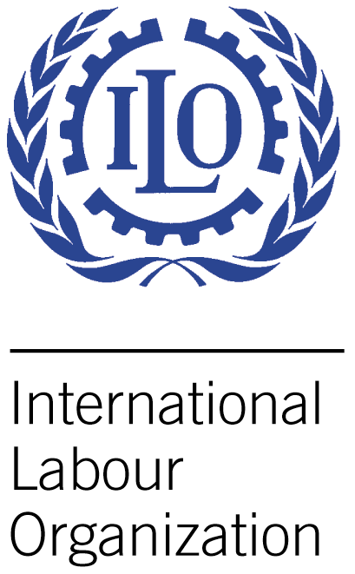
ILO/Korea Project Towards the Realization of the Asian Decent Work Decade

Fellowship Training on Employment Insurance (EI)
and Employment Injury Insurance (EII)

at Vabien Hotel, Seoul, Republic of Korea
11-15 October 2010

PROGRAMME DESCRIPTION

BACKGROUND

Asia and the Pacific region is characterized as a group of nations with rapid changes of industrial, employment and demographic structures as well as diverse level of economic and social development which all have gendered various types of social security systems. It is widely known that most countries in the region still suffer from the narrow coverage of social security for the formal economy and general lack of any social protection for the informal economy.

Given a certain dilemma of more needs and lower resources especially after the recent financial crisis, many countries in the region have been requested to produce more meticulous policy response with regard to social security.

As for EI, the scheme has been limited to a few countries which have been faced with policy challenges of upgrading their EI. A great number of unemployed workers in the region still rely on employers’ direct compensation like severance payment which is unreliable in times of economic downturns. Therefore, EI schemes in the region have to be extended at a vertical as well as horizontal level.

Compared with EI, most of countries in the region have already put EII in place. It is, however, true that the established EII schemes also have reform issues like better coordination between prevention, compensation and rehabilitation.

Against the current situation of EI and EII in the Asia and the Pacific region, the fellowship trainings of EI and EII have been implemented since 2005 (EII) and 2007 (EI) respectively under “the component on Labour Market Governance and Social Protection of ILO/KOREA Partnership Programme”. The fellowship trainings to date have provided an arena where participants can deepen the understanding of EI and EII not only by studying related ILO conventions and developed model cases but also by exchanging experiences of participating countries with varying socioeconomic contexts and developmental stage of EI and EII. 4 ~ 6 countries for EI and 7 ~ 8 countries for EII each year have attended the training. The total number of participants by the year of 2009 has reached 35 for EI and 79 for EII training.

There is no doubt that the trainings have directly or indirectly helped participating countries newly introduce or improve their EI and EII with respect to research, policy framework and capacity building. Especially EI of Vietnam and EII of Cambodia which were recently introduced are representative cases to show how immediately the trainings have fulfilled the extension of social security.

Problems and constraints, however, could be found from the evaluation of the activity. Apart from the above model cases, it appears unclear what real impacts the repetitive trainings have given to the participating countries. It is not only because some participants have been only technical-level officers who are relatively weak in the policy-making process but also because there has not been enough follow-up monitoring and evaluation.

OBJECTIVES

At the end of the fellowship training, the participants will be able to:

- Identify priority needs in establishing or improving EI and EII in line with ILO Social Security Conventions, notably, the ILO Convention No. 102 (Minimum Standards) and international good practices especially of the Republic of Korea;

- Have clear visions and ideas to establish or strengthen EI and EII in terms of legislation, scheme design, administrative procedure, awareness-raising, training, etc;

- Develop policy measures of EI and EII toward external shocks like global economic crisis through studying global initiatives and case studies of peer participants.

METHODOLOGIES

- Lecture by topics some of which are followed by Group discussion and presentation

- Study visit to relevant organizations of EI and EII in the Republic of Korea for direct observation of actual work process

- Presentation of country report by each participant

PRELIMINARY ASSIGNMENT FOR PARTICIPANTS

As for “the session of country report presentation on 15 October” to share national experiences of EI and EII, each participating country is required to submit its country report the outlines of which are as follows

- Comprehensive overview of EI (or compensation mechanism for unemployed workers like severance pay) or EII(or compensation mechanism for injured workers like employer-liability system) including the recent socio-economic context, legislation & administration framework, fact sheets of coverage and benefits, financial management, cooperation works with ILO to date, etc.
- Policy responses toward the recent global economic crisis since 2008 in terms of EI or EII management;
- Challenges ahead regarding the development of EI or EII.

The country report is expected to contain around 3,000 words in MS-Word format. MS-Powerpoint slides of 15 minutes’ presentation is also required to be submitted together with the MS-Word paper to ILO no later than 5 October. through e-mail.

TARGETED PARTICIPANTS

EI | EII
Vietnam | Cambodia
Malaysia | Sri Lanka
Lao PDR | Nepal
Philippines | China
Indonesia | Thailand

* 2 participants (government officials concerned with EI or EII) of each country will be selected by responsible ministries in the above countries and finally accepted by ILO Fellowship Unit.
* The above countries are subject to change after consultations among ILO Fellowship Unit, Social Security Specialist in ILO DWT-Bangkok and Korean partner institutions {KOILAF(Korea International Labour Foundation) for EI, COMWEL(Korea Workers’ Compensation & Welfare Service) for EII}.

TENTATIVE TRAINING AGENDA

Date | Session | Programme |  | Responsible org.
Date | Session | EI | EII | Responsible org.
9 Oct.(Sat.) | - | Arrival to Seoul |  | -
10 Oct.(Sun.) | - |  |  | -
11 Oct.(Mon.) | M 1 | Opening Ceremony & Orientation |  | COMWEL & KOILAF
11 Oct.(Mon.) | M 2 | ILO Conventions  & ILO initiatives on Social Security |  | ILO  (Social Security Specialist in DWT Bangkok)
11 Oct.(Mon.) | A 1 | Comparative analysis of EI & EII in the Asia & the Pacific region |  | The same with above
11 Oct.(Mon.) | A 2 | Overview of EI  in ROK | Overview of EII  in ROK | MOEL(EI) & COMWEL(EII)
11 Oct.(Mon.) | E | Welcome Party |  | COMWEL & KOILAF
12 Oct.(Tue.) | M | Application & Premium-collection of EI | Application & Premium-collection of EII | COMWEL
12 Oct.(Tue.) | A | Employment Information Service | Financial Management of EII fund | KEIS(EI) & COMWEL(EII)
13 Oct.(Wed.) | M | EI benefits &  Study visit to local service branch | “Medical care/Customised service” & “Compensation” of EII | Job centre under MOEL(EI) & COMWEL(EII)
13 Oct.(Wed.) | A | EI benefits &  Study visit to local service branch | “Medical care/Customised service” & “Compensation” of EII | Job centre under MOEL(EI) & COMWEL(EII)
14 Oct.(Thu.) | M | Vocational Training of EI & Study visit to local service branch | Vocational Rehabilitation for Return to Work of EII | HRD Korea(EI) & COMWEL(EII)
14 Oct.(Thu.) | A |  | Study visit to “Incheon Workers’ Compensation Hospital” & “Rehabilitation Engineering Institute” | HRD Korea(EI) & COMWEL(EII)
15 Oct.(Fri.) | M | Presentation of Country report on EI | “Presentation of Country report on EII” & “Introduction of Asian WC(Workers’ Compensation) Forum” | KOILAF(EI) & COMWEL(EII)
15 Oct.(Fri.) | A | Overall Evaluation of Fellowship Training |  | COMWEL & KOILAF
15 Oct.(Fri.) | E | Farewell Party |  | COMWEL & KOILAF
16 Oct.(Sat.) | - | Departure from Seoul |  | -
17 Oct.(Sun.) | - |  |  | -

* MOEL : Ministry of Employment & Labor, KEIS : Korea Employment Information Service, HRD Korea(Human Resources Development Service of Korea)

PERFORMANCE MONITORING AND EVALUATION

- Evaluation report: Evaluation reports the methodology of which is “questionnaire” will be completed by participants right after the training and delivered to ILO Fellowship Unit which will share the result with Korean partner institutions.
- Final report: All the participants will be requested to submit “their final reports the format of which will be provided later” “within three months after their return to their home countries” to ILO Fellowship Unit which will share the result with Korean partner institutions as well.

ESTIMATED BUDGET

Organizations | Description
ILO | Travel cost including economy class return air ticket, per-diem of USD 20/day per person, termination allowance of USD 100/person) and medical insurance
COMWEL & KOILAF | Accommodation, meals, training materials and airport pick-up/delivery

