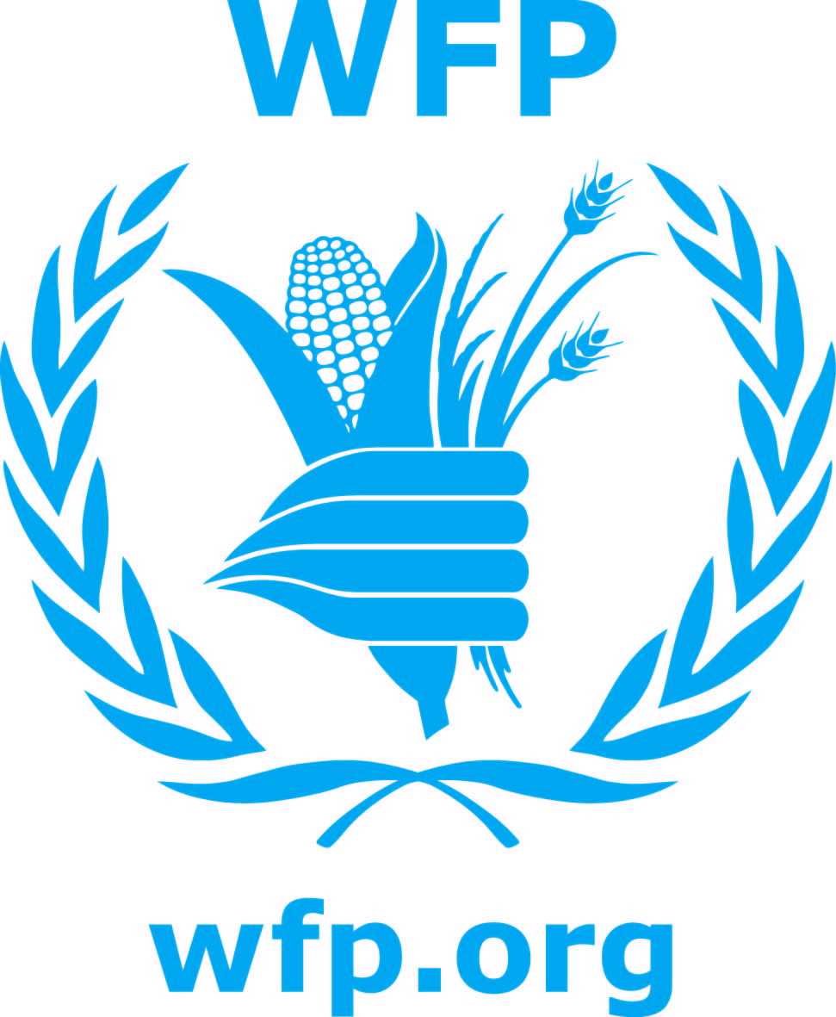 Briefing Note on School Meals in Cambodia
Overview: WFP Cambodia’s school meals programme provides daily on-site cooked breakfast using a standard nutritionally optimized WFP food ration of rice to over half a million primary school children. The breakfast includes canned fish, vitamin A-fortified vegetable oil, yellow split peas and iodized salt. It encourages poor and hungry children to come to school as well as giving them the chance to concentrate on their study among other benefits. Breakfast is provided in primary schools for grades 1 to 6 (from ages 6 to 12) in 12 provinces.
How big is the ration? The daily food ration per student is: 100 grammes of rice, 15g of yellow split peas, 10g of canned fish, 5g of vitamin A fortified vegetable oil and 3g of iodized salt.
How is it prepared? Cooking starts between 4am and 4.30am in most schools so that the breakfast will be ready by 6.30am. The cooks wash the yellow split peas, pour them into boiling water and boil for 3-5 minutes until the peas become soft. The peas are then fried for 10 minutes (or alternatively they can be made into a paste). Water, vegetables, fish and any other ingredients are added as appropriate
Cooks are selected from the community, based on their time availability, and their willingness and ability to cook. The number of cooks depends on the size of school, e.g., one cook is required to serve 100 children. Children bring their own plates, spoons and bottles of water. They arrive at school between 6.00 and 6.30 am. Breakfast is served from 6.30am until 7am when class starts. The serving of breakfast is monitored by the teachers and/or parents, and in some schools the older students help the smaller grades with the distribution of food. Food is also provided to the storekeeper and the cook at each school who receive 15kg per month of rice and 1kg per month of vegetable oil, in addition to developing their skills in food management and record keeping.
What else is involved? Complementary inputs and activities: Additional inputs, such as school equipment, uniforms, latrines, safe drinking water, or nutritional and hygiene education are provided by the Royal Government of Cambodia (Ministry of Education, Youth and Sport), with support from the multilateral financial institutions (World Bank, ADB), other UN agencies (such as UNICEF), as well as, private corporate sponsors (e.g. TNT). De-worming tablet distribution is organized in all schools within the School Feeding Programme (20% of all primary schools) and is integrated into the national programme through collaboration with the Ministry of Health, WHO and UNICEF.
WFP also provides vegetable seeds for the establishment of school vegetable gardens as part of the ‘life-skills’ curriculum when feasible and appropriate. The vegetables are used to diversify and complement the breakfast. Other non-food items such as fuel efficient stoves, cooking pots, watering cans and battery lamps may also be provided. Local communities may also provide fresh vegetables, water, fuel, kitchen and food storage facilities.
Where does the food come from? Whenever possible, WFP procures commodities within Cambodia to provide a stimulus to the domestic market and benefit local farmers. In total in 2009, 74% of commodities were purchased locally, 17% was purchased internationally and 9% were contributed in-kind. WFP Cambodia has warehousing capacity of 20,000 metric tonnes with warehouses located in Phnom Penh, Kampong Cham and Siem Reap. WFP has unparalleled capacity to transport commodities across Cambodia and in 2009, delivered over 27,000 metric tonnes of food across all 24 provinces of Cambodia, 8,000 metric tonnes of which went to School Feeding.
Why School Feeding and why WFP? WFP’s primary objective in School Feeding is for food-insecure households to improve the education of their children. Although Cambodia has made considerable progress in recent years in expanding basic education, dropout rates and retention remain major areas of concern. Primary- school indicators as shown in the Education Management Information System (EMIS) 2009/2010, show the net enrolment rate in primary education is 94.8%, however the survival rate to grade 6 is only 59.3% and even less in remote areas at less than 30%. Furthermore, only 33.9% of children are enrolled in lower secondary school. National literacy levels are one of the lowest in the region and child labour remains a significant challenge in Cambodia.
The long-term objective of WFP’s interventions is to contribute to the government policy of ensuring "Education for All" through the achievement of universal primary education by 2015 (MDG 2), and to support the strategic priorities of the Education Sector Support Plan (ESSP) 2006-2010. The immediate objectives are to ensure regular attendance and improve retention in primary schools of children from poor food insecure households.
WFP has been implementing School Feeding worldwide for the last 45 years, developing considerable expertise and experience in this area. The school feeding programme in Cambodia has been running since 1999. WFP has extensive field presence, logistical and technical expertise and strong monitoring capability.
Who does WFP partner with? Partnerships are critical to maximizing impact and ensuring the sustainability of programme interventions. WFP provides food assistance to all six UNICEF priority provinces and collaborates with 8 NGOs in other areas, including KAPE, School Aid Japan, For the Smile of a Child, Cambodian Women in Crisis Center, Samaritan Purse and World Vision. In addition, WFP-supported schools receive complementary support from UNICEF and other NGOs in the area of water and sanitation, training on general hygiene, capacity building of teachers and school directors and provision of some other non food items. WFP works closely with the Ministry of Education and with local communities and school committees.
What is the impact of school feeding? WFP Cambodia measures the impact of the School Meals Programme in terms of attendance and enrolment. There are also nutritional impacts, addressing of immediate hunger, improvements in the ratio of girls to boys attending school, improvements in learning capacity, concentration and increased punctuality. Evaluation of these wider impacts is ongoing. Currently indicators are focused on attendance and enrolment.

