Cambodia: Toward A National Employment Strategy for Sustained
Poverty Reduction

A study carried out under the EU-ILO project,
“Improving Social Protection and Promoting Employment”

M. Muqtada

Geneva, Switzerland
15 March 2011

Acknowledgements

The author wishes to express his deep indebtedness to Makiko Matsumoto for her extensive support with data-base of the study, as well as various suggestions toward the improvement of the study. He is thankful to Peter Peek, Sukti Dasgupta, and Iyanatul Islam for various comments, guidance and inspiration. The study has benefitted immensely from extensive consultations with many senior officials of several ministries, NBC, workers and employers groups, researchers, and representatives of ADB, WB, AFD, UNDP and other donor agencies. This was possible through the author’s undertaking of a mission to Phnom Penh, during November 2010. He wishes to express his thanks to all those individuals and to Tun Sophorn and Malika OK of the ILO office in Phnom Penh for all their cooperation and logistical support during the mission.

Table of Contents
Executive Summary i
1. The study: an introduction 1
2. The context of an employment-friendly development strategy for Cambodia 4
The MDGs and the Rectangular Strategy 4
Growth and Poverty 7
Cambodia’s development strategy and employment 12
A ‘look-East’ policy? 12
Re-thinking development strategy in the post-crisis period 15
The basic framework of NES 17
4. The Employment Challenge and Labor Market Dynamics 18
The Employment Challenge 19
Labor Market Dynamics 26
4. Macroeconomic Policies and Employment 29
The conventional indicators 30
Macroeconomic policy, growth and employment 32
5. Sectoral Policies and Structural Change 34
Agriculture and rural development 37
Industrialization and Trade Policy: 39
Enhancing the Job Generation Potential 39
Employment in other sectors: construction and services 44
Services Sector Employment 46
6. Labour Market Policies: Selected Issues 48
Employability and skills development 48
Labour Migration 50
A Labour Policy 51
7. Social Protection and Employment 55
In lieu of Conclusion 62
REFERENCES 66
Appendix 69

Executive Summary

- The study has attempted to contextualize the significance of planning for the generation of productive employment as critical to sustainable reduction of poverty. While growth is indeed a necessary condition, it will not by itself yield satisfactory poverty outcomes since the relationship between growth and poverty incidence is not always straightforward. A key lesson that is often derived from historical experiences and empirical evidence from contemporary development is that growth that generates productive jobs is more likely to reduce poverty than when growth is jobless. In order to pursue an employment-friendly growth strategy, there arises the need for articulating and embedding a National Employment Strategy (NES) in the development framework of a country.
- Cambodia’s pursuit of attaining the MDGs also warrants that it develops a strategy toward the achievement of target 1b, i.e. the goal of “full, productive employment and decent work”. This, in itself provides a strong rationale for designing and formulating a National Employment Strategy.
- Further, while a NES would likely remain a medium-term goal, it will need to be complemented by a strategy of gradually extending social protection and safety nets (e.g. ILO’s minimum “social protection floor”) in order to support income and employment entitlements of the poor and vulnerable. Development planning, in the post-crisis era, will need to shift policy measures to address the twin objectives of promoting productive employment and improving social protection. This study focuses largely on the relevance and construct of a NES in Cambodian development planning.
- Cambodia is staunchly committed to attaining the Millennium Development Goals (Cf. The Rectangular Strategy; NSDP Update 2009-2013); in particular to reducing poverty. The country’s rapid growth since the late 1990s until about 2007 has been associated with tangible reduction in poverty, whether defined by the national poverty line, or by the globally standardized US $ 1.25 per day. Regarding the other MDG goals and their indicators of target achievements, the results provide a mixed picture. Some indicators, such as female-male enrolment ratios in primary and secondary education, are on ‘track’, while others, such as infant mortality ratios, are not so. Heighted public interventions will be necessary to ensure some of these MDG goals are achieved by 2015. The focus of this study is, however, on the MDG goals of poverty reduction, and of attaining full productive employment and decent work.
- The country’s recent success with poverty alleviation is impressive. Nevertheless, it needs to be noted that the poverty incidence still remains high, especially in the rural areas, in particular regions, and among particular groups of population such as the self-employed farm workers and the domestic workers. Moreover, the “poverty gap” measure tends to show that there exists a large percentage of vulnerable population in Cambodia, especially those close to the poverty line. Further, the economy has been, in the recent years, experiencing a rise in income inequality, which may likely slowdown the progress in poverty reduction unless high growth rates bring about a rise in mean income of the vulnerable groups.
- As observed, the economy, by and large, pursued a growth-induced poverty alleviation strategy. Here, the study underscores the need for a rigorous analysis of the channels through which growth induces positive poverty outcomes. Furthermore, now that growth has been adversely affected by the recent global crisis, and that poverty incidence and vulnerability have likely risen, doubts are being expressed on whether, and how soon, the economy could return to high growth of the recent past. The NSDP Update 2009-2013 appears to address these doubts; it has revised the growth rates sharply down, to an average of 5-6 per cent, from the double-digit growth attained in the recent past. This is likely to slow down job generation and poverty elevation.
- More significantly, the crisis has provided policy planners a pause for reflecting on the very growth strategy of Cambodia. Thus far, it has followed, like many of its East Asian and ASEAN neighbours, a labour-based, export orientated growth strategy. While this has resulted in some early successes, e.g. the rapid growth in garments exports (and hence jobs and enterprises), analysts attribute this to a number of fortuitous circumstances (guaranteed markets, especially the US; global boom of 2002-2007), and an overdose of incentives, policies and resources directed to attract FDI. One thus observes FDIs accounting for the bulk of the investment in garments sector. The study points out that the East Asian export-orientated growth was not simply labour-based; it was designed with backward-forward linkages and with concomitant policies to encourage appropriate factor use, domestic investment, entrepreneurship and skills to capture the markets. These economies pursued a broad-based, employment-generating growth strategy, which was supported by an export-oriented industrialization strategy. The export sector in Cambodia, with little presence of domestic investment and skilled workers, is yet to manifest such industrialization dynamics.
- In fact, the NSDP Update 2009-2013 provides an implicit recognition of the need to move towards a broad-based development strategy, without forsaking the goals of macroeconomic stabilization and openness of the economy. Thus, much greater emphasis is being placed, quite rightly, on rural development; this is a shift from poverty reduction being seen simply as a function of growth to being contingent on the patterns of growth. It remains to be seen how a broad-based development strategy evolves in Cambodia, and how the intended goals and targets of the new plan are implemented, to bring about much-needed diversification and structural change. It is within the framework of such a renewed development outlook, a national employment strategy would help articulate and enhance the employment-content of growth. After all, it would be the growth of wage-based employment, and mobility of labour to higher-productivity jobs that would likely indicate the process of structural transformation of the economy.
- In order to design and formulate a NES, it is foremost necessary to understand and assess specifics of the employment and labour market situation. The study has provided some insights on the employment challenges of the economy, and on its labour market dynamics. During the decade 1998-2008, there appears to have been a significant growth in employment, with wages being pushed-up in certain sectors. The study argues that since current unemployment is low at 1.6 per cent, the reduction of unemployment cannot be a meaningful policy target. Also interesting to note is the co-existence of low unemployment with a high incidence of poverty and low levels of productivity. This implies that most of the jobs created during the decade are neither adequately remunerative nor productive. Useful policy targets could instead lie in pursuing progress in the four indicators of MDG target 1b (namely, the incidence of working poor, employment-to-population ratio, proportion of vulnerable population, and labour productivity);and/or facilitating and monitoring the growth of paid formal sector jobs in the private and public sectors. The study cautions that one needs to be mindful of definitional problems of the MDG indicators, especially regarding vulnerable population, and of the need to design indicators of targets and progress. In the case of the latter, i.e. the growth of formal sector jobs will depend on the economy’s growth patterns and structural transformation. Currently, the Cambodian labour market is characterized by a limited formal sector, with the bulk of employment being in the informal economy. Youth share in total unemployment is relatively high. Women`s employment-to-population ratio is increasing, but there exist significant disparity in access to training and education, and better-paid jobs.
- Employment generation is a complex phenomenon, and is influenced by the entire range of economic and social policies; hence, the design and formulation of a national employment strategy would need to be conducted as an integrated approach, possibly through an inter-ministerial platform. Macroeconomic policies, sectoral and social policies, skills development programmes, labour and social protection policies as well as institutional reforms and regulatory frameworks need to be closely reviewed in order to formulate the necessary reforms toward an articulated employment strategy, and an Action Plan.
- In the above context, the study has cursorily examined some of these policies. The macroeconomic policy stance of Cambodia is perceived to be conducted within the framework of the Washington Consensus, and is overwhelmingly concentrated on the goal of macroeconomic stability. Such other goals as employment generation and/or social protection do not feature in the macroeconomic framework. Even on the stability goal, due to highly dollarized nature of the economy, use of the traditional instruments is restricted. Inflation targeting is done not through variations in policy rates; NBC has limited intervention, except through buying/selling of US dollars to regulate money supply. Often the fiscal levers are used to control investment and consumption to stabilize prices. Since such stability is yet to generate a momentum in domestic investment, the study calls for a prudent use of fiscal policy for expanding social and physical infrastructure, and an appropriate monetary/credit policy for boosting investment and employment generation.
- While Cambodia has registered rapid employment growth, most of this has taken place in low-income, low-productivity activities. An indicator of this is that the employment share in the modern industrial sector is still quite low, implying that the economy, despite rapid growth, is yet to witness any major structural transformation. The study examines the potential of selected sectors (agriculture, industry and trade, construction, and services) toward employment generation. Sectoral strategies need to be reviewed in the light of the economy’s comparative advantages, such as through the capacity utilization and increasing productivity and incomes in land-intensive production and exports. The NSDP Update, in this context has enhanced allocations for rural development which is likely to improve the earnings and job prospects of the rural poor. This study notes that while agriculture growth has been increasing in the recent period, its productivity remains low compared to that in the ASEAN countries. Cambodia can invigorate productivity and labour absorption in the sector both through the development of small-holder farming as well as through large-scale production, including forestry development and plantations. This would require addressing several constraints, such as moving to multiple-cropping, use of high-yielding varieties, dedicated public policy and expenditures on expansion of irrigation, facilitation of access to credit, inputs and training.
- The industrial sector in Cambodia is expanding, greatly spurred by the rapid growth of the garments sector. However, its employment share, though increasing, is still very low (8 per cent!) to effect any structural transformation, e.g. through inducing labour from low-productivity to high-productivity sector. Industry sector will require diversification, which, in turn, is necessary for a diversified export portfolio. Aggressive attention is needed to encourage domestic entrepreneurs, and specifically the small and medium enterprises. The high proportion of expatriate workers as currently exist in the high-end jobs in the export industries need to be brought down through a well-designed programme of Cambodianization of targeted skills The study contends that Cambodia’s export competitiveness does not necessarily rest on cheap labour, but on enhancing productivity and skills competitiveness. For micro and informal enterprises, MFI loans need to be boosted, and various barriers (such as collaterals) need to be removed, and access to credit, technology and training facilitated. Skills policies need to be further tuned to reduce mismatches in the job market, and to support youth and women to enhance their employability in better-paid jobs.
- The study has maintained that Cambodia needs to articulate and develop the existing labour policy, in order to complement the NES. The LM regulatory framework, guided by the Labour Code 1997, and the institutions needed to enforce the regulations, would need to be further strengthened and expanded, including those of the workers’ and employers’ organizations. On ALMPs, various elements exist, such as employment interventions (public works etc.), formal and non-formal training establishments, and the newly initiated public employment services. A streamlining and coordination of ALMPs (such as the ‘active employment policies’ in China) is warranted.
- Country experiences of Europe have shown how policies toward full-employment and social protection need to go hand-in-hand in the development and institutionalizing of social welfare. In Cambodia, with a low proportion of market-based formal job creation, and with severe constraints on the budget, it has been difficult to embody such policies in the planning framework. Social protection, in the traditional sense, is still in its very early stages even in the formal sectors, and will require major efforts and resources at institution and capacity-building. A National Social Protection Strategy (NSPS) has recently been enunciated, but whose implementation and finance mechanisms are yet to be spelt out. The study observes that some of the sub-elements of the NSPS could be synergized through establishing interrelationships between employment and social protection programmes. Through ‘solidarity’ and ‘redistribution’ principles, the NSPS will need to raise resources and set up an implementation mechanism to be able to pursue its mandate to extend social protection to all who are poor and vulnerable. The present study further contends that it would make good economic sense for the government to enhance its fiscal space and expand public expenditures in order to boost employment and social protection.
- In conclusion, the study recalls the importance of employment-friendly growth strategy not only for a sustained reduction in poverty, but also to effect structural transformation in the economy. This would require policy reforms and policy shifts towards a broad-based development strategy that engages the labour of the poor in a productive, remunerative way. Such a strategy would also require coordinated social protection and safety net measures in order to support the vulnerable, to sustain the employment and income gains of growth, and to move toward a full-employment society. The RGC, through its NSDP Update 2009-2013, has given recognition to the need for a renewed framework of growth and poverty alleviation. The study maintains that an employment generation strategy would need to be embedded in this framework to move towards achieving the MDGs, to which the RGC is fully committed.

1. The study: an introduction

Policy planners in developing countries have traditionally placed their faith on economic growth to attain reductions in poverty. The World Bank, through use of cross-country scatter to establish a relationship between the two, has found that “growth is good for the poverty.” A cross-sectional result, however, may not be of great significance for an individual country. That is because there is no mechanistic, straight-forward, relationship between growth and poverty reduction. Of course, growth is a truly necessary condition, but how far such growth addresses the poverty question depends on the patterns of growth, on the built-in redistribution strategy, on extent of safety nets and social transfers (i.e. pattern of public expenditures), on institutions and perceptions. There are for instance, perceptions, sometimes statistically underlined, that growth may do some good for the poor, but that growth is doing better for the upper quintiles of the income groups. Hence, inequality is being pervasively observed. Even in China and India, where growth has been impressively high, there are debates and doubts on how far this has helped reduce poverty in the two economies. Analysts suggest that inequality has likely increased, while poverty reduction has been disappointing given such high growth rates.
International experiences clearly suggest that there is no invariant relationship between growth and poverty. If an individual country were to rely on growth-induced poverty reduction, how long is the “wait” for a defined poverty-target to be achieved? One thus would have to review not only the patterns of growth, but also how the growth-poverty linkages play out, and what policy processes and interventions governments design that result in varying poverty outcomes of growth.
Individual developing countries also have to contend with not only sustaining and strengthening the drivers of growth, but also with how to safeguard their poor and vulnerable population from volatility of growth. Countries much too often face internal shocks (crop failures; natural disasters) and/or external shocks, such as the recent global economic crisis. These can push back large numbers of the workforce below the poverty line, and countries, with weak fiscal space, can face an enormous task to get back to benchmark incidence of poverty.
In the more recent period, policy planners have started reflecting on pro-poor growth (PPG); why a PPG strategy if growth were good for the poor? In fact several donor agencies, including the World Bank, have conducted intensive case studies of 14 countries in order to understand patterns of growth that could yield better poverty outcomes. These studies appear to find associational relationship between PPG and a number of factors ranging from macroeconomic discipline to policies and interventions toward agriculture, non-agricultural rural activities, public provisions and transfers. However, PPG has been under debates both with regard to how it should be measured (relative or absolute), and on what strategies an economy ought to pursue to achieve those yardsticks. In other words, studies are still ambivalent on what precisely are the “intermediating” factors that can provide maximum poverty outcomes of growth.
In this context, a particularly striking common element that we observe, both in the context of the advanced economies in the post-War period, as well as in the more recent times, of the countries of East and South-east Asian is the close relationship between growth of productive employment and the successful reduction of poverty. The advanced economies during the 1950s and 1960s pursued a goal of full-employment, which was a central objective of their macroeconomic policy. Similarly, in East and South-east Asian economies, a relatively egalitarian pattern of growth (thanks to a programme of land reforms in some cases), followed by a labour-intensive export-orientated industrialization are often cited as important forces that led to a near-full employment and reduction of poverty. The former set of countries, especially in Europe, also pursued, in parallel, the development of social institutions and social protection systems (albeit in different details) such that the society, in solidarity, could take care of the unemployed, should economies fall short of the full-employment norm.
Policy planning in most of the developing countries of today, which face persistently high poverty, and volatility in growth and vulnerability, among the poorer population, are increasingly leaning towards the twin objective of employment generation and extension of social protection. One thus observes a recent spate of engagement on planning towards a PPG strategy to attain elements of the two objectives. Such a PPG strategy is also purported to give effect to their commitments to attain the MDGs, in particular the targeted goals of halving poverty by 2015, and the non-targeted progress toward the goal of “full, productive employment and decent work” (MDG Target 1b). While productive employment generation is increasingly recognized as a critical process for sustainable poverty reduction, most countries continue to considered employment as a residual outcome of growth. Lessons from country experiences of successful employment performance point to the need for designing and embedding a national employment strategy (NES) in the development framework of the country.
While NES would need to be a central tenet in a medium-term strategy, a PPG in order to support large populations in vulnerable conditions would need to incorporate several other measures, to including, inter alia a strategy of extending social protection and safety net systems. At present, there exist in these economies numerous programmes of employment and labour market interventions, and programmes of (non-contributory) social transfers. These are largely ad hoc and temporary in their impact, and an expanded programme for an ever expanding labour force is often constrained due to fiscal space.
Development planning, especially in the aftermath of the recent global economic crisis, is under close scrutiny. There appears to be a growing consensus that it would be highly risky for the next generation of development plans not to incorporate an unemployment-friendly growth strategy and a minimum “social protection floor”. These two are not separate, but inter-related, objectives, and will have to be pushed within an integrated approach. The recent policy practices in India, Brazil, China and South Africa on enhancing the twin objectives are instructive.
This study, attempts to establish the need for and significance of a national employment strategy in Cambodia, especially in light of the RGC’s commitment to achieving the targets under the MDGs, including poverty reduction and attainment of full productive employment and decent work. The study reflects on how these are linked to the country’s development strategy, and how an integrated approach to policy-making would be necessary to build a consensus on, and formulate a national employment strategy (NES). This study per se is not a NES, but provides the contours and ingredients of one. Some of the findings of the report, and the policy issues raised need to be delved in greater details. The study, thus, focuses on the NES dimension of the framework outlined earlier, although reflections are made on the potential synergy between employment and social protection.
The study has been organized in the following manner. The next section 2 provides an assessment of Cambodia’s commitment to and pursuit of the MDG goals, poverty alleviation in particular. It provides a rationale into the need for integrating an employment-based development strategy for a sustained poverty reduction, and to attaining the MDG target of attaining full, productive employment and decent work. Section 3 examines the employment and labour market challenges in the economy, especially when a policy objective of reducing unemployment and/or increasing employment-to-population ratio is not meaningful. Some LM characterizations are also observed. A national employment strategy, as argued, embraces a whole range of economic and LM policies. Section 4 introduces the macroeconomic policy stance of Cambodia, and points to the need for incorporating the employment objective in macroeconomic framework. It also raises some of the restrictions that currently exist with respect to the instruments of macro-planning. Section 5 provides insights into sectoral employment and policies that could bring out a greater labour absorption capacity of various sectors; i.e. in agriculture; trade and industrialization; services and construction. Section 6 deals with some supply-side issue of LM; in particular, the high priority of developing skills and employability, in all the sectors of the economy. It examines LM policies to encourage disadvantaged groups; and calls for the articulation of an ALMP. In the following section 7, the importance of linking social protection policies and employment generation policies is reviewed, as well as the need for developing a strategy for developing synergies between the two. Some concluding remarks are made in section 8.

2. The context of an employment-friendly development strategy for Cambodia

The MDGs and the Rectangular Strategy
The Royal Government of Cambodia (RGC) has been unequivocal in its commitment to reducing poverty in the economy, and to achieving the millennium development goals (MDGs) by the stipulated 2015. The RGC’s design of the Rectangular Strategy that underpinned the National Strategic Development Plan (NSDP), 2006-2010, expresses this commitment and the manner in which the development strategy would be defined to achieve the MDGs. As well known to the readers of the Cambodian economy and its planning, key policy corners of the Rectangular Strategy are: i) enhancement of agriculture sector; ii)physical infrastructure; iii) capacity building and HRD; and iv) private sector development and employment. The key themes are interwoven and buttressed through good governance, and the various reforms that the latter entails (see figure below).

Figure 2.1
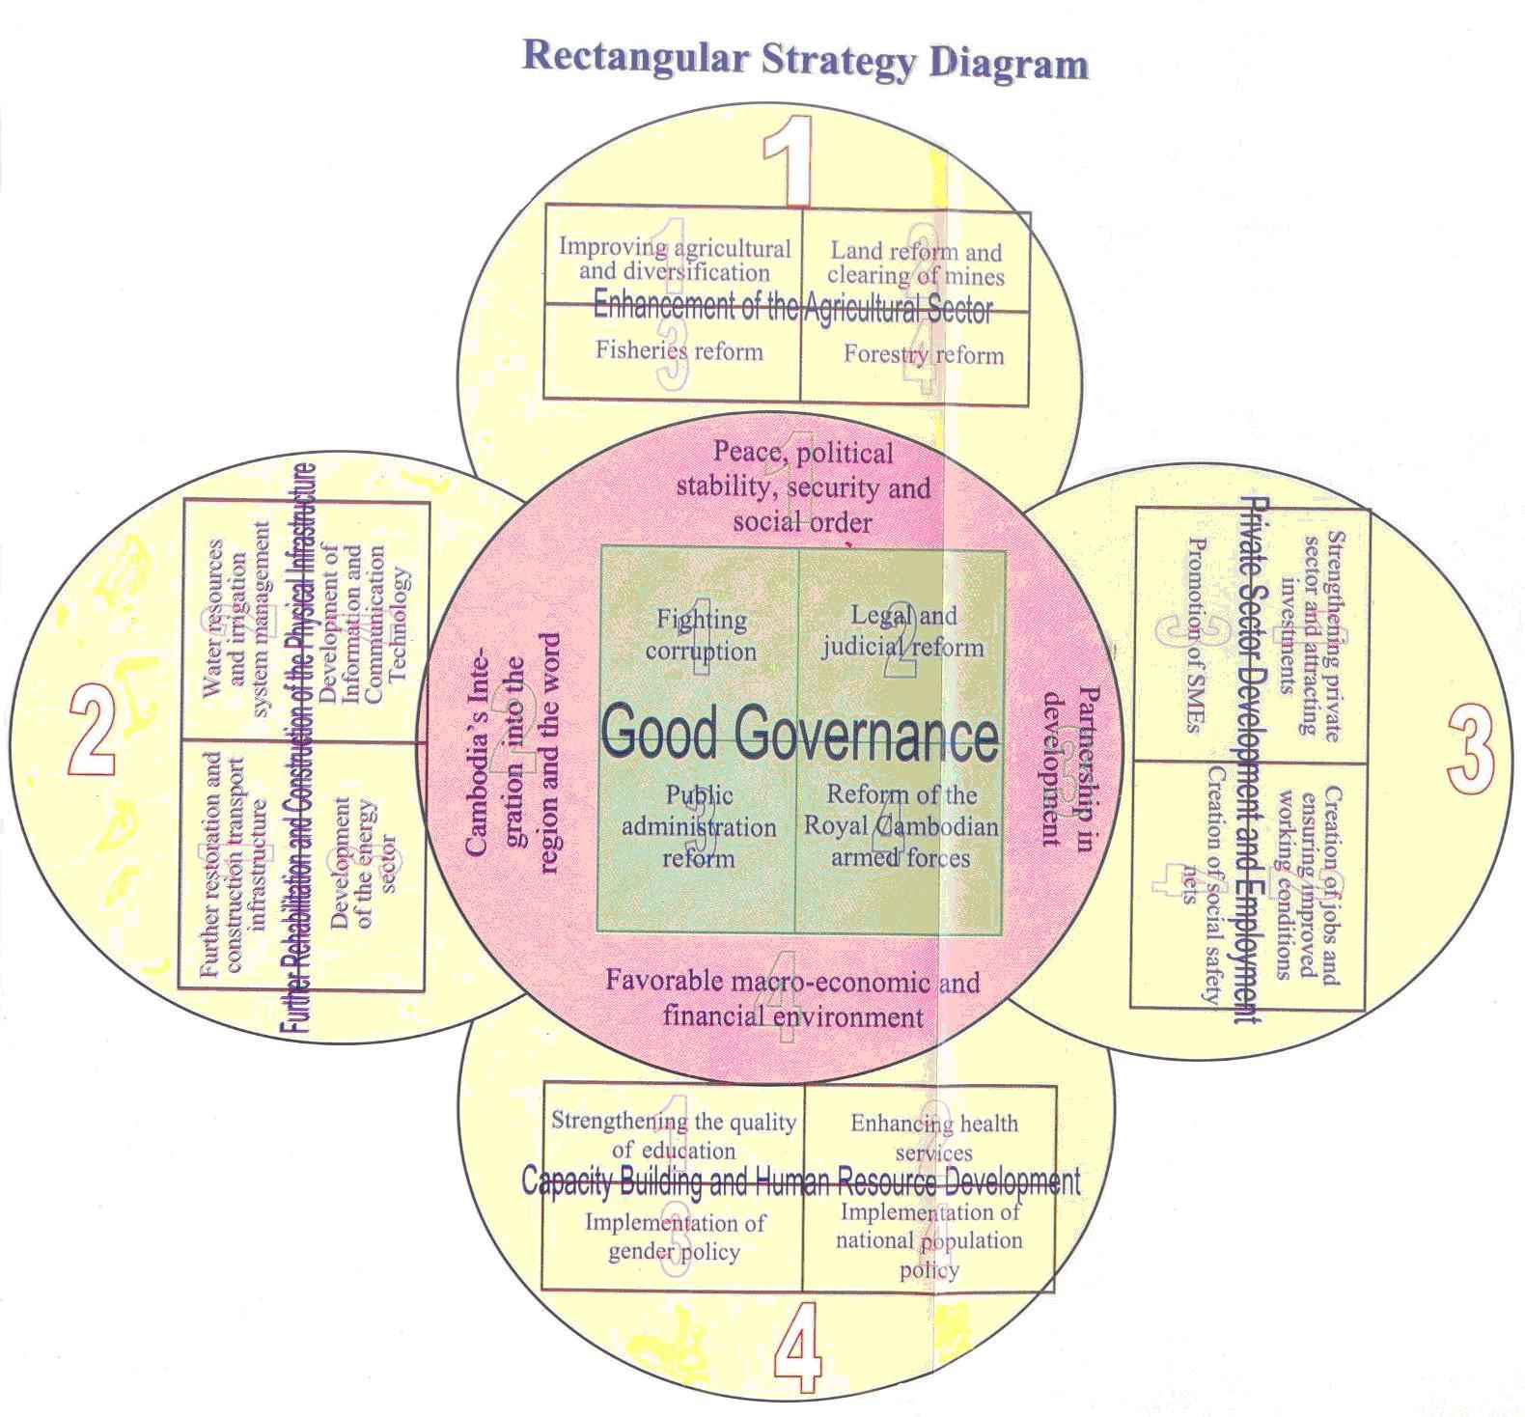

It may be argued that alongside the country’s recent economic success, the social progress of the RGC as pursued within the framework of the Rectangular Strategy will be mirrored in the country’s progress towards the CMDGs. A brief account of the attainments and deficits in respect of the CMDGs is given in Table 2.1.

Table 2.1
MDGs and the state of progress
MDG indicators |  | Progress status | Earliest year | Intermediate year | Latest year
Goal 1
 | Poverty (%, less than 1.25$ a day) | Slow progress | 48.6 (1994) | 40.2 (2004) | 25.8 (2007)
 | Vulnerable employment (% of total employment) | .. | 86.8 (1998) | .. | 79.0 (2008)
 | Working poverty (%) | .. |  | 38.4 (2003)
 | Employment-to-population ratio (%) | .. | 73.0 (1998) | .. | 77.0 (2008)
Goal 2 | Net primary school enrollment (%) | Slow progress | 72.2 (1991) | 87.3 (2000) | 88.6 (2008)
 | Children reaching last grade of primary (%) | Slow progress | 47.9 (1998) | 55.0 (2002) | 54.4 (2007)
Goal 3 | Primary education female-male enrollment ratios (%) | On track | 81.1 (1991) | 87.2 (2000) | 93.6 (2008)
 | Secondary education female-male enrollment ratios (%) | On track | 43.0 (1991) | 54.7 (2000) | 81.6 (2007)
 | Tertiary education female-male enrollment ratios (%) | Slow progress | 33.5 (2000) | 46.2 (2004) | 53.6 (2008)
 | Seats held by women in national parliaments | .. | 6.0 (1997) | 7.0 (2003) | 16.3 (2009)
Goal 4 | Under-5 mortality rates (per 1,000 live births) | Slow progress | 116.7 (1990) | 106.4 (2000) | 89.5 (2008)
 | Infant mortality rates (per 1,000 live births) | Slow progress | 85.3 (1990) | 79.6 (2000) | 69.3 (2008)
 | Measles immunization rate for 1-year-old children (%) | .. | 34.0 (1990) | 65.0 (2000) | 89.0 (2008)
Goal 5 | Maternal mortality ratio (per 100,000 live births) | .. | .. | .. | 540 (2005)
 | Births attended by skilled health personnel (%) | Slow progress | 34.0 (1998) | 31.8 (2000) | 43.8 (2005)
 | Live births with at least one antenatal care visit (% of live births) | .. |  |  | 69.0 (2005)
Goal 6 | HIV prevalence (% of 15-49 population) | On track | 0.7 (1990) | 1.6 (2000) | 0.8 (2007)
 | Antiretrovial therapy coverage (% of people with advanced HIV infection) | .. |  | 54.0 (2006) | 67.0 (2007)
 | Incidence of tuberculosis (per 100,000 people) | On track | 585 (1990) | 530 (2000) | 490 (2008)
Goal 7 | Forest area (% of land area) | No progress | 73.3 (1990) | 65.4 (2000) | 56.7 (2007)
 | Improved water source (% of population with access) | On track | 19.0 (1995) | 38.0 (2000) | 65.0 (2006)
 | Improved sanitation facilities (% of population with access) | Slow progress | 8.0 (1995) | 16.0 (2000) | 28.0 (2006)
Source: WDI, except for vulnerable employment and employment-to-population ratio, which were taken from NIS (2010), based on Population Census and LFS data for population aged 15 and above. Progress status are taken from the assessments made by UNESCAP, ADB, UNDP (2010) Achieving the Millennium Development Goals in an Era of Global Uncertainty: Asia-Pacific Regional Report 2009/10, table 1-3. On-track = expected to meet the target by 2015; Slow progress = expected to meet the target but after 2015; No progress/regressing = stagnating or slipping backwards.

The Table shows that while the country is making progress in general, the results are mixed in terms of specific indicators. The economy is well on track with regard to the goal of halving poverty incidence by 2015; also on MDG#3 on enhancing the female-male enrolment ratios in primary and secondary education. Apart from these targets, the progress is observed to be rather slow on the other goals and targets. In particular, the extent of vulnerable population, and of working poor (which are recently-introduced indicators under Target 1[b]), though declining, remain unacceptably high. In some other cases, e.g. the goal of infant mortality, progress has been halted and/or reversed. With another 5 years to go, the RGC in order to perform better with the CMDGs, would require heightened programme interventions as well as expanded public expenditure to step up actions on the other goals. Equally, there are also institutional and socio-cultural factors that may need to be addressed to move closer to the other targets, for instance in addressing school drop-outs.
Notwithstanding the CMDG deficits, it is important to ask whether the achievements so far of the CMDGs provide an authentic account of the real economic and social progress of the Cambodian economy. And how far can these achievements be sustained and improved upon? Any stringent enquiry of these need to be tempered by the fact that development planning in Cambodia is of recent origin, and that apart from economy-disrupting civil war and strife, the economy has undertaken a resolve to move toward a full transition to market economy. Institution and capacity building, rules and framework of governance to support development planning are equally in their experimentation stages.

Growth and Poverty
As mentioned in a previous section, the critical conventional indicators of economic and social progress are GDP growth and reduction in poverty (See Figure 2.2).

Figure 2.2 Real GDP growth rate and poverty (%)
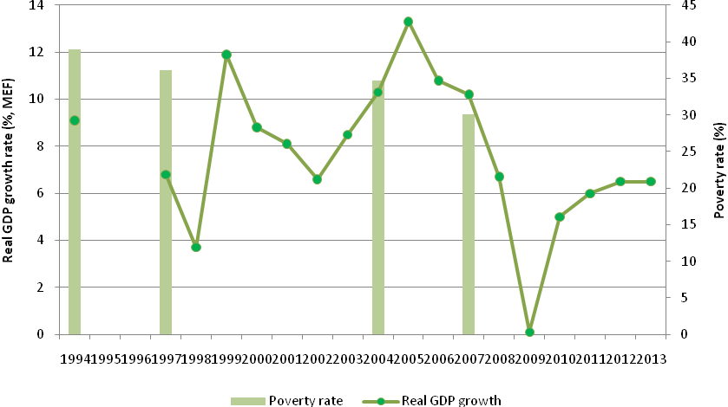
Source: Real GDP growth rates are taken from NSDP update 2009-2013, tables 8 and 9; and poverty rates are taken from NIS (2010).
The real GDP growth in Cambodia during the decade 1998-2007 has on average has been above 9 per cent, the 6th fastest in the world. During the so called “reconstruction phase” (1999-2003), Cambodia registered nearly 8.8 per cent growth in GDP, which increased to 10.3 per cent during “take off phase” (2004-2008). Analysts often qualify such impressive growth as having started from a low base. Nevertheless, rapid growth in the economy has indeed been a proximate factor in the decline of poverty incidence, from around 48 per cent in 1994 ($1.25ppp/day) to around 26 per cent in 2007 (See Table 2.2 below).

Table 2.2 Poverty rates: $1.25 a day, $2 a day and national poverty line
Poverty lines | 1994 | 2004 | 2007
Head count ratio (% of population):
$1.25 (PPP) a day (%) | 48.6 | 40.2 | 25.8
$2 (PPP) a day (%) | 77.9 | 68.2 | 57.8
National poverty line (%) | 39.0 | 34.7 | 30.1
Poverty gap (%):
$1.25 (PPP) a day (%) | 13.5 | 11.3 | 6.1
$2 (PPP) a day (%) | 33.3 | 28.0 | 20.1
Source: World Bank, WDI for $1.25 and $2 (PPP) a day. National poverty figures are taken from NIS (2010).
Due to lack of time series estimates of poverty, it is difficult to ascertain the rates at which poverty has been declining, i.e. the poverty elasticity of growth. Despite data limitations, the following observations merit consideration:
- While poverty elasticity estimates are lacking, high growth appears so far to have had a strong associational link with poverty reduction; especially during 1998-2007. In particular, extreme poverty has declined substantially.
- As figure 2.1 shows, there is no invariant relationship between growth and poverty reduction; the precise linkages between growth and poverty, i.e. how growth leads to poverty reduction, do not have a systematic explanation. Hence, high growth need not always “cause” poverty to come down at the rates that are currently observed.
- The “poverty gap” measures tend to show there is a large percentage of vulnerable population in Cambodia (see Table 2.1 above). If the poverty threshold is considered at US $2.00 per day, the poverty incidence sharply increases to 58 per cent! Poverty and vulnerability are still very high.
- The recent global financial crisis has adversely affected the growth rate which is currently being revised downward; also the very foundations and “drivers” of growth are being seriously reconsidered. Thus, as figure 2.2 shows, the country’s growth rates are being projected sharply downwards; this could increase the incidence of poverty, if the latter were to depend solely on growth.

The upshot of these observations is that growth –poverty linkages are not always straight forward; that growth may be a necessary but not always a sufficient condition for poverty reduction. Further, since growth projections have been revised downwards, it remains to be seen whether the MDG goal on poverty, which is currently on track, can in fact be achieved. It is important to understand and establish how growth benefits the poor. If redistribution mechanisms matter, then the precise processes of asset and income distribution, social transfers and public expenditures need to be identified and evaluated. The contention that if ‘distribution’ structure remains the same (e.g. Gini coefficient) then higher growth is likely to lead to greater poverty reduction than otherwise does not appear to hold for Cambodia.
Table 2.3 Measures of inequality: Gini coefficients
Area | 1993/94 | 1997 | 2004 | 2007
Phnom Penh | 0.39 | 0.46 | 0.37 | 0.34
Other urban | 0.44 | 0.44 | 0.44 | 0.47
Rural | 0.27 | 0.33 | 0.34 | 0.36
Cambodia | 0.38 | 0.42 | 0.30 | 0.43
Source: NIS (2010), Table 3.5

As Table 2.3 shows, inequality, as measured by the Gini, has been increasing substantially during the recent period. High growth in a situation of growing inequality may reduce poverty if the mean incomes of the poorer households were to increase. It would be risky to assume that the latter could simply rely on trickle down effects of growth. There ought to be more dependable “agent” that could translate growth in to sustainable poverty-reduction outcomes. One such critical agent as argued in the Introduction is the generation of productive employment generation.
At the risk of some repetition, it is evident that Cambodia is making progress on the CMDGs, with slower progress in some than others. What is well on track appears to be Cambodia’s progress on MDG1, target1 on halving poverty in the economy by 2015. However, as the discussion above suggests, predicating poverty reduction by simply relying on growth rates, which have now been adversely affected by the global crisis, is perhaps risky. In this context, it is equally necessary to understand the variations in poverty incidence amongst various groups of the population, and the various regions.
In particular, a disaggregated picture shows that poverty in Cambodia is overwhelmingly a rural phenomenon, and that there are enormous variations in poverty incidence among the rural and urban regions, (Figure 2.3) and among various occupational groups (Figure 2.4).
Figure 2.3 Percentage of rural-urban population below national
poverty line (%)
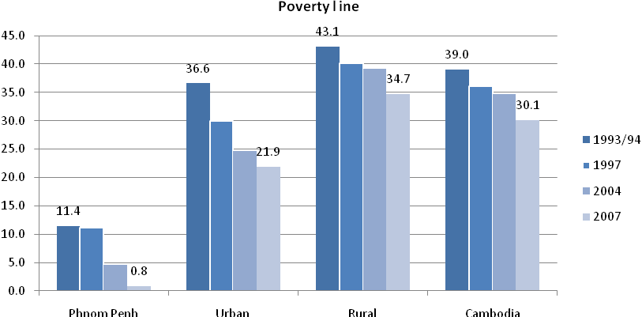
Source: NIS (2010).

Figure 2.4 Poverty by economic activity and employment classifications of the household head, 2004
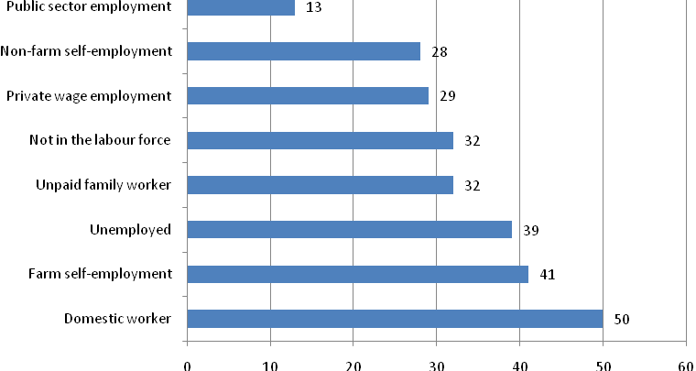
Source: As cited in figure 8.4 in E. Morris (2007)

Thus while aggregate poverty incidence has declined to 26 per cent, it has not been so for all regions and income classes, especially self-employed farm workers and domestic workers. Specific intervention measures may be necessary to address urban, semi-urban and rural poverty, as well as to support such occupational groups as small farmers, self-employment, domestic workers, and other vulnerable categories in informal employment. The RGC has a fairly elaborate social policy, public provisions, and special programmes that offer income and employment entitlement to the poor and vulnerable. These are, however, rather uncoordinated, and ad hoc, and substantially donor-driven.
Let us recall, and as stated in the Introduction, the MDG goal of poverty alleviation, is associated, quite understandably, with the goal of attaining “full, productive employment and decent work” (MDG Target 1b). In order for an economy to move towards a state of full-employment, it would need to generate and sustain productive job growth. Public programmes to provide employment and income entitlements to the poor and/or unemployed as mentioned above can bring in temporary relief. However, is largely through a strategy of employment-friendly development that the above MDG goal is likely to be attained.

Cambodia’s development strategy and employment

A ‘look-East’ policy?
Cambodia’s rapid economic growth during 1999-2007 has been closely associated with the first generation macroeconomic reforms, largely reflecting the Washington Consensus, and various liberalization policies towards greater integration with the global economy. It appears that the policy mind-set was entirely toward opening up the economy and concentrating on an export-led growth process. It is not difficult to deduce that various policy reforms, the incentive structure (including tax relief and profit repatriation); regulatory framework and resources were geared toward an open-economy strategy. Many of the East and South-east Asian economies during their early phase of growth has indeed followed, quite successfully, an export-led labor-intensive growth strategy, and took advantage of the trade boom of the period. Cambodia also appeared to be on track to follow a similar process, with similar outcomes. In fact, the global economy boom, together with low-labor costs allowed the Cambodian economy to reap significant growth dividends. Employment generation, especially formal sector job generation was attained in such specific sectors as garments, hotel & tourism and construction. As an employment strategy, export-led labor incentive growth, if the external conditions are ripe, can bring about substantial job creation. However, when the external conditions turn adverse, export-led economies can equally face rapid contraction, as observed during the 2008-09 global economic crises. Employment under the circumstances is extremely sensitive to changes in relative production costs, especially among countries producing and exporting similar products. Workers and working conditions are further affected as attempts are made to restrain wages and trade union activity. In Cambodia, employment and workers’ wages suffered during the crisis, and were further affected due to limited maneuverability of the exchange rate, that could otherwise have enhanced competitiveness in garments exports.
The essential difference perhaps between the export-led growth strategy of Cambodia and that in most of East Asian and ASEAN countries is that in the latter it was embedded in an overall development strategy, with clear linkages with the domestic structure of production and labor markets. Policies and prices were set in place for domestic enterprises and resource structure including skills to respond to rising export opportunities for labor intensive manufacturing goods. In Cambodia, the principal export-sector, i.e. garments, has had very limited backward/forward linkages with the domestic economy. Moreover, unlike its ASEAN neighbours, the sector has been pre-dominantly dependent on FDIs, that shrank sharply during the crisis.
It must be emphasized that attracting FDIs as part of an economy’s overall investment strategy need not be seen as harmful. On the contrary, East and South-east Asian countries in the past, and Vietnam, China etc in the recent periods, have successfully harnessed FDIs toward their impressive industrial and export performance. However, an overt reliance on FDIs which promises only restricted value-added, and limited backward-forward linkages to encourage domestic investment and employment, can potentially impart volatility and vulnerability to the economy. Lessons from the “look East” policy would need to be seen in a broader framework than has been the case in Cambodian development planning.
Further in East Asian economies sustained labor demand, and shifts (mobility) of labor from low productivity and unskilled work to high productivity, sectors induced a process of structural change in the economy. This was broadly reflected in the changing shares of various sectors in total employment; with a declining share for agriculture and increasing shares of the modem manufacturing and service sector. The advanced economies of the West, as well as the East Asian economies have experienced the so-called Lewisian turning point, when the modem sector played a significant role in generating productive employment. In many of these economies, viz. South Korea, Taiwan-China, Singapore etc., the modern manufacturing sector accounted for more than 25% of total employed workforce. Compared to this Cambodia has some distance to go before such structural change can be visibly observed (see Figure 2.5).
Figure 2.5 Sectoral composition of real value added and employment (%)
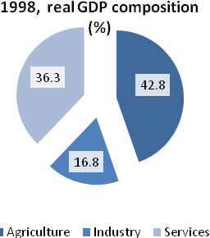 | 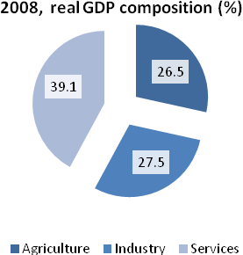
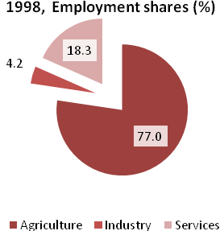 | 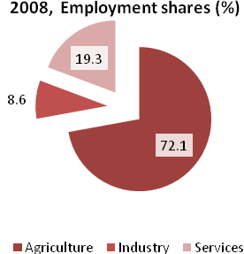
Source: NIS (2010); NIS Statistical Yearbook 2005; NIS 2008 National Accounts data published at http://www.nis.gov.kh/index.php/statistics/national-accounts

The figure above shows that while sectoral shares of GDP have undergone tangible changes (e.g. manufacturing GDP increased from 17 per cent to 27.5 per cent during 1998-2008) the employment shares of the sectors do not reflect the structural change. In particular, the share of agriculture in employment has remained constant over the decade. While the manufacturing’s share in employment doubled over the period, it remains very small (8.6%) to absorb the surplus labour from the low-productivity sectors.
Thus, the twin elements of Cambodian economic planning, viz. orthodox macroeconomic reforms to bring about macroeconomic stability and rapid openness toward pursuit of greater global integration and an export-led growth, as now can be seen with the benefit of hindsight, have not been yielded major structural transformation. One must note the Cambodian economy during the late 1990s, when development planning and reforms started taking roots, was not only trying to recover from the ravages of a long-drawn war, but was also in transition to a market-based economy. As international experiences of such transition and liberalization reforms have tended to point out, e.g. as observed in China and Vietnam recently, and in Eastern and Central Europe during the 1990s, this would require careful sequencing, management and monitoring of the reforms programme. While private sector would eventually emerge as the dominant source of job growth, policy and institutional reforms for labor market would be as critical and significant as those for private sector investment. It is thus imperative to draw up policies, regulatory framework, incentives and institutions to ensure a gradual economic restructuring and structural changes in the economy, and at same time, to ensure a smooth functioning of the LM and higher employment growth.

Re-thinking development strategy in the post-crisis period
The global economic crisis has not only jolted the Cambodian economy, but also the RGC into initiating special measures to offset the adverse effects on growth as well as on the vulnerable population. Perhaps the most positive effect that the crisis has brought about is the significant change in the RGC’s approach and strategy towards development. This is fairly well reflected in the NSDP Update 2009-2013, although one has to see how the intended goals and targets of the new plan are implemented. The new NSDP Update, in the light of the crisis and its ability to withstand external shocks, has revised downwards its growth rate and is planning to move towards a broad-based development strategy, the latter constituting a significant divergence from a single-minded export oriented growth strategy that would deliver all. In the revised Update, the Rectangular Strategy (Phase II) will be pursued and the highest priority will continue to be the reduction of poverty. Without forsaking the goals of macroeconomic stabilization, and openness of the economy, the NSDP Update appears to have a shift in the development paradigm:
- Poverty reduction is being seen not simply as a function of growth, but the pattern of growth especially through a major emphasis on rural development;
- The binding constraints on a broad-based growth are not simply eased through stability and liberalization; major efforts are needed toward structural change, skills development and employment generation.
Thus, recurrent expenditures on agriculture are planned to increase from CR 78 billion in 2009 to CR 128 billion in 2013; similarly, rural development’s share will increase from CR 54.5 billion to CR 121.7 billion over the same period. If appropriately articulated and implemented, NSDP Update proposals will have shifted attention from an overwhelming reliance on export-based growth to a more aggressive stance on rural development. Since poverty in Cambodia is largely a rural phenomenon, this would likely reduce poverty much faster. Similarly, the policy focus on agriculture, its productivity as well as on agro-industries, are expected to yield significant growth, mobilization of surplus and generation of jobs in the economy. Land-intensive growth, if supported by the development of physical infrastructure, skills and appropriate technology would attract investment and support agro-based exports.
The relative shifts in policy priorities also reflect a broad-based development strategy, as witnessed in the cases of East Asian countries in the early stages of their development. Agriculture investments, land reforms and skills development in these economies ensured high productivity and earnings in the sector, and generated the surplus which facilitated industrial growth. Cambodia has a comparative advantage in land-intensive growth and exports, which could facilitate structural changes in a number of ways. A broad-based development strategy, alongside the effective implementation of decentralization policy, is likely to be more employment-friendly than has been in the recent period. Within the framework of such a renewed development outlook, a national employment strategy would help articulate and enhance the employment-content of growth.
An employment-friendly growth strategy assumes paramount significance for the Cambodian economy for a number of reasons:
- Productive and remunerative employment generation, largely through private sector investment would not only support the sustained reduction of poverty, but would also diminish the fiscal constraints of the government to support programmes for the poor, the unemployed and the vulnerable;
- Productive employment generation to absorb the unemployed or slack labor is likely to increase labour productivity, enhanced earnings and labour mobility and effect structural change.
- Formal sector job creation, whether in the private or public enterprises is likely to ensure employment “contract” to the workers that would provide a basis to pursue elements of “decent work”.
Further, the need for an NES, and for embedding an employment-friendly policy planning in the national development strategy is all the more underscored by RGC’s commitment to the CMDGs, which now, as stated earlier, incorporate the attainment of “full productive employment and decent work”, which, in turn, would facilitate a sustainable reduction of poverty (MDG#1). A NES in also a useful instrument to monitor and report on the country’s employment and LM performance, as warranted by its commitment to ILO’s Convention 122, which the RGC has ratified.

The basic framework of NES
The basic objective of NES is to provide support to policy planners, the social partners and other stakeholders to formulate an integrated framework of policies and programmes leading towards a state of full employment with full respect for workers’ and employers’ rights. A National Employment Strategy framework is expected to assist governments to put employment at the centre stage of their economic and social policy making, and give substance to their commitment to promote the goal of full employment and quality of the employment through an appropriate choice of economic and social policies, as well as through the establishment of efficient institutions and the necessary legal framework.
The mapping of the employment challenge, in quantitative and qualitative terms, through its benchmarking and “outlook” (under alternative assumptions of aggregate and sectoral economic growth, and employment growth) would provide an initial basis of (i) assessing how far current policies, national and sectoral, can deliver the ‘targets’ set in the “outlook”, and (ii) designing an employment-friendly policy framework to enhance the potential employment content of growth. The “outlook” on the demand-side would need to closely correspond to supply-side considerations, viz. the employability of the work force in the scheme of jobs that would be generated.
The NES is purported to be a forward-looking policy document, consistent with the national development plan, that would set out in a comprehensive and holistic manner, the employment-related objectives for the medium term (say, over a 5 Year Plan period). This should ideally be supplemented by a plan/programme of action to meet the stated objectives. In short, a NES could provide:
- An assessment of the key employment challenges, and identification of the priorities;
- A detailing, within a coherent and coordinated framework, of the policy initiatives and concrete measures that could be taken (further to, or in place of, existing measures) to address the priority challenges;
- A possible linking of the above to budgetary allocations and financing mechanisms (with possible understanding of ranking priorities by their costs, and (social) returns to investment.
The design and formulation of a NES needs to be seen as an integrated approach, and consistent with, and embedded in, the national planning framework. Needless to emphasize, employment generation is crucially influenced by the objectives pursued through macroeconomic policies as well as regional and decentralization policies. The quality of employment is safeguarded often through a regulatory framework, social and appropriate institutional policies. Thus, full-fledged NES, and a potential Action Plan would require detailed studies to ascertain employment outcomes of various policies, and consultations amongst various ministries and agencies, and other stakeholders, on potential policy and programme reforms.
In the sections to follow, the study provides a broad contour of the possible ingredients of a NES for Cambodia, viz. approaches to sizing up the employment challenge, and various policies that could enhance the quality and quantity of employment.

4. The Employment Challenge and Labor Market Dynamics
Given the critical significance of employment generation and labor market policies in a pro-poor growth strategy, it is necessary to understand and assess the employment and LM challenges of the economy. It is all the more significant in an economy like Cambodia, one which is moving towards a market-based functioning of the LM. Effective employment and LM policies can be enunciated if the empirical foundation, and sizing up, of the employment challenges are properly established. This, in turn, warrants the development of a systematic database and knowledge building which is an essential pre-requisite both for informed policy decisions as well as monitoring employment and LM indicators. Dedicated surveys and data analysis, as done in most countries, are needed to be installed in Cambodia.

The Employment Challenge
How should the employment challenge be perceived in the Cambodian economy? How can it be quantified? In the absence of systematic trend figures on LM and employment, the task is difficult, and would have to draw on assumptions, and some past benchmarks. It must be recognized that employment generation is not an easy pursuit, and has to be seen through the functioning of LM dynamics. In Cambodia, the latter is made complex by segmentation of LM, missing markets and a vast, heterogeneous informal sector.
In advanced economies, the LM is relatively well-developed and LM functioning is relatively smooth; a first policy consideration in these economies is the reduction of unemployment, whenever the rates increase to unacceptable levels. Curiously, and for well-known limitations of estimating unemployment, unemployment rates in most developing countries are very low. In Cambodia too, the rates of unemployment is extremely low, even lower than what is normally accepted as frictional unemployment (see Figure 3.1 below).

Figure 3.1 Unemployment rates (%), 1998 to 2008
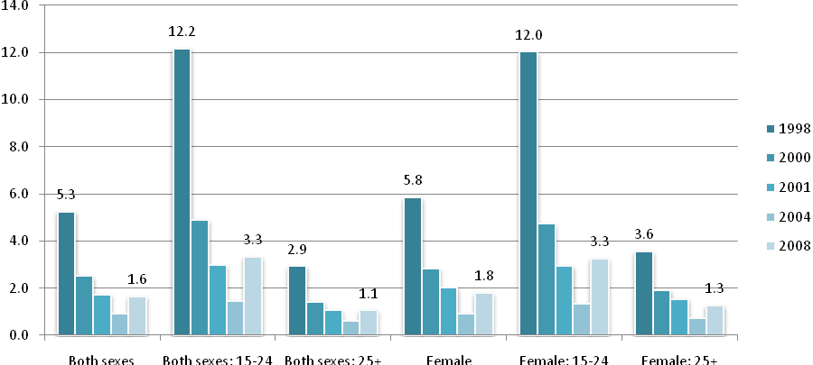
Source: NIS (2010)

Thus, we note that the unemployment rate registered in 2008 was 1.6 per cent, having decreased from 5.3 per cent in 1998. In such a scenario, reduction of “open” unemployment as a policy/development goal would be misleading. Most analysis show that low income economies actually are saddled with surplus labor, often characterized as ‘underemployment’. As is well known, in the absence of any unemployment/social insurance, there is widespread work-sharing that is reflected in low productivity and a high incidence of productivity-based estimate of unemployment. This is particularly so in the agricultural sector (and rural in general), and in the vast informal economy. The above also explains, in some measure, the obvious variance between the officially registered unemployment (1.6 per cent) and the poverty incidence (30 per cent) in the economy. One must note, though, that irrespective of the problems of estimating unemployment level, there has been a distinct decline in that level, particularly in respect of youth unemployment. One must equally note that despite a rapid decline, youth unemployment still constitutes a large proportion of the total unemployed labour force.
If the RGC were to remain focused on attaining the MDG Target 1(b) of full employment and decent work, the employment challenge would have to be framed differently. In the absence of a single alternative indicator, multiple indicators can be used to monitor employment performance. In this regard, the progress toward MDG Target 1(b) could be monitored in terms of the four suggested UN indicators. It must be noted that there are no agreed earmarking of the targets that need to be achieved, so long as there is tangible progress in each. Let us briefly review Cambodia’s current status on these indicators.
(i) Employment-population ratio: The employment to population ratio (EPR) is a widely used measure to indicate the proportion of the working age population that is employed. For Cambodia, Figure 3.2 provides the ratio, disaggregated by sex during the inter-censal period 1998-2008.
Figure 3.2 Employment-to-population ratios for workers aged 15 and older (%)
64
66
68
70
72
74
76
78
80
82
Both sexes
Male
Female
1998
2008

As Figure 3.2 shows, the EPR as a whole increased from 73 per cent to 77 per cent, during the stated period. While the gender gap declined, the female EPR was still lower than that of the males. Nevertheless, the EPR values indicate a fairly high degree of employment performance, with an employment growth rate of nearly 3.6 per cent over the decade, which is higher than the LF growth of 3.3 per cent. The trend is indicative of the declining unemployment which we observed above. The major drawback of this indicator is that while employment has grown, one is unsure of the extent to which this is productive and remunerative, and how this is linked to poverty reduction and/or vulnerability of the workforce.
(ii) Vulnerable Population: The ILO defines vulnerable population as those who are unpaid family workers and own-account workers. This, for Cambodia, yields a current (2008) vulnerable populations of 82.5 per cent, a decline from 86.8 per cent in 1998 (See Figure 3.3).
Figure 3.3 Employment status (% of employed by sex), 1998 and 2008
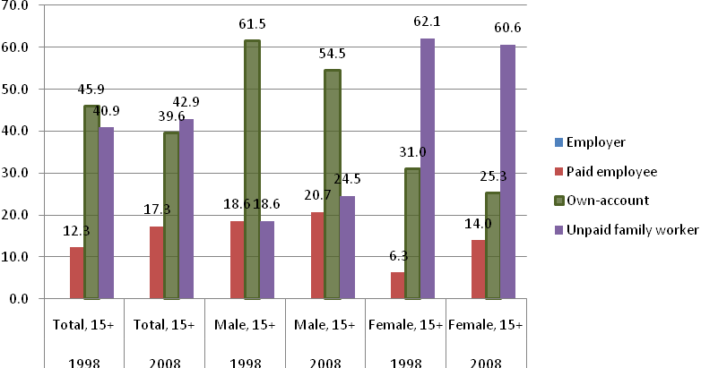
Source: NIS (2010), Table 18. Vulnerable employment = “own-account” + “unpaid family worker”.

This decline was driven by declining share of own-account workers, while the share of unpaid contributing family workers went up by 2 per cent. The latter share for women declined, though in a small measure.
Thus, while there may be reservations on the definitional accuracy of the vulnerable population, one observes a very high incidence of the group; this is curiously so despite a high EPR that we observed earlier. Vulnerability can have various dimensions: low income, low employability, low access to credit etc, as well as high insecurity, and lack of any systematic social protection or safety net. There can, of course, be vulnerability even among the paid employed categories. One comparable indicator would be their relative earnings, and in their trends, such a picture is given in Figure 3.4.

Figure 3.4 Real average daily earnings of vulnerable workers (Nov 2000 = 100), 2004-2010
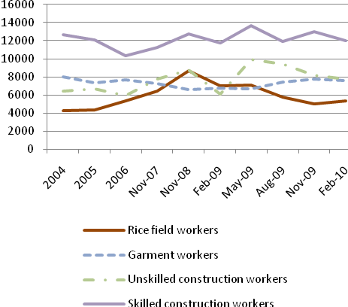 | 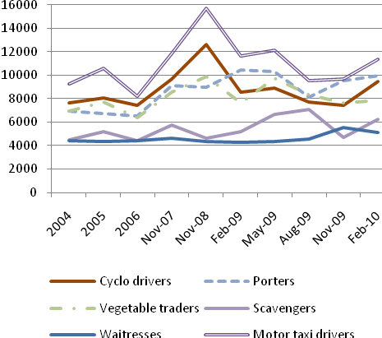
Source: Data from August 2009 onwards are from CDR Vol.14, Issue 2, Apr-Jun 2010; Data for prior periods are from CDR, Vol.13, Issue 4, Oct-Nov 2009.

As shown in the Figure above, data from purposive surveys show that the real average earnings of the vulnerable workers groups (except those in construction) declined steadily since 2008 after having risen from 2004-2007. Real earnings have declined steeply given the tangible increase in the CPI.
(iii) Working Poor: There are data difficulties in estimating the “working poor” in Cambodia. The working poor is essentially the proportion of the working population who are working normal (or more than normal) hours a day, but are unable to earn enough to cross the poverty threshold. Proper labor force and household income and expenditure surveys are required to capture the incidence of the working poor. Based on some available survey statistics, some broad indications can be collected on the working poor in Cambodia. (See Figure 3.5).

Figure 3.5 Working poor ( $1.25 a day) by education and employment status, 2004 (%)
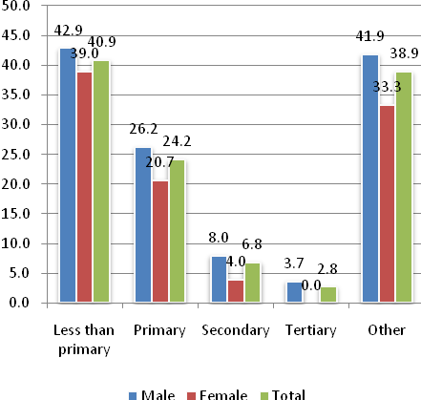 | 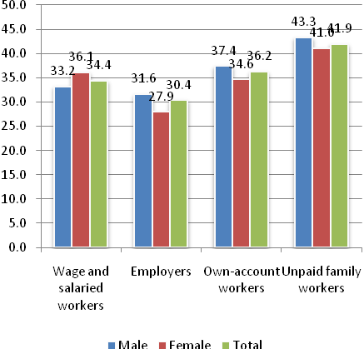
Source: EMP/TRENDS (unpublished data)

The figure provides some estimates of the working poor (i.e. at $1.25 a day), disaggregated by the education and employment status. In terms of education status, it is evident that those with less than primary education registered the highest incidence (41 per cent). Among the various employment categories, it is the own-account workers (36 per cent) and unpaid family workers (41.4 per cent) who have the highest incidence of working poor. The ‘wages and salaried workers’ category also show high proportion of working poor (34 per cent). Thus, while the generally broad definition (ILO) of vulnerable population returns an incidence of 82 per cent, more than half of that population could be characterized as working poor. Due to data limitation and definitional categories, there would evidently be certain discrepancies among estimates of ‘poverty’, ‘working poor’ and ‘vulnerable population’. Nevertheless there is no doubt that there is a high degree of slack labor, and/or lack of productive, remunerative jobs in the Cambodian economy.
(iv) Labor Productivity: Less-than-full utilization of labor and low income of labor could be seen linked to low productivity in the economy. In the case of Cambodia, the recent period during 1998-2008 has witnessed a fairly impressive rate of growth in most sectors of the economy. Labor productivity (in US dollar forms) has grown at nearly 5 per cent on aggregate (note: employment has grown at 3.6 per cent over the same period). Labor productivity has been, however, uneven among the sectors (See Table 3.1).

Table 3.1 Average annual growth rates of real value added per worker (constant Riels)., 1994-2008
 | 1994-1997 | 1998-2004 | 2005-2008 | Period average  1994-2008
Total | 1.8 | 1.6 | 6.9 | 2.9
Agriculture | -2.2 | -0.9 | 3.9 | 0.6
Manufacturing | 16.1 | -8.0 | 11.3 | 2.8
Mining | 0.0 | 6.5 | 10.5 | 7.2
Others | 8.9 | -3.4 | 5.2 | 0.9
Source: Calculated from ADB, Cambodia Economic Data

Long term productivity in agriculture (1994-2008) has been only 0.6, although during 2005-08, it has risen to 3.9. As well known, this sector, which absorbs more than two-thirds of the workface, needs to sustain a high labor-productivity in order to raise income and standards of living, and to reduce the incidence of “working poor”. This is further important in order to ensure structural transformation in the economy, through raising and mobilizing surplus in the agricultural sector. A gradual rise in wage employment, increase in wages in agriculture, and movement of labor from low-productivity to high-productivity sectors have been observed in some measure. Future growth patterns, especially in the aftermath of the crisis, will need to reinforce these developments largely through employment-friendly, productivity-enhancing growth in the economy.
The employment challenge in Cambodia, as in many developing countries, will in the foreseeable future remain somewhat ambivalent, especially when reducing unemployment (already low at 1.6 per cent), or raising employment-to-population ratio (already high at around 80 per cent) appear superfluous as policy challenges.
Regarding the four indicators of the MDG goal (target 1b) of attaining “full productive employment and decent work”, there are no set targets set in their achievements. One can only monitor progress in each. In addition to the above, a path to full, productive employment is seen to be related to the growth of paid employment and/or formal sector jobs in the economy, whether wage-based employment in agriculture and rural sectors; the modern industrial sector, or in the public sector. As historical experiences show, such formal sector job growth is a challenge that, in turn, is linked to structural transformation in the economy, and labour moving from low-productivity to high-productivity sectors. The latter would warrant a monitor of such job growth and employment elasticities in the various sectors, in as much detail as possible, which, in turn, would depend on the establishment of regular labour force surveys and related database.
In absence of a rigorous data base, and an employment monitoring framework, the current employment challenge in Cambodia would apparently rest on creating additional jobs for the unemployed labour force (1.6 per cent) and additional labour force growth (3.3 per cent). Employment growth of 3.7 per cent during 1998-2008 (NIS, 2010) was adequate to cope with the latter. One must note that this was possible when GDP growth was nearly 9 per cent. Now that GDP is projected to grow, at best, at 6 per cent over the next few years (and assuming constant employment elasticity, and labour force participation rates) employment growth will likely be around 2.2 per cent, i.e. lower than the labour force growth rate. Moreover, as we know, most of the employment is neither appropriately productive, nor remunerative, for which there is a large proportion of “working poor” (see above). The employment challenge would also need to incorporate productive employment generation for this large category of the workforce.

Labor Market Dynamics
The employment challenge can not be simply seen in terms of aggregate numbers and nominal targets. Employment generation and, hence an employment strategy, must be founded on a detailed understanding of the LM dynamics. The trends and changes in the LM performance can be seen through a number of ways. In particular, these would have reference to the status of the various disaggregated occupational groups and the quantity and the quality of employment these various groups hold. The latter, in turn, would be reflected through, inter alia, wages and earnings, their skills and education levels, mobility (physical and sectoral), nature of discrimination, income/job security and various ‘decent work’ deficits each group may face.
In Cambodia, there are a number of reports and studies which have provided reflections on various aspects of the LM dynamics. In the absence of regular survey data, such as the labor force surveys, it is difficult construct firm observations and trends. Positive LM dynamics would be seen critically in terms of the positive changes and transformation that is happening in the LM. Some of the indicators in the early stages of a country’s development would, for instance, be the extent of job growth in the formal sector; the share of wage employment in agriculture; labor productivity in various sectors, exp. among self-employed in agriculture and informal sector; movements in wages and earnings and impact in sectoral labor mobility; skills upgradation; positive changes in conditions of work. One must note that these dynamics of the LM are intricately related to the patterns of growth and structural change in the economy.
As stated above, a proper understanding of LM dynamics is critical for designing an employment strategy and LM policy. A few studies that exist provide, with caveats, some understanding of the LM dynamics in Cambodia. For instance, the following merit attention, and further investigation:
- Jobs growth in the formal sector has been quite impressive during 1998-2007, but one must note that this growth is recorded from a very small base, and limited largely to garments, construction and hotel and tourism sectors. Jobs in these sectors have already been hit hard by the global economic crisis, and public sector cannot hold much prospect for employment in the near future. Formal sector job growth, which is essential for LM transformation, needs to be much more broad-based;
- The extent of wage-employment is still very low in agriculture. The growth of agricultural productivity, which has been reasonable (3.9 per cent) in 2005-08, needs to be sustained/increased, and greater commercialization and agro-related rural industrialization would be necessary for an increase in wage employment in agriculture in particular, and rural areas in general;
- Positive movement in real wages and earnings is often seen as indicating an increasing demand for labour, and as inducing labor mobility, albeit subject to easing of skills constraints. This, too, reflects a sign of structural change in the LM, and hence the economy. In Cambodia, while some positive changes are discernible (Godfrey et al, 2001), it is too early to establish that such structural changes, esp. labor moving out of low-productivity sectors, are taking place. As we noted previously, wages and salaries (except for skilled construction workers) rose somewhat till 2008, and then deteriorated substantially.
- Physical mobility of labor is often push-induced, as distinguished from pull-induced sectoral mobility. In Cambodia, there is a high incidence of internal migration, with labor moving to more prosperous regions and centers to seek better prospects of work and income. In many instances, they end up in the informal economy, or add to non-formal forms of labor-use. International migration has increased, and so has remittances from migrant workers (see Figure 3.6). Nevertheless, international migration is still relatively small compared to that in many neighboring labor-exporting countries in the region.

Figure 3.6 Workers’ remittances, 1993-2008
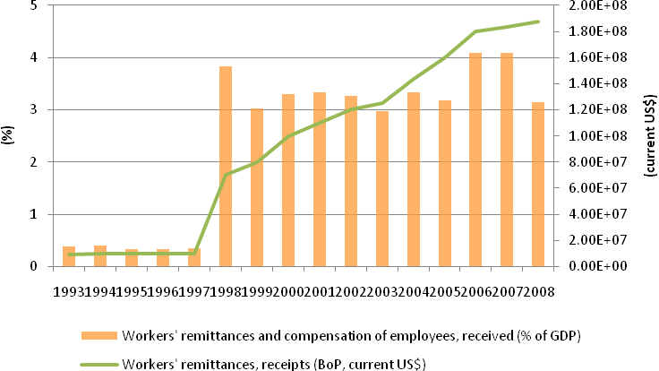
Source: WDI

- There are some specific groups in the labor market which are often faced with relatively much greater constraints to employment, e.g. women and youth. While women’s EPR, as observed earlier, has risen, they usually occupy the less-paid and low spectrum in the jobs chain. Youth unemployment, too, is relatively high, and the share of youth unemployment, though declining, was still more than 50 per cent in 2008 (see Table 3.2

Table 3.2 Share of unemployed youth in total unemployment (%)
15-24 year olds | 1998 | 2000 | 2001 | 2004 | 2008
Both sexes | 58.3 | 60.8 | 59.6 | 58.6 | 52.3
Male | 62.4 | 69.5 | 73.1 | 66.7 | 57.8
Female | 55.2 | 54.6 | 51.0 | 50.8 | 47.9
Source: NIS (2010)

- Positive LM developments are likely to be associated with not only greater earnings, but also better conditions of work and quality of jobs. Formal sector job growth, in particular, and LM tightening are likely to act as preconditions for improving the bargaining position of workers, esp. with regard to core labor standard and job/income security. Currently, social protection in Cambodia, even in formal private sector, is hardly existent, though some compensation and elements of protection may exist in some sectors of the public and private jobs.

4. Macroeconomic Policies and Employment
The role of macroeconomic policy has been a matter of intense debate especially during the 1980s and 1990s, when most developing countries were urged, often under loan conditionalities of the Bretton Woods institutions, to undertake specific measure of stabilization and liberalization as central to the design of their macroeconomic policy framework.). The overwhelming policy mindset that came to be established was that the dominant, perhaps the sole, function of macroeconomic policies was to maintain price stability (“inflation targeting” in recent terminology), and the main instrument to achieve this was the policy (interest) rate.). In order to “getting prices right”, developing countries under the influence of the Washington Consensus, were urged to maintain strict fiscal and current account discipline. Further, in order to sustain macroeconomic stability, the country’s overall debt-GDP ratio was also set as an additional anchor (usually less than 50 per cent).
A coordinated macroeconomic reforms programme in Cambodia began in all earnest during 1999-2003, embracing as done in many other developing countries, the macroeconomic orthodoxy of the Bretton Woods institution. The first reforms were, however, introduced at the time of the lifting of economic embargo in 1993. Prior to this, the country had resorted to monetary financing of its fiscal deficit that had led to hyper inflation (121 per cent in 1991). Coincidentally, this was also the period that saw the dollarization of the economy increase with the loss of public and international confidence in the local currency. The Cambodian economy still remains highly dollarized both as a medium of exchange, a store of value; more than 97 per cent of Cambodia’s bank assets are held in US dollars. While the macroeconomic performance of the Cambodian economy is often judged in terms of the expressed goals (i.e. macroeconomic stability), one needs to assess other goals of macroeconomic policy, as well as the restrictive instruments, especially under the usual constraints of a highly dollarized economy.

The conventional indicators
Up until the food and fuel price shock of 2007 and 2008, macroeconomic stability of the Cambodian economy was well sustained (see Figure 4.1).
Figure 4.1 Inflation, budget deficit and current account balance (%),
1993-2008
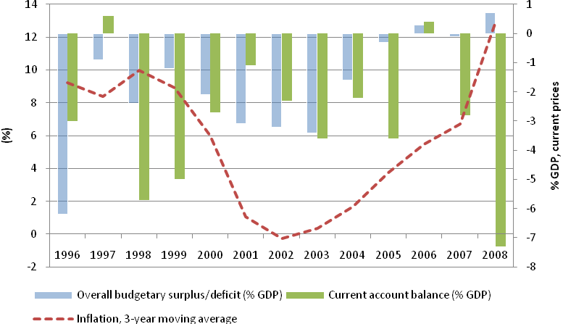
Source: Calculated from IMF 2010 for average inflation rates; ADB Cambodia Economic Data for current account balance and overall budgetary surplus/deficit.

The 3 year moving average rate of inflation, since 1999, was in the single digit (between 0 to 6 per cent). The rate rose sharply during 2007, and continued to climb (to around 19 per cent in 2009) as the global financial crisis hit the Cambodian economy, on the heels of the food-fuel crisis. Similarly, the fiscal deficit has been restrained during 1999-2007 through conservative public expenditure management, after which the budget deficit started to widen. In 2009, the impact of the global crisis necessitated a fiscal stimulus that led to a substantial budget deficit. The current account deficit which was commendably low (in fact, in surplus in 2006), also rose sharply to 12 per cent of GDP in 2009, as imports outstripped declining exports).
On balance, it would appear that orthodox stability-focused macroeconomic policies yielded reasonable price stability, esp. during 1999-2007; and fiscal deficits were contained through appropriate restraints on public expenditure; and the economy enjoyed a stable current account balance, thanks largely to the surge in exports of ready made garments. Coincidentally, as we noted earlier, this was also the period that saw the GDP of the economy growing at impressive rates, and poverty incidence falling. Indeed, there seems to be a prima facie case to argue that stabilization reforms helped Cambodia to achieve an enabling macroeconomic environment that facilitated investment and growth, and reduction of poverty.
Arguments are however emerging that while the RGC has undertaken commendable measures to sustain macroeconomic stability, growth itself has been facilitated equally by various fortuitous circumstances. Importantly, due to the financial crisis, the macroeconomic instruments hitherto used to maintain stability are under considerable strain. The rapid openness and liberalization of the economy have not been marked either by financial deepening or by institutions and regulations that could offer better resilience to the impact of the crisis. The dollarization of the economy further entailed “loss of seignorage, loss of the central bank’s ability to act as lender of the last resort and loss of independent monetary policy, all of which restrain the ability to respond to external shocks”.

Macroeconomic policy, growth and employment
The uni-dimensional approach of macroeconomic policy (i.e. maintaining price stability), as practiced within the stabilization programme, remains a risky form of Cambodia`s macroeconomic management . There needs to be a rethinking on the goals of macroeconomic policy; in particular, Cambodia’s commitment on achieving MDG target of full employment and decent work would require a macroeconomic policy framework that would need to incorporate multiple targets, the relative weight of which would depend on the country’s specific situation. The East Asian countries, during the 1970s and 1980s demonstrated such multi-dimensional perception where macroeconomic fundamentals were achieved in tandem with policy support toward savings, investment and growth, and employment generation.. There has been an increasingly strong advocacy, from various quarters, not to relegate the centrality of employment in the design of macroeconomic policy, as had been the practice prior to the onset of the Washington Consensus.
The employment objective in a macroeconomic policy design would, as stated above, need to be aligned to sustaining and enhancing aggregate demand. One significant element of aggregate demand is the I/GDP ratio, which has ranged from around 20 per cent to 24 per cent during 2003-2009 and which yielded a GDP growth of around 9 per cent. This phase of Cambodian growth may be increasingly difficult to sustain in the future (since the implicit current ICORs of around 2.3 are likely to increase) unless I/GDP expands tangibly, say, to around 28-30 per cent. What is of critical importance is that national savings ratio, as well as I/GDP ratio have been strongly buttressed by foreign sources: foreign savings was 12 per cent of GDP in 2008, while foreign investment was nearly 47 per cent of total investment in the economy. This over-dependence of I/GDP on FDIs, which declined substantially during 2009 onwards, can effect domestic private investment to follow suit. Thus, the RGC, given that FDI in the present climate may remain stagnant or even decline in the near future, projects a non-increasing I/GDP over 2009-2013 period (see Figure 4.2).

Figure 4.2 Public and private investment (% GDP), 1994-2013
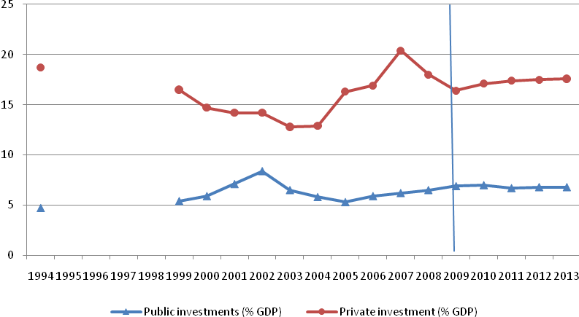
Source: As cited in NSDP update 2009-2013, tables 8 and 9. 2009 onwards are estimates and projections.

Also notable, is the non-increasing public investment which is vital for “crowding in” private investment, both domestic as well as FDI. The over-dependence of the economy, in multiple ways, on external resources, as well as the dollarization factor have created additional constraints to the “usual” functioning of macroeconomic instruments. Thus, the fiscal stance does not allow monetary financing of budget deficit; or, the NBC’s lack of appropriate control over the policy rate can create uncertainty in the investment climate. Monetary policy and inflation targeting without immediate control of the interest rate can indeed be fragile, especially when macroeconomic policy to support aggregate demand and employment would require a degree of fiscal expansion and accommodative monetary policy. Inflation and budget deficit targets are significant, but to subject the entire development strategy of investment, growth and employment to these nominal anchors may appear risky. Fiscal discipline need not be conflated with fiscal policy, and the proactive role that this instrument can play in both stabilization and growth processes.
In order to boost employment generation, a degree of fiscal space needs to be created in order to support public expenditures on infrastructure as well as social safety net programmes. There are indeed various sources through which such a fiscal space could be created. In Cambodia, currently, the dominant source appears to be ODAs, since the other options, viz. public borrowing, raising revenue and/or reprioritizing public expenditure, offer limited opportunities, at least in the short term. In order to create greater self-reliance to meet the challenges of fiscal deficit, and to enhance the fiscal space a degree of autarky would need to evolve in macroeconomic management of the economy (also see section 7).
The basic impasse in respect of the current macroeconomic management lies with the following: i) the limited role of the NBC with regard to monetary policy, especially with regard to its lack of control over the policy rates; ii) attempts at “inflation targeting” at less than 5 per cent are currently being done, not through controlling rates of interest, but largely through controlling money supply via buying and selling of US dollars; iii) given dollarization of the economy public expenditure is restrained, and fiscal deficits have often been met through donor support; iv) with the recent weakening of the dollar, especially in the aftermath of quantitative easing in the US, the current account is under severe strain as import costs have risen. Thus, in effect, the crisis has not only exposed the vulnerability of the economy, and its growth potential, but also the vulnerability of the macroeconomic management of the economy. Macroeconomic policy framework would need to be further reviewed, both with regard to the goals as well as the policy instruments, for a more robust approach to longer term growth and structural change.

5. Sectoral Policies and Structural Change
The rapid growth of the Cambodian economy since the late 1990s, and which accelerated during the global boom period of 2002-2007, brought in tangible changes to the sectoral shares in GDP. In particular, the industry sector grew at a rapid rate, thanks to the burgeoning exports of RMG, which saw the sector’s share rise from around 12.6 per cent of GDP in 1993 to about 25 per cent in 2007. The share of the services sector remained surprisingly static around 39 per cent over 1994-2008. As one would expect during an economy’s structural change, the agriculture sector declined; from about 43 per cent of GDP in 1998 to around 27 per cent in 2008 (see Figure 2.5).
The experience of the developed and emerging economics of East and South-east Asia, varied as they are, had nevertheless broadly conformed to the time-honoured development model, which underscored the necessity of bringing about structural changes to enhance the living conditions of the people. As well known, at the heart of such structural change, lies the increasing growth of the modern sector, led by increasing industrialization. The Lewisian development model largely underpins this strategy, where as one observed in the early stages of the successful Asian countries, industrial share (in particular that of manufacturing) rose from a bare 10-15 per cent nearly 30 per cent or more of GDP. What is equally critical to the process of structural change, is the shift of labour from low-productivity agriculture to high-productivity manufacturing sector. In other words, the sectoral shares in total employment change in favour of the latter. Manufacturing sector’s share in total employment, in many of the East Asian economics rose to nearly 25-30 per cent; and more in some cases. This structural transformation was characterized by the following:
- Labour productivity in industrial sector grew at a faster rate than that in agriculture;
- Agriculture productivity also rose, and played a significant role in the enhancing output surplus, employment and exports; value added per worker in agriculture grew faster than labour force growth rate;
- Employment elasticity of manufacturing was relatively high, and which allowed a high rate of labour absorption in the modern sector.
In Cambodia, the following two Figures show the growth rates of the broad sectors of the economy, and that of the value-added per worker (proxying labour productivity).
Figure 5.1 Sectoral pattern of growth (%), 1998-2008
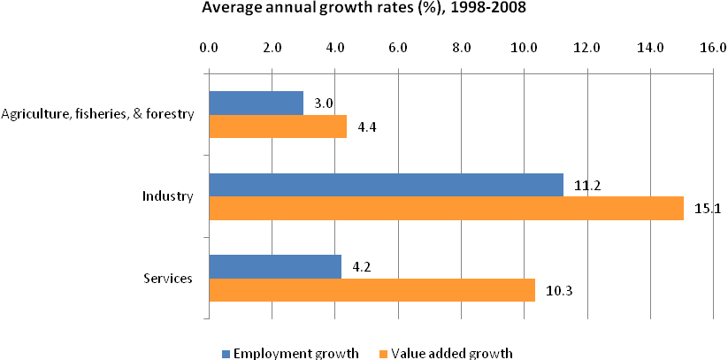
Source: Calculated from NIS (2010); NIS, Statistical Yearbook 2005; NIS 2008 National Accounts data published at http://www.nis.gov.kh/index.php/statistics/national-accounts

Figure 5.2 Value added per worker, 1993-2008 (constant Riels)
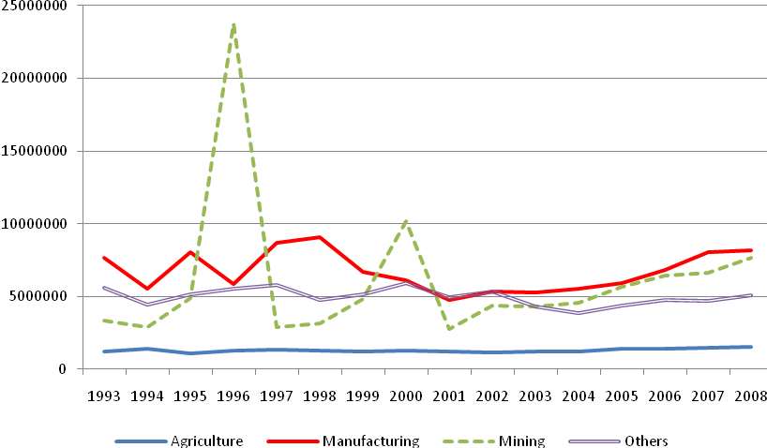
Source: Calculated from ADB, Cambodia Economic Data.

From the two Figures we observe that the three broad sectors have registered fairly rapid growth rates during the decade 1998-2008. Employment generation has also been quite tangible, with industry sector employment growing relatively faster than that in the other sector. These are, in some measure, indicative of a process of change. However, labour productivity growth in the three sectors has been uneven, and has slowed down in the post-crisis period. More significantly, the rapid growth of the sector has emanated from a rather low base; hence the need to sustain high growth rates to effect real structural change. The slow shifts in sectoral shares in total employment would denote the limited nature of structural transformation in the Cambodian economy. A further consideration in this regard is that although employment appears to have increased across all sectors, it is difficult to ascertain how remunerative such employment has been. In other words, much of the employment generation could have simply been in the informal economy, and in low-productivity, low-income sub-sectors. By contrast, one (proxy) indicator of productive/remunerative employment is the growth in formal sector jobs, such as those in the public sector employment, and in the modern private sectors. Here too, one has to distinguish the casual, temporary and/or subcontracted workers from the full-time formal workers.
In short, the Cambodian economy has, through rapid growth, undergone tangible changes in the sectoral shares in GDP. However, in terms of sectoral shares in the employment, the structural changes have been much more limited. Bulk of the workforce is still in the agriculture and rural sector, which, not surprisingly, also contains the bulk of the poor in the economy.

Agriculture and rural development
The bulk of the workforce in Cambodia is still dependent on the agriculture sector, which is characterized by peasant farming with many subsisting on small farm plots. The dominant product is rice, though its share in the sector’s value-added has been declining. Fisheries and livestock have reasonably significant contribution in the country’s GDP. One must note that alongside subsistence agriculture, there is also the existence of commercial farming, and commercial logging which not only contribute to the sector’s share in GDP, but is an important source of exports and foreign exchange earnings.
Agriculture sector contributes nearly 27 per cent to the country’s GDP, and to more than 72 per cent of the total employment. Agriculture (including forestry) contributes significantly to export earnings. In 2007, Cambodia produced nearly 6 million tons of rice; this not only allows Cambodia to be self-sufficient, but also to export a sizable marketable surplus (nearly 2 million tons). Although agriculture sector has grown in recent periods, productivity is still relatively low compared to the other Asian countries (see figure 5.3).
Figure 5.3 Value of crop production per hectare, Cambodia and other Asian countries
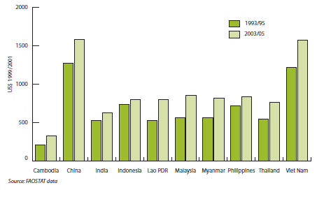
Source: UNDP (2010)
The lessons from the early stages of structural transformation in the East Asian countries tell us that growth and productivity in agriculture have helped these countries to attain marketable surplus, offer greater employment opportunities, and ease potential “wage-goods” constraints that can arise out of increased wages and incomes. In these countries, there was an increasing use of labour per hectare of land, which was consistent with an increasing output and labour productivity. Analysts attribute this success to the agrarian structure and institutional framework that was developed. The twin emphasis was on egalitarian structure of production (notably through land reforms), and the use of labour-intensive technology (e.g. community-based irrigation and construction activities) facilitated an increase in labour absorption in agriculture.
Cambodia’s true comparative advantage, at this stage of structural change, perhaps lies in land-intensive production, employment and exports. In Cambodian agriculture, the potential for raising productivity and absorption of labour (i.e. fuller utilization of labour and capacity) is vast. Both through the development of small-holder farming and through commercial large-scale farming (including forestry and plantations), Cambodian agriculture can invigorate productivity, and mobilize resources for financing growth. There are, of course, several constraints and issues that need to be addressed to realize such potential. At the present situation, mono-crop cultivation, e.g. rice, is still predominant. Multiple cropping, high-yielding varieties of crops, and diversification towards higher value-added crops would significantly enhance productivity as well as utilization of labour. This would, in turn, require, dedicated public policy and expenditure on expansion of irrigation and facilitation of access to inputs, technology and resources. Institutionally, security of tenure, easing of access to credit as well as to training and extension services need to be ensured.
Through increasing productivity and labour utilization, agriculture growth can be seen as land-augmenting and employment maximizing. This is also likely to lead to increase wages, and wage-based employment, which in many Asian countries, were seen as the early signs of structural change. Agricultural growth has also generated demand in other sectors, especially, off-farm, rural enterprises, that further helped wages and incomes to increase among the rural population and to reduce rural poverty.
Part of Cambodian agriculture is already commercial, and given rising commodity prices, agriculture stands to exploit its export and commercial potential. This would require appropriate incentive structures and facilities, such as inducing domestic investment, in addition to FDIs that are likely in large-scale commercial farming, plantation and logging. Imparting and enhancing skills, introducing technology and improving transport and physical infrastructure would be essential in further commercialization of agriculture. Indeed, appropriate public measures would be needed to ensure that Cambodia does not become ‘food insecure’ in the process of its commercialization. The recent rice price support programme to stabilize prices is an important step towards ensuring stability in farm incomes.
In the post-crisis period, the RGC has placed a distinct emphasis on agricultural and rural development. This is broadly seen in the NSDP Update 2009-2013, which has placed highest priority to reducing poverty in rural areas. Various policies and resources have been directed toward raising the productivity, employment and livelihood of the rural people, and in reducing disparities in rural living standards. The crucial test will lie in the implementation of these planned policies and programmes, and in ensuring the institutional framework that would be necessary for the success of this strategy.

Industrialization and Trade Policy: Enhancing the Job Generation Potential

In Cambodia, the development planning period 2004-2008 that pursued the Rectangular Strategy, has been dubbed by the country’s policy planners as “the economic take-off phase”. In the economic literature and empirical work, a country’s take-off phase has often been linked to the process of industrialization taking roots, and its contribution to GDP and employment increasing on a sustained basis. Such a process has indeed been recorded in the experiences of many East and South-east Asian economics during the 1970s and 1980s. In contrast, during the same period there have also been cases where a strong industrialization drive ended in a “frustrated” take-off; and the manufacturing sector, which was expected to generate a tangible proportion of jobs, failed to contribute to the much-needed job generation process. Pakistan, during the 1970s, is a case in point.
The varying experiences of industrialization success and frustrated take-off have been widely debated, and often linked to export-orientation of industrialization. In short, success has been often attributed to export-led labour-intensive industrialization of East Asia; whereas ‘frustrated’ take-off in Pakistan has often been linked to the country’s faulty import substitution strategy. The dichotomy is not always that simple, and there are many other policy considerations that relate to individual country experiences.
The “economic take-off phase” (i.e. 2004-2008) in Cambodia can apparently be seen as following the East Asian strategy of export-led, labour-intensive industrialization. In fact, the liberalization reforms that started in the late 1990s, and various incentive structures opened up the prospects of such a strategy. In fact, the industrial growth since the then has been rapid, and grew at nearly 14 per cent in the recent period, and its share in the total GDP increased from a low of 12 per cent in 1993 to around 25 per cent in 2007. The chief contributor in this industrial growth has been the garments and textiles sector. Garment production grew at a spectacular pace; enterprises in this sector increased from 53 to 398, and exports increased from a mere US$ 2.8 billion during the period 1995-2007. Jobs, largely unskilled and semi-skilled, also increased accounting for nearly 350 thousand workers, mostly women (see figure 5.4).
Figure 5.4 Employment, Investment and Enterprise growth in the Textile Industry 1995-2003
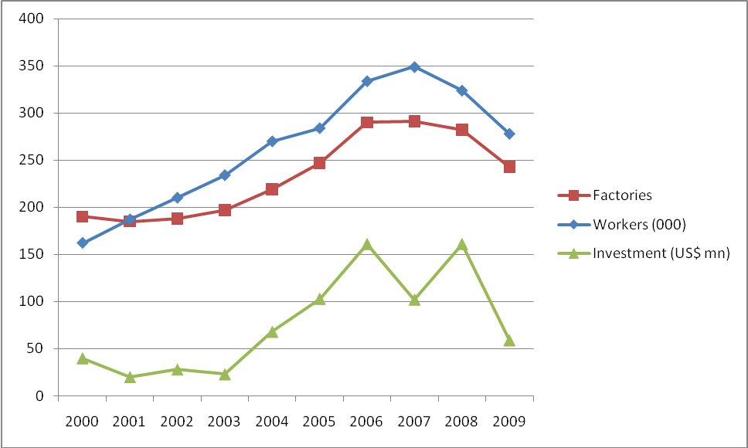
Source: HANG Chuon Naron, Cambodian Economy: Charting the Course of a Brighter Future, 2009
It is fairly well-known that the meteoric growth of the garments sector in Cambodia has been an outcome of the generous incentive structure, the liberalization reforms and is closely linked to the MFN and GSP status given to the country by the US during the mid-1990s. The industrial growth strategy, with an over-reliance on the garments sub-sector, has come under scrutiny especially after the global economic crisis hit badly the garments sector. There was an over-concentration in the product-export basket, and in the export market. Moreover, the favourable circumstances, such as the MFN and GSP status, no longer exist. Hence, as many analysts have pointed out Cambodia, in order to revive and invigorate the garments industry could no longer depend on provisions and preferences but would require to review various factors that could enhance productivity and competitiveness. A WB/ILO study has investigated into some of these issues, and has concluded that bulk of the enterprises in the Cambodian garments industry are less productive and competitive by international standards; and the root causes lie in the lack of appropriate training and management competitiveness. While there is ample scope to revive and expand the garments sector, and increase employment, there are analysts who suggest that industrial expansion in the Cambodian economy, and a sustainable recovery would require much deeper review of the overall industrialization and trade policy. The garments industry which grew through an overdose of policy and resource redirection in this sector, could provide appropriate lessons, and the basis of a renewed trade and industrialization policy.
One needs to acknowledge that the rapid growth of the garments industry has had several positive outcomes for the economy especially in generating a larger number of formal sector jobs, and foreign exchange earnings. There have been some weaknesses too in the process of its development, some of which have been exposed by the impact of the global economic crisis. Some of these limitations have been highlighted by various analysts. One would need to formulate a forward-looking industrialization and trade policy that would not only address these weaknesses, but also support the overall development strategy as enunciated in the NSDP Update. In this very context, the following policy considerations may merit attention:
- At the broad policy level, Cambodia would need to re-think its industrialization strategy in a manner that truly reflects its comparative advantage, and relative factor endowments and prices. In this context, labour-based technology and export-led industrialization would presumably continue to define the country’s comparative advantage. This, however, need not be interpreted as condemning the prospects of the country’s industrial growth to simply low, labour-costs manufacturing; i.e. garment sector, has so far been characterized by relatively low productivity and efficiency. While the future policy framework would need to underscore measures to encourage relatively greater labour-intensity in industrial production, i.e. for greater labour absorption, there must equally be considerations of how the sector must enhance productivity and higher skills competitiveness.
- One major factor behind the relatively low productivity is the lack of appropriate training, entrepreneurial drive and management skills in the garments sector. In particular, there is a dearth of skilled workers and mid-level management skills among the workforce engaged in the sector, for which foreign skills have been ‘imported’. This brings into question the concept of comparative advantage, and how far it is served, especially in an economy-wide sense, of low-skilled, low-income enterprises. Moreover, the movement of labour from unskilled sector, as in agriculture or rural non-form activities to unskilled and low-productivity work in manufacturing will not do much to pace up structural transformation in the economy. A greater attention to upgrading and utilization of higher skills would facilitate a reinforcement of the country’s comparative advantage.
- The bulk of the garments industry has been set up through foreign resources and investment. While this has been catalytic in the growth of the sector, domestic investment and entrepreneurship have lagged behind. In similarly placed economies, which have a dominant garments sector, as in Bangladesh, there has been a strong growth of domestic private investment and skills use in the sector. In order to reduce an over-reliance on foreign investors, and potential vulnerability it is imperative to build up an incentive structure to bolster domestic investment, not just in garments, but in all other potential sub-sectors in the future. There is thus a need to develop a systematic climate and culture of entrepreneurship in the country. In this regard, the incentive structure to the foreign and domestic investors need to be reviewed in a comparative framework.
- Particular attention would be needed to develop the productivity and employment potential of the SME sector. The SME sector currently accounts for 65 per cent of Cambodia’s GDP, and 85 per cent of the industrial sector employment. Many SME enterprises that have grown in recent years to support the growth industries in textiles, construction and services, have been hit by the recent economic downturn. To ease constraints of access to credit facilities, training, lack of entrepreneurial skills, and quality of products, the RGC would need to design specific public policy and investment.
- An industrialization strategy would need to be broad-based, whether or not labour-based and export-oriented. This can be pursued even if the country were to follow a ‘lead sector’ approach. This implies that industrial development needs to be more diversified, especially in order to avoid reliance on one or two industries, as currently exists, for major export earnings. Simply, the manufactured exports cannot be diversified unless the industrial production is diversified. Moreover, historically, Cambodia’s garment exports have been marketed overwhelmingly to only two or three destinations, viz. to the US and EU markets. This can be highly risky as has been seen during the recent global economic crisis, and hence the need to search for market diversification.
Table 5.1 Markets for Cambodian garments
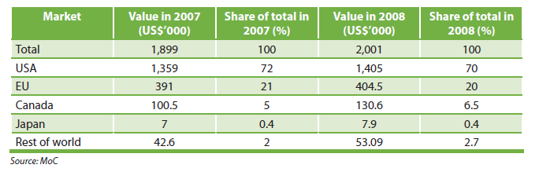
- Cambodia would need to put in place and/or strengthen appropriate institutions and regulatory framework consistent with policy and programme interventions. This would include, among others, the need to streamline financial reforms, tax reforms and industrial relations machinery in order to facilitate smoother performance in the industrial sector and to ensure fundamental rights at work. One must note that investment, foreign or domestic, would tend to increase, and be stable, when not only the macro-fundamentals are right, but also on how industrial peace is enforced.

As indicated earlier, the Cambodian policy planners are showing increasing awareness of the need to review its development strategy given the observed vulnerability of the economy, and reliance on external world for markets and investment that is driving the current industrialization process. The need to attach high priority to poverty alleviation, to make the economy skills competitive, and to seek greater linkages between agriculture, industry and the export sector are gradually being crystallized. The following actions which are being proposed and/or underway would attest to the changing industrial development paradigm in Cambodia.
- Greater emphasis is being planned to develop small and medium enterprises (SMEs); review is being undertaken to ease constraints to SME development, in particular, access to capital and finance; entrepreneurial skills development; improving quality of products through appropriate technology;
- In respect of reforms toward attracting FDI, especially in infrastructure, measures are being articulated to encourage the big business to support SMEs in related activities;
- As part of the decentralization process, greater provincial autonomy is envisaged to encourage local investment and mobilize resources;
- Steps are afoot to resolve the apparent paradoxical situation where banks have surplus deposits, and SMEs and microfinance are liquidity-constrained. A ‘no collateral’ strategy for small and MFI loans is envisaged.
Policy measures, such as above, would encourage SMEs, and boost domestic investment and development of local entrepreneurs. These are also sectors that would help to generate employment and incomes, both in urban centres as well as in the provinces.

Employment in other sectors: construction and services
The RGC has accorded a significant weight to the construction sector, especially during the rehabilation and reconstruction phases of the economy, both in order to support growth, as well as to generate jobs. Historically, the construction sector is usually seen as the lead sector at early stages of an economy in order to combat the mass unemployment that usually exists at that time. The potential of the sector arises from its ability to absorb relatively higher doses of labour, and often with little imported materials, as well as from the sector’s strong backward and forward linkages. It must be noted in this context that as in most industrial sectors, construction sector is also characterized by ‘dualism’ with the coexistence of modern and traditional technologies (and the relative use of skilled labour) defining the dualism. Construction sector generally, however, is known to have a greater labour absorption potential than many other industrial subsectors.
In Cambodia, construction sector has grown at a rapid pace, averaging around 13 per cent during 1994-2007, having reached a peak of 20 per cent during a boom that occurred during the 2002-2007, in view of both infrastructural growth as well as residential construction, especially around Phnom Penh and Siem Reap.
The growth of the sector has, however, slowed down considerably since 2008 as the economy was hit by the global crisis. As observed historically, construction booms do have a tendency to end or slow down rather abruptly, with adverse consequences on the levels of employment.
Up until the economic downturn in 2008, the construction sector have played a significant role in the country’s GDP growth. Labour productivity grew at more than 3 per cent during the past decade. Wages in the sector rose tangibly, both for skilled and unskilled workers (see Table 5.2) shows the absolute increase of construction workers by age groups. It may be noted that although female participation almost doubled over the decade, it was still only around 13 per cent out of employment in the sector. Nevertheless, employment overall in the sector has grown considerably.
Table 5.2 Employment in Construction (1998-2008) by age groups
Age Groups | 1998 | 2008
15+ | 44,946 | 140,104
15-24 | 11,579 | 50,438
24+ | 33,367 | 89,666
Source: NIS Labour and Social Trends, 2010 (Appendix)
The short-term volatility of growth and employment in construction is closely linked with the economic performance, i.e. the booms and busts of the economy and the other sectors. Nevertheless, given the sector’s potential for employment generation, it is important to seek to enhance labour absorption through measures that could impart some stability in the sector. Public interventions, to the extent permissible, may be used to introduce infrastructure programmes, especially in the rural areas where the workforce that is relatively hit hard by recessions, can find income cushions.
Similarly, incentives may be designed to encourage private investment through, say, review of pricing imports and inputs, since input prices in the sector have gone up considerably. In the medium term, the RGC would need to review the growth and employment potential of the sector, and develop local capabilities for production of materials and inputs. Further, as observed in many other Asian countries, a long-term low-cost housing policy may be instituted that would have a built-in “stabilizing” effect on the sector to sustain employment in the economy.

Services Sector Employment
The services sector in Cambodia accounts for about two-fifths of the country’s GDP, and about 20 per cent of the total employed workforce. There is thus a non-correspondence between the sector’s share in GDP, and its share in employment, implying an overall low productivity in the sector. The growth of the employment has been slower than that of the sector’s value added. The sector, on aggregate, has grown at nearly 8.6 per cent during 1994-2007, much of the growth being powered by the boom in hotel and tourism, transport and communications, banking, financial services and real estate.
The employment size of the services sector in many countries is often quite high, sometimes more than twice that in Cambodia. However, in the developing countries, employment in the sector is largely characterized by own-account work and self-employment in informal trades, retail services. A proliferation of such informal employment in the tertiary sector is often interpreted as reflection of lack of job opportunities in manufacturing and the modern services sector. In Cambodia tertiary employment is still relatively small, and much of the modern services employment has been on account of a reasonable job generation in the hotel and tourism sector. The growth of tourism has been particularly rapid since 2003. (See Figure 5.5)

Figure 5.5 Investment in hotel and restaurant (in million USD)
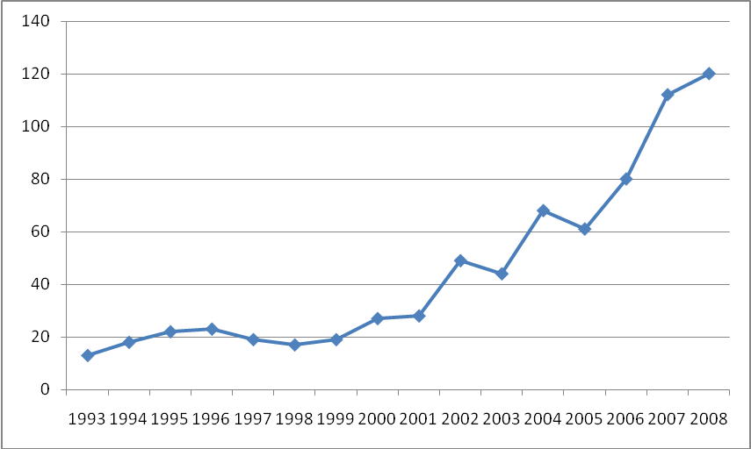
Source: HANG Chuon Naron, Cambodian Economy: Charting the Course of a Brighter Future, 2009
The tourism and hotel industry was hit badly during the recent crisis, and slowed down considerably during the last quarter of 2008. Thus, this tertiary sub-sector witnessed a substantial loss in jobs and a worsening of job conditions, such as wage declines and casualization of the workforce.
The potential of employment generation in services sector will, in the future, enormously depend on overall growth in other sectors, as well as policies and public support toward the development and diversification of the sector. For instance, hotel and tourism, which will continue to be a dominant contributor to GDP and employment, would require greater promotion, incentives and resources in order to improve its performance, irrespective of the sector’s vulnerability to crisis and external shocks.
As regards the informal services sector, the employment size is relatively small and the productive employment potential is in commerce, transport, repair and retail trades. These are important activities for the growth of the economy, and can contribute to rising production and income with relatively low inputs of capital per person employed. In order to enhance productivity in the sector, training, access to credit and appropriate technology, infrastructure and technical advice and support would need to be stepped up.

6. Labour Market Policies: Selected Issues
The previous two sections have discussed various policy issues related to generating labour demand in the economy. Employment performance would, however, depend on not only how much labour demand is generated but also on how far labour and skills are in supply, as well as on how far the supply-demand exchange is mediated without much ‘frictions’. Most of these issues are usually addressed through well-articulated labour market policies, that range from a labour regulatory framework skills, development and employability, to specific public interventions to promote employment.

Employability and skills development
Cambodia, like many developing countries, faces several constraints to building an appropriate social infrastructure, a critical one being the skills of its labour force. In the absence of a comprehensive skills map, and appropriate data, it is also difficult to make precise policy judgements on the extent and direction of skills development required to ensure its employability.
There are a few studies that have dealt with various, but general, aspects of the skills picture; some have dealt with specific groups (such as youth, women); some have reflected on sectoral skills use and requirements. The MOLVT, through its STVET programme, is trying to assess both non-formal training needs in at least 7 provinces, as well as for selected trades in the formal sector (especially construction, mechanic/technicians, IT and tourism).
Although the skills map is nowhere near comprehensive, there is enough evidence to suggest that the bulk of the country’s labour is unskilled; that the school enrolment and returns to education is low; that there is an overall skills mismatch between supply and demand in various sectors; that the skills situation is particularly acute among youth and women. A WB study estimate nearly “63 per cent of Cambodia’s youth have either never attended school or left school before completing basic education”.
One must note, however, that despite the above weaknesses in the human resources development, there has been quite substantial progress, especially in access to education (note: primary level enrolment), as well as growth in formal and non-formal training providers. The number of graduates has been increasing over the past 15 years, but also there is a high incidence of unemployment among the educated, largely owing to mismatches between orientation of graduate skills and employers’ skills requirement. The concern of the employers is captured in the following sectoral survey-based figure.
Figure 6.1 Percentage of firms that identify a skill mismatch between employers’ demands and vocational training institution offer

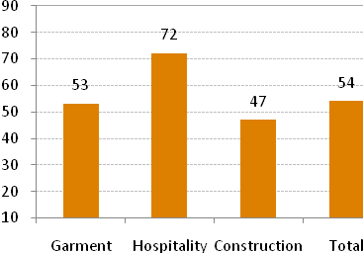
Source : World Bank
In order to enhance the skills profile, and turn the largely unskilled labour force into productive assets with skills competitiveness in international markets, Cambodia will need to devote considerable attention to human resources development. Given limited resources, there will be controversy and debate on how best to promote human resources, and what the relative costs-benefits are of various programmes. For instance, there needs to be a careful review how the government’s resources, and its policies and incentives be structured with respect to the pressing needs of the job market as well as the expectations of youth regarding the future of labour markets. The latter will depend, not just on supply of skills, but also on the much-needed diversification of the economy. In other words, supply and demand for skills need to be seen as a continuous process, and skills restructuring will depend to a large extent on the structural transformation that is likely, as well as the income and incentive structure that evolve to support labour mobility.
At the current state of skills supply and demand, it appears that a high rate of youth unemployment among school and university graduates (will liberal arts orientation) coexist with an undersupply of technical and vocational skills. Quite in line with this situation, the RGC, through the MOLVT, has embarked on a concerted programme toward enhancing such vocational and technical skills for various sectors, not only in the urban but also in rural areas. In fact, such training is being expanded on a two-track basis: for non-formal and formal sectors. In the rural areas, the focus is on skills needs of both agriculture (e.g. rice milling) and non-agricultural occupations (e.g. repairs), with emphasis on increase in productivity through use of newer technology, and on various commercial farming. Women’s participation is being encouraged, though concerted actions will be required to overcome cultural and other barriers to pull them out of unpaid family work.
While measures would have to be devised to redress the entrenched skills mismatches, both through the supply side (resources, programmes and incentive) and demand side (economic restructuring), there needs to be concerted attention toward Cambodianition of skills in the existing formal sector job market. Mid-level skilled workers and management skills are currently being “imported” to run the formal sector industries, viz. garments, construction, hotel and tourism. The development of such skills requires urgent attention. Also the development of entrepreneurs and increasing the management ability of broad layers of small entrepreneurs (men and women), and an increase in government and private training agencies could make a significant contribution to expanding the employment potential of small and medium-sized enterprises.

Labour Migration
International labour migration as a means to “promote” employment is not yet a mainstreamed instrument within the development planning framework of Cambodia. Cambodia is also a country which sends workers abroad as well as receives workers (e.g. from Vietnam). Unlike many other labour-exporting Asian countries (such as the Phillippines, Pakistan), Cambodia is yet to formulate a national policy guideline on international migration. Information and statistics on workers going abroad are patchy, and are beginning to be crystallized. The institutional mechanism for the governance of migration, as exists in many labour-sending countries of Asia, has to evolve if Cambodia were to pursue a programme of sending its workers abroad.
The number of migrant workers is somewhat uncertain since much of Cambodia’s migration is especially to Thailand. Following an MOU between the two countries, an estimated 110,000 Cambodians obtained work permits, though the registered official figure of migrant workers in Thailand is shown as 8,231. It is quite likely that given large physical movement of persons, especially youth, from amongst the poor and vulnerable households and regions, there would be a propensity to move across borders in order to move out of poverty. There is also an increasing tendency for Cambodians to work in Malaysia and South Korea. Although precise numbers of workers are difficult to come by, a more reliable statistics come from figures on remittances, which has grown to around a sizable $325 million, or 3.5 per cent of GDP. Further, women constitute a tangible proportion (nearly 47 per cent) of migration to Thailand; but this too is not fully documented as women’s migration is often clandestine. Female workers are reported to engage largely as domestic help, in grocery stores and entertainment business.
The MOLVT has recently set up a specific unit to oversee the management of international migration, given its rising importance and contributions to the economy. Nevertheless, a first step would be to design a national policy on migration, an institutional mechanism to promote migration and protect migrant workers, provide essential skills and training to be able to adapt to changing skills needs of labour-receiving countries, and provide adequate attention to returning workers.

A Labour Policy
An articulation of labour policy is an integral element of an employment generation and labour protection strategy. It usually contains legal and promotional intrsuments that would (i) facilitate the smooth functioning of the labour market with a focus on employment, and on development of skills of the workforce as a competitive and productive asset; (ii) safeguard and protect fundamental rights at work. Both are purported to promote decent work. The former, further, requires the establishment of guidelines, institutions, and programmes to promote a number of policies, including passive and active labour market policies (ALMPs). The latter is often based on a consensual Labour Law that provides legal guidelines for the protection of workers’ and employers’ rights, and a basis for negotiations and social dialogue. A well-designed labour policy is all the more necessary when an economy is on a transition path toward market-based principles, and the private sector is being encouraged to emerge as the dominant source of job generation.
In Cambodia, the Labour Code enacted in 1997 provides fundamentally the labour regulatory framework, which is further reinforced by a number of decrees (prakas). The regulatory framework provides legal guidelines for protection of workers’ ad employers’ rights in workplace; in particular these relate to guidelines on workers’ right to form trade unions; labour rights (e.g. right to strike); collective bargaining; working conditions; and provisions toward dispute settlement. As earlier stated, Cambodia has been on a transition to a market economy, and institution-building towards that end is on-going. The practice of collective bargaining agreements (CBAs) and dispute resolution would require time and strengthening of capacity to be fully functioning. Nevertheless, it is encouraging to note that the regulatory framework is taking roots, and its implementation being enforced. For instance, CBAs has increased tangibly, from around 45 during 2003-2006 to a reportedly 131 in 2009. Similarly, settlement of labour disputes is also being regularized, with MOLVT’s Department of Labour Disputes and arbitration council being strengthened.
An effective conduct of the labour regulatory framework also requires the strengthening and capacity building of workers’ and employers’ organizations, and a regular institutionalizing of training, and an objective exposure to the critical issues of the economy in general, and to issues of labour market in particular. In many ways, the functioning of workers groups is perhaps handicapped not by lack of unions but rather by the existence of too many. There are an estimated 1725 cumulatively registered unions, within the framework of 42 federations and 5 confederations. Thus, there is a likelihood that there would exist differences in opinion and on weights placed on national priorities, and overall interests of workers. The employers on the other hand articulate their voice through the Cambodian Federation of Employers and Business Associations (CAMFEBA), with a dominant presence of the Garments Manufacturing Association of Cambodia (GMAC).
There are indeed substantial differences in opinion between the two groups on several matters regarding implementation of rights at workplace. For instance, CAMFEBA is resentful of hikes in minimum wages and extension of social security provisions since these may lead to Cambodia losing its international competitiveness. The workers groups, on the other hand would wish to press home higher wages in line with productivity, and better working conditions. It may be noted that Cambodia, the garments sector in particular, is acclaimed internationally to have high labour standards. While this has worked to the advantage of Cambodian exports till recently, the global economic crisis has not only hit garment exports, but has also exposed various weaknesses of the sector, in particular its productivity, efficiency and skills competitiveness. Both the workers and employers groups agree on supporting and enhancing the export potential of the garments, and other sectors. This is where honouring the regulatory framework, through objective assessment and training of workers and employers, would play a significant role towards enhancing productivity in enterprises, and security of workers.
Labour laws and labour protection measures, and their implementation would need to be reviewed as the economy grows and diversifies. It needs to be observed that the regulatory framework is only limited to formal private and public sector jobs, which is a small proportion of the total workforce. Even here, unless appropriately implemented, labour laws can contribute to labour market segmentation, and to reducing the labour-absorptive capacity of the organized sector. There may be an increasing tendency for such firms to subcontract part of their production to informal sector or casual labour, thus reducing average levels of pay and protection in the labour market, and distributing wages and and job security more unevenly. There also needs to be a careful review of how informal sector workers can have better protection and working conditions than at present exist.
A labour regulatory framework also needs to ensure that there is no discrimination, or abuse of labour in the labour market. Indeed, Cambodia has ratified all the core Conventions of the ILO. It needs not only to enforce the legal framework but also to design and implement programmes towards non-discrimination and protection, in particular to reduce incidence of child labour, and to advance the skills, employability of women in higher productivity, remunerative job market. Child labour, for instance, has, despite public policy has increased during 1998-2008.Working children between the age of 5-17 years have increased from 8 per cent of the workforce to around 10 per cent. This is disconcerting, and appropriate research and measures need to be undertaken to reduce the incidence of child labour. Currently, the focus of public attention is on eliminating the worst forms of child labour, and on stemming the trafficking of children.
Apart from the regulatory framework, the government’s overall labour policy need to contain a strengthened approach to developing the skills of the workforce, and to avoiding discrimination in the labour market. At the risk of repetition, it is widely observed that the bulk of the workforce is unskilled, poorly educated, hence relatively of poor quality compared to its Asian neighbours. We have also observed, that if Cambodia were to pursue a labour-intensive, export-oriented development strategy, its comparative advantage would lie in extending its skills competitiveness and diversification, and not simply on low-labour costs. At present, the dominant export sector, i.e. garments, has a disproportionate presence of unskilled production workers, and very little among production supervisors and managers. It must also be noted that unskilled workers constitute a major proportion of the workforce in agriculture, as well as among the migrant workers. An aggressive stance on better quality education and skills programmes would be a high priority in the design of a labour policy in Cambodia.
Apart from skills interventions, a labour policy would need to articulate an active LM policy (ALMPs) although various elements of it exist to differing extent. The public employment services a critical cornerstone of ALMPs are beginning to be crystallized and expanded under the authority of the National Employment Agency (NEA). The two important functions that NEA is entrusted with would require budget support and capacity building; these are expansion of employment services (both through on-line and job centre), and the instituting of LMIS, which is vital for monitoring employment and LM performance of the economy. NEA will also need to link up with training schemes, both public and private, and gradually extend beyond urban centres. Cambodia also has a large number of employment interventions scheme, such as public works programmes etc., which would need to be incorporated in a full-scheme of ALMPs. Special attention needs to be given to the more disadvantaged groups, such as women, youth and the workers with disability.

7. Social Protection and Employment
Social protection policies and policies towards the goal of full employment must be seen as critically inter-related in the fight against poverty. Further, the institutions necessary to safeguard the outcomes of these policies need to be built up as the economy progresses. While the advanced economies, especially those in Western Europe, stand out as prime examples of how social protection and full employment policies can be blended towards institutionalizing social welfare, this process has not been so pursued in most developing countries. Even in the fast-growing East and South-east Asian economies which, through their labour-intensive growth attained near-full employment, there have been less than proportionate emphasis on social protection measures. That inadequate attention has been paid to the latter was exposed during the Asian financial crisis 1997, when those economies, especially Thailand, South Korea, Indonesia, faced severe downturns in GDP growth with adverse consequences on jobs and earnings of the workforce. It is only after the crisis that these countries have sought to reinforce social protection policies and institutions.
Most other Asian economies are saddled with high incidence of poverty and underemployment, and very low levels and coverage of social protection. The global financial crisis 2008 has seriously hit the poor and the vulnerable, and has exposed the urgency among the national policy-planners to install social safety net mechanisms to cushion the poor from various internal and external shocks. Until recently, most countries have paid less than adequate attention on the weights that need to be given to employment generation, and less so on the need to develop social protection mechanisms. The challenge to do both interactively is tremendous, and not without trade-offs. Yet, the challenge needs to be addressed if poverty has to be stemmed and adverse social consequences are to be averted.
In Cambodia, the level and coverage of social protection among the labour force is relatively very low. This is particularly striking given that the incidence of poverty, though falling, is still high (at 30 per cent), and that of the vulnerable population is around 82 per cent (in 2008).
The RGC, in principle, is fully committed to providing social protection to all Cambodians, in particular the poor and the vulnerable. This is clearly enshrined in the Constitution of 1993:
“Every Khmer citizen shall have the right to obtain social security and other social benefits as determined by law” -(Article 36)
The RGC has since then been attempting to prioritize social protection through the Rectangular Strategy and the NSDP. Given the limitations of the fiscal space, and the limited extent of formal sector job growth in both public and private sectors, how does the RGC perceive to give effect to the above commitment?
The current status of social protection in the country appears to be as follows:
- A total, systematic and coordinated approach to social security is yet to evolve, a primary reason being the extent to which fiscal space can be extended to accommodate a universal system of social security and a pension scheme (in 2012). Equally, there exist the formidable challenge of extending social protection to the vast informal economy workers, which is likely to create “dualism” in the social protection system.
- For the ‘formal’ sector, the enactment of the Law on Social Security has mandated the establishment of a National Social Security Fund (NSSF), purported to support the development of an employment injury scheme (started in 2007); a health scheme (in progress). Since its launch in 2007, the employment injury scheme has covered nearly 400 thousand workers, largely women, in the garments, shoes, construction, hotel and banking sectors. The NSSF, which applies to enterprises with eight workers or more, is still in its early stages, and far from being universal. A similar fund for public sector civil servants, NSSF-C was initiated in 2008, which purport to cover pension, employment injury, disability and maternity. The programme, which covers around 180,000 civil servants and currently financed by the government, plans to move towards a voluntary contribution-based operation. One must note that building up a social protection system would require capacity building and resources.
- For the informal sector, there are various programmes, of varying scale and coverage, both within the framework of government budget and donor support. There are health insurance programmes for the ultra-poor (e.g. the health equity fund, HEF) and the near-poor (e.g. the CBHI which operates with some minimal premium from the beneficiaries. HEF, in their recent estimates, is expected to provide health insurance coverage to about 68 per cent of the poor.
- Apart from health insurance provisions for the informal population, there exist a large number of social safety net programmes that target the poor’s income and employment entitlements. These are non-contributory schemes financed by the government budget and/or donor-supported. Examples include:
- Cash and/or kind transfers to targeted poor, largely with conditionalities on education and health;
- Wage-based labour-intensive public works programmes;
- Food stamps, food rations, school feeding programmes, mother and child supplement programmes;
- Price subsidies on food or energy;
- Fee waivers for essential services such as healthcare, utilities or transport; etc.
While there is a plethora of income/employment support, these are often ad hoc, with varying impact on variously-defined target groups.
Thus, we note that both for the formal and informal sector workforce the process of social security coverage is of recent origin, and is rather limited. Many of these programmes are donor-driven. Nevertheless the process of policy-making and institution building has begun, and various factors such as continued commitment, resource-allocation, implementation and capacity building would need to play their part for a successful social protection strategy. The biggest challenge in any universal coverage will indeed come from the vast informal sector employees, whether in agriculture, industry or services sector; whether in rural or urban areas.
Currently, the vast majority of them resort to informal mechanism of risk management, i.e. often a family or community-based ‘survival algorithm’. Such traditional social networks have existed for long in Cambodia for mutual help and support, which range from providing food, lending land and/or animals and petty loans for establishing livelihoods etc. While a large proportion are in a way perennially at risk their situation is rendered even more vulnerable during internal and/or external shocks, whether they be induced by natural disasters, price rises or impact of global crises. The crisis episodes following the food, oil price shocks of 2008, and the impact of the global financial crisis via deceleration of growth on incomes, bring in additional vulnerability to this population. There have now been several studies in Cambodia to document the impact of the recent global economic crisis on the poor and vulnerable. There are all indications to suggest that income and job situation has worsened, and the incidence of poverty has increased. This has been as much true for Cambodia as in many other developing countries, for which there has been a global clarion call for instituting a well-designed, well-articulated social protection systems at the national level.
To revert back to the question posed earlier, what could the RGC do give effect to its commitment to build a national social protection strategy, whose urgency has been underscored by the severe impact of the recent crisis on the poor and the vulnerable. The Council for Agriculture and Rural Development (CARD) has been mandated to conduct “a scoping and mapping exercise and gap analysis on existing social safety nets and to coordinate the development of a more integrated social safety system.” CARD has developed such a strategy paper, the National Social Protection Strategy (NSPS). The NSPS is captured in the following figure:
The NSPS, which has been very recently introduced, is, a scoping exercise, and must be seen as such. As the Figure above shows, it is a comprehensive mapping of social safety nets, which take recourse to a number of sub-elements or strategies. The NSPS which purports to build a social protection floor is yet to crystallize into an integrated mechanism, and further thoughts would be required on how the various elements, as in the Figure, are blended, and elaborated to form a non-overlapping holistic approach. The financing of the NSPS is not fully clear, through the line ministries would play their part in the implementation of the sub-elements, such as non-contributory transfer programmes, public works, etc. At present, the NSPS reflects the urgency towards the design of a social security system, underpinned by the contention that investment in human capital, in the poor and the vulnerable, matters.

Figure 7.1 National Social Protection Strategy
Social Protection

Social Insurance (Contributory)
Labour Maket Policies
Social Safety Nets (Non-Contributory)
Complementary Social Welfare Services
Community-Based Helath Insurance
Other Insurance
Subsidies (to facilitate access for health, education, housing, public utilities)
Cash or In-kind Transfers (conditional or non-conditional
Public Works Programmes (food or cash for work)

In the context of the implementation of the NSPS, two observations are in order. First, it may be noted that the various strategy blocks could not all be pursued by the State. For instance, the State could enunciate ‘regulatory framework with respect to “social insurance”, but its implementation would be dependent on how the formal sector jobs grow, and on the negotiations and social dialogue among the stakeholders. Similarly, regarding non-contributing social safety nets, it may be at least currently beyond the public budget to design a universal package. Hence, the NSPS would have to build on a ‘solidarity’ and ‘redistributive’ principle to invoke participation of the State and the society to support the poor and the vulnerable. Second, in addition to the usual elements of the non-contributory social transfers (including employment entitlements through public works programmes), the NSPS includes “labour market policies” as a sub-element of the strategy. One is unsure of whether this refers to the traditionally-understood active LM policies (or active employment policies as called in China), or would also include other labour policies that are underpinned by the Labour Law. It would be useful and innovative if the NSPS were to integrate elements of ALMPs, and draw programmes to derive synergies between social security and ALMPs.
Nevertheless it is important to realize that Cambodia with its existing underdeveloped institutions and under-resourced budget has initiated a bold framework toward a security for all. However, given the varied tasks and target groups of the sub-elements, the NSPS will run the risk of becoming an amalgam of uncoordinated programmes. The strategy can come together only when these elements are inter-active, and the synergies between the elements are appropriately captured. In this context, it is of paramount importance that the NSPS and a national employment strategy are pursued in equal vigour, for inter alia the following reasons:
- As elaborated in previous sections, an employment-friendly growth strategy could be crucial in Cambodia’s pursuit of sustained poverty reduction. In particular, the growth of formal sector jobs, that are productive, remunerative and non-discriminatory, would go a long way in expanding (contributory) social insurance, thereby reducing the burden on the government budget for social transfers etc. Formal sector jobs, that are usually associated with an employment contract, would likely open the avenue for negotiations and social dialogue, especially on matters of wages and earnings and productivity. The “gradual progression towards comprehensive social protection, as per the NSPS long-term vision”, would continue to remain dualistic unless efforts are made to enhance formal sector job creation in the economy. Otherwise, informal sector employment and non-formal jobs will continue to grow, with the consequences that there will be horizontal expansion of non-contributory social transfers.
- In as much as an employment-generation strategy can help build up and strengthen the NSPS, the social protection policies can equally support employment and employability. Conditional in-cash and in-kind transfers are already linked to supporting education and health of the poor household beneficiaries. These can be further extended to link with active LM policies (ALMPS), such that beneficiaries could be provided access to training and job placement facilities, and thereby are given opportunities to employability. In other words, the various non-contributory social provision programmes can be designed to boost ALMPs, employability, and job placement facilities.
- Similarly, social transfers for job entitlements can be equally articulated to synergize social protection and employment generation strategies. The Indian National Rural Employment Generation (NREG) Act, provides a recent example of how provisions of employment can act as a measure of social protection. The Act mandates the states and decentralized bodies to provide 100 days of work to agricultural/rural poor unskilled workers, failing in which would require the authorities to pay the workers equivalent wages for the days for which work could not be found for them. This is a nationwide, self-selecting programme of social transfers which in turn is linked to various infrastructure and other sectoral programmes (e.g. agriculture, skills and education, environment etc.) Whether Cambodia can articulate some of the social transfers and build up a nationwide model of employment-social protection interaction would depend on political consensus, resources and institutional capabilities. Various innovative programmes are also in vogue elsewhere, such as in Brazil and South Africa, where employment and social protection policies and programmes are being articulated in a common framework of social welfare for the poor. The NSPS could draw on the several country experiences in the developing world that are trying to pursue the twin objectives of social security and productive employment within a common development strategy.
A significant consideration in the design and formulation of a coordinated approach to employment generation and social security would be the extent of resources availability. While innovative approaches will have to be found for meaningful engagements of the state and the society, i.e. to invoke the ‘solidarity’ and ‘redistributive’ principles, the first steps and initiative will perhaps have to come from public actions, in particular public expenditures. This, of course, is an issue of how the government attempts to enhance the ‘fiscal space’ (also see section 4), and apportions allocations to inter-related programmes of employment interventions and other social transfers (see Figure I in Appendix). The figure summarizes (i) the potential sources of increasing the fiscal space (increasing revenue resources; higher ODA; possible increases in public borrowing; and reprioritizing of public expenditure; (ii) items of social transfers and employment interventions that can in turn boost social protection and employment expansion both directly, as well as via increase in aggregate demand.

In lieu of Conclusion

The study has purported to set out the context and significance of a national employment strategy for Cambodia. It has, further, provided a contour and a possible approach, and the policy elements that need to be incorporated for a construct of such an employment strategy. The study contends that an NES is particularly significant since Cambodia is fully committed to attaining the MDGs which include, among others, the goals of reducing poverty (by half by 2015), and of achieving “full,productive employment and decent work” (Target1b). The study has further argued that it would be risky planning to depend solely on growth to deliver the above outcomes, without an understanding of how growth could induce reductions in poverty. One particular “agent”, as observed through international experiences, of how growth can be geared towards sustained poverty reduction is the generation of productive employment. The study goes on to provide some insights on the current employment challenges in the Cambodian economy , and traverses a range of policy issues that are pertinent to the design and formulation of the NES. These include inter alia a rethinking of the macroeconomic policy framework, developing sectoral policy priorities, and articulating and integrating labour market and social protection policies. This section refrains from summarizing the findings and conclusions of the discussions , which are aptly contained in the Executive Summary. It must be emphasized that the study`s findings are tentative, and further, and more intensive studies would be required on the various policy areas identified, in order to formulate a comprehensive NES, and a possible Action Plan.
It needs to be reckoned that planning employment generation is always a complex and difficult task, since it is intricately related to multiple policy areas, and hence to a particular development strategy. While an NES , as the study contends, needs to follow an integrated approach, the NES itself needs to be embedded in the NSDPs. In other words, the national development framework itself would need to pursue a employment-friendly strategy, and to articulate various policy priorities that would produce the conditions of, and/or ease some of the binding constraints to, generating productive employment .
The significance of integrating the generation of productive, remunerative employment in Cambodian planning is underscored by a few simple observations. While a rapid growth rate during the better part of the last decade has helped generate jobs in the economy (as indicated by the numbers of employed labour force), the incidence of “vulnerable population” and “working poor” is still at unacceptably high levels. Moreover, even though poverty has generally declined, its incidence is quite high in rural regions, and among certain of the labour force, esp. small farm workers. Growth may not necessarily `trickle down` to raise the incomes in these regions , or these workforce categories. Purposive policies and interventions would need to be designed to provide sustainable income-earning opportunities. The present study contends that such opportunities are created largely through access to productive, remunerative jobs.

Cambodia’s near double-digit growth rate, which has been extolled by the international community, has been badly hit by the recent global recession. The growth rate forecast has been revised downwards. More significantly, concerns are being expressed on whether the economy can return to previous rates of growth. This is a time for introspection regarding the foundations and “drivers” of growth, since much skepticism exists on how far the growth strategy hither to practice is viable, in particular, the economies overt reliance on external circumstances and on FDIs, almost to the neglect of domestic investment. Such introspection is gradually being reflected, as in the NSDP Update 2009-2013, but would require a re-think of the overall policy framework if Cambodia were to give effect to its commitment to the MDG goals. For instance, as the study points out, the current macroeconomic policy is overwhelmingly focused on ‘stability’ indicators. Yet, while stability has been largely maintained, the economy has had less-than-satisfactory domestic investment growth, and little structural transformation. The latter is observed through the small share of the modern sector in total employment, implying inadequate movement of labour from low productivity to high productivity sectors. Such transformation can be enhanced through possible re-orientation of macroeconomic policies (e.g. through the prudent use of fiscal and monetary policy towards employment-friendly investment growth), as well as through selecting priorities on job content of sectoral growth.
Since such a strategy, if it were to be implemented properly, would need to be spread out over a medium term, the working poor and the vulnerable would still continue to require income and job support. In Cambodia, such support is being currently extended through a large number of non-contributory social transfers and special employment intervention schemes (e.g. public works). These are often transitory, and largely donor-finance programmes. The present study argues for reviewing these “social protection” and employment intervention programmes in order to seek synergies, and to create a more durable, systematic, nation-wide programme, e.g. as exists in India and other countries. In planning such a framework, public policies and institutions, as well as the issue of ‘fiscal space’ would also need to be addressed. As the study has maintained, the real employment challenge in Cambodia does not necessarily lie in reducing the unemployment rate (1.6%) but in offering productive job and income entitlements to the working poor, both through increasing the job content of growth as well as through targeted interventions.
Thus, the challenge of development strategy that appears to be emerging, would be in developing a macroeconomic framework and appropriate sectoral strategies that would reflect effective use of its relative factor endowments, especially land and labour. Also needed is the development of programmes and institutions that would support employment and income entitlements of the working poor. It is beyond the terms of the present study to discuss such a development strategy. Nevertheless, it has reviewed a range of policies that concern the formulation of an NES. Some suggested reforms in these policies would have implications for the orientation of a development strategy. In this regard, what is important for the policy mind-set is to accommodate the centrality of employment, and to recognize the integrated nature of NES.
A full-fledged design and formulation of the NES would require an intensive investigation into the various issues treated in the study. For instance, research studies would need to be conducted on a number of issues, which could include inter alia the following:
- A detailed analysis is required of the precise nature of the employment and labour market challenges in Cambodia. Apart from existing data limitations, which need to be properly specified, it would also be necessary to identify some benchmark indicators to monitor employment and labour-market performances, both in terms of quantity and quality. The database should be adequate to conduct, for example, projections regarding sectoral employment generation; movement in employment elasticities; skills mismatches and skills needs assessments; wage trends and labour mobility etc.

- It would be useful to review Cambodia’s true comparative advantages. The current emphasis on cheap labour-based, export-led growth, largely confined to the garments industry, needs to be reviewed. This would allow developing and industrialization and trade policy that could draw on the lessons from the experience of the garments industry. Particular attention needs to be given to skills competitiveness; industrial and export diversification; development of incentive structure for raising domestic investment, especially through SMEs.

- Poverty being largely a rural phenomenon, greater attention and resource allocations are needed toward the rural sector. The study, for instance, observes the significance of agriculture and rural development in invigorating rural productivity and employment generation. In particular, Cambodia’s comparative advantage in land-intensive production and exports need to be fully explored. What are the specific policy and programme interventions that would be needed to reap such a comparative advantage.

- A labour-policy is of paramount significance to the functioning of the labour market, and is a key feature of the NES. Cambodia’s Labour Law is of recent origin and its implementation is still patchy. The constraints need to be assessed, including the need for capacity-building and training. In parallel, the ALMP framework needs to be further developed, including the institutional coordination that would support the implementation of the various elements of the ALMPs.

Finally, the design and formulation of NES would also warrant a broad-based national consensus among the various stakeholders, particularly the social partners, since many policies can have trade-offs and may require adjustments, e.g. those on the regulatory framework. Since several ministries and agencies would have a stake in, and responsibility towards, employment generation, the design of the NES would be best conducted through the establishment of an inter-ministerial platform.

REFERENCES

AFD/GTZ/DFID/WB, Pro-poor growth in the 90s: lessons and insights from 14 countries, 2006.
CARD, National Social Protection Strategy for the Poor and Vulnerable, April 2010.
CDRI, Youth Migration and Urbanisation in Cambodia, November 2007.
CDRI (2009c), Cambodia Development Review, July-September (Phnom Penh: CDRI).
Chan S. & Ear S. (2004), “Towards Understanding Social Protection in Cambodia”, Cambodia Development Review, Vol. 8, No 4 (Phnom Penh: CDRI).
Chandarat, K.,et al, Rapid assessment of the impact of the financial crisis in Cambodia, ILO Asia-Pacific Working Paper, March 2009.
de Zamaróczy, M. & S. Sopanha, S. (2002), Macroeconomic Adjustment in a Highly Dollarized Economy: The Case of Cambodia, IMF Working Paper No. 02/92, http://www.imf.org/external/pubs/ft/wp/2002/wp0292.pdf (accessed 7 October 2009).
Edgren, G. & M. Muqtada, “Strategies for Growth and Employment in Asia: Learning From Within” in Employment Challenges for the 90s, 1990.
Edmonds, G., A Public Works Programme as part of Social Protection Strategy: A Background Note, 2010 (mimeo.)
Ghose J., Poverty reduction in China and India: Policy Implications of recent trends, UN DESA Working Paper No. 92, 2010.
Godfrey, M., et al, A Study of the Cambodian Labour Market: Reference to Poverty Reduction, Growth and Adjustment to Crisis, CDRI, August 2001.
Hang, Chuon Naron, Cambodian Economy: Charting the Course of a Brighter Future – A Survey of Progress, Problems and Prospects, 2009.
ILO, ILO policy brief on youth employment in Cambodia, 2007.
ILO, World Social Security Report 2010-2011, Geneva,2010.
ILO, Effects of non-contributory social transfers in developing countries : a compendium,Geneva,2010.
ILO-ARTEP, Employment and Structural Change in Pakistan issues for the Eighties, 1983; Chowdhury, N., “Relative Efficiency of Alternative Techniques in Cotton Weaving Industry of Bangladesh,” Bangladesh Development Studies, Vol.IX, No.3; Poot, H., “Recent Industrial Development Trends in Indonesia,” Dept. of Industry, Jakarta, 1987.
IMF (2009a), Country Report No. 09/47 (Cambodia: 2008 Article IV Consultation – Staff Report; Staff Supplement; and Public Information Notice on the Executive Board Discussion), (Washington, DC: IMF).
IMF (2009b), Country Report No.9/325 (Cambodia: 2009 Article IV Consultation – Staff Report; Staff Supplement; and Public Information Notice on the Executive Board Discussion), (Washington, DC: IMF).
Ishikawa S., Labour Absorption in Asian Agriculture, ILO-ARTEP, Labour Absorption in Agriculture: The East Asian Experience, 1980.
Islam, I., & S. Verick , eds: From the Great Recession to labour market recovery: Issues, evidence and policy options, Palgrave 2010.
Islam, R. (ed): Fighting poverty: The development-employment link, Lynne Rienner, London, 2006.
Jalilian, H., & G. Reyes, “Cambodia in the Sweep of the Global Financial and Economic Crisis” in CDRI Annual Development Review 2009-10.
Kang C., Sok S., Kim S. & Liv D., (2009), Rapid Assessment on the Impact of the Financial Crisis in Cambodia (Phnom Penh: CIDS).
Khan, A.R. and M. Muqtada, eds: Employment expansion and macroeconomic stability under increasing globalization, McMillan Press Ltd, London and St. Martin’s press, New York, 1997.
Kim S. (2001), “Reciprocity: Informal Patterns of Social Interactions in a Cambodian Village”, MA thesis (Northern Illinois University, Department of Anthropology).
Lee, E., Employment and Social Protection in Developing Countries: A framework for Policy Integration, 2010 mimeo.
Majid,N. (2001),”The working poor in developing countries” in International Labour Review, Volume 140, September.
Morris, E., Promoting employment in Cambodia: Analysis and options, 2007.
Muqtada,M., Macroeconomic stability, growth and employment : issues and considerations beyond the Washington Consensus, Employment Paper 2003/48,ILO, Geneva, 2003
Muqtada,M. The crisis of orthodox macroeconomic policy : the case for a renewed commitment to full employment, Employment Paper No 53, ILO, Geneva, 2010.
NIS-ILO, Labour andSocial Trends in Cambodia, 2010.
National Strategic Development Plan 2006-2010, www.cdc-crdb.gov.kh/cdc/aid_management/nsdp.pdf (accessed 23 October 2009).
Polaski, S., Harnessing global forces to create decent work in Cambodia, ILO/IFC Research series 119, 2009.
Ranis, G., “Industrial Sector Labour Absorption”, Economic Development and Cultural Change, April 1973.
Ravallion,M. Pro-poor growth : a primer, World Bank, Washington DC, 2004
Rodrik, D. (2009), “Growth after the Crisis”, paper prepared for the Commission on Growth and Development.
Royal Government of Cambodia, National Strategic Development Plan Update 2009-2013, June 2010.
UNDP, Cambodia Country Competitiveness: Driving Economic Growth and Poverty Reduction, 2009.
Vaidya, K., Appropriate Wage Rate and Estimate of Labour Availability for a Public Works Based Safety Net in Cambodia, March 2010.
World Bank, Cambodia : providing skills for equity and growth, Washington DC, 2010.

Appendix
Fiscal space
Fiscal deficit
Reprioritize PE
Revenue
ODA
Public expenditure (PE)
Employment interventions
Social safety net
Infrastructure spending
Skills and employability
Self employment
Wage-based
Aggregate demand
Sustained labour demand
Employment, wages, productivity
Enhanced fiscal space
Increased private and public investment
Figure I

Dollar and Kray (2002), who state the above based on a cross-section study of 92 countries.
See, various country studies in R. Islam ed. (2006)
See J. Ghose (2010), for a recent comparative study of poverty and inequality in India and China.
For instance, see CDRI (2010) for an account of the impact of crisis on Cambodia
The studies have been conducted through a partnership among WB, GTZ, AFD and DFID
See Ravallion (2004).
In fact, Rectangular Strategy continues to be embodied in the recently updated NSDP Update 2009-2013. The subtitle of this RGC document is “For Growth, Employment, Equity and Efficiency to Reach Cambodia Millennium Development Goals.”
Cf. the NSDP, 2006-2010.
For a detailed treatment of the modem economic history of Cambodia, see
Cf. The World Bank quoted in Choun Naron (2010).
Jahlian and Reyes (2010).
See RGC (2010)
For such an advocacy see NIS-ILO (2010)
CDRI (2010); see various contributions in the Annual Development Review.
See CDRI (2010, op.cil)
For a succinct account of the impact of the 2008-09 global economic crisis on wages and employment in Cambodia, see Chandararot (2009)
The Lewisian turning point is attained when, generally speaking, surplus labor in agriculture is pumped out, and absorbed in the expanding modem (manufacturing) sector.
Cf. CDRI (2010); also RGC’s NSDP Update 2009-2013.
NSDP Update op.cil, Table 14, p.98
Cf. Hausmann, Rodrik and Velasco, << Getting the diagnosis right >>. Finance and Development, March 2006
In many countries which have formulated a NES, an inter-ministerial platform has been established
The NIS is currently embarking on the development of systematic data, esp. through re-introduction of LF surveys.
Cf. Godfrey et al (2001) for useful reflections on the characterization and functioning of the LM in Cambodia.
In the EU, the focus is on increasing employment-to-population ratio; a là the Lisbon Treaty.
See NIS 2010
See NIS (2010), for greater details.
See N.Majid (2001 ) for details of methodology, and cross-country estimations of the working poor.
See SES 2004, 2009.
See, for further details, NIS (2010), op.cit.
See, Godfrey et al. (2001).
See Morris (2005); NIS (2010); Godfrey et al (2001); EIC (2007) for various perspective on LM dynamics.
E.g. on wages and mobility of labor; Cf. Godfrey, ibid.
See CDRI (2007), especially in relation to the patterns and consequences of internal migration of youth.
See MOLVT/ILO (2010)
NIS/ILO (2001)
This would warrant the articulation of a labour policy and a regulatory framework that is developed through consensus among the social partners.
For an account of the principles behind these reforms, see World Development Report, 1991; also Williamson (1997).
For an IMF acknowledgement of this position, see Blanchard (2010).
The macroeconomic policy reforms that were introduced under the stabilization programme had, as well known, enormous impact on the developing economies, which were not always encouraging. See Easterly (2002); Muqtada (2010).
See Choun Naron (2010);
Ibid. p53
RGC (2010), op.cit. Table 9, p93.
See Jalilian and Reyes (2010) persuasively argue that growth in Cambodia was as much due to favourable circumstances (such as guaranteed markets for garments under the MFA and GSP) as stabilization policies.
Also see IMF (2009).
Cf. Jalilian and Reyes (2010), p38
See Khan & Muqtada (1997; Muqtada (2003).
Bruton (1997 ) contended that the pursuit of “sustained labor demand” must lie at the heart of macroeconomic policy.
RGC (2010); p22, p93.
I. Islam (2010)
For a detailed discussion; ibid
In fact, nearly three-quarters of the additional labour force migrating from rural to urban centres were absorbed by the manufacturing sector. Cf. Bai and Kim (1985).
Cf. Chuon Naron (2010), op cit
ibid., p60
ibid
Ishikawa (1981) for insightful empirical investigation
Cf. NSDP 2006-2011 ; also Choun Naron (2010), op cit
See Edgren and Muqtada (2001), op cit
See ILO/ARTEP (1983)
See Choun Naron (2010), op cit
NI
See, for example, Jalilian and Reyes (2010); Choun Naron (2010); WB/ILO (2010, mimeo);
For a detailed review, see WB/ILO (mimeo) op cit also see USAID (2005)
Cf. Jalilian and Reyes (2010) ; UNDP (2010) ; USAID (2005)
See for detailed account of the explanatory factors, Jalilian and Reyes (2010) ; UNDP (2010) ; WB/ILO (mimeo, 2010)
See the NSDP Update 2009-2013
A recently concluded Forum on Microfinance, SME and Employment Generation nearly 400 SMEs and several banks participated to identify major constraints to SME development, and to seek ways forward.
Cf. Edgren and Muqtada (1990)
See Choun Naron (2010), p61
NIS (2010), op cit
Cf. UNDP (2009)
See Choun Naron (2010) ; Morris (2005)
Edgren and Muqtada (1990) op cit
CDRI (2010)
See, for example, WB, Cambodia : Providing Skills for Equity and Growth, 2010
Cf, ILO (2007), Policy Brief on Youth Employment in Cambodia
AFD has conducted base line studies on skills assessment in garments, and other formal sectors.
This is a major programme of the RGC, founded by the ADB
WB (2010), op cit
See Godfrey et al. (2001), op cit
See MOLVT/ILO, Policy on Labour migration for Cambodia, 2010
Ibid, p13
For an interesting survey-based account of internal migration of youth in Cambodia, see CDRI, Youth Migration and urbanization in Cambodia
International experiences of such transition towards liberalization, as in China, and Eastern and Central Europe during the 1990s, underscore how important it is to oversee employment and LM outcomes through articulated LM policies.
NIS/ILO, Labour and Social Trends, 2010, Table 3.21
ibid
Ibid, p36
This was evident when the author met with and consulted five different workers’ groups’ representatives (Nov. 2010)
This has been facilitated by conduct of Better Work programme, coordinated by ILO. Cf IILS/Better Work (2009)
CDRI (2010)
See NIS-ILO (2010)
Cf. UNDP (2010) op cit
See EIC (2008)
For a detailed account of the social impact of the Asian financial, see E. Lee (1998)
See ILO’s World Social Security Report 2010-2011
For example, the concept of a social protection floor has been forwarded by the ILO and adopted by the UN system as part of its response to the global economic crisis.
NIS/ILO (2010), ibid, provides a succint review of the existing programmes of the RGC
See Sovannarith, S (2010)
For interesting insights into traditional forms of social insurance, see Sovannarith (2010), op cit ; CDRI’s Moving Out of Poverty Study provides a survey-based details on risk management through social networks; also see Kim (2001)
See various articles in the CDRI Annual Development Review 2009-2010, especially Jalilian et al (2010); also Chandararot et al (2010) for a survey-based account of the impact of the crisis on garment workers
For example, the ILO’s campaign to promote a social protection floor.
Cf CARD (2010)
The NSPS is already embarking on a programme framework to include such ALMPs as public works and vocational training.
See the graphical illustration in CARD (2010), Figure 3, p15
See V. Schmidt (2010), mimeo
For the NSPS, several studies and proposals are being conducted on such non-contributory social transfer programmes. See for example, G. Edmonds (2010) A Public Works Programme as part of Social Protection Strategy (mimeo), which provides proposals for nationwide schemes for public works and food for work programmes. Also, Vaidya (2010)
See World Bank ( ) for an elaboration

