Comments on Arthur’s document, Valerie Schmitt ILO DWT Bangkok, 29 March 2012
- Towards integrated benefit packages that provide both SP and Employment services and contribute to the growth of the economy
The growth diamond is a good idea but should be elaborated in details for each priority economic sector (Rice production, Silk industry, Hotels, Rubber plantations, etc.)
For instance for Rice production the branches of the Growth diamond could be:
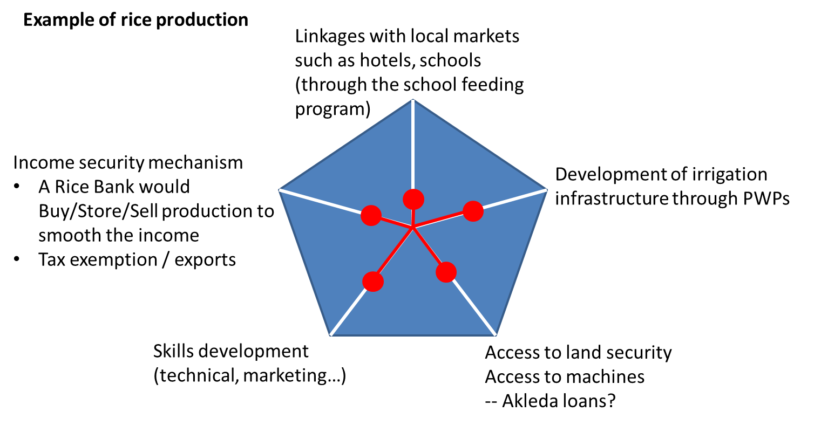
Branch of the Diamond | Concrete example | Social protection and Employment services (NSPS)
Technical conditions | Development of irrigation infrastructure through PWPs | PWPs
Economic conditions and legal constraints | Access to land security (enforcement of land reform) and to assets (capital/machines…) | Income security for the working age
Social requirements | Establishment of a rice bank which would buy/store/sell the production and smooth the income of the Rice producer | Income security for the working age
Human capital requirements | Skills development (technical, marketing…) | Vocational training
Economic conditions  & Social requirements | Linkages with local markets such as hotels, schools (through the school feeding program)  Tax exemption to facilitate exportations | School feeding program  Income security for the working age

The diamond can be used to describe the combined benefit packages that will be provided by the PEOPLE service. These combinations of SP/Employment services would contribute to economic growth, reduction of poverty, etc. We will discuss this at the CARD retreat next week and can share with you the results of the discussion.

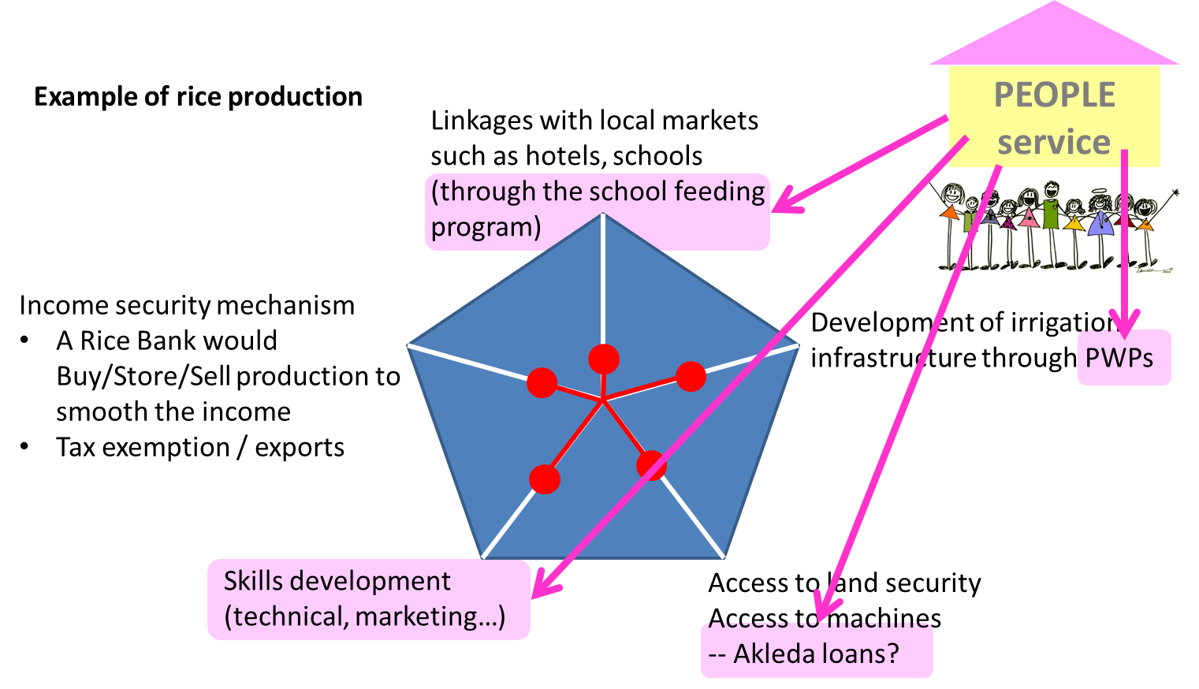

- The recommendation on the creation of a SSO should be reviewed
If I understand well:
- The proposed SSO would be established at the same level of the NEA. Therefore it would miss its function on integrating employment/social protection (since it would not coordinate all the employment part).
- In addition creating a new organization may be cumbersome and not so efficient (as mentioned by the employers’ representatives) whereas the need is merely to increase efficiency, outreach and coordination.
I therefore propose the following structure: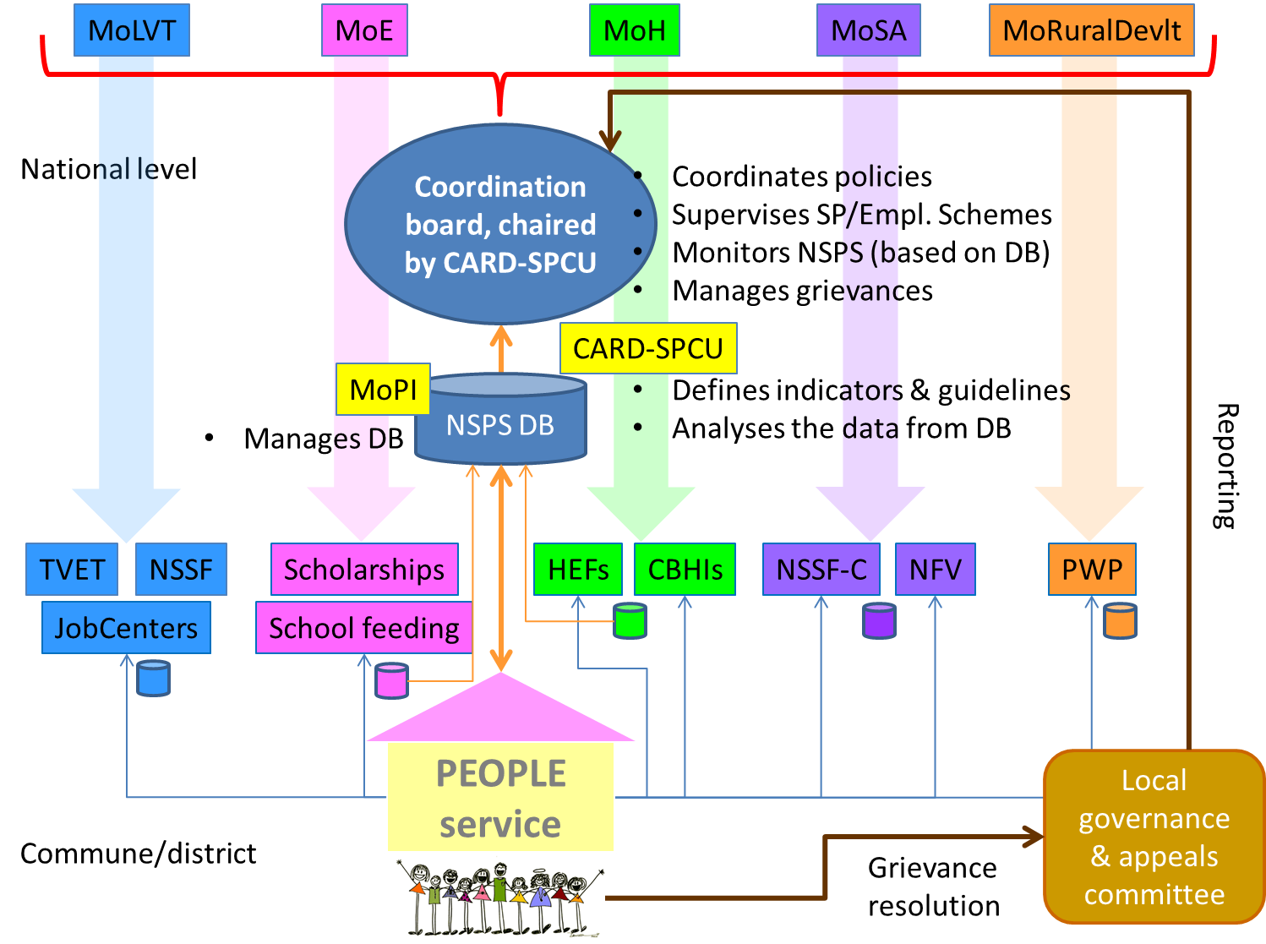

A coordination board would be established at national level:
- Composed of representatives from all line ministries = the social protection task force (11 line ministries) and representatives from the provinces governors, and final beneficiaries (the PEOPLE); it would be chaired by CARD-SPCU
- Functions = (1) share information and coordinate policies, (2) establish a list of indicators to monitor the NSPS and extension of coverage, (3) establish assessment protocols of the impact of the NSPS on poverty reduction and other indicators, etc.
- CARD-SPCU would use the information of the consolidated database managed by the ministry of planning.
Each line ministries would implement its own policies through relevant institutions:
- MoLVT → TVET, Job centres, NSSF
- MoE → Scholarships and school feeding
- Ministry of Health → HEFs, CBHIs
- Ministry of Social Affairs → NSSF-C, NFV
- Ministry of rural development → PWP
The final beneficiaries would have access to the social and employment services through the PEOPLE service. All the data collected at the level of the PEOPLE service (on people, services used…) would be channelled to the central database. Each program would keep its own database (but that should dialogue with the NSPS Database).
At commune/district level an appeals mechanism would ensure that issues of access to services or availability of the integrated package would be solved. A direct mechanism would ensure that grievances can be reported to the provincial and central levels.

- The idea of graduation is missing (in line with the social contract)
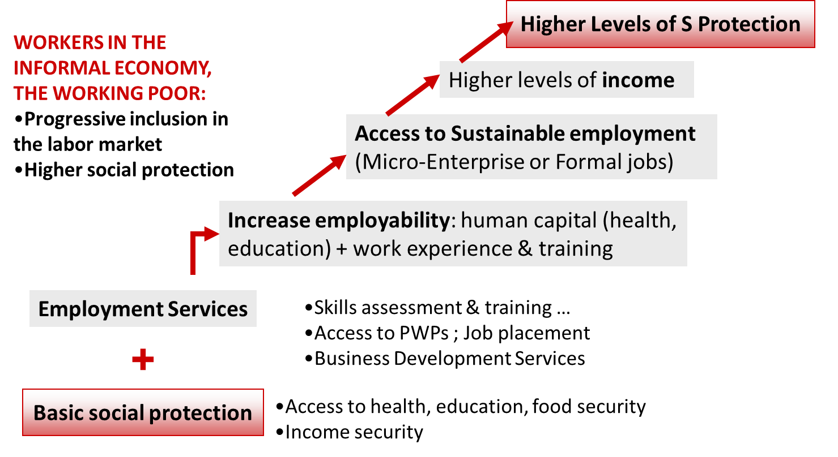

For more information please read:
- Linking the social protection floor to employment promoting and enhancing interventions to tend towards social protection and economic inclusion (ConceptNote_Draft_Feb22.doc)
- Linking the social protection floor to employment promoting and enhancing interventions to tend towards social protection and economic inclusion (project document “en_prodoc_ValerieSchmitt.doc)
- PPT “Next steps: ILO’s activities in Cambodia on social protection” (29 March 2012)

VS, 29 March 2012

