UNICEF
Integrating a System of Child Benefits Into Egypt’s Fiscal Space
Poverty Impact, Costing, and Fiscal Space
Amjad Rabi
20-Jan-12

Aknowledgement
This study benefited from a valuable research input from Prof. Dr. Heba El-Laithy and Dr. Dina Armanious; Department of Statistics, Faculty of Economics and Political Science, Cairo University, who conducted a simulation exercise using survey data as outlined in section 3.2.

The author would like to thank the following persons for the substantive comments and feedback: Leonardo Menchini; Chief of Social Policy and Monitoring and Evaluation UNICEF Egypt, Prof. Karima Korayem, Al -Azhar University, Matthew Cummins; Social Policy Specialist UNICEF HQ, Jennifer Yablonski; Social Protection Specialist UNICEF HQ, Javier Aguilar; Chief of Child Protection UNICEF Egypt, Roberto Benes; Regional Social Policy Advisor UNICEF MENA, Louisa Lippi; Social Policy Specialist UNICEF MENA. The author is grateful for the support and direction received from Philippe Duamelle; Representative UNICEF Egypt, Isabel Ortiz; Associate Director Division of Policy and Practice UNICEF HQ, and Jingqing Chai; Chief Social Policy and Economic Analyses UNICEF HQ.

The findings, interpretations and conclusions expressed in this paper are those of the author and do not necessarily reflect the policies or views of UNICEF or of the United Nations.

Executive Summary

Despite of a period of sustained economic growth experienced in Egypt during the past decade, incidence of poverty increased over the same period, pointing out the need for more effective fiscal and social policies that produce more equitable social outcome. This study examines the feasibility and sustainability of introducing a system of child cash transfers in Egypt. It mainly answers three specific questions: i) what poverty reduction can be expected if the system is implemented? ii) how much does it cost?, and iii) how can the policy be financed within Egypt’s fiscal space?. Furthermore, the study highlights key underlying factors that shape the design of effective policy response, such as Egypt’s favourable demographic profile, which is characterized by working age population growing at a higher rate than the overall population coupled with declining dependency ratios. The study also emphasises that education deprivation is a major impediment for the upward intergenerational social mobility.

The main findings are: the proposed cash transfer scheme has the potential to lift around one fifth of poor Egyptians out of poverty with greater impact on children (reduction of 28.2 percent among children age 0-14). This result can be achieved with an investment of only 0.88 percent of GDP. Moreover, the cost of the system is projected to even decline as a percentage of GDP over time, benefiting from the favorable demographic profile. This is true when the value of the benefit amount is maintained in real term as well as a percentage to per-capita GDP.

Several options are open to finance the proposed system of benefits, the most feasible two are: First, packaging the system with the planned VAT tax and promoting it as one of the tools to make up for some of the welfare loss expected from introducing the VAT. Second, removing only one item of the subsidized energy products that has very marginal impact on poverty (poverty was estimated to increase by 0.02 of one percent if it is removed). The study recognises the need for short-term measures to smoothen the transition to fund the proposed system of cash transfers in combination with other long-term adjustment measures (i.e. tax restructuring or fuel reform), the most feasible short-run measures include: Firs, benefiting from the debt swaps agreements that allows Egypt to commit injecting the equivalent amount of the debt into social sector projects. Second, if the current period of instability is proven to be a transitory shock and the economy resumes its growth path, borrowing from the International Reserve held by the central bank.

Table of Contents

Executive Summary 3
Table of Contents 4
1- Introduction 6
1.1. Overview and Study Objective 6
1.2. Definitions and UNICEF Engagement in Social Protection 6
2. SocioEconomic background 9
2.1. Demographic Profile 9
2.2. Labor Market and Macroeconomic Profile 11
2.3. Poverty Profile and Education Deprivation 13
3. Obverview and impact of the proposed system of child benefits 16
3.1. Benefit parameters, conditionality, targeting, and linkages to existing programs 16
3.2. Impact of proposed system on consumption poverty -simulation 17
3.3. Impact on non-income dimensions- international experience 20
3.4. Impact on economic growth 21
4. costing the System of Child Benefits 23
4.1. Projection Methodology 23
4.2. Projection Assumptions and Results 23
5. Financing and Fiscal Space 27
5.1. Improved taxation 28
5.2. Reprioritization of expenditures 29
5.3. More accommodating macroeconomic framework 34
5.4. Using fiscal and central bank foreign exchange reserves 34
5.5. Increased aid and transfers, borrowing or restructuring existing debt 35
References 37
Annex: Overview of Transfer Programs in Egypt 39

List of TableS
Table 1: Population Change in thousands, 1980 – 2010 9
Table 2: Main Economic Indicators, 2000-2010 12
Table 3: Comparison between Two Hypothetical Households 17
Table 4: Population Projection (Medium Variant) Main Characteristics, 2012 - 2020 23
Table 5: National Budget in Million Egyptian Pound and as a Percent of GDP, 2009/10-2011/2 28
Table 6: Budget Revenues (Tax and non-Tax) as a Percent of GDP for Different Regions 28
Table 7: International Recommended Spending on Key Social Sectors Vs. Egypt’s Allocation in Fiscal Year 2011/2 31
Table 8: Budget Allocation to Subsidies, 2009/10-2011/2. 32
Table 9: Estimated Costs of Some Cash Transfer Programs 32
List of Figures
Figure 1: Total Fertility Rates, 1980 – 2010 9
Figure 2: Population Pyramid, 1980 - 2050 10
Figure 3: Population Growth Rates, by Major Age Groups, Percent, 2000 – 2010 11
Figure 4: Dependency Ratios, Percent, 1980 – 2010 11
Figure 5: Unemployment Rates (left axis) and Participation Rates by Age Group, 2010 12
Figure 6: Growth Rates, 2000-2010 12
Figure 7: Poverty Rates among Households by Number of Children in the Household, 1999-2009 13
Figure 8: Poverty Rates among Households by Educational Level of Household Head, 2008/9 14
Figure 9: Education Deprivation by Wealth Quantile, 2000-2008 15
Figure 10: Education Deprivation by Sex, 2000-2008 15
Figure 11: Simulated Poverty Rates before and After Proposed System of Benefits, 2011 19
Figure 12: Size of Social Protection Component of Stimulus Packages (% of total announced amount) 22
Figure 13: Projection Model Components and Dependency Structure 23
Figure 14: Population Growth Rates by Major Age Groups, 2010 - 2030 24
Figure 15: Macroeconomic Model’s Assumptions- GDP Growth Rate and CPI Rate 24
Figure 16: Beneficiaries in Thousands of children, 2012-2020 25
Figure 17: Benefit Amount in Current Local Currency and as a percentage of Per Capita GDP (right axis). 2012-2020 26
Figure 18: Overall Cost of the System of Child Benefits in Billion Egyptian Pound and as a percentage of GDP (right axes), 2012-2020 26
Figure 19: Real-Term Growth Rates in National Budget between Fiscal Year 2010/1 and 2011/2. 29
Figure 20: Public Spending Functional Classification as A Percent of Overall Spending and as a Percent of GDP, Fiscal Year 2011/2 30
Figure 21: Public Spending as a Percent of Total Spending, Economic Classification, Fiscal Year 2011/2 31
Figure 22: General Budget Allocation to the Different Energy-Products Subsidies as a Percent of GDP, 2011/2. 33
Figure 23: Retail Prices of Gasoline in Selected Countries as of November 2008, in US cents/liter 33

- Introduction

  - Overview and Study Objective

Over the past decade, Egypt’s economy enjoyed a period of sustained growth. However, poverty increased over the same period suggesting that the economic growth experienced was not pro-poor. Not surprising, achieving social justice has been a central demand by the Egyptian revolution. Like in many countries, Egyptian children (in particular those living in large households) are overrepresented among the population living in poverty. The current social protection system in Egypt, mostly in the form of subsidies, has a very limited success in lifting these children out of poverty, which points out to the need for more effective fiscal and social policies that produce more equitable social outcome.

This study proposes the integration of a system of child benefits into Egypt’s mix of social protection measures. The study provides essential information that are key for decision makers to base their decision on solid evidence, including: i) the expected impact in terms of poverty reduction that the country would expect if the policy is adopted (chapter 3); ii) cost of the proposed system (chapter 4); and iii) elaboration on the fiscal space to finance the intervention (chapter 5).

This study comes at a critical time when there have been on-going debates about future policy directions of the Government, which have opened up space for discussion on the budgeting issues, and on possibility of reform of subsidies. It is hoped that the work presented here will initiate a broader and inclusive dialogue that will ultimately arrive at the optimal policy mix that maximizes the society’s social welfare.

  - Definitions and UNICEF Engagement in Social Protection

Social Protection is defined as the set of public and private policies and programmes aimed at preventing, reducing and eliminating economic and social vulnerabilities to poverty and deprivation. Social protection is essential to furthering UNICEF’s commitment to the realization of the rights of children, women and families to an adequate standard of living and essential services. At the core of social protection measures, UNICEF places emphasis on four components:

- Social cash transfers
- Programs to ensure economic and social access to services
- Social support services
- Legislation and policies to ensure equity and non-discrimination in children’s and families’ access to services and employment/livelihoods

The study’s proposed system of child benefits falls under the social cash transfer component. These transfers are small predictable sums of money to households to alleviate household poverty and achieve other desired social outcomes. Such grants empower recipients by providing them with greater freedom of choice in consumption decisions, and have demonstrated positive effects on food consumption, diet diversity, and expenditure on basic rights to health and education.

In addition to sharing many of the sources of vulnerability faced by their families and communities, children further face age-specific vulnerabilities that differ from those of adults. This is coupled with the fact that children tend to be over-represented among the poor. Children, therefore, require special attention during the process of designing or re-engineering of the country’s Social Protection system.
As a global advocate for children, UNICEF has a unique role to play in ensuring that social protection programmes are sensitive to children’s rights and needs. UNICEF has been working on social protection for many years. As of 2009 its engagement in social protection spans 124 programmes in 88 countries, reflecting the increasing recognition of UNICEF as an influential partner in Social Protection at national and international levels.

Social Protection is a potentially powerful tool in helping UNICEF realizes its vision of a world where the rights of every child are realized. Children’s right to Social Protection is outlined in Article 26 of the CRC:

- “States Parties shall recognize for every child the right to benefit from social security, including social insurance, and shall take the necessary measures to achieve the full realization of this right in accordance with their national law.

- The benefits should, where appropriate, be granted, taking into account the resources and the circumstances of the child and persons having responsibility for the maintenance of the child, as well as any other consideration relevant to an application for benefits made by or on behalf of the child.”

Article 27 is also particularly relevant:

- “States Parties recognize the right of every child to a standard of living adequate for the child's physical, mental, spiritual, moral and social development.

- States Parties, in accordance with national conditions and within their means, shall take appropriate measures to assist parents and others responsible for the child to implement this right and shall in case of need provide material assistance and support programmes, particularly with regard to nutrition, clothing and housing.”

Other articles that support Children’s right to Social Protection include: 18, 19, 24, 28, and 32.

In the concluding observations of the Committee on the Rights of the Child: Egypt, 30 May – 17 June 2011, further recommendations were made, including:

“20. In light of articles 2, 3 and 6 of the Convention and with a view to further strengthening the provision of and effective monitoring of budgetary allocations for children, the Committee recommends that the State party:
(a) Ensure a child-rights perspective in all budgets affecting children to guarantee equal access for all children to services and assistance necessary for their development;
73. The Committee urges the State party to accelerate and intensify its poverty reduction programme, giving priority to children. In particular, the Committee recommends that the State party:
(a) Improve social benefits and security schemes for poor families with many children and increase their social security pensions to the equivalent of the minimum wage, as established by the Constitutional Court, and focus anti-poverty programmes in rural areas."
(Committee on the Rights of the Child, 2011)

It is important to underline that social protection is a cross-sectorial issue for children. With its explicit focus on reducing children’s vulnerability, social protection can play a key role in addressing some of the underlying barriers which stand in the way improving children’s wellbeing. By reaching out to those who are economically and socially excluded, social protection compliments sector interventions in health and nutrition, education, child protection, and HIV/AIDS to improve outcomes and increase equity.

UNICEF’s work on social protection highlights three key principles:

- As a human-rights organization, UNICEF is committed to social protection as a fundamental right for children and as a key policy for supporting equity and social justice. While UNICEF supports the goal of achieving universal coverage, it recognizes the challenges inherent in providing universal coverage i.e. resource constraints. With this in mind, UNICEF advocates for progressive realization of universal coverage: UNICEF supports measures conducive to building universal coverage over time in a given context. Targeted programs may be chosen when it is desired that specific tailored interventions address the additional needs of particular populations. But when vulnerability is widespread, universal coverage is more appropriate and more efficient method for ensuring that all those who are in need benefit (less stigma, higher poverty impact, less error of exclusion, administratively easier and cheaper).

- One of the key principles for UNICEF’s work in this area is inclusive social protection. Mainstreaming inclusive social protection entails moving away from targeted approaches towards particular groups to look at the underlying causes of exclusion these groups share – such as discrimination, stigma, and geographical location. From a child-sensitive perspective, most vulnerable children often experience age-specific vulnerabilities, compounded by other sources shared at household and community level such as location.

- UNICEF supports long-term, nationally-owned and –led systems. Work on social protection must fall within and support the national framework. Except in cases where government capacity to implement or coordinate is weak or when there is a humanitarian crisis, UNICEF will not implement or fund others’ implementation of social protection programs outside of government collaboration.

As one of the cooperating agencies, UNICEF’s engagement and key principles support the realization of the UN adopted Social Protection Floor Initiative (SPF-I). The SPF-I emphasizes the need to guarantee a basic set of rights across the life cycle (from children to old-age). This basic set of right aims at enabling and empowering all members of a society to access a minimum package of transfers and services at all times.

- SocioEconomic background

Key findings
- Egypt’s demographic profile illustrates favorable conditions characterized by working age population growing at a higher rate than the overall population coupled with declining dependency ratios. It represents a “window of opportunity” for Egypt to invest in children in a sustainable manner.
- Persistent high youth unemployment rates suggests that the local economy has not been able to absorb the rapid entry to the labor market, which limits the prospect for the young people to fulfill their potential and highlights the need to invest more in education and link it to the needs of the labor market.
- Data on poverty suggests a very large portion of Egyptian children did not benefit from the recent period of sustained economic growth, pointing out the need for more effective fiscal and social policies that produce more equitable social outcome.
- Education deprivation is a major impediment for the upward intergenerational social mobility.

  - Demographic Profile

The most recent population census of 2006 estimated Egypt’s population at 72.798 million. Approximately 98.2 percent of inhabitants live in the Nile valley and the Delta, which both constitute only 7.8 percent of the overall size of Egypt (CAPMAS, 2011). Over the past decade, Egypt’s population grew at an average annual rate of 1.82 percent, which is similar to that of MENA region, but is significantly higher than that for Low Middle Income Countries (LMIC), estimated at 0.9 percent (UN, 2011c).

Table 1: Population Change in thousands, 1980 – 2010
Period | Population growth rate % | Population change per year | Birth | Death | Net Migration
1980-1985 | 2.4 | 1141 | 1817 | 536 | -140
1985-1990 | 2.3 | 1237 | 1883 | 516 | -130
1990-1995 | 1.8 | 1044 | 1731 | 465 | -222
1995-2000 | 1.7 | 1117 | 1724 | 418 | -189
2000-2005 | 1.9 | 1311 | 1779 | 394 | -74
2005-2010 | 1.8 | 1384 | 1856 | 394 | -78
Source: Based on data from (UN, 2011c)

The pattern of natural population growth (excluding migration) can be explained by two underlying factors: fertility rates and mortality rates. Since 1980, Total Fertility Rate (TFR) decreased by almost half, from 5.20 children per woman in early 1980 to 2.85 children per woman in 2005-2010 (UN, 2011c).

Figure 1: Total Fertility Rates, 1980 – 2010
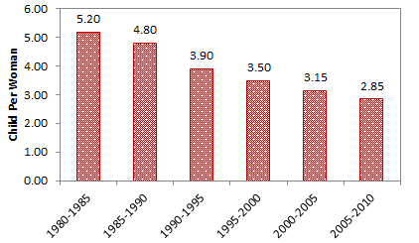
Source: Based on data from UN (2011c).

The second factor, the mortality rate, has shown significant improvement over the same period. The infant mortality rate declined from a rate of 101.1infant deaths per 1,000 live births in early 1980s to 25.9 infant deaths per 1,000 live births in 2005-2010. The crude death rate was estimated at 5.2 deaths per 1,000 live in 2005-2010, more than half the rate of 11.2 deaths per 1000 in the early 1980s. Life expectancy at birth, therefore, increased steadily and reached 72.3 years in 2005–2010, compared to 57.6 years in 1980-1985(UN, 2011c).

As a result of declining fertility rates, improved mortality and increased life expectancy, the population structure has changed notably over the past few decades. The median age in Egypt increased from 18.5 in 1980 to 24.5 in 2010 (UN, 2011c).

Figure 2: Population Pyramid, 1980 - 2050
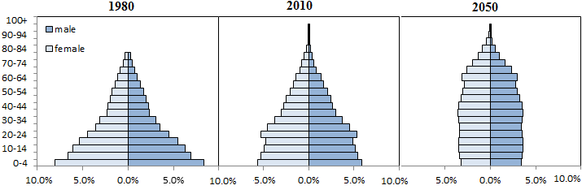
Source: Own calculation based data from on UN (2011a).

The broadening midsection of Egypt’s population pyramid has two main consequences: First, the likelihood of a steady, possibly an increased, population growth, even when the fertility rate is declining. This phenomenon is known as the “demographic momentum,” which occurs due to the fact that more people are in their productive years. This might explain the increase in the pace of the population growth in the first half of 2000s. Second: favorable demographic environment in which the working-age population has expanded at a higher rate than that of the general population as shown below, which is widely referred to as “demographic window of opportunity,”.

Figure 3: Population Growth Rates, by Major Age Groups, Percent, 2000 – 2010
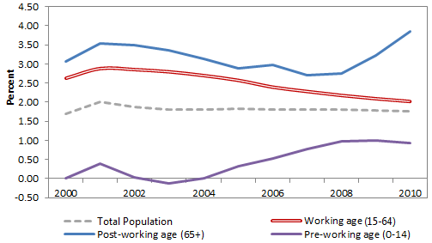
Source: Own calculation based on data from UN (2011a).

Similarly, decreasing trends have been observed in the Youth Dependency Ratio (number of children under 15 years to one working-age person) and the Total Dependency Ratio (number of children under 15 years and elderly over 65 year-old to every person of working-age).

Figure 4: Dependency Ratios, Percent, 1980 – 2010
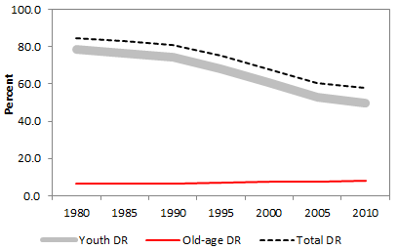
Source: Own calculation based on data from UN (2011a).

  - Labor Market and Macroeconomic Profile

While the expansion of the working-age population, as explained earlier, and subsequently the enlargement of the labor force, can present a favorable condition (reduced dependency ratios), it also constitutes a substantial challenge to the local economy to create adequate jobs to absorb the rapid entry into the labor market of new participants. Youth unemployed of age less than 25 accounted for 70 percent of the overall unemployed population in 2008 (CAPMAS, 2011). The overall unemployment rate averaged 9.8 percent between 2000 and 2010 (WB, 2011) and stood at 11.9 percent as of March 31, 2011 (IDSC, 2011). Another main characteristic of Egypt labor force is the low labor force participation rate among female, resulting in a predominantly male labor force in Egypt (3 out of 4 economically active are men).

Figure 5: Unemployment Rates (left axis) and Participation Rates by Age Group, 2010
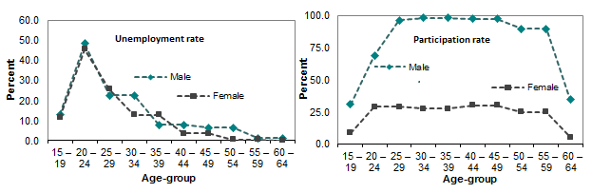
Source: based on data from CAPMAS (2011).

Over the past decade, Egypt’s economy grew at an average annual rate of more than 5 percent in real term (WB, 2011), which is 3 percentage points above the population growth, resulting in a general improvement in real GDP per capita. Nevertheless, Egypt’s economy has suffered from high inflation environment, structural deficit (further discussion on chapter 5), and widening gaps in income and consumption (see next section).

Table 2: Main Economic Indicators, 2000-2010
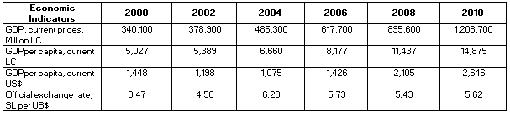
Source: Own calculation based on data from WB (2011).

Figure 6: Growth Rates, 2000-2010
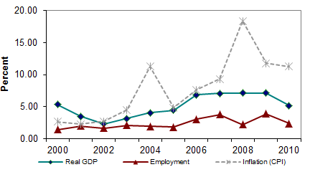
Source: Own calculation based on data from WB (2011).

  - Poverty Profile and Education Deprivation

The difficulty of analysing poverty in Egypt over a long period of time arises from differences in the methods and surveys used to measure poverty. For the purpose of this study and in order to preserve comparability of results, we will mainly use throughout this section data and results from the UNICEF work on poverty titled “Child poverty and disparities in Egypt” and “Trends of child poverty and disparities in Egypt,” both studies use the Household Expenditure, Income and Consumption Surveys (HEICS).

Despite of the strong economic growth over the past decade mentioned earlier, the poverty rate in Egypt increased from 16.7 percent in 1999/2000 to 21.6 percent in 2008/9 using the national poverty line; with significantly higher rate in rural areas than in urban areas (28.9 percent versus 11.0 percent) (UNICEF, 2010c). Poverty in Egypt is characterized by its sensitivity to the poverty line used; this is largely due to the fact that significant parts of the population are clustered around the poverty line. For instance, using the national upper (moderate) poverty line, the incidence of poverty almost doubled and stands at 41.7 percent for 2008/9. This characteristic also presents a positive feature that poverty in Egypt is shallow (relative to the national poverty line). The poverty gap (the percentage deficit of per-capita expenditure from poverty line) was estimated at 4.1 percent in 2008/9(UNICEF, 2010c). At the average annual per-capita poverty line for Egypt as a whole, estimated at E£ 2,223 for 2008/9, an annual amount of E£ 1.569 billion (only 0.151 percent of GDP) is required to eradicate poverty (assuming perfect and costless targeting).

Poverty in Egypt has age dimension. Children and youth are more likely to experience poverty than older age groups. Between 2004 -2009, the number of children living in poverty increased from 6.278 million in 2004/5 to 7.0 million 2008/9 (UNICEF, 2010c). Household with children are particularly at higher risk of falling into poverty. Moreover, the incidence of poverty increases as the number of children in the household increases.

Figure 7: Poverty Rates among Households by Number of Children in the Household, 1999-2009
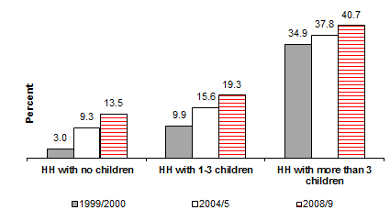
Source: Based on data from UNICEF (2010c).

Education of household heads is strongly inversely correlated with poverty for all types of households (with and without children). Heads of households who did not complete a primary education are almost three times more likely to be poor as compared with those who have at least secondary education (UNICEF, 2010a).

Figure 8: Poverty Rates among Households by Educational Level of Household Head, 2008/9
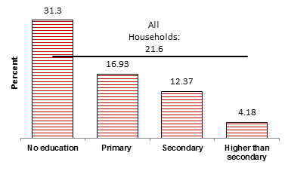
Source: Based on data from UNICEF (2010a).

While the above graph shows that children of illiterate heads of households are at significantly higher risk of experiencing poverty, children in poor households are also two times more likely not to complete a primary education than children in non-poor households(UNICEF, 2010a), which perpetuates poverty and impedes the upward intergenerational social mobility.

The issue of education, therefore, needs further investigation as it has a strong potential for tackling the intergeneration transmission of poverty. The UNDP MDG monitor indicates that Egypt is on track to achieve MDG 2: Achieve universal primary education (UNDP, MDG Monitor: Egypt, 2011). Educationally deprived children, children above age 6 and less than 18 who never attended school and are not currently enrolled in an academic program, decreased from 7.8 percent in 2000 to 3.2 percent in 2008 (UNICEF, 2010c). However, disaggregation of data on education deprivation by wealth quintile, gender, household characteristics, and place of residence suggests the existence of significant disparities and inequalities. Education deprivation in Egypt is strongly correlated with wealth of household; this is despite of the significant improvement in education enrolment over the past decades among children from the lowest quintile.

Figure 9: Education Deprivation by Wealth Quantile, 2000-2008
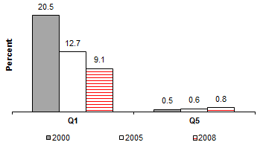
Source: Based on data from UNICEF (2010a).

The high prevalence of education deprivation among poor household can be attributed to the fact that poor households depend partly on their children’s earnings, particularly boys. Survey data in 2008/9 indicated that 14.1 percent of poor boys work (UNICEF, 2010a). When educationally deprived children were asked about the reason for not attending school, 14.3 percent of boys responded “work” (ENCRO, 2011). Another reason for the high child deprivation among poor households is the inability of poor household to afford the cost of education. One out of three of the educationally deprived children indicated financial barriers as the reason for not attending school (ENCRO, 2011). While the data showed that child labor seems to have affected boys more than girls, inability of households to afford the cost of education affected girls more than boys. This added to other reasons that affect school attendance by girls more than boys (parents do not want, customs, and health related). Therefore, education deprivation in Egypt has a gender dimension with female children still suffer almost as twice as male children from education deprivation (UNICEF, 2010c); this is despite of the significant reduction in the gender gap in education enrolment over the past decade.

Figure 10: Education Deprivation by Sex, 2000-2008
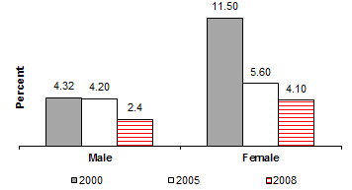

Source: Based on data from UNICEF (2010c).

- Obverview and impact of the proposed system of child benefits

Key findings
- The study simulation shows that the proposed system of benefits is expected to reduce the overall poverty rate by 19.3 percent (reduction of 28.2 percent among children age 0-14).
- Larger effect of the system on the poverty gap reduction, which is simulated to drop by 27.9 percent.

  - Benefit parameters, conditionality, targeting, and linkages to existing programs

    - overview

The proposed system of child benefits consists of two main parts: First, cash transfer for pre-school children (less than 6 years-old). Second: cash transfer for school age children (6-14 years-old). This age range was selected to cover the period of greatest vulnerability for the survival and development of the child (0-5 years) as well as a period long enough to ensure the completion of primary school.

For the first year, the benefit amount is set at E£60 per child per month for each benefit. However, the school-stipend benefit is payable only during the school year (9months), while the pre-school benefit is paid 12 months a year.

    - Conditionality and linkages

There is increasing evidence on the impact and outcomes of both conditional cash transfers and unconditional transfers. Although there is evidence to suggest that both have positive outcomes, the particular role and attribution of these outcomes to conditionality remains an open debate.

The study proposes that the cash transfer directed to children in school age is to be conditional on attending school. As for the pre-school children, health check-ups and linkages to other sought positive behaviour changes can be also investigated. The study is hoped to initiate a broader discussion with cross-sectorial experts to ultimately decide whether conditionality and linkages are desired, and if yes, what they are. A separate exercise is needed to make sure that whatever conditionalities imposed are costed and within the supply side constraints.

    - Targeting

While both benefits (pre-school benefit and school stipend) hypothetically cover all children, it is assumed that a form of targeting is implicitly built in:

- Self-selection targeting: the low level benefit amount coupled with other administrative measures, such as excluding children form well-off households who attend private Arabic and foreign language schools, will ultimately result in less than 100% coverage.

- Categorical targeting: as discussed earlier, poverty is positively correlated with the number of children in the household. Therefore, cash transfers that varied with the number of children in the household are pro-poor, even if non-poor households receive the same per-child benefit amount. To illustrate this point, assume that there are only two households: A and B. Household A is a low-income household with monthly income of E£ 600. Household B is better off with monthly income of E£ 3000. As in many poor households, household A has 4 children whereas household B has 2 children. Furthermore, for simplicity, assume that the proposed system is fully financed by an income tax (more realistic and reasonable financing mechanisms are discussed in chapter 5). The income tax that is needed to fund the system is 10% on income of all households. Assuming that the two households take up the child benefit and applying the study proposed categorical targeting, the following table compares between the two households:

Table 3: Comparison between Two Hypothetical Households
 | HH A | HH B
Monthly HH income before | E£ 600 | E£ 3000
Number of Children | 4 | 2
Total entitlements, proposed benefit | 4 x 60 = E£240 | 2 x 60 = E£120
Tax | 10% x 600 = E£60 | 10% x 3000 = E£300
Monthly Household income after | E£ 780 | E£ 2820
Net gain | 780 – 600 = E£ 180 | 2820 – 3000= - E£ 180

Note that impact can be even further strengthened if the financing mechanism is selected in a way that does not affect the poor households (see chapter 5).

    - Linkages to existing cash transfer programs

A wide selection of cash transfer programs exist in Egypt. These include the social solidarity pension, cash transfers for low income pregnant women ineligible for other forms of assistance until their child is 2 years old, and child pensions for children of divorced parents and orphans, the old age and disability pensions. There are specific financial provisions for low-income families (under 300 EGP) with mentally disabled children. There are also some transfers through the Ministry of Awqaf (Endowment). (See Annex A for a summary these programmes).

The proposed system is sought to complement the existing programs for stronger impact, particularly among vulnerable households. More specifically, the proposed system is promoted as the first level of the safety net where households with children receive the benefit to help meet part of the expenses associated with school and nutrition. The other existing programs are additional benefits that can address the extra and special needs of the particular household. The combined benefits will, therefore, have a consolidated and stronger impact.

  - Impact of proposed system on consumption poverty -simulation

In order to assess the potential impact of cash transfers in 2011, data from HIECS 2008/9 were inflated with detailed price indices to reflect 2011 prices and then poverty measures were simulated.

3.2.1. Update HIECS data

Specific prices indices were used to simulate the monetary value of household consumption in 2011 based on the HIECS survey of 2008-09. For each household, the study calculates the budget share of consumption groups –disaggregated as CPI allows. Multiplying budget shares by the percentage increase in price (derived from published CPI) gives an estimate of household consumption in 2011. In practice, however, households may be able to reduce the impact of the price increase by substituting away from expensive groups and using cheaper alternatives. Given that short-run substitution elasticities are smaller than long-run elasticities, the estimated household consumption is likely to closely approximate short-run welfare impacts. This estimate is also likely to be highly relevant for the poorest households who have more limited opportunities for substitution.

Similarly, food poverty lines were also updated using overall regional food CPI and non-food poverty lines were also calculated using the parametric estimates of food share.

3.2.2. Simulation assumptions

The simulation uses the following simplifying assumptions:
- All additional welfare benefits households would receive will be used for consumption: this implies that when new benefits are introduced, beneficiaries’ welfare would increase by the amounts they receive.
- Demand and budget shares are fixed: our estimates should be interpreted as upper bounds on the magnitude of income effects. The simulation compares baseline measures of poverty with measures of poverty taken after transfers are added to household consumption expenditure. It does not take into account households’ behavioural responses to the transfer, which can be positive or negative from a poverty reduction perspective. For example, studies have shown that regular and reliable transfers can improve the productive capacity of households, especially in rural areas, so that the increase in income or expenditure is actually greater than the amount of the transfer (Sadoulet, de Janvry, & Davis, 2001). On the other hand, if transfers are mismanaged, the impact on food consumption could be lower than the amount of the benefit. The simulations below ignore these behavioural responses.
- This simulation excludes the richest quintile and/or children attending private Arabic and foreign language schools. Therefore, according to HIECS 2008-09, the take up rate will cover 68.3 percent of households, constituting 76.6 percent of the eligible population.

3.2.3. Consumption poverty indicators

The simulations provided estimates of the change in the poverty headcount and poverty gap, for all individuals and for children in particular, that is expected to result from the proposed transfers. Three types of indicators are used in this evaluation; 1) change in per capita consumption; 2) incidence of poverty and poverty gap; and 3) an inequality measure; Gini coefficient.

3.2.4 Simulation results: consumption poverty before and after the proposed system

As a result of the price change between 2008/9 and the baseline year 2011, the simulated baseline poverty rates differ from the latest poverty rates discussed in chapter 2. The simulated before-benefit head count rate is estimated at 30.6 percent in 2011. Despite of the magnitude change, the relationship between poverty rates and households characteristics remains the same. For instance, poverty rate continues to be higher among households with children aged 0 to 14 (33.4 percent for households with children aged 0 to 14 years of age compared to 20.9 percent among households with no children), similar to the pattern discussed in chapter 2.

The proposed system of cash transfers is estimated to increase per capita consumption on average by 3.5 percent for all households and 11.8% for households of the lowest quintile. Since consumption pattern varies with household composition and age structure as well as with location, the impact of price changes affect households differently according to their location, age and composition. Households with children aged 0-5 experience the largest increase by 6.6 percent of their per capita consumption, while consumption of households with children aged 6-14 years increase by 5.3 percent. Simulated poverty reduction patterns follow the pattern of per capita consumption increase. Households with children of age 0-5 exhibit the largest impact with a reduction of 27.2 percent. The poverty rate of households with children aged 6-14 decreases by 22.5 percent. Furthermore, since poor households have more children, the impact of the proposed benefits is found greater when the incidence of poverty is measured as a percentage of children instead of household with children. While the incidence of poverty reduced by 19.3 percent for all individuals, poverty declined by 32.1 percent among children 0-5 and by 26.0 percent among children 6-14. It is also shown that reductions in poverty incidence are stronger among: children residing rural areas and especially in Upper Egypt, children living in households with heads with no education, children of large households, and children raised in a female headed households; particularly age 0-5 years.

Figure 11: Simulated Poverty Rates before and After Proposed System of Benefits, 2011
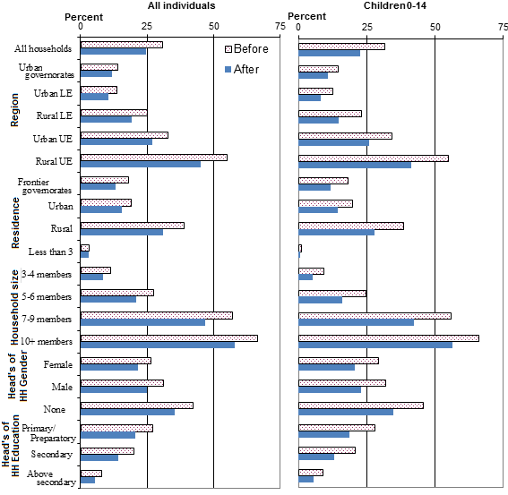
Source: Calculation is based on data from CAPMAS (2009b).

In terms of poverty gap reduction, the impact is found to be much higher than the impact on the poverty rate. The simulated poverty gap reduction amounts to 27.9 percent for all households, and it reaches 38.7 percent for households with children of 0-5 years of age and 32.3 percent for households with children age 0-14 years. Gini coefficient, as a measure of inequality, follows similar pattern. Overall improvement in Gini coefficient amounted 2 percentage points with improvements are higher among households with children.

  - Impact on non-income dimensions- international experience

While simulating the impact of the proposed system on non-income dimensions is challenging and beyond the scope of this study, evidence, from different countries, shows that progress to achieve the MDGs can be accelerated when cash transfer programs and approaches are used to complement supply side interventions by increasing demand to services. Below is a list of selected country examples:

School enrolment, child labour, and early marriage
- Bangladesh: The stipend program for girls’ education (FSP) is believed to have increased girls’ net primary enrolment between 1996 and 2002/3 from 48% to 86%.
- Ethiopia, South Africa, Malawi, Mexico, Nicaragua, Brazil, Ecuador, Cambodia, Pakistan and Turkey: Transfer programmes have demonstrated significant percentage point increases in enrolment and/or attendance.
- Zambia, Malawi, Brazil, Columbia, Nicaragua, Mexico: overall positive effects on girls’ education.
- Malawi: new enrolment was twice as high in households participating in cash transfer scheme (8.3% vs 3.4%) within a one year period.
- Malawi: cash transfers to adolescent girls increased school attendance, and led to a significant decline in early marriage, pregnancy, self-reported sexual activity and HIV prevalence among beneficiaries.
- Mexico: Oportunidades had little impact at primary level (where enrolment was already high), but secondary school enrolment of girls increased by 11-14%, compared to 5-8% for boys. It also resulted in a reduction in probability of working for ages 8-17.
- Brazil: the Programa de Erradicaçao do Trabalho Infantil (PETI) reduced both the probability of children working and their likelihood to be engaged in higher-risk activities.
Nutrition:
- Nicaragua: The Red de Protección cash transfer programme reduced stunting among children 6-59 months by 5.3 percentage points, with stronger impacts among poorer families. Moreover, during the coffee price shock, beneficiaries of this program were able to maintain and modestly increase per capita food consumption, while in other comparable households per capita consumption declined sharply.
- South Africa: children in households receiving a pension have on average 5cm greater growth than those in households without a pension – this is the equivalent of approximately half a year’s growth for Black and Coloured children.
- Mexico, Malawi, and Colombia: Social Protection programmes demonstrate reductions in stunting.
Health
- Mexico: Oportunidades led to a 17 per cent decline in rural infant mortality (8 percentage points on average). It also led to a reduction of maternal mortality by 11% among women participating and impacts were strongest in more marginalized communities.
- Bolivia: between 1993 and 1997, infant mortality rates among participating households in Bolivia’s Social Fund declined from 61 to 31 per 1000. For non-participating comparable households, infant mortality rates did actually increase from 60 to 67 per 1000. Under 5 mortality rates fell over the same period from 94 to 55 per 1000 in participating households, but rose from 93 to 108 per 1000 in comparable non-participating households.
- In all cash transfer programs for which there is data, with the exception of the PATH programme in Jamaica, incidence of illness has decreased among children, particularly younger children.

  - Impact on economic growth

A coherent social cash transfer program that ultimately results in an income transfer from the rich to the poor can play a significant role as an economic stimulus to foster economic growth. This is due to the fact that poor households have a high marginal propensity to consume. The additional incomes poor households receive (from the program or other sources) are spent in large on basic necessities, whereas richer households’ incremental reductions of their incomes (resulted from financing the benefit) are not expected to reduce their consumption with the full amount. This gives a rise to a multiplier effect: the increased consumption resulted from the benefit leads to increased incomes of local producers and service providers, which further leads to increased consumption, etc. In other words, the initial amount spent on the proposed system of benefits may cause a change in aggregate output that is a multiple of the initial change. For instance, an increase of 1 percent of GDP in Bolsa Familia program in Barzil was estimated to result in a positive change of 1.44 percent in GDP (ILO, 2011). Not surprising, cash transfers programs comprise a significant portion of the fiscal stimulus packages in rich and poor countries alike. It was estimated that on average about 25 percent of fiscal stimulus spending was invested in social protection in both middle and higher income countries (UNICEF, 2010b).

Figure 12: Size of Social Protection Component of Stimulus Packages (% of total announced amount)
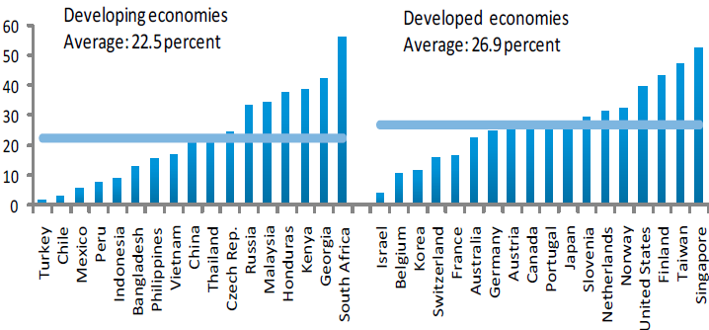
Source: UNICEF (2010b)
- costing the System of Child Benefits

Key findings
- The overall cost of the system of child benefits is estimated at only 0.88 percent of GDP.
- Benefiting from the favorable demographic profile, the cost of the system is projected to even decline as a percentage of GDP over time. This is true when the value of the benefit amount is maintained in real term as well as a percentage to per-capita GDP.

  - Projection Methodology

The projection model is built on the logical approach employed by the UNICEF-ILO Social Protection Costing Tool. In this study, the projection exercise is divided into two parts: First, projecting the underlying factors (demographic and macroeconomic). Second, under the set of specified assumptions on the benefit parameters discussed earlier (eligibility conditions, coverage, benefit level etc.), beneficiaries, benefit level, and overall costs are projected for the next 10 years. In next chapter, the cost structure will be integrated within the overall fiscal envelop of the country.

The linkages and dependency structure of the projection parts are illustrated in the following diagram.

Figure 13: Projection Model Components and Dependency Structure
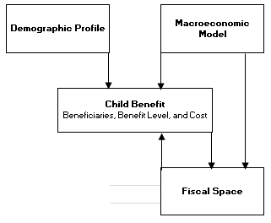

  - Projection Assumptions and Results

    - Projection of the Demographic and Macroeconomic Profile:

For the demographic projection, the study uses the medium-variant population projection made available by the United Nations Department of Economic and Social Affairs, Population Division. The data set is disaggregated by sex and single-year age. The following table summarizes the population projection main characteristics relevant to the study.

Table 4: Population Projection (Medium Variant) Main Characteristics, 2012 - 2020
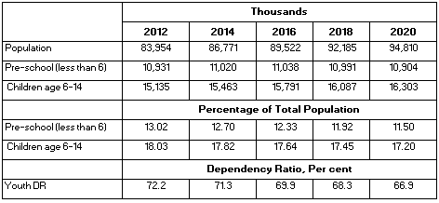

Source: Own calculation based on data from UN (2011a).

Figure 14: Population Growth Rates by Major Age Groups, 2010 - 2030
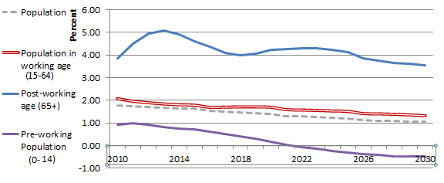Source: Own calculation based on data from UN (2011a).

For the macroeconomic model, the study uses the latest IMF’s medium-term forecast for real GDP growth rate and inflation rate, which covers until 2016. From 2016 to 2020, the rates are fixed at the rate of 2016. GDP in current prices and per capita GDP are calculated for the projection period.

Figure 15: Macroeconomic Model’s Assumptions- GDP Growth Rate and CPI Rate

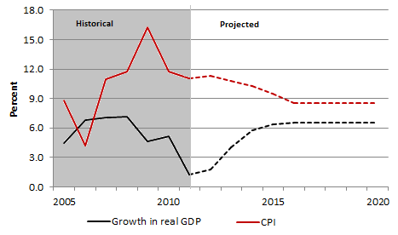
Source: Based on data from IMF (2011).

    - Projection of Beneficiaries

As discussed in chapter 3, take up rate is estimated at 76.6 percent of the eligible population. Applying this rate into the corresponding age groups gives the program beneficiaries.

Figure 16: Beneficiaries in Thousands of children, 2012-2020
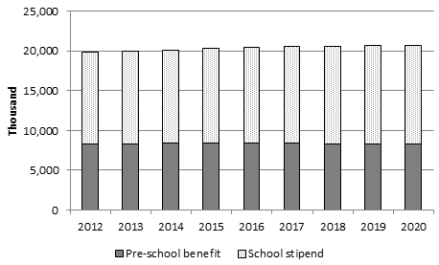

    - Projection of Benefit Level and Overall Cost

As discussed in chapter 3, the benefit amount is proposed at E£60 per child payable monthly (for the school-stipend benefit, it is payable during the school year only -9 months).

The benefit amount is indexed under two different scenarios: first, benefit amount inflated with the CPI for the corresponding year. Second, the ratio of benefit amount to GDP per capita is maintained constant. While the first indexation method maintains the benefit amount value in real term, the second indexation method permits possible improvement in the benefit amount in real term in line with the overall improvement in the economic condition.

Figure 17: Benefit Amount in Current Local Currency and as a percentage of Per Capita GDP (right axis). 2012-2020
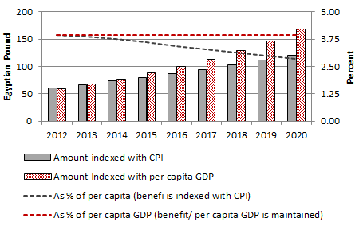
Total benefit amount spent on benefits is calculated as the product of the beneficiaries and the benefit amount for each year in the projection period. Administrative cost is assumed at 10 percent of the benefit amount. The overall cost for the proposed system of child benefits is estimated at less than one percentage point of GDP, precisely 0.88 percent of GDP, divided almost equally between the pre-school and school stipend benefits.

Figure 18: Overall Cost of the System of Child Benefits in Billion Egyptian Pound and as a percentage of GDP (right axes), 2012-2020
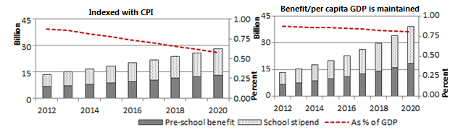

- Financing and Fiscal Space

Key findings
- Public Spending in Egypt highlights an imbalanced spending pattern where Social Protection (mostly in the form of subsidies) is strong but spending on key child-related sectors (such as education and health) is one of the lowest in the region and below international recommended spending levels.
- Egypt has a low tax/GDP ratio in comparison with countries at the same economic level.
- Several options are open to finance the proposed system of cash transfer. The most feasible two are: 1) packaging it with the planned VAT tax as one of the tools to make up for some of the welfare loss expected from introducing the VAT 2) removing only one item of the subsidized energy products that has very marginal impact on poverty (poverty was estimated to increase by 0.02 of one percent if it is removed).
- There is also a need for short-run measures to smoothen the transition to fund the proposed system of cash transfers in combination with other long-term adjustment measures (i.e. tax restructuring or fuel reform), the most feasible short-run measures include: 1) benefiting from the debt swaps agreements that allows Egypt to commit injecting the equivalent amount of the debt into social sector projects. 2) if the current period of instability is proven to be a transitory shock and the economy resumes its growth path, borrowing from the International Reserve held by the central bank.

The study recognises the importance of the national budget as a tool to achieve sustainable progress in the fulfilment of societies’ goals. This chapter provides an assessment of Egypt’s fiscal envelope to identify preliminary areas to free some fiscal space to fund the proposed system of child benefits. It is hoped that this will initiate a broader and inclusive dialogue that will ultimately arrive at the mix that maximizes the society’s social welfare.

Fiscal space is defined as “the room in the government’s budget that allows it to provide resources for a desired purpose without jeopardising the sustainability of its financial position or the stability of the economy’ (Heller, 2005). In general, there are several options available for decision makers to create fiscal space to fund economic and social development. Main options include (Ortiz, Chai, & Cummins, 2011):
- Improved taxation
- Reprioritization of expenditures
- More accommodating macroeconomic framework (eg tolerance to some inflation, fiscal deficit)
- Using fiscal and central bank foreign exchange reserves
- Increased aid and transfers
- Borrowing or restructuring existing debt for national development

Before investigating each option, the national budget including the overall accumulated debt for the past three years is presented below in current currency and as a percent of GDP, the information in the budget will be referred to frequently in the coming sections.

Table 5: National Budget in Million Egyptian Pound and as a Percent of GDP, 2009/10-2011/2
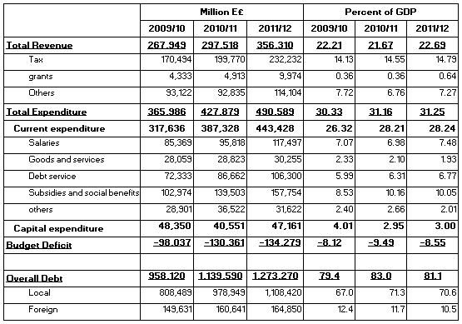
Source: Based on data from Ministry of Finance (2011).

  - Improved taxation

Overall revenue as a percentage of GDP in Egypt is in line with countries at the same economic level. However, the tax revenue ratio to GDP is lower than other Lower-middle-income countries.

Table 6: Budget Revenues (Tax and non-Tax) as a Percent of GDP for Different Regions
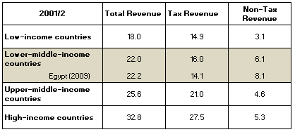
Source: Compiled from different national budgets and reported in UNICEF Learning Module on Social Budgeting (UNICEF, 2011). For Egypt: (Ministry of Finance, 2011).

There are several reasons that might have contributed to the low tax/GDP ratio. Incomprehensive tax structure and low tax rates are among the main reasons. Other important reasons may include: poor tax administration and low enforcement of legislation. The distribution of power might have affected the government resource mobilization decisions and processes in Egypt, this included low tax rates on corporate profits, exemptions and loopholes; which permitted legal “tax avoidance,” and inadequate adjustment of the tax structure to take account of structural changes in the economy. Just as the government expenditure has implication for equity, the low tax collection affects government expenditures that can redistribute wealth to the poor and ensure the socioeconomic rights of all citizens, including children (UNICEF, 2011).

Achieving social justice has been a central demand by the protestors. The first post-revolution national budget has included some corrective tax measures. For instance, it has added a new and higher tax bracket for the income tax code (individual and corporate) for incomes exceeding E£10 million, increased the excise tax on cigarette from 40 percent to 50 percent, and partially addressed the tax avoidance (Ministry of Finance, 2011). These measures have contributed to the projected increase of the tax collection (see table 5). Furthermore, the Ministry of Finance reported plans for the medium-term to introduce Value-Added Tax (VAT), amendment to the income tax code to enlarge the contributing base and limiting the tax-exempts, increase in excise tax on cigarettes, impose a property tax on buildings, and revisit customs exceptions (Ministry of Finance, 2011).

Using this option to finance the proposed system of child benefits is reasonable. This can be done through two main entry points: First: packaging the proposed benefits with the planned VAT in Egypt. VAT is generally a regressive tax; the proposed benefit can be promoted as a parallel measure to offset the welfare loss resulted from introducing the VAT. Second: addressing the issue of tax avoidance. The proposed system of child benefits represents a small fraction of what the government can generate if the issue of tax avoidance is addressed. According to some estimates, tax avoidance amounts for E£100 billion in the current fiscal year (Al-Ahram Hebdo, October 26, 2011), which represents 7.41 percent of GDP for the same year.

  - Reprioritization of expenditures

The post-revolution government issued key measures to respond to the popular demands, for example: increasing the minimum wage for public employees, and increasing allocation to social sectors (public housing and subsidies). The national budget for fiscal year 2011/2 projected an increase of 6.84 percent in real term from last year’s national budget. Overall spending is projected at E£ 490.59 billion, which represents 31.2 percent of the projected GDP for the same period (Ministry of Finance, 2011). While the increase in the wage bill resulted from the minimum wage increase is one of the drivers for the projected increase in expenditure, sectorial allocation to public housing and to Social Protection (mostly energy and food subsidies) increased in real term by 25.83 percent and 14.31 percent for housing and Social Protection, respectively.

Figure 19: Real-Term Growth Rates in National Budget between Fiscal Year 2010/1 and 2011/2.
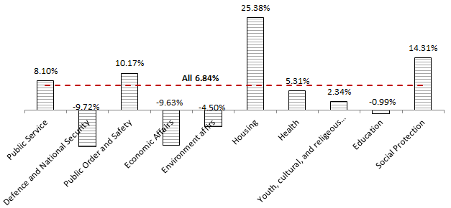
Source: Based on data from Ministry of Finance (2011).

To pay for this increase, the government is projected to run a deficit of 8.55 percent of GDP (Ministry of Finance, 2011); it also cuts spending on key social sectors. Allocation to education decreases in real-term by 1 percent. The increase in overall allocation to health is below the average increase in the general budget and does not take into account the very low government allocation to health, which stood at only 1.5 percent of GDP.

Figure 20: Public Spending Functional Classification as A Percent of Overall Spending and as a Percent of GDP, Fiscal Year 2011/2

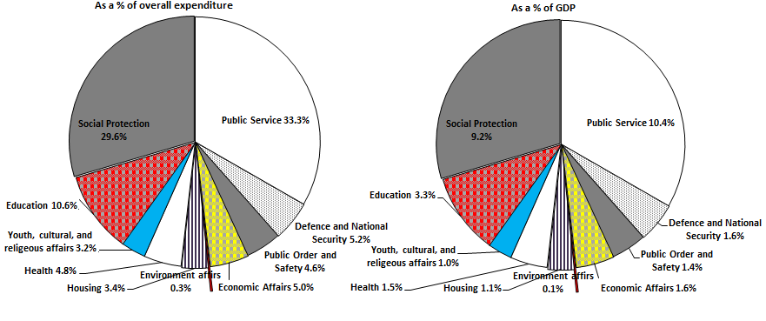
Source: Based on data from Ministry of Finance (2011).

In comparison with internationally recommended spending (see table 7), the current budget allocation is almost one-half and one-third of the recommended establishment for spending on education and health, respectively.

Table 7: International Recommended Spending on Key Social Sectors Vs. Egypt’s Allocation in Fiscal Year 2011/2
Sector | Agreement | Target | Egypt
Education | Education for All Initiative (2000) | 20% G. Exp. | 10.50%
Health | Abuja Declaration (2001) | 15% G. Exp. | 4.70%
Social Protection | Social Policy Framework for Africa (2008) | 4.5% GDP | 9.20%
Water and Sanitation | eThekwini Declaration (2008) | 1.5% GDP
 | Sharm El-Sheik Commitment (2008)
Source: Hagan-Zanker & McCord (2011) and Ministry of Finance (2011)

Table 7 also illustrates that spending on social protection is more than twice the recommended spending. This highlights a distorted spending pattern that if corrected might provide space to fund the proposed benefit along with an improvement in spending in other key social sectors, mainly health and education. An economic classification of the budget also highlights spending on Social Protection as a possibility to create fiscal space.

Figure 21: Public Spending as a Percent of Total Spending, Economic Classification, Fiscal Year 2011/2
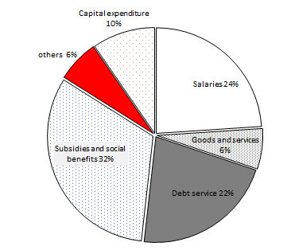
Source: Based on data from Ministry of Finance (2011)

Debt services might be a possible area for improvement especially in line with the debt swap proposed by many donors. However, international debt represents less than 13 percent of the overall national debt. In addition, the debt service paid to local creditors represents an income source that is re-injected in the local economy. Among the local creditors is the national pension fund, almost 16 percent of the overall debt service for fiscal year 2011/2 is payable to the pension fund. For these reasons, any attempt to reduce the share of the debt service is a gradual strategy that will take very long period to achieve. Salaries, capital expenditure, and good and services are already at low levels and are expected to increase in absolute values in order to achieve an improvement in the services provided by the government.

Spending in social protection is almost one third on the overall expenditure, re-stressing its potential role in freeing space to fund the proposed benefit as well as correcting the distorted spending pattern discussed above. The bulk of the social protection spending is on the system of subsidies, which is projected at 8.47 percent of the GDP for 2011/2. Closer scrutiny of projected expenditures for the different subsidy schemes show that allocation to the energy-products subsidy alone counts for 6.09 percent of GDP in 2011/2 (Ministry of Finance, 2011), which costs more than the combined spending on health and education.

Table 8: Budget Allocation to Subsidies, 2009/10-2011/2.
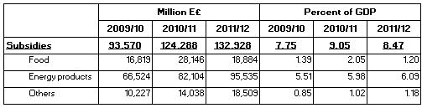
Source: Based on data from Ministry of Finance (2011)

Reforming the energy-products subsidy provides an excellent opportunity to make great inroads in creating fiscal space to invest in children in a more efficient and effective manner. For the purpose of illustrating what social programs can be implemented at the same cost if the energy-products subsidy is phased out completely, the study estimates the cost of the following three categories to be still less than the cost of the energy-products subsidy alone:

- A set of universal social cash transfer benefits, including:

Table 9: Estimated Costs of Some Cash Transfer Programs
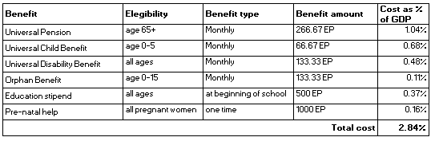
Source: Own calculation based on data from (UN, 2011), (IMF, 2011), (WB, 2011).

- Allocation to health and education could be increased by another 50%, respectively.

- The Government would still have a remaining 13.174 Billion L£ for other needs, which is twice the amount of all of its foreign grants (Saudi, US, and others) (Ministry of Finance, 2011).

Phasing out the petroleum-product subsidy is politically difficult. Furthermore, if it is removed swiftly, it may result in welfare loss, spike in inflation, and disadvantages to industries. Nevertheless, the study argues that the proposed system of child benefits can be financed by eliminating only the subsidy to products that are consumed by the rich in a way that does not affect the poor and vulnerable segments of the population. The following graph decomposes the energy-products subsidy into its main items.

Figure 22: General Budget Allocation to the Different Energy-Products Subsidies as a Percent of GDP, 2011/2.
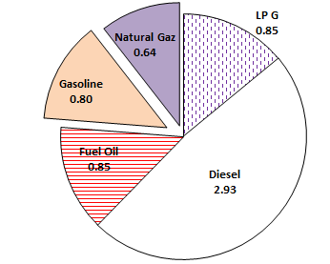
Source: Based on data from Ministry of Finance (2011)

Our estimate is that the total benefits amounts paid under the proposed system of child benefits can be fully covered by the cost of the gasoline subsidy alone. The selection of gasoline subsidy to cover the proposed system is based on two important factors:

- Gasoline subsidy is very regressive: according to a 2005 World Bank study; the richest 20 percent of the population captures 93 percent of the total gasoline subsidy. The effect of eliminating the gasoline subsidy will increase the incidence of poverty by only 0.02 percent. Natural Gaz subsidy is also highly regressive, if it is eliminated the incidence of poverty will increase by only 0.13 percent (WB, 2005).

- Retail price of gasoline in Egypt is significantly lower than prices paid by consumers in neighbouring countries, countries at the same economic level, and other countries in the world. Keeping Egyptian isolated from price changes will result in costly long-term distortions in production and consumption incentives.

Figure 23: Retail Prices of Gasoline in Selected Countries as of November 2008, in US cents/liter

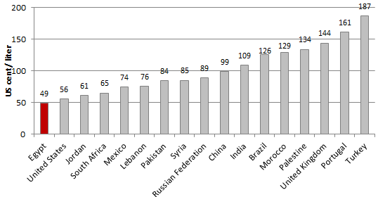
Source: based on data from GTZ (2009)

  - More accommodating macroeconomic framework

This option entails expansionary fiscal and monetary policy framework. This includes tolerance to higher budget deficit and higher levels of inflation. While Egypt has resorted to this option in the current fiscal year to stimulate the economy and achieve sought social objectives in the wake of popular demands, continuing the reliance on this option is restricted for two main reasons: First, Egypt deficit averaged 8.72 percent of GDP for the last 3 years and accumulated debt averaged 81.2 percent over the same period (see table 5). Second, inflation rates have been two-digits for the last 3 years, and averaged above 10 percent over the past two decades (WB, 2011).

  - Using fiscal and central bank foreign exchange reserves

This option includes two main sources: First, fiscal reserves including savings from budget surpluses and other state revenues (profit of state-owned companies, export revenue from natural resources). Second, foreign exchange reserves in the central bank.

Egypt’s fiscal reserve can possibly benefit from the revenues accrued from surpluses from the natural resources sector (oil and natural gas), the Suez Canal, and other state-owned companies. These surpluses are projected to amount for 4.4 percent of GDP for the 2011/2 (Ministry of Finance, 2011). Nevertheless, the continuation of running high deficit coupled with the low tax/GDP ratio consume these surpluses and leave no room to allocate some of the returns to support the proposed benefit.

Foreign exchange reserves are accumulated through foreign exchange market interventions by central banks within the context of current account surpluses and/or capital inflows. Countries build up foreign exchange reserves usually to self-insure against economic and financial shocks and also as part of broader efforts to stabilize the macro-economy, especially exchange rates (Ortiz, Chai, & Cummins, 2011).

While the Net International Reserve is still at comfortable levels totalling US$ 20.15 billion as of November 30, 2011, which covers almost 4.8 months of imports (1.8 months above the three-month safe level benchmark), the declining trend is particularly alarming. Since January 2011, the Net International Reserve lost almost US$ 15 billion (Central Bank of Egypt, 2011). The continual decline of the reserve reflects the pressure on the external sector in the wake of the recent instability in the Middle East. For the fiscal year 2010/1 the balance of payment ran an overall deficit of US$9 billion, compared with a surplus of US$ 3.4 billion a year earlier (Central Bank of Egypt, 2011). Tourism industry was severely hit; international arrivals were 40.8 percent lower in May 2011 compared with May 2010 (IDSC, 2011). The capital and financial account resulted in a net outflow of US$ 4.8 billion in 2010/1 compared with a net inflow of US$ 8.3 billion a year earlier. Furthermore, the net FDI declined by 67.6% and stood at US$2.2 billion (Central Bank of Egypt, 2011).

If the reserve continues to be depleted at the current rate, pressure will continue to build on the local currency and inflation, which, therefore, restricts the ability of the government to borrow from the central bank’s reserve to fund its programs (including the proposed benefit). This is added to the increased risk of lending the government associated with the high national debt/GDP ratio as discussed earlier. Nevertheless, if the current transition is proven to be a transitory shock and the economy resumes its growth path, this option can be used in the short-run to smoothen the transition to fund the proposed system of cash transfer in combination with other long-term adjustment measures. For instance, the gasoline subsidy can be reformed over a longer period of 5 years, during which the government borrows from the central bank’s reserve to finance the child benefit until the subsidy is totally phased out and can alone cover the cost of the proposed benefit.

  - Increased aid and transfers, borrowing or restructuring existing debt

As a middle income country, Egypt’s reliance on the flow of aid to finance the proposed system of child benefits is not a reliable option. While there have been reports on obliged aid to Egypt to overcome the post-revolution transition (Aljazeera, 2011a), aid is not predictable and therefore are not a sustainable source of funding. However, it might be used to smoothen the transition period while attempting to create the fiscal space through other long-term adjustment measures.

Egypt has also reached a high national debt/GDP ratio as discussed earlier. Local debt is particularly high- the minister of financed recently stated that Egypt’s reliance of local debt sources reached its limit (Aljazeera, 2011b). In addition, excessive local borrowing might crowd out private investments, which can ultimately slowdown the recovery process. Furthermore, Egypt’s government bond rating was downgraded by Moody’s Investors Services to B1, pushing it deeper into junk status. Standard & Poor’s was also downgraded to BB- citing negative views on the future of Egypt’s sovereign debt (Aljazeera, 2011c). These ratings translate into limiting Egypt government’s access to international credit markets and raising the interest rate it will face.

What might be relevant for the purpose of funding the proposed benefit is structuring existing debt. There have been reports over the past few months of agreements between several donor countries to debt swaps according to which the Egyptian government commits to injecting the equivalent amount into infrastructure, education, health or other social projects in Egypt (Aljazeera, 2011c). Again, this option should be viewed as a temporary measure to smoothen the transitional period while gradually freeing fiscal space of other long-term measures such as fuel subsidy reform, or tax restructuring.

In addition to legal financial flows, curtailing Illicit Financial Flows (IFFs) could also free up additional resources. IFFs involve capital that is illegally earned, transferred or utilized and include, inter alia, traded goods that are mispriced to avoid higher tariffs, wealth funnelled to offshore accounts to evade income taxes and unreported movements of cash (Ortiz, Chai, & Cummins, 2011). A recent study estimated on average IFFs outflow from Egypt between 2005-8 to have totalled US$ 6.36 billion annually (Kar, & Curcio, 2011), which is about 5.18 percent of GDP over the same period and amounted to more than ten times the total aid received by Egypt. Thus, it is worthwhile for Egypt to examine possible strategies to crack down on IFFs through increased transparency rules.

References

Al-Ahram Hebdo. (October 26, 2011). Marches en bref. Cairo.
Aljazeera net. (2011). Egypt Negotiates to Obtain Arab Financing. Retrieved October 31, 2011, from http://www.aljazeera.net
Aljazeera net. (2011). El-Beblawi Justifies Foreign Borrowing. Retrieved 10 26, 2011, from www.aljazeera.net
Aljazeera net. (2011). Standard & Poor's Warns another Credit Downgrade for Egypt . Retrieved 11 2, 2011, from http://www.aljazeera.net/ebusiness?GoogleStatID=33
CAPMAS. (2009). Egypt's Population Projection: 2006-2031. Cairo: CAPMAS.
CAPMAS. (2009). Household Income, Expenditure and Consumption Survey (HIECS). Cairo.
CAPMAS. (2011). Population Research and Studies, issue: 82. Cairo: CAPMAS.
Central Bank of Egypt. (2011, October). Monthly Statistical Bulletin. Retrieved from http://www.cbe.org.eg/Bulletinyrs.aspx
Committee on the Rights of the Child. (2011, July 15). Concluding Observations of the Committee on the Rights of the Child: Egypt. Fifty-seven session.
ENCRO. (2011). Never Attending School. Children in Egypt: Facts of Today, Vision for Tomorrow(1).
GTZ. (2009). International Fuel Prices 2009: 6th Edition — More than 170 Countries. Eschborn: GTZ.
Hagan-Zanker, J., & McCord, A. (2011). The Affordability of Social Protection in the Light of International Spending Commitments. ODI Social Protection Series.
Heller, P. S. (2005). Understanding Fiscal Space. Washington D.C.: IMF.
IDSC. (2011). Social and Economic Indicators Periodical. Retrieved 9 2011, from http://www.eip.gov.eg/upload/periodicals/13/3041/November_Bulettin_Ar.pdf
ILO. (2011). Social Protection Floor for a Fair and Inclusive Globalization. Report of the Social Protection Floor Advisory Group. Geneve.
IMF. (2011). World Economic Outlook Databases. Retrieved September 2011, from http://www.imf.org/external/ns/cs.aspx?id=28
Ministry of Finance. (2011). Egypt's Finance Minister in Talks over G8 $38 billion pledge. Retrieved November 17, 2011, from http://www.mof.gov.eg/English/MOFNews/Media/Pages/Egypt%27sfinanceministerintalksoverG8%27s$38billionpledge.aspx
Ministry of Finance. (2011). State's General budget for FY 2011/2012 . Retrieved July 2011, from http://www.mof.gov.eg/English/Main%20Topics/Pages/budget11-12.aspx
Ortiz, I., Chai, J., & Cummins, M. (2011). Identifying Fiscal Space: Options for Social and Economic Development for Children and Poor Households in 182 Countries. New York: UNICEF.
UN. (2011). Department of Economic and Social Affairs, Population Division. World Population Prospects: The 2010 Revision, CD-ROM Edition.
UN. (2011). National Account Main Aggregates Database. Retrieved from The Economic Statistics Branch of the United Nations Statistics Division: http://unstats.un.org/unsd/snaama/
UN. (2011). World population prospects: the 2010 revision population database. Retrieved from Population Division of the Department of Economic and Social Affairs of the United Nations Secretariat: http://www.un.org/esa/population/
UNDP. (2010). Human Development Report 2010. Retrieved 2011, from http://hdrstats.undp.org/en/countries/profiles/EGY.html
UNDP. (2011). MDG Monitor: Egypt. Retrieved from http://www.mdgmonitor.org/country_progress.cfm?c=EGY&cd=
UNICEF. (2010). Child Poverty and Disparities in Egypt: Building the Social Infrastructure for Egypt's Future. Cairo: UNICEF Egypt.
UNICEF. (2010). Social Protection: Accelerating the MDGs with Equity. New York.
UNICEF. (2010). Trends of Child Poverty and Disparities in Egypt Between 2000 and 2008. Cairo: UNICEF EGYPT.
UNICEF. (2011). Public Finance and Social Budgeting, learning Module. New York: UNICEF.
WB. (2005). Egypt- Toward a More Efficient Social Policy: Subsidies and Social Safety Net. Washington D.C.
WB. (2011). World Development Indicators (WDI). Retrieved from http://data.worldbank.org/data-catalog/world-development-indicators

Annex: Overview of Transfer Programs in Egypt

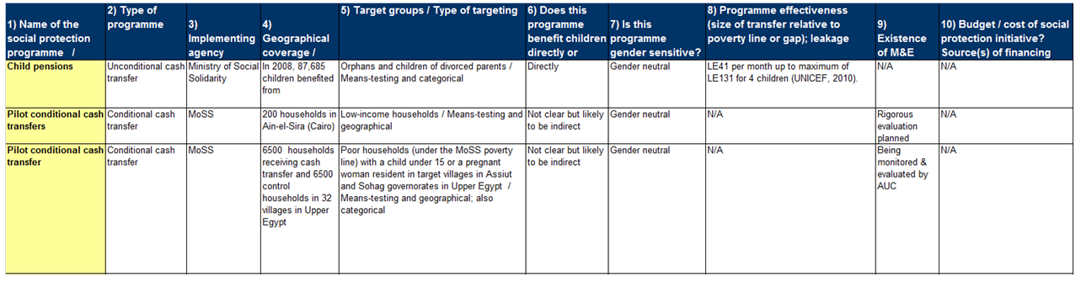

Some parts of this section are adapted from an unpublished UNICEF Social Protection Program Guidance.
The UN Chief Executives Board for Coordination (CEB), supported by its High level Committee on Programmes (HLCP) adopted the Social Protection Floor Initiative (SPF-I), as one of its nine joint crisis initiatives to cope with the effects of the economic crisis. For further information, please check http://www.socialsecurityextension.org/gimi/gess/ShowTheme.do?tid=1321
The indexation of benefit amount is discussed in chapter 4.
conditional cash transfers are given to beneficiaries conditional on particular actions, such as sending children to school or attending regular health check-ups
This is not expected to significantly create supply-side problems as primary school enrolment in Egypt is already high. There is enough ground to think that the additional increase in demand due to the incentive will be within the current capacity of the government. But once conditionalities are agreed upon by wider audience, a separate exercise can look into this in more details.
This is the most commonly used measure of inequality. Its value ranges between 0 and 1: A low Gini coefficient indicates more equal income or wealth distribution, while a high Gini coefficient indicates more unequal distribution. 0 corresponds to perfect equality (everyone having exactly the same income) and 1 corresponds to maximum inequality (where one person has all the income, while everyone else has zero income).
The evidence was collected from multiple sources and used in the brief (UNICEF, 2010), available at http://www.unicef.org/socialpolicy/files/Social_Protection_Accelerating_the_MDGs_with_Equity(2).pdf
Data obtained on October 13, 2011 from the IMF website
The budget for fiscal year 2010/1 is actual, for fiscal year 2011/2 is expected, and for fiscal year 2011/2 is budgeted. Note that there has been some reports of reassessment in the budget 2011/2.
Note that exempting goods/services that are disproportionally consumed by the poor can reduce regressivity and may actually make the VAT progressive. At this stage there are no details released on the planned VAT.
There have been recent reports that the projected deficit has been reassessed; its estimate now around 19.4% higher than the released budget. http://english.ahram.org.eg/news/29785.aspx
There has been some recent news report that the government has approved a plan to cut subsidy to energy-intensive industries, final decision needs approval from the military. If implemented, this will save about E£5 billion, which is still a very small fraction of the overall subsidy directed to energy products. http://english.ahram.org.eg/news/29785.aspx
This matrix was developed by ODI as part of a background paper on the existing social protection programs in Egypt.

