Method of costing for LTC :

The costing method use
demographic trend
data from survey ( as heath survey with ADL and IADL)
scenarios on “social model “
Demographic projections of population ( sex , quinquennal age class )
Unit Care needs ( hours per level of disability )
Projection of dependent people
Population (by level of disability)

Prevalence rates of disability (from national health survey) )
(
Social model :
Means- tested ?
Participation of family ?
Number of care hours need for all the beneficiaries (of the scope plan)

Final estimation of final cost
( ex ante : before of return of jobs creation )

- Estimation of number of dependent people
Suppose you have a set of dependence rate by group of sex and age (quinquenal) i with several levels j of dependency for year n (for instance n = 2008) according on a grid of dependency based on combines of incapacity ( ADL and IADL).
Several draft grids could be tested preparing to prepare the better choice scope / cost
On year n, there are $\text{Dn},j=\sum{N_{n,i}}P_{n,i,j}$ number of dependent with the level j ( formula A)
where $Nalignl{\begin{aligned}n,i\end{aligned}}_{}$is the number of people in the sex and age class vi on the year n
and$P_{n,i,j}$is the prevalence of dependent level j in the group vi on year n , for instance j=2008

Figure 1 : French prevalence of dependence by age the grid AGGIR ( from national health survey 2008)
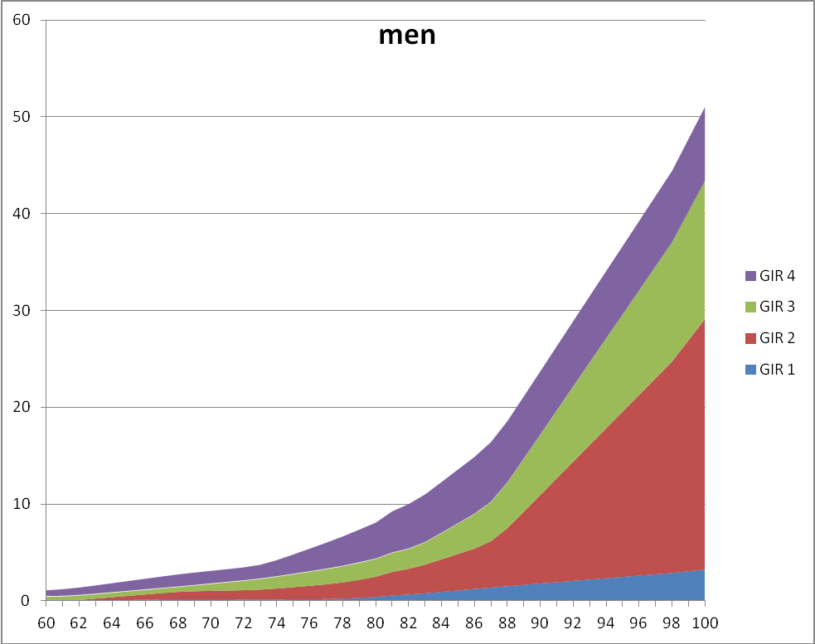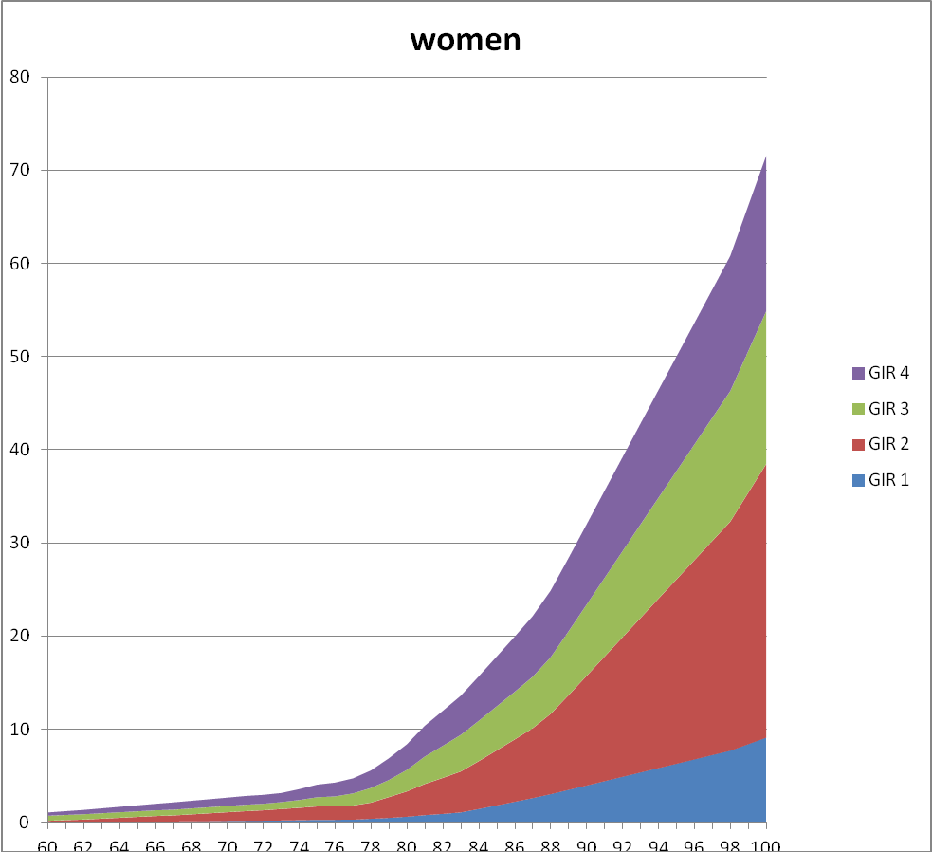
If you apply the formula (A) you can get the a first number and rough projection with the hypothesis $\text{Dn},j=\sum{N_{n,i}}P_{n,i,j}$.
For a first approach, let have a first (pessimistic) hypothesis of stable prevalence rate $P_{n,i,j}=P_{\text{2008},i,j}$
Other hypothesis are based on a reduction $P_{n+m,i,j}<P_{n,i,j}$according to the LHE ( Healthy life expectancy) augmentation. See annexe 2.
As the diagram shows the number of dependant old people will increase from 1.300.000 to 1.800.000 in 2040
Figure 2: Number of dependent old people from 2012 to 2040.
Then we need data of number of hours needed for each level of dependency ( for instance 30 hours / month in average for people GIR 3). This data come from survey or /and care givers observations.
- Basic cost model for LTC ( based on needs of care hours by 4 graduations of dependency )
2012 | Number of beneficiaries | number or hours / unit | cost of 1 hour € | montly unit cost € | annual cost ( millions €)
 | a | b | c | d= b*c | e=a*12*d
GIR 1 | 104 928 | 47 | 17 | 807 | 1016
GIR 2 | 397 590 | 36 | 17 | 612 | 2920
GIR 3 | 359 381 | 30 | 15 | 457 | 1971
GIR 4 | 423 019 | 21 | 13 | 276 | 1401
total |  |  |  |  | 7308
2020 | Number of beneficiaries | number or hours
GIR 1 | 117 312 | 47 | 21,5 | 1022 | 1439
GIR 2 | 444 421 | 36 | 21,5 | 775 | 4135
GIR 3 | 398 679 | 30 | 19,0 | 579 | 2770
GIR 4 | 468 855 | 21 | 16,5 | 350 | 1967
total |  |  |  |  | 10310
2030 | Number of beneficiaries | number or hours
GIR 1 | 118 443 | 47 | 28,9 | 1374 | 1953
GIR 2 | 458 306 | 36 | 28,9 | 1042 | 5730
GIR 3 | 422 459 | 30 | 25,5 | 778 | 3944
GIR 4 | 506 435 | 21 | 22,1 | 470 | 2856
total |  |  |  |  | 14482
2040 | Number of beneficiaries | number or hours
GIR 1 | 144 403 | 47 | 38,9 | 1846 | 3199
GIR 2 | 541 858 | 36 | 38,9 | 1400 | 9105
GIR 3 | 507 827 | 30 | 34,3 | 1046 | 6372
GIR 4 | 609 698 | 21 | 29,7 | 631 | 4620
total |  |  |  |  | 23296

Annexe 2 : forecast of dependent people in France : Three main scenarios

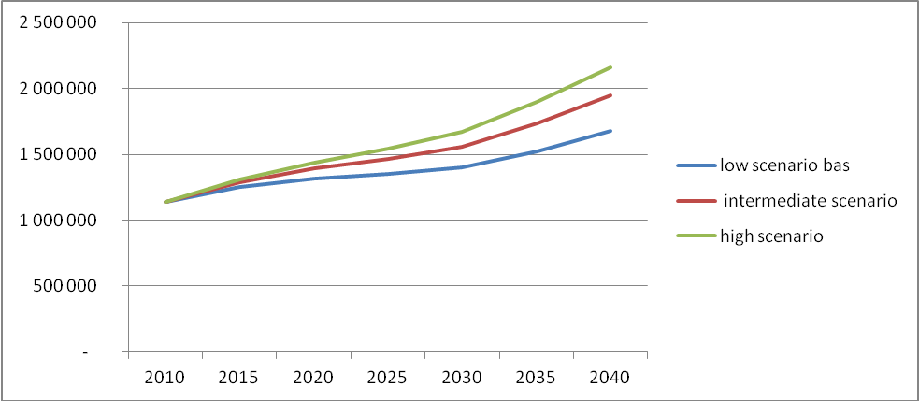

The hypothesis
 |  | High hypothesis | Intermediate  hypothesis | Low hypothesis
Men | LE at 60 years | 23,6 years
Men | Gains EV 2010-2060 | + 5,3
Men | GHLE | 21,3 | 21,7 | 22,1
Men | GHLE / LE | 90% | 92% | 94%
Men | Gains GHLE 2010-2060 | + 4,5 | + 4,9 | + 5,3
Women | LE at 60 years | 27,6 years
Women | Gains EV 2010-2060 | + 4,9
Women | GHLE | 22,8 | 23,4 | 24,1
Women | GHLE / LE | 82% | 85% | 87%
Women | Gains GHLE 2010-2060 | + 3,5 | + 4,1 | + 4,9

GIR 1 : old people inable to leave their bed or armchair and with heavy mental desease ( ex Alzheimer) GIR 2 : old people inable to leave their bed or armchair or with heavy mental desease GIR 3 : old people without mental limitations but with mobility limitation restriction . They need help for mostly all ADL and are frequently incontinent. GIR 4 : old people who need ponctual help for bathing and clothing

