Knowledge Products  Policy Briefs, Delivering Social Protection Briefs, Universal Social Protection Briefs, Publication Briefs | Version 2.0  Date: 06.08.2014

Terms of reference for the production of social protection briefs

1. Rationale

The family of social protection briefs includes four different types of short notes (1-4 pages) which provide timely key policy messages and up-to-the-point information on good practices in social protection and recent ILO publications, aimed at a wide audience including ILO constituents, policy makers, practitioners, and experts. The briefs series will:

- Have immediate visibility and impact; each week at least one new brief of one of the four series is issued, printed and disseminated through the social networks;
- Update the Social Protection Platform (SPP); the briefs will be available on the SPP and will enrich the county and thematic pages;
- Contribute to the consolidation of knowledge; the briefs will be bundled and published as an online and printed compendium(s).

2. Respective Objectives, Key Elements, Audiences

POLICY BRIEFS (PB)
Objective
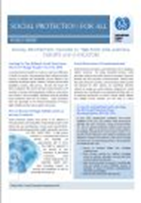
This series should address timely issues ("hot topics") of relevance to high level policy makers and anybody interested in current policy developments. The objective is to contribute to the discussion based on solid evidence to convey the ILO’s policy messages based on the firmly rooted ILO’s rights-based approach and mandate of promoting social justice.
Key elements
Summary of policy debates, good practices, ILO contribution to the debate, policy positions (including positive developmental messages), references for further reading.
Audience
ILO and other specialists, representatives of ministries in charge of social protection, other policy makers, social partners, UN agencies, IMF, the World Bank, development partners, academics.

DELIVERING SOCIAL PROTECTION FLOORS (DSP)

Objective
This series should focus on innovative country experiences, including those lesser known, aimed at providing useful insights and suggestions on how to implement national social protection floors.
The briefs will reflect on all of the guiding principles as described in the Social Protection Floors Recommendation, 2012 (No. 202). Guiding principle 3 (a) on the universality of protection, will however be the main focus of the Universal Social Protection briefs (see below).
Key elements
Description of innovative country experiences and good practices, videos, diagrams, references for further readings.
Audience
ILO and other specialists, representatives of ministries in charge of social protection, other policy makers, social partners, managers of social security institutions, decentralized governments, academics, UN agencies, development partners, civil society organizations (CSOs).

UNIVERSAL SOCIAL PROTECTION (USP)

Objective:
This series will focus on successful experiences of countries, including those lesser known, that have made substantial progress in achieving universal coverage in at least one branch and/or extending coverage to a specific population group (e.g. domestic workers). The experiences will be shared as a means to provide evidence of and feed into the policy debate on the feasibility of universal coverage. The briefs will describe the development process, challenges and lessons learned, results and socio-economic impact.
The briefs will thus reflect on guiding principle 3 (a) on the universality of protection, and on guiding principle 3 (l) on coherence with social, economic and employment policies, as described in the Social Protection Floors Recommendation, 2012 (No. 202). These country briefs may at some point contribute to the contents of the Policy Briefs (“hot topics”).
Key elements
Description of innovative country experience and good practices, focus on developmental benefits, link to ILO policy messages, references for further readings.
Audience
ILO and other specialists, representatives of ministries in charge of social protection, other policy makers, social partners, managers of social security institutions, academics, UN agencies, development partners, CSOs.

PUBLICATIONS BRIEFS (PUB)

Objective
The briefs will serve as press releases to promote recent ILO and non-ILO flagship reports, guides and other publications. The briefs will be produced by the main author(s) of the publication.
Key elements
Relevance of the publication, the publication’s structure and main contents, target group, a cover of the publication, hyperlink to the *.pdf version available on the Social Protection Platform.
Audience
ILO and other specialists, representatives of ministries in charge of social protection, other policy makers, social partners, managers of social security institutions, academics, UN agencies, development partners, CSOs and training institutes.
(Tentative Lay-out)

3. Drafting, Validation & Launching Process

- All briefs are numbered for internal use only:
- Policy Briefs (“hot topics”): PB- (year)- 00X (e.g. PB-2014-001)
- Universal Social Protection: USP-(year)-00X (e.g. USP-2014-001)
- Delivering Social Protection: DSP-(year)-00X (e.g. DSP-2014-001)
- Publications Briefs: PUB-(year)-00X (e.g. PUB-2014-001)
- Once briefs have received final validation, they will be assigned a series number by Victoria Giroud (in absence Karuna Pal).
- For each series an ISBN number is generated.

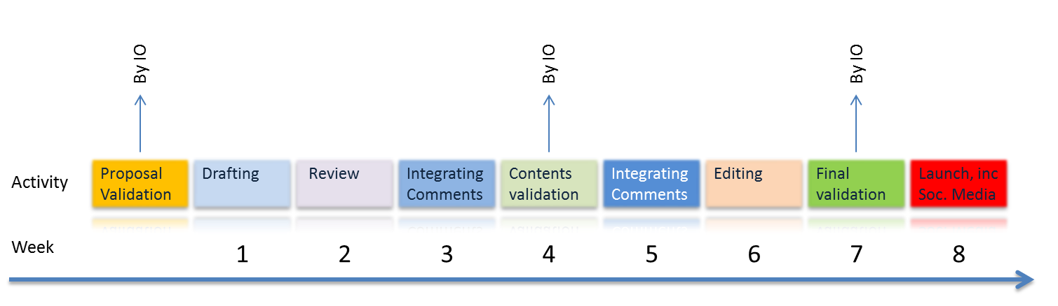
- All briefs will have the following drafting & validation cycle:

The briefs will be launched (i) online and (ii) as printed editions.

The online launch of the briefs includes:
- Uploading the brief on the Social Protection Platform (SPP), linking to Topics, Countries and the Publications page;
- Creating a news item for the SPP;
- Creating a post for the social media (i.e. twitter, facebook, linkedin).

The launch of the printed editions includes:
- Distribution in the field through Regional Office’s communication specialists and technical specialists;
- Distribution (on shelves etc.) at ILO HQ, Regional Offices, DWT, Country Offices;
- Distribution at the ILC, GB and other events;
- Distribution at ITC ILO Turin and UN Staff College.

4. Storage and consolidation of the briefs

The briefs will be stored on the Social Protection Platform (Library) and displayed through the Country, Topics, and Publications pages of the platform.

The Country pages will include relevant Universal Social Protection briefs and Delivering Social Protection briefs.

The Topics pages will include relevant Policy briefs (“hot topics”), Universal Social Protection briefs and Delivering Social Protection briefs.

The Publications page may include one section per type of publication:
- Global reports (ex: World Social Protection Report)
- Working papers
- Policy papers
- Compendiums of country experiences (collection of Country Briefs)
- National/TC reports.

Each section will include an introduction and for each publication: (1) Cover and link to PDF, (2), Publication brief, (3) Video, (4) PowerPoint (if relevant), (5) Policy/USP/DSP briefs.

For instance for the Global reports section:

GLOBAL REPORTS

Introduction blablablabla

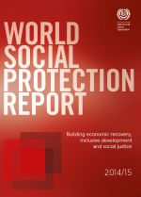 | Publication brief on the WSPR (PUB-2014-xx)   | Video  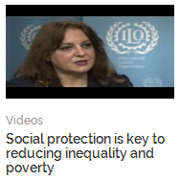 | Policy briefs related to the WSPR (PB-2014-xx)  - policy trends  - children  - working age  - old age  - health
Other publications …

For instance for the Compendiums of country experiences section:

COMPENDIUMS OF COUNTRY EXPERIENCES

Introduction blablablabla

Universal Social Protection Country Briefs |  | Delivering Social Protection Floors Country Briefs
Introduction blablablabla

> Thailand: universal health coverage

Universal SP Brief  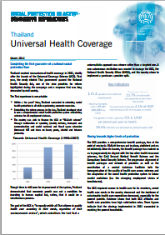 | Interview / video on Thailand’s UCS  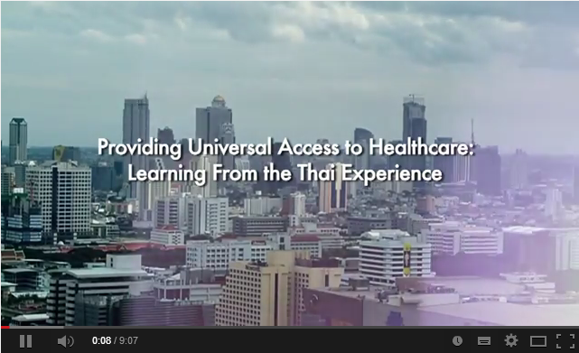 |  | PPT presentation  
> Colombia: Universalizing health protection

Universal SP Brief | Interview/video on Colombia’s experience |  | PPT presentation
> Other USP Briefs…

Universal Social Protection Country Briefs |  |  | Delivering Social Protection Floors Country Briefs
Introduction blablablabla

> ICROP, South Africa: Reaching out to the rural poor

Delivering SPF brief |  | Interview of ICROP manager  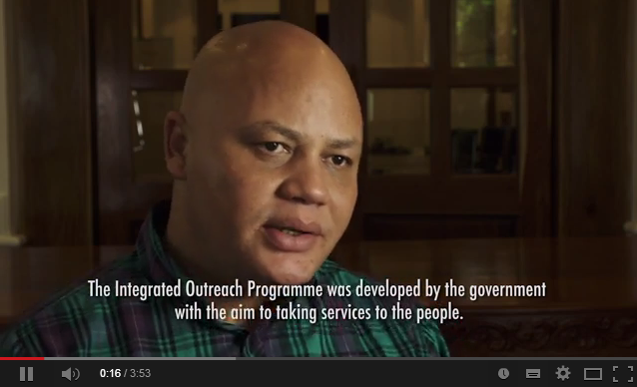 |  |  | PPT presentation |  | Video of the PPT presentation  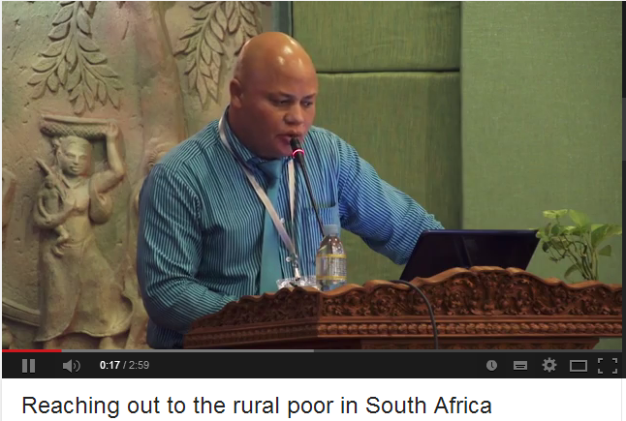
> Worker Facilitation Centres, India: A single window service for social protection

Delivering SPF brief |  | Interview of WFC manager  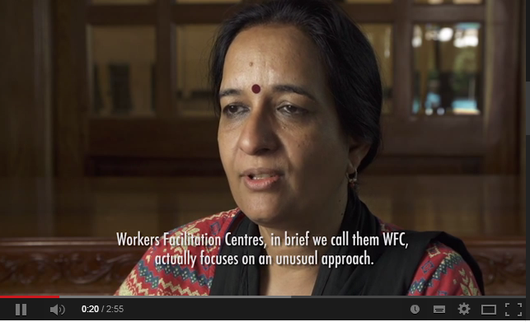 |  |  | PPT presentation |  | Video of the PPT presentation or of the scheme  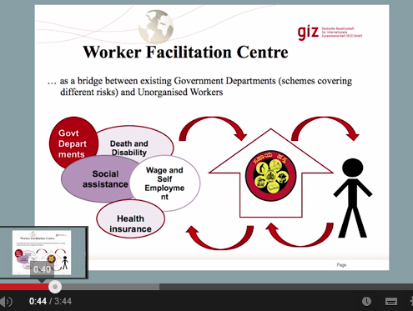
> Other DSP Briefs …

Once the series Universal Social Protection Coverage Country Briefs and Delivering Social Protection Floors Country Briefs will include 30-40 briefs we will be in a position to bundle the briefs and publish them in online and printed compendiums.

5. Taking action!

Please sign in on the www.social-protection.org platform, and then go to:
http://www.social-protection.org/gimi/gess/ShowProjectWiki.do?wid=2475

You will find:
- The present document: Terms of Reference for the production of social protection briefs (last update 6 August 2014)
- A preliminary List No. 1 of proposed Policy Briefs (with assigned responsibilities) (last update 6 August 2014)
- A preliminary List No. 2 of Universal Social Protection (USP) and Delivering Social Protection Floors (DSP) Country Briefs (with assigned responsibilities) (last update 6 August 2014)
- Template USP Brief
- Template DSP Brief

Examples of Policy Briefs
- Social Protection Floors in the Post 2015 Agenda: Targets and Indicators
- Rapid Extension of Health Protection

Example of a Country Brief
- Thailand: Universal Health Coverage

If your name is not in one of the two lists, or if you have concrete suggestions of new briefs that you would like to prepare, please send an email to:
- Isabel Ortiz ortizi@ilo.org
- Valerie Schmitt schmittv@ilo.org
- Victoria Giroud giroud@ilo.org
- Clara Van Panhuys vanpanhuys@ilo.org

Let’s make it happen…

