Social protection assessment based national dialogue: A good practices guide

The social protection floor (SPF) is a basic set of social security guarantees that should be extended to all. The establishment of social protection floors (SPFs) has increasingly been recognized as an efficient approach to combating poverty, inequality and exclusion, and a key element to promote human development, political stability and inclusive growth. As such SPFs provide an enabling framework for national development strategies.

Building SPFs is a long and continuous process. The ABND exercise is the first step towards the achievement of nationally defined SPFs. It helps formulate relevant and feasible policy options, based on an assessment of the social protection situation, cost estimations and sustained national dialogue.

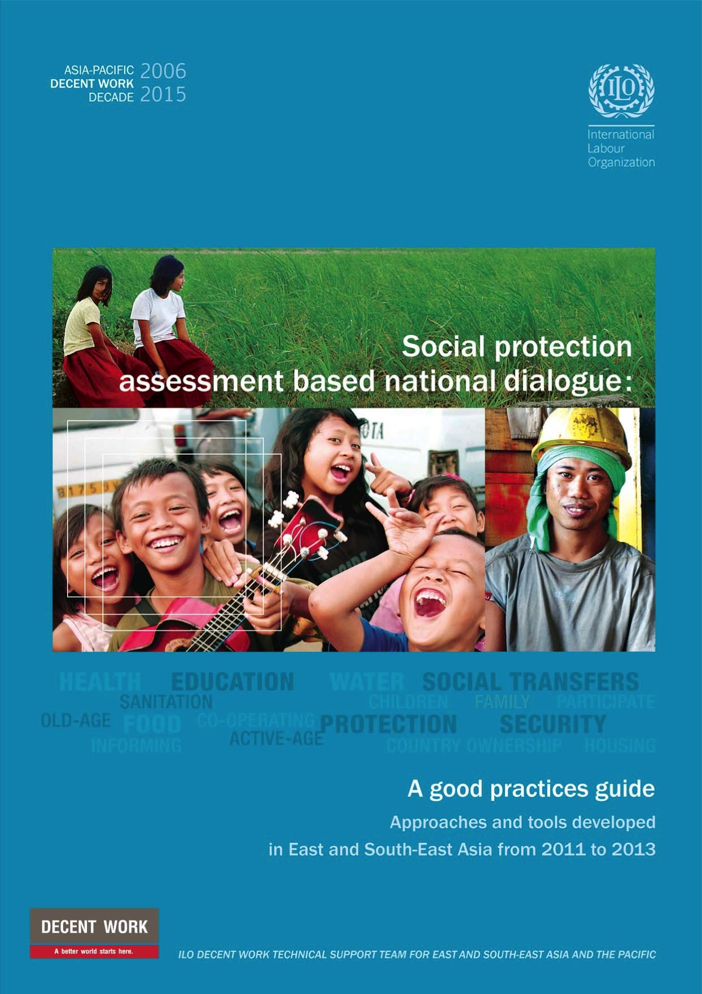 | Social protection assessment based national dialogue: A good practices guide  is a unique resource package that provides step-by-step support for conducting an ABND exercise. It can be used for self-learning, delivering training workshops and conducting full-fledged ABND exercises.

The guide is available in two forms:  - Textbook (publication);  - e-Box (website and CD),  which is complementary  to the textbook. | 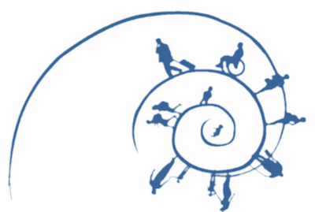

The textbook comprises modules that describe the ABND exercise, and the case study of a fictitious country called Coresia. The case study is designed to simulate the ABND exercise and give users practical experience of conducting the ABND.

In addition to the modules and case study of Coresia, the e-box also contains videos, presentations, instructions for group activities, and a cost- estimation model for Coresia. | 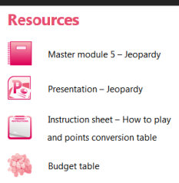

The guide can be used and disseminated among government agencies, social protection institutions, social partners, civil society, UN agencies and development partners, social protection taskforces and experts in the field.

The guide was developed based on the experiences of Cambodia, Indonesia, Thailand, and Viet Nam. A preliminary version of the guide has been tested at various training workshops, and has been used to start ABND exercises in Lao PDR, Mongolia, Myanmar, Philippines and other countries.

Download the Guide (textbook)!
http://www.social-protection.org/gimi/gess/ ShowRessource.action?ressource.ressourceId=44257

Access the e-box!
http://www.social-protection.org/gimi/pages/abnd/

