Assessment Based National dialogue for a social protection floor: the case of the review of the national strategy for basic social security in mozambique

Introduction:

In the last decade Mozambique has made significant progress in the extension of basic social security coverage to the most vulnerable populations, through the establishment of a legal framework for basic social protection and the implementation of the National Strategy for Basic Social Security. Following the approval of the Law on Social Protection of 2007, which defines social protection as a right for all citizens, the Government of Mozambique approved the Regulation of the Basic Social Security Sub-system--85/2009. In order to achieve the objectives outlined in the Regulation, the Council of Ministers of adopted a multi-sectoral National Strategy for Basic Social Security 2010-2014 (ENSSB), which established the principles, key actions, implementation tools, and targets, for the implementation of basic social protection between 2010 and 2014.

The ENSSB was a milestone for the sector and created the foundation for the development of a costed expansion plan, the redefinition of the basic social security programs, and the comprehensive review of the administrative and management instruments for basic social security. With financial and technical assistance from UN agencies, the Ministry of Women and Social Affairs (MMAS) and the National Institute of Social Action (INAS) revised the program rules and procedures, and developed operational manuals for each program, which led to significant reforms in the INAS business model.

These advances in the legal and operational framework facilitated significant increases in budget allocations to basic social protection programs, thereby enabling the expansion of the number of beneficiary households and the level of benefits. In 2009 there were approximately 160,000 beneficiary households. By 2014, coverage had increased to almost 450,000 households.

Evolution in the coverage of INAS Programs 2008-2015
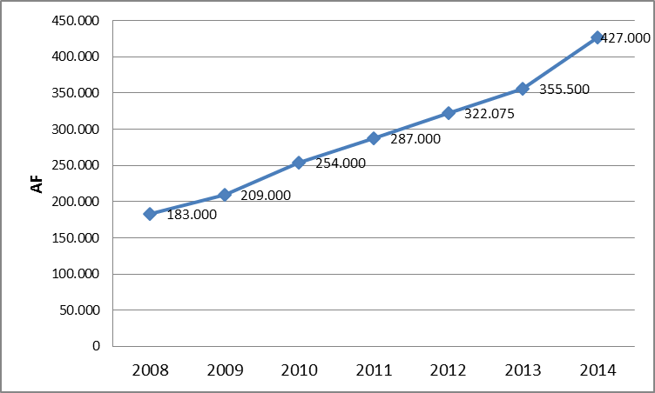
Source: ILO et al (2014)
The value of the social transfers in the Basic Social Subsidy Program also increased from approximately 70 Mts per households in 2008, to between 280 Mts for a single-person household and 580 Mts for households with up to four dependents. Budget allocations for INAS Programs increased from approximately 0.21% to 0.51% of GDP from 2010 to 2014.

Budget allocations to INAS Programs as a % of GDP and the State Budget 2011-2014
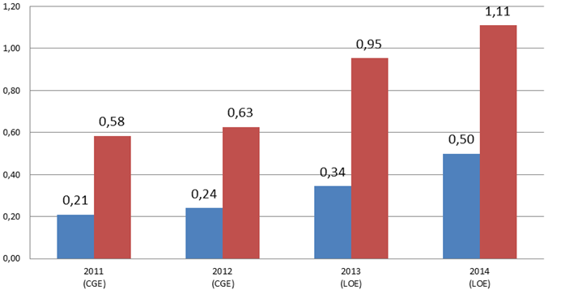
Source: ILO et al (2014)

The current ENSSB came to an end in 2014. At the request of the Government of Mozambique, and in coordination with development partners and civil society organizations, the ILO launched an assessment based national dialogue process in 2014 for the evaluation and revision of the ENSSB.

The Structure for Decision-Making and Internal Governance

The Assessment-Based National Dialogue process (ABDN) for the evaluation and revision of the ENSSB in Mozambique began in January 2014 and is due to be finalized at the end of 2015. It is a participatory process, led by Government of Mozambique through the Ministry of Gender, Children and Social Action (MGCAS) and the National Institute for Social Action, with financial and technical support from the ILO.

In order to guide the ABDN process, a technical working group was established, with technical support from the ILO, which includes the advisor to the Minister of MGCAS, the Director of Social Action, the Director of INAS, the Deputy Director for Planning. The role of this group was not to make final decisions regarding the evaluation and elaboration of a news strategy. Rather it was to provide technical expertise and advise to the Consultative and Coordinating Council of the Basic Social Security Subsystem, who are ultimately responsible for validating the proposals before they are submitted to the Council of Ministers for approval. The Council of Ministers is the final decision-making body.

Fig 3. The decision making process for the evaluation and revision of the ENSSB

The technical working group works in close collaboration with the PARP Social Protection Working Group to ensure a participatory, inclusive and representative process. The PARP Social Action Working Group was created in 2006 and is one of three forums of coordination for social protection in Mozambique. It serves as a platform to discuss the programmatic and strategic aspects related to the implementation of the social protection programs. It includes the Embassy of the Kingdom of the Netherlands, DFID, ILO, UNICEF, WFP, the World Bank, HelpAge International, Handicap International, the Civil Society Platform for Social Protection, Irish Aid, and the Embassy of Sweden. The use of an existing internal governance structure, developed over nearly a decade of national dialogue processes for the extension of social protection, in an effective way to ensure a participatory ABDN for the evaluation and revision of the ENSSB. It draws on the comparative strengths of partners, reducing fragmentation and streamlining interventions, thereby decreasing the transaction costs for government and ensuring an efficient use of resources.

Fig 4. Internal Governance Structure for Social Protection in Mozambique
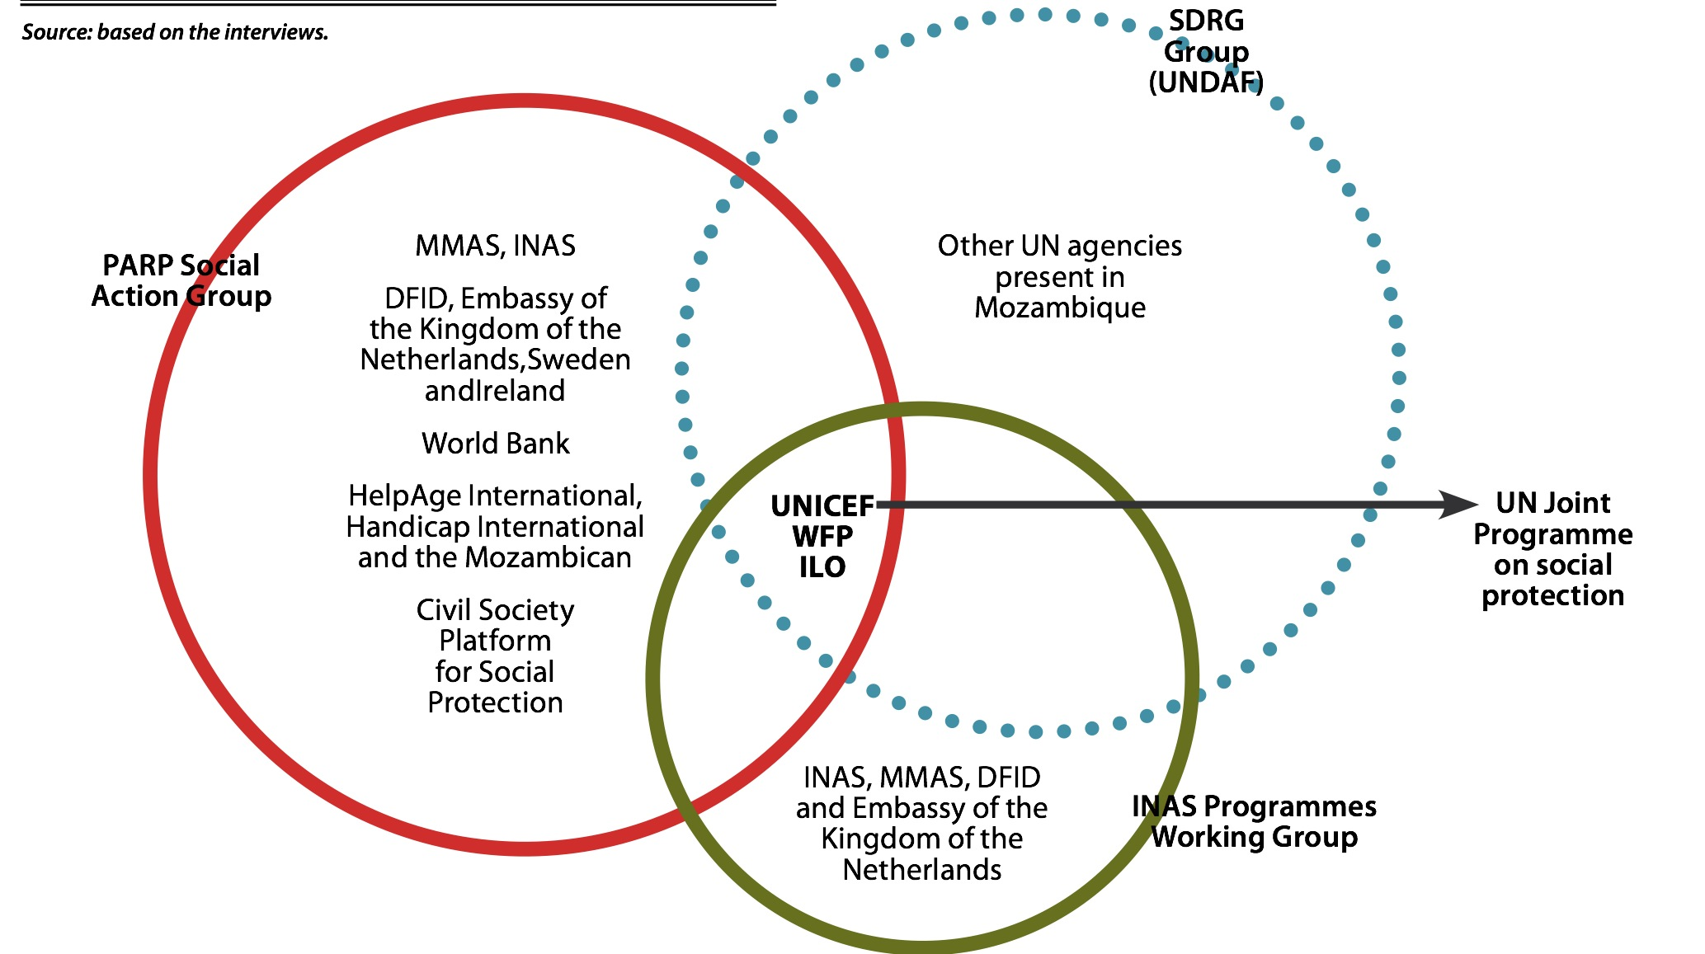
Source: ILO et al (2015)
Key Moments in the Evaluation and Revision of the ENSSB

The ABDN for the evaluation and revision of the ENSSB was composed of four phases:
- PHASE 1: Pre-Evaluation
- PHASE 2: Evaluation of the ENSSB
- PHASE 3: Elaboration of the ENSSB 2015-2019 and of the Operational Plan
- PHASE 4: Dissemination of the ENSSB 2015-2019

PHASE 1: Pre-Evaluation
January 2014-June 2014

During this phase he ILO undertook, at the request of the Government of Mozambique and in close collaboration with development partners and civil society organizations, three studies in underrepresented areas considered key for the revision of the ENSSB, specifically: HIV-senstitive social protection; maternity, nutrition and social protection; and public perceptions of social protection as an instrument for social justice. These studies highlighted:

- The need to focus on motherhood and early childhood, particularly in the first 1000 days of a child’s life, to combat chronic malnutrition,;
- The potential of social protection in reducing the impact of HIV/AIDS, and ensuring that households affected by HIV/AIDS can benefit;
- The importance of simple methods of targeting that can be understood by community members so as to ensure public support to for the programs.

Following a national dialogue where the the findings of the studies were presented and discussed with the Government, civil society organizations and development partners, the ILO commissioned a literature review of all previous studies related to the design and implementation of the ENSSB to inform the elaboration of the Terms of Reference for the evaluation and revision of the ENSSB. The ToRs were developed by MMAS and the ILO, in consultation with civil society organizations and development partners, and Oxford Policy Management was contracted, with ILO financial support and technical supervision, to undertake the evaluation and revision of the ENSSB.

PHASE 2: Evaluation of the ENSSB
July 2014-December 2014

The evaluation of the ENSSB was launched during the first National Social Protection Conference in 2014, which brought together provincial and national representatives of the Ministries involved in the implementation of the ENSSB, civil society organizations from across the country who represent the interests of children, the elderly, people with disabilities and women, and development partners. This was an initial opportunity to take stock of the advances of the basic social protection system in Mozambique, as well as the challenges. The Government then convened a smaller follow up meeting with PARP Working Group members to outline the process of the evaluation and the opportunities to provide input.

Objectives of the Evaluation

The objectives of the evaluation were to:
- Evaluate the progress made in relation to the objectives and targets outlined in the ENSSB and other implementation documents for basic social protection;
- identify coverage gaps, using the Social Protection Floor as a framework;
- and make recommendations to strengthening of basic social protection system.

The Framework for Evaluation

The evaluation framework is based on an analysis of the following:
- The relevance of interventions: taking into account Mozambique’s vulnerability profile, based on data from national surveys;
- The effectiveness and impact of interventions: in relation to the potential numbers of beneficiaries, and the adequacy of the value and quality of the services;
- The efficiency: of beneficiary selection, payment mechanisms, and cost-efficiency;
- The adequacy of the institutional framework: including coordination between actors at national and local level, operating systems and human resources;
- The levels, composition and trends of public expenditure on social protection, funding sources, and analysis of fiscal space for sustained long-term funding.

National Dialogue Process

The national dialogue process was led by the Technical Working Group for the evaluation and revision of the ENSSB, with support from the ILO and OPM. In order to guarantee a participatory and transformative national dialogue process, the ILO enlisted the support of the training and facilitation team at IPK to support the process design.

At the heart of the design approach is the concept that processes of transformation follow three phases: divergence, emergence and convergence. Divergence, often embedded in a structural tension or discomfort, opens up the space of possibility. Emergence is a central turning point where something new—a new social protection programme for instance—emerges and becomes the beacon of future action. Convergence is the final movement where participants in the national dialogue process close in on the options that are conducive, practicable and doable. Because the language barrier, IPK trained Mozambican facilitators, thereby strengthening the national capacity to facillitate a transformative national dialogue process.
Source: IPK
The technical document of the evaluation of the National Strategy for Basic Social Security was developed through the following iterations:

- Thematic group discussions with stakeholders and key informants. The thematic groups were based along the lines of the pillars:
  - Health social action
  - Productive social action
  - Education Social Action
  - Direct Social Action
  - Social Services
  - Institutional Capacity
  - Financing for social Discussions
- Follow up interviews with key informants and stakeholders involved in the policy design and implementation of the ENSSB. These included Government departments, civil society organizations and development partners. It also included field visits to rural districts.
- The development of thematic notes, based on group discussions and on-one-one interviews, triangulated with household and beneficiary data, which explored: the relevance of interventions, the effectiveness and efficiency of interventions, the adequacy of the institutional framework and questions of financing. The thematic notes were circulated to all participants and stakeholders for comments.
- The development of an evaluation report, based on the thematic notes, which was circulated to stakeholders and participants.
- Capacity-building workshops with 120 stakeholders, including the Civil Society Platform and members of political parties, to analyze findings of the evaluation report and support the development of position papers on basic social protection.
- National dialogue workshops with almost 200 provincial INAS and MGCAS delegates, national Government representatives, civil society organizations and development partners to: develop a common framework of analysis of vulnerability, broaden thinking about the role of basic social security for economic and social development, discuss the outcome of the evaluation and implications of the recommendations, and to develop proposals of policy options to be costed http://www.social-protection.org/gimi/gess/ShowNews.action?id=19789
- The costing of policy options for social protection programs.

Positions of Key Stakeholders
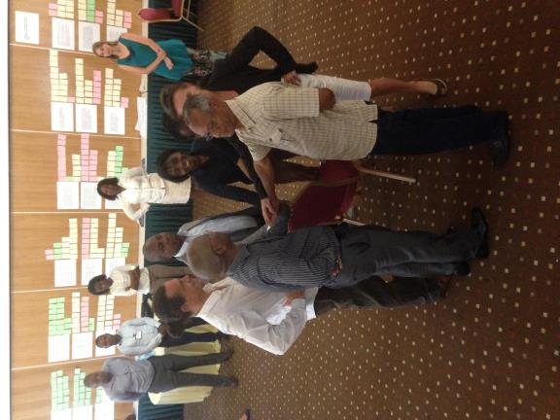
Political Party Manifesto

In order to secure continued political support for basic social protection and increase fiscal space, the ILO provided financial and technical support to organize a workshop with representatives of political parties ahead of the national elections to strengthen the visibility of social protection their respective manifestos 2015-2019.
- The Frelimo manifesto states that voting for Frelimo and President Jacinto Nyusi will ensure the continuity of the implementation of basic social security programs for the elderly, children and people with disabilities.
- The Renamo manifesto calls for a social protection system that is “functional, sustainable and accessible” and commits to increasing investment in the health and social welfare sectors, to ensure, in particular, the health of infant children, elderly, people with disabilities and the chronically ill.
- The MDM manifesto calls for a greater investment in social services including social security.

Photo: Representatives of MGCAS, Helpage, Handicap International, INAS and UNICEF close out the first day of the national dialogue for the evaluation of the ENSSB.

To ensure broad-based and active participation in the national dialogue process, the ILO collaborated with the Civil Society Platform for Social Protection (CSP) to prepare their. This process led to the development of a Civil Society Position Document on the evaluation and revision of the ENSSB, which clearly outlines their demands.

Main points of the position paper of the Civil Society Platform for Social Protection:
- The need for increased budget allocations to the basic social protection sector in order to ensure that INAS programs are able to meet the ambitious targets outlined in the National Development Plan for 2035;
- The progressive extension of basic social security through new programmatic options, specifically: a universal old-age pension, a universal disability subsidy and a maternity cash transfer (in order to address malnutrition among children and pregnant women);
- Improvement in the delivery of services, including the identification of beneficiaries, case management, payments and grievance procedures, by placing at least one INAS delegate in every district, replacing in-kind social transfers with cash transfers, and collaborating with civil society organizations when necessary;
- Simple and easily comprehensible eligibility criteria, that aspire towards universality;
- Stronger accountability to civil society organizations, by publishing budget allocations per delegations.

Key Findings of the Evaluation of the ENSSB

The first finding of the evaluation of the National Strategy for Basic Social Security is that ENSSB played a critical role in the significant advances in the social protection system. In addition three quarters of the key actions identified in the ENSSB 2010-2014 were either completed or partially completed (Fig 6). There was an increase in the coverage of the social subsidy program and the value of the social transfer; a new program for non-labor constrained households, Productive Social Action, was designed and launched; a process for the reregistration of beneficiaries and development of an information management system was started; a plan to outsource payment mechanisms, in order to free up social action staff to provide services, was developed; and a multi-sectoral mechanism for coordination was established, among other achievements. Only one quarter of key actions were not initiated, the majority of which are related to the Health and Education Social Action, which is beyond the mandate of the Ministry of Gender, Children and Social Action.

Fig 6. Traffic lights: Completion of the Key Actions outlined in the ENSSB
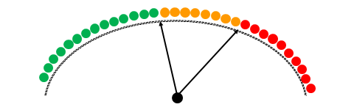

Despite these progresses, the evaluation points to significant gaps (Fig 7).

Fig 7. Strategic challenges in relation to the current social transfer programmes
Program |  | Main Strategic Challenges
Social Subsidy Program |  | Very limited (covers less than 10% of households). The current eligibility criteria, based on a household’s ability to work means that 40% of the elderly, 75% of people with disabilities, and 95% of children in poverty are excluded because they live in non-labour constrained households. Despite increases in the cash transfers, they continue to be very low.
Direct Social Action | Child headed households | A very small target group
 | Malnutrition (children) | Very limited coverage. Focus on the short term, which does not adequately prevent or respond to chronic malnutrition
 | Malnutrition (ARVs) | Unclear objective, relation with health interventions.
 | Immediate support | Important, but the focus is on immediate responses to malnutrition and not prevention.
Productive Social Action |  | Potentially enormous target group (non-labour constrained households living in a situation of poverty). The question of how to balance broad coverage with the objective of graduation. Lack of complementary measures and very short participation times.
Based on the strategic challenges outlined above, the following programmatic proposals were developed for the ENSSB 2015-2019 and costed, taking into account a gradual expansion plan of 10 years:
- A quasi-universal cash transfer for the elderly, people with disabilities and people with degenerative diseases
- A quasi-universal cash transfer for pregnant women and infant children between the ages of 0-2
- A cash transfer for child headed households and a foster grant
- A cash transfer for able-bodied adults through a public works programme

Fig 8. Cost of transfers as a % of GDP 2019 Cost of transfers as a % of GDP 202
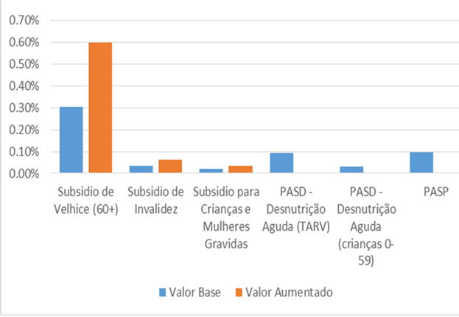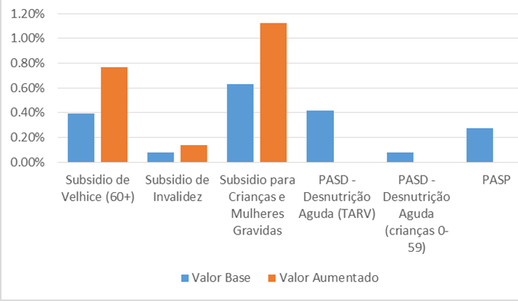

PHASE 3: Elaboration of the ENSSB 2015-2019 and of the Operational Plan
January 2015-August 2015

The Process

The findings of the costing exercise and the technical document of the new National Strategy for Basic Social Security 2015-2019 were presented at a series of back-to-back national dialogue workshops in February 2015. This included:
- A 3-day retreat with the technical working group of MMAS and INAS, and ILO technical support;
- A one day strategic meeting with the Ministry of Health, responsible for implementing the pillar of health social action;
- A one day strategic meeting with the Ministry of Education, responsible for implementing the pillar of education social action;
- A 1-day meeting with members of the technical and consultative Council of the Ministry of Gender, Children and Social Action
- And a 1 day meeting with civil society and development partners
- And meeting with the Minister of Gender, Children and Social Action;

Key Outcomes

What is notable is that at the technical level, the proposals outlined in phase 2 were accepted. In addition, there was consensus at the technical level that the in-kind food kit program, should be replaced with a more effective and efficient cash transfer program. This marks a radical shift in the conception of social protection. The new programs can be introduced at a gradual rate, taking advantage of the reregistration to test a maternity-child grant on a small scale. There continues to be the risk of operating a system that has a large number of outcomes and limited resources. There is a question therefore of how to prioritize interventions, focusing efforts on larger programs that have the potential to make the case for greater investment in social protection. In addition, the PASP program needs to be better defined given the large scope of potential beneficiaries.

In terms of social services, there was also consensus on the need to improve the provision of social services, bringing social action workers closer to the beneficiaries and setting up referral services to professionals specialized in social action. The services provided should be geared towards the social challenges faced by the majority of the population, namely: negligence, violence, trafficking, child labor, early marriage, sexual assault, and other practices.

In terms of institutional capacity, there was consensus on the need to place INAS technical staff in all district in the country even where there is not a delegation. In addition, emphasis was made on the need to strengthen the capacity of the SDSMAS and to replace the semi-volunteer force of ‘permanentes’ who represent INAS at the local level, with a Social Action agent. Furthermore, there was consensus on the need to invest in operating systems in order to ensure cost-effectiveness and operational efficiency, specifically through the MIS, monitoring and evaluation, the outsourcing of the payment system and a complains mechanism.

Follow-Up in Phase 3

Phase 3 will include one more series of national dialogue workshops through:
- Six thematic working group workshops related to the new pillars of the National Strategy for Basic Social Security 2015-2019, which will include members of the relevant Ministries, civil society organizations, and development partners;
- A one-day workshop with members of the Technical and Consultative council who will ultimately approve the ENSSB 2015-2019;
- Provincial consultations with INAS and MMAS delegates at the regional level in the South, Central and North of the country;
- Follow up discussions with the technical team regarding the monitoring and evaluation framework for the ENSSB 2015-2019.

Furthermore, the full cost of the implementation of the ENSSB 2015-2019—including social services and human resources—will be calculated. The inclusion a costed operational plan is key to ensure that when approved by the Council of Ministers, there is a financial commitment to its implementation.

Follow-Up in Phase 4

Once approved, the ILO will, at the request of the Government of Mozambique, support a nationwide dissemination campaign to ensure that all MMAS and INAS staff are familiar with the content of the National Strategy for Basic Social Security 2015-2019 and the operation plan. This is due to take place between September 2015- December 2015.

Lessons Learned

There are some key lessons learned from the ABDN for Mozambique:
- Respect for the government’s leadership and pace is essential to ensure ownership and the viability of the process
- Political moments and opportunities for change must be engaged through a transformative approach that brings together policy and decision makers, civil society, academia, trade unions and employers.
- The creative and intentional planning of the national dialogue process and moments of interaction is key to ensuring productive outcomes
- Regular informative and discussion sessions are essential to guarantee that the different stakeholders are prepared to participate in a constructive manner;
- The process requires iterative sessions of intensive work, with time in between to reflect an affect change
- It is important to take into account the institutional and financial capacity of each country, as well as the political context, and adapt proposals to these.
- There needs to be a continuous technical investment in champions, in order to strengthen the political influence of the social protection system.
- Regular assessments are essential to inform policy making and program reforms.

