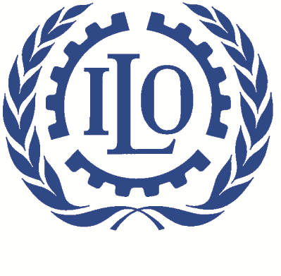

International Labour Organization

Training on “Maternity protection and Gender Dimension on Social Security” for labour and law inspector of trade unions of the Republic of Tajikistan

15-16 June 2017,
Bohoriston hotel complex
Kairakum, Republic of Tajikistan

Agenda

Thursday, 15 June

08:00 – 08:30 Registration

08:30 - 08:45 Opening and welcoming speeches
Mr. Ismoil Faizizoda, Deputy Chairperson of the Federation of Independent Trade Unions
in the Republic of Tajikistan
Mr. Artiom Sici, ILO Social Protection Officer

08:45 - 10:00 Review of trade union activities for 2016

10:00 – 11:15 Session 1: Standards and coverage from C103 to C183.
Ms. Kairgul Sadybykasova, International expert

11:15-11:30 Coffee-Break and group photo

11:30-13:00 Session 2: Employment protection and non-discrimination.
Ms. Kairgul Sadybykasova, International expert

13:00-14:00 Group Photo – Lunch

14:00-15:15 Session 3: Cash and medical benefits related to maternity.
Ms. Kairgul Sadybykasova, International expert

15:15-15:30 Coffee-Break

15:30-17:00 Session 4: Health protection at workplace.
Ms. Sayora Ashrapova, National trainer

17:00-17:15 Wrap up
Mr. Artiom Sici, ILO Social Protection Officer

Friday, 16 June

08:00 – 09:00 Registration, tea-coffee

09:00 – 10:30 Session 5: Breastfeeding arrangements at the workplace.
Ms. Kairgul Sadybykasova, International expert

10:30-12:15 Session 6: Beyond maternity and back to work
Ms. Sayora Ashrapova, National trainer

12:15-13:15 Lunch

13:15-14:45 Session 7: How to assess national law and practice.
Ms. Kairgul Sadybykasova, International expert

14:45-15:00 Coffee-Break

15:00-16:30 Session 8: Role of stakeholders
Ms. Sayora Ashrapova, National trainer

16:30-16:45 Wrap up
Mr. Artiom Sici, ILO Social Protection Officer

