Thematic activity under ILO’s Centenary celebrations
100 years of social protection at the ILO: the road to universal social protection
Knowledge sharing, awareness raising and fundraising campaign
Draft 5.0, 20/03/2018

- Introduction

ILO’s centenary includes the future of work initiative (led by DDG/P) and the centenary celebrations (led by DDG/MR). Both aim at raising ILO’s visibility, developing and sharing a new direction for ILO’s work in the coming years, and building support from ILO constituents as well as a broader audience.

The centenary celebrations will look at the past (commemorative), the present (changing environment; challenges and opportunities) and set the directions for the future (future of work and ILO’s contribution).

DDG/MR has launched a call for ideas to celebrate ILO’s centenary and received over 300 ideas from HQ and field colleagues. This patchwork is difficult to manage and to promote. DDG/MR therefore asked outcome coordinators (e.g. Outcome 3 on social protection) to develop thematic proposals under the ILO’s Centenary celebrations. These proposals include a clear message, clear outputs, and a concrete work plan involving both HQ and field colleagues/offices.
ILO’s Global Technical Team on Social Protection developed the present knowledge sharing, awareness raising and fundraising campaign on “100 years of social protection at the ILO: the road to universal social protection”.

The campaign is not a set of new activities, but builds on ILO’s ongoing work in the field of social protection. It is an opportunity to rebrand some of ILO’s planned and ongoing activities and projects under the “banner” of the centenary initiative, to give them higher visibility and impact, while increasing constituents’, development partners’ and general public’s support for ILO’s current and future work.

Based on a simple and shared message, it includes a common set of activities: knowledge generation, communication, partnerships, resource mobilization and the organization of events. It is targeting several audiences: ILO constituents, general public, private sector, development partners, civil society and academia. Special attention will be given to the dissemination of ILO’s messages among the general public that does not understand ILO’s jargon on social protection.

The campaign is also linked to ongoing centenary initiatives (e.g. future of work, green initiative, poverty initiative, etc.), outcome 3 and ILO’s Flagship programme on building social protection floors for all, and ILO tools (e.g. ILO100 website developed by DCOMM to reach out to the general population).

The campaign is implemented by ILO HQ and field colleagues in a coordinated manner. It therefore fosters knowledge sharing and collaboration within the Global Technical Team on Social Protection. Tools to facilitate joint delivery are developed as part of the campaign: workspace, website, templates, videoconferences, planning spreadsheets, etc.

The campaign will last 20 months (from April 2018 to November 2019). It will culminate with the Global Week on Social Protection that will lead ILO’s and development partners’ future work in the field of social protection.

- Common messages on social protection: past, present, future

100 years of social protection at the ILO
- The ILO, from its inception, has played a major role in guiding the establishment, development and maintenance of social protection systems across the world
- Over the past 100 years many countries have developed progressively more comprehensive social protection systems embedded in law
- Despite this development, more than half of the world’s population (or 4 billion people) lives without social protection at all
A renewed priority
- This situation is unacceptable from a human rights perspective and a missed opportunity from the economic and social development point of view (social protection contributes to ending poverty, reducing inequalities, investing in human capital, developing domestic demand, increasing productivity, building sustainable public institutions and social peace)
- The global context marked by the global financial crisis, persistent informality, new forms of employment, climate change, forced displacements and migration, has raised the importance of social protection on the development agenda
Universal social protection is feasible
- The past decade has seen a massive expansion of social protection in over 30 low and middle-income countries, showing that universal social protection is indeed feasible
- More innovative approaches are needed to extend coverage
- Better governance is key to build trust in social protection institutions
- Ratifying C102 helps to build comprehensive social protection systems
- ILO, World Bank, other UN agencies, workers and employers organizations, private sector enterprises, NGOs and champion countries are promoting the Universal Social Protection (USP) Initiative 2030
Universal social protection is our mandate
- Building social protection systems and floors is a priority of the 2030 Agenda
- It is also at the centre of ILO’s two dimensional extension strategy: ILO supports the development of basic social protection guarantees for all (horizontal dimension – social protection floors) while promoting progressively higher levels of protection guided by up-to-date ILO social security standards (vertical dimension)
Time for action
- The ILO’s Flagship Programme on Social Protection Floors for All supports constituents in giving effect to Recommendation No. 202 and contributing to the achievement of the related SDG targets
- Partners can make a difference by joining the multi-stakeholder partnership for SDG 1.3 and its various networks: the UN SPF Initiative; the Social-Protection Inter-Agency Coordination Board (SPIAC-B); the Social Protection, Freedom and Justice for Workers Network; the Global Business Network for SPFs; the NGO Global Coalition for the SPFs; the Global Partnership for Universal Social Protection (USP 2030); and partnerships with universities on capacity building and research
- Individuals can also contribute to making the right to social protection a reality for all by taking an active part in ILO’s awareness raising and fundraising campaigns

- Key activities

The campaign will include global, regional and country level activities and knowledge development that will take place from April 2018 to November 2019, culminating with the organization in Geneva of a Global Week on Social Protection on “100 years of social protection at the ILO: the road to universal social protection”.

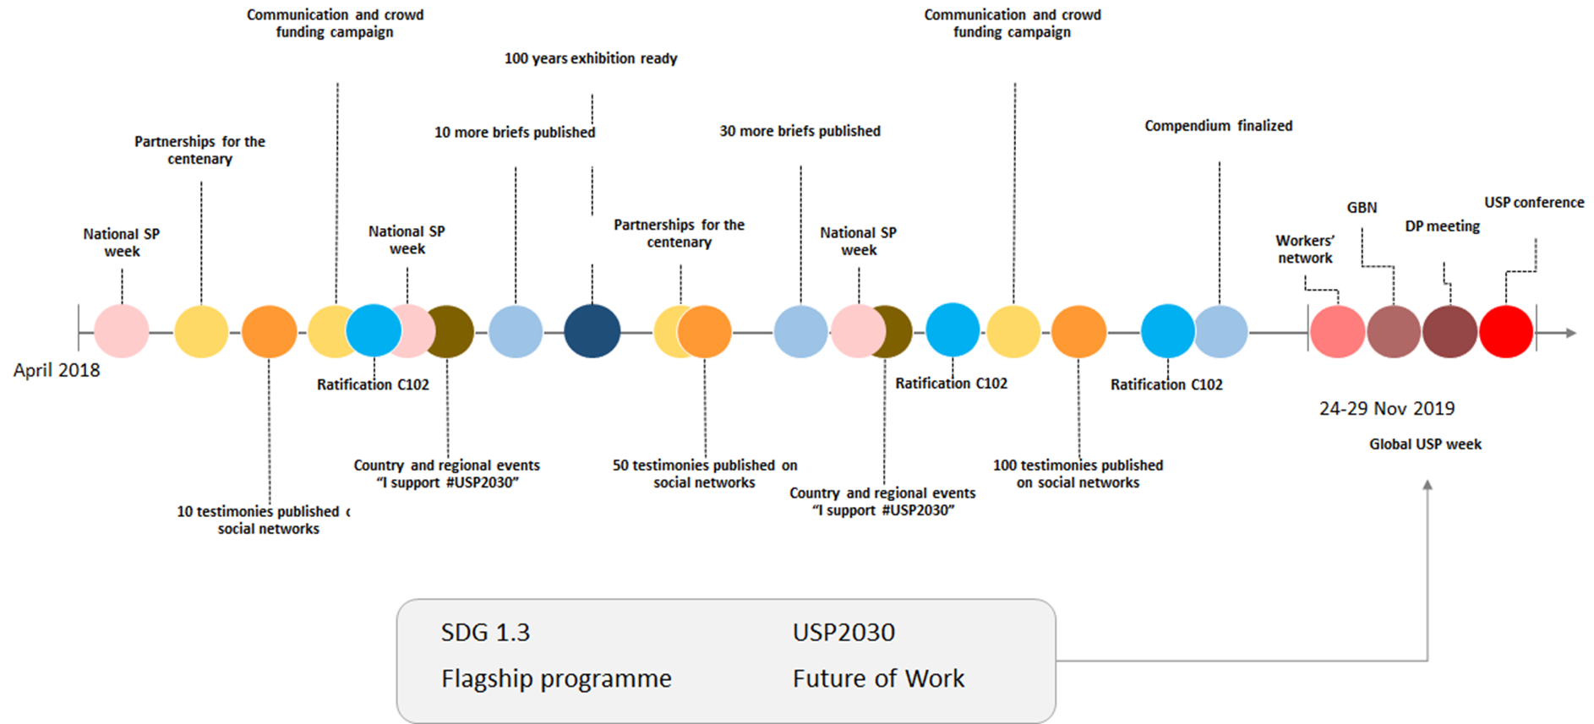

Figure 1. Tentative calendar for the thematic activity
“100 years of social security: the road to universal social protection”

Resource mobilization including communication and crowd funding campaign “100 million raised for social protection”
Date: | April 2018 → November 2019 (20 months)
Description: | The centenary campaign is a good opportunity to contact development partners and sponsors to inform them of ongoing centenary celebrations and seek their involvement. Some development partners may be interested to support the campaign to increase their own visibility. The current note could be shared with them (it includes a budget). Similarly, country action plans could be prepared by field specialists and shared locally.  Actions:  ☑ At HQ level: contact development partners of ILO Flagship programme; explore sponsorship from private sector.  ☑ At country level: contact local embassies, private sector (sponsors), resident coordinators, national governments that may be willing to play an active role, as well as workers and employers organizations.
Description: | Several communication and crowd funding campaigns will be organized during 20 months targeting the general public, employees and clients of private sector enterprises, trade union confederations, and civil society organizations. These campaigns will raise awareness on social protection and ILO’s projects and boost voluntary donations through the ILO/King Baudouin Foundation Social Protection Floors fund. The results of the campaigns will be shared during the Global Week on Social Protection (24-29 November 2019).  Link to the donate button: http://www.social-protection.org/gimi/gess/Flagship.action#donate
Contributions from GTT experts: | Sara: ILO Cairo’s click funding campaign to raise awareness and resources  Valerie: ongoing discussions with some of the DP partners on the organization of national conferences and USP events.
ILO units: | ☑ ILO Country Offices, development cooperation projects  ☑ ILO Regional Offices and DWTs  ☑ ILO SOCPRO, DCOMM, PARDEV, ACT/EMP and ACTRAV
Targets: | ☑ Development partners (traditional, emerging, UNRCs, private sector, …)  ☑ General public  ☑ Employers organisations  ☑ Workers organizations  ☑ CSOs
Templates: | Templates will be shared later on the workspace http://www.social-protection.org/gimi/gess/ShowProject.action?id=3078
Voices “100 beneficiaries provide their testimonies” or “100 voices on social protection”
Date: | April 2018 → November 2019 (20 months)
Description: | 100 testimonies will be collected:  ☑ Beneficiaries (children, mothers, injured persons, unemployed, older persons, persons with disabilities, fathers, migrants, refugees, domestic workers, workers in the rural areas, persons in the informal economy benefiting from a simplified scheme …)  ☑ People excluded from social protection (working older persons, persons who are sick and had to sell their land to pay for hospital bills, families with children that had to stop school, etc.)  ☑ Workers representatives  ☑ Employers representatives  ☑ Private sector enterprises (CEOs, CSR managers, HR Directors)  ☑ Governments  ☑ ILO and UN experts, experts from social protection institutions  ☑ UN resident coordinators, development partners  ☑ Ambassadors (M. Guy Ryder, M. Somavia, Ms. Bachelet, Mr. Assane Diop, Mr. Ocampo)  They will be asked to explain why social protection is important for them / the country / their institution. Those excluded from social protection will describe their lives in the absence of social protection (e.g. older persons that need to continue to work).  Each testimony will include a picture and a text (and if possible videos). Testimonies will be collected through country offices and social protection projects.  They will then be posted on our workspace (and then website), social networks and ILO CO/Regional Offices websites. The most beautiful ones will be selected by DCOMM for the ILO100 communication website.  The testimonies will also be printed in posters and can be exhibited during country/regional events, national social protection week and global week on social protection.
Contributions from GTT experts: | Ippei: ILO Japan interested to collect testimonies in Viet Nam and Indonesia through ILO Japan project  Celine: ILO Mongolia could collect testimonies on the Child Money programme; ILO Dakar could collect testimonies on the programme of “bourses familiales”  Helmut: ILO could collect testimonies in Mexico from families victims of the earthquake (role of unemployment protection); in El Salvador from migrant workers; in Central America from sugar cane workers; in Costa Rica from domestic workers; etc.  Luis: various initiatives on the development of a culture of social protection in Southern Africa; Luis wishes to partner with relevant institutions to ensure that they can contribute to the 100 years campaign of the ILO.  Ariel: testimonies should also contribute to building trust in social protection institutions (show that it works). ILO could use a network of local ambassadors of the social protection system (retired beneficiaries) that volunteer to raise awareness among the public.  Charles: ITC ILO Turin interested to use the 100 testimonies for the eLearning platform.  Luca: A lot of material (videos on Regina…) has been produced and can be used – more could be done. ILO will join an annual review of the Zambia UNJP which includes field visits. This could be a good opportunity to collect more testimonies.  Nita: Nepal has just passed the social security act; possibility to collect and disseminate testimonies (including from the Government).  Malika: Collecting testimonies from beneficiaries and employers is possible as part of the Government’s campaign to increase enrolment under NSSF Health Insurance scheme.  Sergio: Testimonies could be collected from Andean countries (pensioners, beneficiaries of Esalud, independent workers…).  Samia and Clara: Collection of testimonies on social protection for migrant workers will be done during the ITC ILO course in March.  Nuno Tavares: Collection of testimonies from PALOP countries can be done through Action Portugal project.
ILO units: | ☑ ILO Country Offices, DC projects  ☑ ILO Regional Offices and DWTs  ☑ ILO SOCPRO, DCOMM, PARDEV, ACT/EMP and ACTRAV
Targets: | ☑ General public  ☑ Governments, workers and employers representatives
Templates: | List of questions and instructions are available on http://www.social-protection.org/gimi/gess/ShowProject.action?id=3078.
Country and regional conferences on “100 years of social protection at the ILO: the road to universal social protection”
Date: | From April 2018 to November 2019
Description: | GTT members are often organizing or participating in national and regional conferences on social protection.  ☑ They could use a common template for their powerpoint presentations (using the new logo of the centenary initiative), a banner and a backdrop.  ☑ They could stress the key messages of the campaign through the presentation or the agenda of the meeting, focus on specific branches of social security or target groups or regions (e.g. universal health care, maternity benefits, social protection for migrants, social protection in Asia-Pacific, etc.) depending on priorities.  ☑ They could also use the conference as an opportunity to come up with a Declaration or Statement from participants on social protection. A group picture with a participants holding a banner could be taken and shared on the website and social networks.  ☑ They could also organize a “campaign” inviting participants to take a picture of them with a poster “I support #USP2030”.  ☑ Furthermore, the conferences could serve as a vehicle to promote and advance “Initiative C102.0– Ratify and Apply” which supports governments in ratification process for the Social Security (Minimum Standards) Convention.
Contributions from GTT experts: | Celine: Preparation of an ECOWAS declaration (will take several years).  Sara: South South events in North Africa.  Helmut: Conference of the CISS on 75 years of social security in Latin America in April 2018- explore whether there would be space to come up with a common declaration.  Luis: regional event planned on maternity protection.  Kenichi: ILO Budapest is celebrating its 25th anniversary; good to link the Centenary and the 25th anniversary.  Dramane: A meeting of all workers organizations in Central Africa is planned in 2018 in collaboration with FES. This could lead to a joint declaration.  Charles: use the SS Academy as one of the regional / global events – we could prepare a special session on the centenary (historical/forward looking)  Luca: Organization of yearly conference with SASPEN network on Universal Social Protection (historical perspective in Southern Africa; current situation and way forward)  Malika: Possibility to add the centenary initiative on social protection to events planned by NSSF in Cambodia
ILO units: | ☑ ILO Country Offices, DC projects  ☑ ILO Regional Offices and DWTs  ☑ ILO SOCPRO, DCOMM, PARDEV, ACT/EMP and ACTRAV
Targets: | ☑ Governments  ☑ Social protection experts  ☑ Employers organisations  ☑ Workers organizations  ☑ CSOs  ☑ Academia  ☑ Development partners including from the private sector  ☑ UN agencies  ☑ Social security institutions, ISSA
Templates: | A template for the organization of these conferences (guidance, messages, branding, PowerPoint presentation), a generic text of the Declaration or Statement, the Ratification Toolkit and pictures of the campaign “I support #USP2030” will be available on http://www.social-protection.org/gimi/gess/ShowProject.action?id=3078.
Preparation of a compendium on “100 countries committed to social protection”
Date: | From April 2018 to October 2019 (date of publication)
Description: | ☑ This compendium will include 100 case studies of countries’ successful experiences & good practices in developing social protection systems and floors (NB: we have already published 49 briefs from 27 countries in 2016). The compendium will be launched during the Global Week on Social Protection.  ☑ More knowledge will be produced and disseminated during the 20 months of the campaign notably on the future of social protection.  ☑ All the publications and web tools will follow a common branding and use the new logo of the centenary initiative.
Contributions from GTT experts: | Luis: We could document the importance of a culture of social protection in Southern Africa (Kampala declaration)  Ariel: Possible brief on social protection and climate change (country tbc)  Dramane: Possible brief on Gabon  Charles: ITC ILO Turin interested to use the 100 country cases for the eLearning platform.  Luca: Through an existing network of practitioners in 4/5 countries, possible development of new country cases on the extension of social protection to workers in the informal economy.  Sergio: More country experiences could be documented in the Andean countries.
ILO units: | ☑ ILO Country Offices, DC projects  ☑ ILO Regional Offices and DWTs  ☑ ILO SOCPRO
Targets: | ☑ Governments  ☑ Social protection experts  ☑ Employers organisations  ☑ Workers organizations  ☑ CSOs  ☑ Academia  ☑ UN agencies  ☑ Social security institutions
Templates: | A template for the briefs will be shared on http://www.social-protection.org/gimi/gess/ShowProject.action?id=3078.  Published briefs are available here:  Volume 1 universal schemes http://www.ilo.org/wcmsp5/groups/public/---ed_protect/---soc_sec/documents/publication/wcms_538984.pdf  Volume 2 innovations http://www.ilo.org/wcmsp5/groups/public/---ed_protect/---soc_sec/documents/publication/wcms_538986.pdf  Volume 3 governance and financing http://www.ilo.org/wcmsp5/groups/public/---ed_protect/---soc_sec/documents/publication/wcms_538987.pdf  Many videos of these briefs available for instance here http://www.social-protection.org/gimi/gess/RessourceSearch.action?id=3&ressource.type.ressTypeId=392
Ratification of the ILO Convention C102 – “Ratify and Apply Initiative”
Date: | From April 2018 to December 2019
Description: | ☑ In 2012, the Governing Body approved the ILO’s Social Security Plan of Action aiming at reaching a total of 60 ratifications for Convention No. 102 by 2019, the year of the ILO’s Centenary, thus ensuring that at least 30 per cent of the global population would live in countries where the requirements of the Convention No. 102 are accepted as minimum standards.  ☑ Currently, 55 countries have ratified ILO C102, and five more ratifications are needed to reach the target of 60.  ☑ HQ and GTT experts should use the centenary initiative to communicate with ILO constituents on social protection and proactively promote the ratification of ILO C102, providing to countries all legal and technical support needed for a successful ratification process. This is the “Ratify and Apply Initiative”.  ☑ To reach this objective, the ILO has developed and will soon launch a Ratification Toolkit to support ILO experts and constituents in the ratification process.
Contributions from GTT experts: | Kenichi: Use the Centenary to boost ratifications of ILO C102.  Dramane: Collaboration with WSM “Abidjan Social Movement” that came up with a joint declaration which promotes the ratification of C 102.
ILO units: | ☑ ILO Country Offices, DC projects  ☑ ILO Regional Offices and DWTs  ☑ ILO SOCPRO  ☑ ACTRAV and ACT/EMP
Targets: | ☑ Governments  ☑ Social protection experts  ☑ Employers organisations  ☑ Workers organizations  ☑ CSOs  ☑ Academia  ☑ UN agencies  ☑ Social security institutions
Templates: | The Ratification Toolkit will soon be available on http://www.social-protection.org/gimi/gess/ShowProject.action?id=3078.
Preparation of an exhibition “100 years of social security”
Date: | From April to December 2018
Description: | A global exhibition will be developed by SOCPRO in close collaboration with DCOMM and DDG/MR.  ☑ It will highlight major milestones of the development of social protection globally over the past 100 years as well as the main results achieved with successful country examples, challenges and way forward.  ☑ It will include banners with pictures and texts including testimonies of key personalities that have contributed to the development of social protection globally. A video version of the exhibition (with voice over) will also be developed.  ☑ The exhibition will be disseminated through public events (such as the country and regional conferences), ILO offices, internet, and schools and during the Global Week on Social Protection (in ILO’s colonnade).  Regional/country level exhibitions will be developed by GTT experts and communication specialists by adding a few more banners on the local context to the global exhibition.
Contributions from GTT experts: | Celine: Prepare an Interview of Assane Diop on the development of ILO Recommendation No. 202.  Charles: ITC ILO Turin interested to use the exhibition in 2018 and 2019 (SS Academy and other courses).
ILO units: | ☑ ILO SOCPRO  ☑ DCOMM  ☑ DDG/MR  ☑ ILO Country Offices, DC projects  ☑ ILO Regional Offices and DWTs
Targets: | ☑ General public & schools  ☑ Governments, workers and employers representatives  ☑ Social security institutions  ☑ International fora and events  ☑ ILO and other UN staff
Templates: | Templates for the banners will be ready by May 2018 on http://www.social-protection.org/gimi/gess/ShowProject.action?id=3078.
National social protection weeks
Date: | Various dates (for instance October 2018 and 2019 in Zambia, April 2018 and 2019 in Latin America, etc.).
Description: | ☑ Many countries/regions celebrate the social protection week every year. For instance, in Latin America it is celebrated by the majority of countries during the last week of April.  ☑ Some countries may be interested to launch a SP week during the centenary celebrations.  ☑ Activities, images, photos, statements of the SP weeks could be posted on the social networks, dedicated workspace and dedicated website of the centenary initiative.
Contributions from GTT experts: | Celine: Possible interest to introduce a social protection week in Senegal.  Sara: Possible interest to introduce a SP week in Egypt.  Helmut: Use the SP week to promote the centenary and USP 2030 in Mexico, Costa Rica, El Salvador (what about Uruguay and Paraguay?)  Luis: Possible interest to introduce a social protection week in South Africa.  Ariel: Use the SP week to promote the centenary and USP 2030.  Luca: Use the SP weeks in Zambia and Mozambique to promote the Centenary initiative  Nita: Nepal has just passed the social security act; possibility to launch a SP week as part of ongoing awareness raising activities led by the government.
ILO units: | ☑ ILO Country Offices, DC projects  ☑ ILO Regional Offices and DWTs
Targets: | ☑ Governments  ☑ Social protection experts  ☑ Employers organisations  ☑ Workers organizations  ☑ CSOs  ☑ Academia  ☑ Social security institutions
Templates: | Examples of the process/activities/documents of existing social protection weeks are already available on http://www.social-protection.org/gimi/gess/ShowProject.action?id=3078  Please share more!
Social protection global week “100 years of social protection at the ILO: the road to universal social protection”
Date: | The social protection global week will be organized during the “historical” month of the first International Labour Conference that took place from 29 October – 29 November 1919 (with first GB that took place on 27 November 1919). The social protection global week will take place in Geneva from 25-29 November 2019 (i.e. after the 337th Session of the Governing Body that is taking place from 24 Oct 2019 to 7 November 2019).
Description: | ☑ The social protection global week will include the annual meetings of the various networks that the ILO has developed as part of the multi-stakeholder partnership for SDG 1.3.  ☑ It will also include a number of communication events.  ☑ It will culminate with the organization of a global conference on “100 years of social protection at the ILO: the road to universal social protection” that will also take stock of the national/regional conferences outcomes.  ☑ During the social protection week a number of ILO position papers and publications (e.g. on social protection and the future of work, universal basic income, etc.) will be presented and disseminated.
Tentative agenda: | Day 1. Workers’ meeting “100 trade unions fight for workers’ rights to social security”  - Annual meeting of the workers’ network that aims to defend social security rights and promote universal social protection  - Sharing results at country level, as well as results of global campaign, and announcing new activities  - Acknowledging workers’ network contribution to the achievement of SDG 1.3  - Signature of partnerships with trade union confederations (engagement to support specific projects on workers’ mobilization for social protection floors)
Tentative agenda: | Day 2. Global Business Network for SPFs meeting “100 enterprises support Universal Social Protection through the Global Business Network for SPFs”  - Annual meeting of the GBN that aims to promote ILO social security standards to shape corporate social protection guarantees, develop the business case for social protection and promote companies’ in-country support to the development of sustainable social protection systems and floors  - Sharing results and announcing new commitments from enterprises  - Acknowledging GBN contribution to the achievement of SDG 1.3  - Signature of new partnerships with enterprises  NB: the GBN includes already 50 enterprises including 25 active. We would need to increase membership.
Tentative agenda: | Day 3. Development partners’ meeting “100 development partners are supporting the Universal Social Protection (USP) Initiative and SDG 1.3 on social protection”  - Results of ILO’s Flagship programme (2016-2019) and its role as part of the USP 2030 Initiative  - Special segment on the UN SPF Window and ILO/King Baudouin Foundation Social Protection Floors fund  - Panel discussions and market place to share results of the Flagship programme (country level projects, thematic areas, etc.), to emphasize the importance of multi-stakeholder partnerships for achieving results  - Signature of new partnerships with development partners as well as multi-stakeholder initiatives
Tentative agenda: | Day 4. High level conference on “100 years of social protection at the ILO: the road to universal social protection”  - Presentation of the USP 2030 Initiative by participating agencies, institutions and champion countries  - Share progress made towards achieving SDG 1.3. based on ILO’s World Social Protection Database and selected country examples  - High level panel discussions on challenges and way forward: role of social protection in a changing environment (future of work, climate change, refugee crisis, universal basic income)  - Share highlights of the events organized by the country and regional offices during 20 months as part of the 100 years campaign  - Share the results of the CEACR on the global implementation of R202 that will be discussed by the Committee on the Application of Standards (CAS) at the ILC 2019  - Launch of the compendium on “100 countries committed to social protection” as well as other key publications (on the future of work, UBI, etc.)  - Share the results of the communication and crowd funding campaign “100 million raised for social protection”  - Consensus building for the future of social protection: signature of a global consensus or declaration on USP2030
Tentative agenda: | Communication activities during the week:  - Signature of a poster during the week to crystalize and publicize governments’, employers’, workers’, private sector’s and development partners’ commitment for USP2030  - Exhibition “100 beneficiaries provide their testimonies”  - Exhibition on “100 years of social security”  - Crowd-funding campaign continued during the event  - Signature ceremony of a global consensus or declaration on USP2030
ILO units: | ☑ ILO SOCPRO (and members of the GTT from country and regional offices)  ☑ CABINET, DDG/P, DDG/FOP, DDG/MR  ☑ MULTILATERALS, PARDEV  ☑ ACT/EMP and ACTRAV  ☑ NORMES and relevant policy departments
Targets (and co-organizers): | Members of the multi-stakeholder partnership:  ☑ Governments, workers and employers organizations  ☑ Members of the UN SPF Initiative, Social-Protection Inter-Agency Coordination Board (SPIAC-B), Global Partnership for Universal Social Protection (USP 2030)  ☑ Members of the Social Protection, Freedom and Justice for Workers Network  ☑ Members of the Global Business Network for SPFs  ☑ Members of the NGO Global Coalition for the SPFs  ☑ Universities and research centres, social protection experts  ☑ Journalists
Templates: | Previous editions of the Development Partners meeting, GBN meeting and workers meeting are available on http://flagship.social-protection.org

- Tools to facilitate joint delivery

Knowledge development and sharing
GTT experts are invited to share all the contents produced as part of the 100 years campaign on a specific workspace created for that purpose: http://www.social-protection.org/gimi/gess/ShowProject.action?id=3078. This workspace will soon have an easy to remember url: http://centenary.social-protection.org.

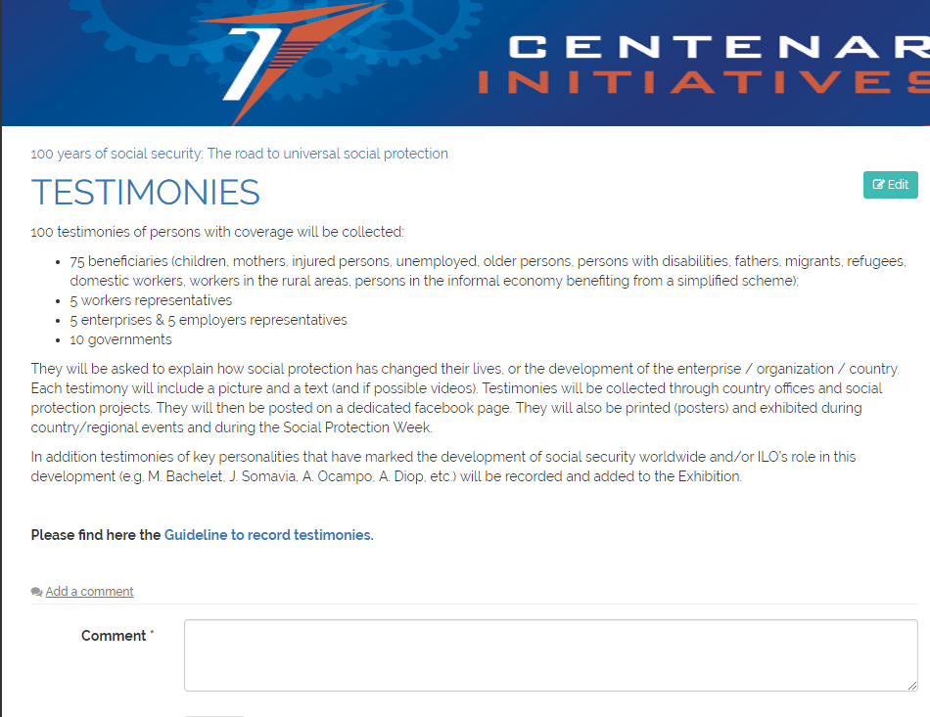

The workspace is opened to all ILO Social Protection GTT members – please register to the Social Protection platform if you haven’t do it yet.

The workspace includes sections for each activity
- Resource mobilization & crowdfunding
- Testimonies
- National/Regional events
- Compendium
- Exhibition
- Ratification of Convention No 102 (1951)
- National Social Protection Week
- Global Social Protection Week

Under each section users can share what they are doing in the “comment” section. They can also share their contributions by email to Victoria Giroud, Huguette Yere or Valerie Schmitt. All contributions are published on the workspace, and are made available to all the members of the GTT.

Dissemination
All activities and events are then published on an ILO official website dedicated to the campaign on “100 years of social protection at the ILO: the road to universal social protection”: http://ILO100.social-protection.org. This website currently under development will be linked to DCOMM’s ILO100 website.

DCOMM will reuse our products and information on our activities for the ILO wide communication campaign. This campaign includes the ILO100 website, a 24 hours event, and “Voices” (testimonies).

All activities and events will also be shared through our social networks:
http://twitter.com/soc_protection
http://www.facebook.com/SPplatform
https://www.linkedin.com/company/social-protection-platform
https://www.youtube.com/channel/UCWf4KIllUoxGa3aeMf-jBvw
https://www.instagram.com/spdilo/

All activities and events can also be published on ILO country office and regional office websites.

Branding and templates
As part of the campaign a common “branding” will be adopted based on the global guidance received from DCOMM for the centenary visual identification. All the templates, logos, banners and other visual materials will be made available on the workspace under relevant sections.

ANNEX 1. Tentative budget
 | unit cost | N | total
Communication and crowd-funding campaign
- Communication officer (P1) during 8 months | 10150 | 8 | 81200
- Partnership officer (P3) during 4 months | 15700 | 4 | 62800
- Service contract | 15000 | 1 | 15000
Testimonies and exhibition
- Communication officer (P1) during 2 months | 10150 | 2 | 20300
- Excolls in 10 countries | 2000 | 10 | 20000
- Editing | 2000 | 1 | 2000
- Printing | 5000 | 1 | 5000
Country and regional conferences (10)
- Travel costs of international participants | 8000 | 10 | 80000
- Coffee breaks, meals | 3500 | 10 | 35000
- Interpretation | 2000 | 10 | 20000
- Publication | 1000 | 10 | 10000
Compendium & other publications
- Excolls | 3000 | 12 | 36000
- Editing | 15000 | 1 | 15000
- Publication | 5000 | 1 | 5000
- Layout | 1500 | 1 | 1500
Workers' network meeting
- Partnership junior officer (P1) during 2 months | 10150 | 2 | 20300
- GS staff during 1 month | 13560 | 1 | 13560
- Travel costs of participants | 20000 | 1 | 20000
- Coffee breaks, meals | 3500 | 1 | 3500
- Interpretation | 5000 | 1 | 5000
- Publication | 1000 | 1 | 1000
GBN meeting
- Partnership officer (P3) during 2 months | 15700 | 2 | 31400
- GS staff during 1 month | 13560 | 1 | 13560
- Travel costs of participants | 5000 | 1 | 5000
- Coffee breaks, meals | 3500 | 1 | 3500
- Interpretation | 0 | 1 | 0
- Publication | 1000 | 1 | 1000
Development partners meeting
- Partnership officer (P3) during 2 months | 15700 | 2 | 31400
- GS staff during 2 months | 13560 | 2 | 27120
- Travel costs of selected participants | 15000 | 1 | 15000
- Coffee breaks, meals | 3500 | 1 | 3500
- Interpretation | 15000 | 1 | 15000
- Publication | 1000 | 1 | 1000
Global Conference on Universal Social Protection
- Partnership officer (P3) during 2 months | 15700 | 2 | 31400
- GS staff during 2 months | 13560 | 2 | 27120
- Travel costs of participants | 20000 | 1 | 20000
- Coffee breaks, meals | 6000 | 1 | 6000
- Interpretation | 15000 | 1 | 15000
- Publication | 1000 | 1 | 1000
Total budget |  |  | 720,160

ANNEX 2. List of published country briefs
 |  | USP | Innovations | Governance & financing
1 | Argentina | 2
2 | Bangladesh |  | 1
3 | Belgium |  |  | 1
4 | Bolivia | 1 |  | 1
5 | Brazil |  | 1 | 3
6 | Cabo Verde | 1
7 | China | 2 | 2 | 2
8 | Colombia | 1 |  | 1
9 | Ecuador |  |  | 1
10 | El salvador |  | 1
11 | France |  | 1
12 | India |  | 1 | 2
13 | indonesia |  |  | 1
14 | Lesotho | 1
15 | Malaysia |  | 1
16 | Mongolia | 1 |  | 2
17 | Myanmar |  |  | 1
18 | Philippines |  | 1
19 | Romania |  | 1
20 | Rwanda | 1
21 | Sahel |  | 1
22 | South Africa | 2 | 1 | 2
23 | Thailand | 2 |  | 1
24 | Timor Leste | 1
25 | Trinidad and Tobago | 1
26 | Uruguay |  | 1 | 1
27 | Zambia |  |  | 1
 | 49 | 16 | 13 | 20

ANNEX 3. What do we have to offer to potential partners of the Centenary initiative?
 | What is in for the partner?
Resource mobilization & crowdfunding | ☑ Logo in the communication and crowd-funding campaigns that will target hundreds of thousands of people  ☑ Click funding to increase the image of the partner and its visibility  ☑ Tailor made communication campaigns targeting the partner’s employees, clients, etc.  ☑ Possibility to join the Global Business Network and/or Development partners network
Testimonies | ☑ Logo in the testimonies that will be disseminated to hundreds or thousands of people through social media and other channels  ☑ Record a testimony from the partner to highlight their engagement in social protection  ☑ Offer to record more testimonies using ILO template and to use these testimonies in national or corporate campaigns
National/Regional events | ☑ Official partner of the event
Compendium | ☑ Document the experience of the partner in expanding social protection  ☑ Logo on the Compendium
Exhibition | ☑ Logo on the Exhibition
Ratification of Convention No 102 (1951) | ☑ Document the experience of the partner in applying international social security standards (if relevant)
National Social Protection Week | ☑ Official sponsor of the SP week
Global Social Protection Week | ☑ Official sponsor of the Global Week on Social Protection  ☑ Slot in the agenda or side events (if relevant)  ☑ Possibility to join the Global Business Network and/or Development partners network and participate in systemic changes at country and global levels in the field of social protection

