
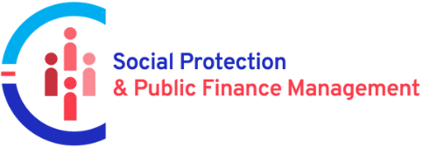
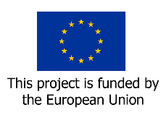

Final Report
March 2022 – June 2023

EU/ILO Programme on Improving Synergies between Social Protection and Public Finance Management

Project Code (GLO/19/53/EUR)

ZAMBIA



March 2023
Project title: EU/ILO Programme on Improving Synergies between Social Protection and Public Finance Management
Country: ZAMBIA
Report type (pick one): Final report
Reporting period: March 2022 to June 2023

Linkages:
Sustainable Development Goal: SDG 1 (End Poverty) and SDG 3 (Good Health and Well-being)
UNDAF Outcome: Improved capacity of the state to extend shock-responsive universal social protection and strengthen the resilience for all people, especially the most vulnerable and marginalized

Preparation and Review
Report prepared by: Felix Mwenge 28/06/2023
Report reviewed by: Andrew Allieu, Insert date
Report approved by: Wellington Chibebe, Insert date

Contents
1 Executive Summary 4
2 Basic Information 4
3 Summary outputs 4
4 Summary outcomes 6
4.1 Achievement of the project outcomes 6
5 Narrative Report: Managing for Results 8
5.1 Results summary 8
5.2 Monitoring, evaluations, and other reviews including with implementing partners and EU Delegations 9
5.3 Main challenges, risks and corrective action 9
5.4 Opportunities and corresponding strategy adjustments 9
5.5 Contribution of the Project to the COVID-19 response and recovery 9
5.6 Specific interventions related to public finance management 10
5.7 Complementarity with the EU Delegation’s interventions and on-going and future Budget Support Programmes 10
5.8 Synergies with other social protection interventions and strategic partnerships with other development partners 10
5.9 Overall budget analysis 10
5.10 Lessons learned and good practices 10
5.11 Visibility & Communication 10
5.12 Conclusions and Recommendations (Mandatory section for projects up to USD 500,000 in lieu of a separate evaluation report) 12
Annexe 1 : Project risk register 13
Annexe 2: Knowledge products of the project 14
Annexe 3: Communication and visibility 15
Annexe 4: Emerging good practice 16

Executive Summary
<Please use the executive summary as a tool to inform the donor about key achievements: be concise, to the point and illustrate results of the project. Please highlight the unique contribution of the project to the work on public finance management for social protection. Maximum one page.

Zambia’s National Health Insurance Scheme (NHIS) was established by the National Health Insurance Act No. 2 of 2018 and SI63 of 2019 as a compulsory social security scheme for all Zambian citizens or established residents above eighteen to provide universal accessible and financially sustainable quality health-care. To secure adequate financing, the NHIS operates on a contributory basis, covering workers in the formal and informal sector. To ensure adequate access for all, the NHIS is legally mandated to provide non-contributory coverage to different population groups, including mentally or physically disabled persons, elderly persons above 65, persons classified as poor and vulnerable by the Ministry responsible for social welfare, and any other person as prescribed by the Minister of Labour and Social Security.

To attain this objective of extending coverage to all, the EU through its Programme on Improving Synergies Between Social Protection and Public Finance Management (SP&PFM) funded a project to support National Health Insurance Management Authority ( NHIMA) to specificallyestablish the cost of extending non-contributory coverage to recipients of the Social Cash Transfer (SCT) (interpreted as constituting the population groups mentioned above) as well as assess the impact of this extension on the overall financial sustainability of the NHIS.

The costing exercise considered multiple scenarios, including the phased on-boarding of SCT beneficiaries. SCT benefiarices include households with an elderly person, with members with severe disability, with ,e,ners who are chronically ill and on palliate care, as well as child-headed households and female-headed households with at least three households.

Outcome 1 of the project focused on strengthening NHIMA’s internal capacities on data collection and analysis to monitor scheme performance on an on-going basis, as well as to undertake periodic actuarial valuation exercises to confirm continued financial sustainabilty.

Outcome 2 focused on progressing an actuarial valuation exercise to determine the cost of extending coverage to SCT beneficiaries on a non-contributory basis, and its impact on the overall financial sustainability of the scheme. The costing exercise was being supported by the ILO, through the application of the ILO/HEALTH actuarial model.

To deliver on the project outcomes, a team of NHIMA and Govermnent of Zambia (GRZ) officials representing the Minstry of Labour and Social Security (MLSS), as well as the Ministry of Community Development and Social Services (MCDSS) were constitued to benefit from training on the application of ILO/HEALTH model and data calibration. Consequently a series of training programs were delivered, starting with the introduction of the actuarial valuation principles, understanding the ILO/HEALTH model, and requisite input data and, finally, the running of the final model.

The data collection exercise to support the actuarial valuation preceded the running of the ILO/HEALTH model, followed by a data validation exercise. The project recommends for NHIMA to undertake frequent cleaning, updating and harvesting of scheme data to improve its quality and completeness. In addition to the ILO/HEALTH model valuation results, the project has built internal capacity for scheme perfomamnce monitoring through robust data which has culminated in the establishing of data dashboards for real time perfomamnce monitoring and evidence based decision making.

Basic Information

Countries covered: | Colombia, Kenya, Kyrgyzstan, Lao People’s Democratic Republic, Viet Nam and Zambia
Donor: | European Union as part of the EU funded Global Programme on Improving Synergies between Social Protection and Public Finance Management
Budget: | 168,400 EURO
Administrative unit: | CO Lusaka
P&B Outcome: | Comprehensive and sustainable social protection for all
DWCP outcome: | Comprehensive and strengthened social protection systems
Start date: | March 2022 March 2022
End date: | March 2023 September 2023
Project Duration in months: | 12 Months 18 Months

Summary outputs
OUTPUT DELIVERY
Output |  | Output status |  | Output summary
Outcome 1: Internal capacities on scheme performance monitoring, data collection for actuarial analysis and actuarial modelling process and outputs are strengthened within NHIMA
1.1 | Assessment of training needs completed, and capacity building plan developed | Completed | At project inception NHIMA had no in-house actuarial capacity. Nominated NHIMA and GRZ officials were included to the project team to develop actuarial costing capacities through a hands-on application of the data collection and analysis, ILO/HEALTH model calibration, and progression of costing outcomes. To support the realization and sustainability of NHIMA’s actuarial costing capacity, the regional actuary who supported its previous costing exercises was included to the team and has supported the training of staff on the application of the ILO/HEALTH model. The model is available on-line, with NHIMA scheduled to secure continued access beyond the project lifespan. NHIMA has enhanced its data management capacity through the recruitment of a dedicated data expert, who supported the project to overcome data collection bottlenecks.
1.2 | Key national stakeholders trained on actuarial data collection & modelling | Completed | Capacity of NHIMA and GRZ officials have been enhanced through training by the project on actuarial principles and data collection. NHIMA is now able to understand actuarial costing principles as a result of the introduction to the ILO-HEALTH Model, and the data needed to enable its successful application. A total of 11 managers were further trained at a later stage when most of the scheme data was ready and this provided an opportunity for NHIMA staff to understand how data is fed into the model. Theses trainings were practical and hands-on in nature as they were delivered in parallel with the actuarial costing exercise.  The project team of national stakeholders also undertook a data cleaning exercise to ensure data was in an appropriate format for the ILO/HEALTH model. The data cleaning exercise while generating variables for the model has improved and strengthened the understanding of scheme data by NHIMA staff who are now able to provide quality assurance on various data should be collected and stored.  A NHIMA multi-disciplinary Actuarial Valuation Committee team has since been constituted under the Directorship for Planning & Research to support data feeds to the new real-time NHIS performance dashboard delivered through this project. The Committee is also progressing data preparations for the follow-up September 2023 actuarial valuation exercise undertaken through the NHIMA post project enrolment to the ILO-ISSA online ILO/HEALTH actuarial platform.  NHIMA has since secured additional USD 75,000 funding from USAID to ensure the availability of in-house data management capacity to support the above initiatives.
Outcome 2: The cost of expanding social health insurance coverage to non-contributory (SCT) participants is quantified, as well as its impact on the overall financial sustainability of the scheme
2.1 | Dataset on vulnerable groups without contributory capacity consolidated with data extracted from existing social protection databases, and cost estimates progressed. | Completed | NHIMA, working with the MCDSS provided the most complete SCT beneficiaries data set which was interrogated and validated jointly with the ILO actuarial team. This data formed the basis for the ILO/HEALTH calibration exercise for extension costing exercise. NHIMA also provided different extension scenarios to provide estimates and liabilities for phased onboarding of beneficiaries. These include a universal approach where all SCT beneficiaries are onboarded at once as well as phased approaches where they are onboarded in different phases based on resource availability and needs.  The SCT extension costing results have since informed the resource mobilization engagements with the Global Fund Zambia to secure funding amounting to USD 2.5 million for the onboarding of the poor and vulnerable to the NHIS, slated for disbursement over the 2024 to 2026 period.
2.2 | Stakeholder consultations on the costing scenarios, outcomes and recommendation convened regularly throughout the project | Completed | NHIMA’s preference regarding policy discussions and engagements was to have them done once the actuarial results were ready. This would realise better value for time to be spent by partners who often have various commitments. Therefore, one meeting was held with donors working in social protection. The rest of the policy engagements happened after the results were ready. These include a validation meeting of results on the 30th of March 2023; followed by a meeting with the Chairman of the Board of Directors of NHIMA and the Hon. Minister of Labor and Social Security; this was followed by a meeting with the Permanent Secretary in the Ministry of Health and later with the Minister of Health. Additional policy discussions and engagements were held with the Global Fund who have ended up considering NHIMA for a US$2.5 million grant to fund coverage extension.  Additional stakeholder engagements to consider the NHIS actuarial valuation results were through the Medium-Term Expenditure Framework Budget Policy discussions through the Ministry of Finance in April 2023 to consider the NHIS financing requirements against the 2024  budget cycle. This discussion was ultimately progressed to the Zambia Parliament for debate on 14 June 2023, following submission of the Information Cabinet Memorandum outlining the additional financing requirements of the NHIS by the Minister of Labour and Social Security.  The resommendation to increase the NHIS contribution rates was also presented to the national Tripartite Consultative Labour Council on 9 May 2023.

OUTPUTS: Overall delivery assessment
☒ | Highly satisfactory  Implementation of almost all (>80%) outputs is on schedule as envisaged in the implementation plan and almost all (>80%) indicator milestones have been met. | ☐ | Satisfactory  Implementation of the majority (60-80%) of outputs is on schedule as envisaged in the implementation plan and the majority (60-80%) of indicator milestones have been met.
☐ | Unsatisfactory  Some (40-60%) outputs are being implemented on schedule as envisaged in the implementation plan and/or only some (40-60%) indicator milestones have been met. | ☐ | Very unsatisfactory  Few (<40%) outputs are being implemented on schedule as envisaged in the implementation plan and/or only a few (<40%) indicator milestones have been met.

Justification of self-assessment:

The project has delivered the expectations of NHIMA in that an actuarial valuation was conducted successfully whose results have been accepted and owned by NHIMA and the Government generally. Throughout this project NHIMA was able to constitute a national project team as well as secure additional human resources to strengthen NHIMA actuarial data capacity and delivery of the initial ILO/HEALTH training. Outreach engagements with national stakeholders have been conducted successfully with more happening after the results of the model were released. Further, the project (through NHIMA) has managed to extract SCT data from the MCDSS data base and different scenarios for onboarding of SCT beneficiaries have been agreed upon with NHIMA. This data has been used to estimate extension liabilities of non-contributing beneficiaries of the SCT.
Suffice to state that the project encountered expected challenges related to data quality, which delayed project delivery. To ensure credible actuarial costing outcomes, additional human resources (inclusive of NHIMA and GRZ officials, as well as the NHIS third-party administrators) was deployed to provide a dedicated support to remedy the evidenced data deficiencies. The outcome of this initiative is a successful data cleaning exercise that has improved the overall quality of NHIS data and produced robust actuarial estimations. The cleaned data base now becomes the standard benchmark for the collection, storage, and management of future NHIMA data. This has provided NHIMA with tools and in-house capacity to understand the data thus enabling the entity to monitor scheme performance with relative ease as earlier envisaged at the beginning of the project.

Summary outcomes
OUTCOME ACHIEVEMENT
Indicator | Baseline  (before project start) | Target (end-of-project goal) | Outcome summary
Outcome 1: Internal capacities on scheme performance monitoring, data collection for actuarial analysis and actuarial modelling process and outputs are strengthened within NHIMA
Number of national stakeholders trained on actuarial data collection and modelling (disaggregated by sex, agency and location) | FORMTEXT 0 | 25 officials trained on actuarial data collection  11 managers were trained on actuarial modelling | Four training sessions were delivered to national stakeholders consisting of NHIMA and GRZ officials. The trainings were focused on providing an understanding of actuarial costing principles, introduction to the ILO-HEALTH Model, and the data needed to enable its successful application. The project team of national stakeholders also undertook intensive data cleaning exercises which provided numerous skills for NHIMA staff to broaden understanding of scheme data not only for actuarial purposes but collection, management, and analysis.  Following the data cleaning exercise, additional training was provided, this time on the actual process of actuarial estimations where 11 managers from NHIMA and MLSS were part of the final actuarial estimation.
FORMTEXT | FORMTEXT | FORMTEXT | FORMTEXT
FORMTEXT | FORMTEXT | FORMTEXT | FORMTEXT
Outcome 2: The cost of expanding social health insurance coverage to non-contributory (SCT) participants is quantified, as well as its impact on the overall financial sustainability of the scheme
Cost estimates of non-contributory participation by SCT beneficiaries produced | Cost estimates of non-contributory participation by SCT beneficiaries  Baseline = 1 (NHIMA 2021 Actuarial Valuation – WHO / EU, Unit cost set at ZMW 1,200 ) | Multiple cost estimates scenarios (conservative, optimistic, best case; quantified in gross and per unit cost, including phased onboarding approach. | The estimates are as follows:  The health expenditure costs related to SCT participants, and their households, is targeted to reach the following:  - 1.3 billion Kwacha in 2032 if they only utilize public services/facilities  - 1.9 billion Kwacha if they are allowed to utilize both public and private facilities.
FORMTEXT | FORMTEXT | FORMTEXT | Fare clic qui per immettere testo.
Application of liability costing results to the financial sustainability considerations of the Scheme | NHIMA Financial Sustainability projections produced Baseline = 0 (NHIMA 2021 Actuarial Valuation – WHO / EU deficient of sustainability projections against on-boarding of non-contributory participants) | NHIMA Financial Sustainability projections produced, premised on multiple scenarios (conservative, optimistic, best case; quantified in gross and per unit cost, including phased on-boarding approach | The estimations are as follows:  Baseline scenario  - Income in 2023: 1.2 billion Kwacha  - Investment returns in 2023: 0.28 billion Kwacha  - Health services benefit expenditure in 2023: 1.1 billion Kwacha  - Marginal operating surplus in 2023: 0.1 billion Kwacha  Actuarial projections  - From 2024 onwards, the NHIS is expected to start realizing an increasing operating deficit and would use all of it reserves currently valued at 1.5 billion Kwacha by 2028, unless corrective action is taken.  - The first iteration to attain financial solvency is a revision of the contribution structure applied to formal (public and private) sector employees from 2 per cent to 3 per cent of basic earnings, effective in 2025. But at this rate NHIS can outpace the expenditure for a short period only (2025 and 2026).  - The next iteration is contribution rate increase to 4 per cent of basic earnings in respect of formal (public and private) sector employees, applied from 2025 onwards.
Outcome 3: <Insert title of Outcome 3>

Achievement of the project outcomes

OUTCOME: Overall outcome summary
☒ | Highly probable  Almost all (>80%) reporting period milestones have been met. Based on the indicators and risk assessment, it is highly probable all outcomes will be achieved by the end of the project. | ☐ | Probable  The majority (60-80%) of reporting period milestones have been met. Based on the indicators and risk assessment, it is probable most outcomes will be achieved.
☐ | Low probability  Some (40-60%) reporting period milestones have been met. Progress is being made on the outcomes but based on the indicators and risk assessment only some outcomes will be achieved. | ☐ | Improbable  Few (<40%) reporting period milestones have been met. Limited progress is being made on the outcomes and based on the indicators and risk assessment only a few outcomes will be achieved.

Justification of self-assessment:

All the data requirements for the running of the actuarial model were provided by NHIMA to the actuaries. Economic and demographic data was also fully collected, and assumptions made and agreed upon with NHIMA management team validating all inputs including current and future utilization rates. The actuary team ran the model on this basis.

Narrative Report: Managing for Results

Results summary

Briefly outline the outcomes achieved in the project, highlighting how project outputs led to (initial or more substantive) outcome changes during the project lifespan.

<Answer here>

Since its inception, the project has completed the delivery of its key outputs. NHIMA also considers the project to have met its intended objectives and the outcome of the actuarial analysis has been used to engage with key stakeholders at various levels. The EU delegation has also vetted the project outcomes and expressed satisfaction of both the findings and the recommendations. The project results can be summarized as follows:

Outcome 1: Internal capacities on scheme performance monitoring, data collection for actuarial analysis and actuarial modelling process and outputs are strengthened within NHIMA.
The SP&PFM project has successfully achieved this outcome with tangible results summarized in the section below by output or activity.

Output 1.1 Assessment of training needs completed, and capacity building plan developed

NHIMA and the ILO actuarial team worked jointly to identify training needs and capacity gaps successfully at the beginning of the project. It was established that NHIMA did not have in-house actuarial capacity. Consequently, staff from NHIMA and GRZ were identified and included to the project team to develop actuarial costing capacities through a hands-on application of the data collection and analysis, ILO/HEALTH model calibration, and progression of costing outcomes. To support the realization and sustainability of NHIMA’s actuarial costing capacity, the regional actuary who supported NHIMA’s initial costing exercises, was included to the team and he supported the training and application of the ILO/HEALTH model. The model has also been made available to NHIMA who will has secured continued access beyond the project lifespan. NHIMA has further enhanced its in-house data management capacity through the recruitment of a dedicated data expert, who supported the project to overcome data collection bottlenecks faced at the beginning of the project. This output has therefore been fully fulfilled and attributed to the SP&PFM project.

Output 1.2 Key national stakeholders trained on actuarial data collection & modelling

NHIMA capacity has been built following the identification of capacity gaps, training needs and development of the plan, implementation followed immediately. Capacity has been built with NHIMA staff now able to understand actuarial costing principles, the ILO-HEALTH Model, and the data needed to enable its successful application. This was achieved through practical and hands-on training delivered in parallel with the actuarial costing exercise. The project team of national stakeholders also undertook an extensive data cleaning exercise before a follow-up training on ILO/HEALTH calibration applications was conducted. The following are some of the outcomes of the data cleaning exercise following capacity building exercises:

- Creation of Real-Time NHIS Indicator Reporting Dashboards: This innovation was an off-shoot of the ILO-HEALTH Model Data Cleaning and Validation Exercise. The extensive exercise created an opportunity to generate and report the performance of the Scheme through real-time interconnection to membership, contribution, and claims data. This dashboard has been created for NHIMA’s Executive Committee who now receive daily reports on the performance of the Scheme on key indicators for decision making.

- Fraud Detection and Elimination in Claims: With the Data Analytics as part of the ILO-HEALTH Model, the NHIS was able to identify and isolate outliers based on the analysis of Levels, Trends and Patterns of Claims that pointed to potential fraud, particularly Supplier Induced Demand in Optical Services. From these indicators the NHIS was able to identify significant leakages related to Optical services, with claims exceeding 112 million Kwacha (approx. 6 million USD), making it the third highest benefit cost centre. This resulted in supporting the introduction of new operational rules, the Gate Keeping Rules aimed at eliminating fraud related behaviours among Healthcare Providers and reducing wastage. These rules have resulted in significant reduction in claims, thus enhancing the solvency of the Fund.

- Through the SP&PFM Project, NHIMA management’s appreciation of data and evidence has increased, alongside increasing the data culture for successful implementation of the NHIS. NHIMA has now rolled-out the Power BI Data Analytics system which was part of the ILO-HEALTH Model Data Clean-Up and Validation Process and integrated it into all Scheme operations. This has made management and government reporting on Scheme operations more efficient and responsive.

Outcome 2: The cost of expanding social health insurance coverage to non-contributory (SCT) participants is quantified, as well as its impact on the overall financial sustainability of the scheme

The SP&PFM project has successfully achieved this outcome with traceable results summarized in the section below by output or activity.

Output 2.1 Dataset on vulnerable groups without contributory capacity consolidated with data extracted from existing social protection databases, and cost estimates progressed.
NHIMA, working with the MCDSS was able to successfully access the data base and obtain data on the SCT beneficiaries which was used to estimate the liability of adding this group of citizens to the scheme as non-contributing beneficiaries. Sample files were first extracted, assessed, and verified by the ILO technical team and the actuarial consultant. Following the completion of the data quality check, the updated data was provided and was part of the ILO/HEALTH calibration exercise. The process of data extraction also built capacity of data managers in the MCDSS who were able to identify important gaps that could enrich the data if filled. For instance, SCT data base does not have data on other household members other than the principal beneficiary. From the health protection perspective, the number of people in the household alongside the principal beneficiary is important for the estimation of health utilization which is captured at the household level. The project therefore provided an opportunity for this data to be developed further.

Estimates of the costs of extension of the NHIS to Non – Contributing members were then calculated. The estimates have provided the basis for the development of financing options that will ensure Scheme sustainability for the extension of NHIS coverage and the sustainability of the Scheme. Through the estimates of the costs of extension, NHIMA has made a case for the inclusion of the NHIS in the next 2024 – 2026 Global Fund allocation to Zambia for the subsidisation of the Poor & Vulnerable under the Global Fund’s agenda to accelerate progress toward universal health coverage and pandemic preparedness by being a leading actor in tackling inequities in health, whether arising from poverty, gender, or human rights. NHIMA has further developed a Policy Position Paper on Feasible Revenue Sources for the extension of coverage of the NHIS. This Position Paper has been adopted by the NHIMA Board of Directors for the development of the 2024 – 2026 Medium Term Expenditure Framework Budget Policy Paper to the Ministry of Finance for the financing of the extension of NHIS coverage.

Output 2.2 Stakeholder consultations on the costing scenarios, outcomes and recommendation convened regularly throughout the project.
Following the project launch, a meeting was held with the donor community in social protection in Zambia at which NHIMA and the ILO made a presentation to share the project objectives and anticipated outcomes. While stakeholder engagements on policy were priority, NHIMA preferred to engage more once the results of the actuarial valuation were ready. Thus, many policy discussions were postponed until the results were ready. The following is a summary of some of the key discussions that were held with results available:

- With the Actuarial Valuation Results complete, the first policy and technical meeting was held on March 30th, 2023, which also validated the initial results. This meeting was attended by Ministry of Health, Ministry of Finance, NHIMA, MLSS, MCDSS and the EU delegation. This meeting laid a foundation for consideration of actuarial results by the different stakeholders who were present. Out of this meeting NHIMA planned a series of other engagements intended to share project results and start mobilizing resources for extension.

- NHIMA further presented the project results to the Chairman of the Board of Directors of NHIMA and the Hon. Minister of Labor and Social Security. The outcome of the policy engagement was the development of a briefing by the Minister which was used for further engagement with the Cabinet/Presidency on financing reform options.

- NHIMA progressed further with more policy discussions with the Ministry of Health for the inclusion of the NHIS in the 2024 – 2026 Global Fund funding proposal. NHIMA held a successful meeting with the Permanent Secretary in the Ministry of Health. The permanent secretary later facilitated for NHIMA to present to the Minister of Health for her final buy-in and approval for inclusion in the Global Fund MoH budget line.

- Additional policy discussions and engagements have been held using the actuarial results and the costing of the extension of coverage to the poor and vulnerable. Consequently, NHIMA has been considered for a US$2.5 million from the Global Fund Zambia allocation for the years 2024 – 2026. This allocation is aimed at subsidizing the onboarding of the poor and vulnerable and would not have been possible without the evidence generated from the Project.

Based on the achievement of outcomes explain how the project is likely to contribute towards the overall development objective.

<Answer here>

Extension of social health protection coverage in Zambia in line with the National Health Insurance Act of 2018 was the overall development objective of the current project. The successful data cleaning and the subsequent skills development for NHIMA staff will lead to better management of the scheme through improved performance monitoring. This will in turn inform and guide policies regarding registration of new members as well as determination of contributions in line with the appropriate benefit package. Data gaps that have been filled because of this project will also improve the general service delivery of the scheme which can lead to increased interest in the scheme by citizens leading to voluntary registration by difficult to reach populations such as those working in the informal economy. This can lead to the attainment of UHC by the Government.

The SP & PFM project has also enabled NHIMA to know the extension liabilities of health coverage to non-contributing members. While the current targeted population for inclusion are the SCT households, the liabilities estimated provides useful information and gives indications to NHIMA on the cost of extending services to other groups in the informal economy in Zambia. This further makes it possible to estimate appropriate contribution rates and design benefit packages for new members that ensure financial sustainability. The new framework provides a strong basis and foundation for extension of health services to different demographics of the Zambian population to attain Universal Health Coverage. The actuarial analysis has also provided a clear picture of financial sustainability of the scheme which is key in driving scheme policy reforms to ensure solvency of the scheme.

Describe how the project has contributed to the achievement of national development strategies (e.g. DWCP, UNDAF, SDGs, etc.) and other development frameworks (e.g. SDG, etc.)

The SP&PFM project objectives were aligned with Zambia’s 7th National Development Plan (7NDP) aspirations of reducing poverty and vulnerability. Before, the Government of Zambia, through the MCDSS and the key Ministries and Agencies under the Cluster on Poverty and Vulnerability Reduction had been implementing several social protection interventions in the form of contributory and non-contributory schemes and programs. In 2014 the National Social Protection Policy was launched which officially classified social protection policies and programs under four pillars, namely: 1) Social Assistance (Protective component of the model); 2) Social security and social health insurance (Preventive component); 3) Livelihood and empowerment (Promotive); and 4) Legal Protection (Transformative component). Since 2014 the government, with support from cooperating partners has gradually continued to build social protection floors as foundation for the provision of minimum social protection coverage for the population.

The establishment of the national health insurance scheme therefore fits within the national framework of building social protection floors intended to reduce poverty and vulnerability. Nonetheless the current scheme is skewed towards the formal sector, thus not reaching most of the labor force employed in the informal sector which accounts for over 70% of the total employed population. The SP&PFM project supported NHIMA to extend coverage to non-contributing members as well as to workers in the informal economy through building in-house capacity for actuarial assessment to enhance scheme performance monitoring. The project has thus contributed to the national objective of strengthening capacity in social protection management and extension of coverage.

The SP&PFM project’s strategic fit was its unique ability to support the provision of comprehensive and sustainable social protection for all as outlined in the ILO’s 2022-2023 biennium. Through the actuarial assessments and consequent recommendations for scheme reforms, the project has provided Zambia with a rare opportunity to make social health insurance comprehensive through coverage extension and service provision improvements while ensuring financial sustainability. The project has also provided important lessons to similar schemes in Zambia regarding the important role of actuarial valuations in assessing sustainability and solvency of contributory schemes in the context of coverage extension to informal groups. The project has thus helped the ILO’s efforts in supporting the government of Zambia to develop new or reformed sustainable national social protection strategies, policies, or legal frameworks to extend coverage and enhance benefit adequacy. Similarly, the project has contributed towards increased capacity of the Zambian government to improve governance and sustainability of social protection systems.

The SP&PFM project in Zambia has further contributed to the country’s advancement towards the attainment of the Sustainable Development Goals, particularly SDG1. Through the actuarial valuation and the estimation of liabilities to inform extending of services to the poor and vulnerable and the informal economy, the project has contributed and will inform Zambia’s decisions regarding the implementation of nationally appropriate social protection systems and measures for all to achieve substantial coverage of the poor and the vulnerable by 2030. The extension of social health insurance services to the poor and vulnerable that will be informed by this project will also play an important role in Zambia’s attainment of Universal Health Coverage which will have an important impact on health inequality. Thus, the project has also contributed to Zambia’s efforts to attain SDG Goal 3 on health and wellbeing.

Self-evaluation results:

For further guidance on the objectives and methodology to conduct a self-evaluation please consult ILO’s evaluation policy guidelines “section self- and internal evaluations”

Relevance - Were the project objectives and strategy consistent with beneficiaries’ requirements, country needs, ILO priorities and partners’ and donors’ policies?
The project’s aim was in line with the original request for support of the partner, the National Health Insurance Management Authority (NHIMA). The project responded to the requirements of Section 16 of the National Health Insurance Act which mandates the Authority to provide social health insurance, on a non-contributory basis, to citizens and residents in the following categories: (a) a mentally or physically disabled person who is unable to work; (b) an elderly person above the age of 65; (c) a person classified as poor and vulnerable by the Ministry responsible for social welfare; and (e) any other person as may be prescribed by the Minister (of Labor & Social Security).
The project was implemented within the framework of the National Strategy on extension of social security coverage to the informal economy, which has an already constituted a comprehensive set of stakeholders, as well as a Technical Working Group (TWG) to drive the extension of coverage agenda. The prospective provision of additional funding to NHIMA by National Government (to fund the social insurance contribution with respect to the most vulnerable) within the public expenditure framework will result in the realization of a more holistic social protection, wherein beneficiaries of social assistance programs are considered for subsidized participation to the national social insurance programs. This will be a step forward in the implementation of the 2018 Integrated Framework of Basic Social Protection (IFBSPP), which seeks to deliver an integrated / multi-sector response to realize meaningful impact on poverty levels, as well as to transition Zambia one step closer to achieving sustainable and universal social protection coverage, in line with SDG 1.3 and SDG 10.
Further, the project overall development objective or impact was aligned with multiple thematic areas of the EU-funded Global Program on Improving Synergies between Social Protection and Public Finance Management (SP-PFM), namely:
- Extension of social health protection coverage in Zambia (particularly the poor and vulnerable) through the application of ILO actuarial health costing model to promote the sustainability of the health insurance scheme.

- SP&PFM and shock-responsiveness and just transition by deepening the capacity of national social protection shock-responsive social protection programming to respond to the national health demands as well to discover avenues to secure the requisite additional financing. The intervention is especially relevant to covid-19 related responses as it contributes to building back better and more comprehensive systems.

- SP&PFM and inclusiveness of people with special needs via the non-contributory participation of vulnerable groups, with an initial focus on beneficiaries of the SCT program as per 16(c) of the NHIS Act.

- SP&PFM and social dialogue related to the selected area of intervention as the progression of this work stream will be progressed through social dialogue engagements with the tripartite plus partners, to collectively carve out the optimal social health insurance policies and supportive financing frameworks.

During implementation the project benefited from the larger scope of social protection programs whereby it was integrated into existing or traditional social protection programs which has improved coordination. In the past social health protection in Zambia was a mandate undertaken under the Ministry of Health making it distant from the larger social protection group of programs that are managed by the MCDSS and the MLSS. At present social health protection has been brought into the fold of other social protection programs and has been earmarked for inclusion into the Single Window Service delivery program at the district level. The project has also facilitated for the implementation of the CASH PLUS policy, which is a new initiative by the Government of Zambia to provide additional benefits to the beneficiaries of cash transfers. Health is one such benefit that will be extended to the poor and vulnerable through this project.
Effectiveness - To what extent can changes in the observed outcomes be attributed to the project? To what extent has the project contributed to changes in the project’s ultimate beneficiaries? How effective was the project in advancing gender equality and inclusion of people with disabilities within the context of project’s objectives?

The outcomes of the project as outlined in the results summary earlier are all attributable to this project. The continuous policy processes that NHIMA has undertaken to engage the central government and donors on additional financial resources to extend coverage to the poor and vulnerable are all based on the findings of the actuarial valuation. Without the results of this project NHIMA would not find a basis to present a case for increased funding.

The process of implementing this project, especially the data cleaning exercise also revealed important trends in claims that the scheme has been paying. NHIMA has used this data identify and prevent potential fraud in the processing of claims. This result led the institution to adjust the purchasing rules of certain services that would not have been possible without evidence generated from this project.

Regarding gender, this project made it possible for NHIMA to have clean scheme data that clearly identifies the utilization rates and other variables by gender and age. Thus, NHIMA is now able to map various service characteristics by gender making it possible to make gender sensitive decisions and programming. With the new information NHIMA is also able to design benefit packages that are sensitive to the characteristics of users such as gender.

Sustainability – To what extent has the project produced durable results that can be maintained, or scaled up and replicated, within the local development context, or as a global approach or policy, after the completion of the project? Are there any internal or external factors that may affect the sustainability of results?
<Answer here>

The strength of the SP&PFM project in Zambia lies in the overwhelming acceptance and ownership of the project results by the principal client, NHIMA. The calculation of valuation results, and the subsequent training on the ILO HEALTH model included staff drawn strategically from the various NHIMA departments involved in the daily management of the scheme such as finance and investments, health insurance services, information technology, quality control and accreditation as well as research and planning. The process allowed for the actuarial assumptions and preliminary results, to be peer reviewed from multiple technical perspectives, and adjusted accordingly to arrive at a universally agreed valuation outcome against the expected evolution of the NHIS over the next 10 years. This process is the foundation of the sustainability of the project results as demonstrated further below.

- The consultative process that characterized the production of the final actuarial valuation results helped to build a stronger knowledge of the operative processes of the ILO-Health model, as well as to foster ownership of the results amongst the NHIMA team. This coupled with continued access to the model that NHIMA will have after the project ensures that results can be replicated annually in line with the requirements of the law using internal actuarial capacity.

- After the presentation of the project results and training NHIMA took over the process of presenting the results to national stakeholders and led the discussions of extension of coverage (to SCT) agenda. The constant participation and involvement of the MLSS was instrumental to fortify their leadership role in driving the NHIMA Universal Health Coverage (UHC) agenda, as well as to guide on the roll-out of the follow-up national stakeholder engagement and likely reform process for years to come.

- The SP&PFM project also contributed towards building NHIMA’s actuarial modelling capacity and helped real-time estimation of the NHIS’ Solvency Position while providing data and evidence on the required financing for UHC. Through this Project, NHIMA has developed advanced data analytics and reporting capabilities for real-time generation of analyzed data for real-time executive management decision making. This means NHIMA will be able to replicate this process when need arises without requiring the same level of support from the ILO and the EU.

Efficiency – How optimally were the resources and inputs (e.g. funds, expertise, time, etc.) used to produce results? Do the expected project results justify the costs incurred? To what extent did the project leverage resources (financial, partnerships, expertise) to promote gender equality and non-discrimination?

The project has a delivery rate of 91%. Despite the slow start in the first half of the project the project has witnessed a significant intensifying of activities (and thus commitment and expenditure) in the second half. In terms of resource allocation, the larger part of the funds was allocated towards the production of the actuarial valuation report. Other components of the funds went to remuneration of project stuff and communication and visibility.

The actuarial valuation results also form the starting point for NHIMA’s financial sustainability. Future actuarial valuations that must take place annually in line with the law will use the current results as the benchmark in terms of quality, the approach used which was widely consultative and the manner of mobilizing data.

The project also leveraged on additional resources from other partners and projects. Within the ILO some aspects of the project with similar objectives as existing ones were implemented jointly. From the NHIMA perspective, support for recruiting a data expert was obtained from the USAID.

<Answer here>

Monitoring, evaluations, and other reviews including with implementing partners and EU Delegations

Outline efforts made to involve a broad range of stakeholders in M&E, including the role played by the EU Delegation, constituents and implementing partners. Highlight efforts to support the implementation of the EU programmation and interventions.

<Answer here>

To achieve the results, the project worked with several key partners including the EU delegation officials. The EU reviewed and approved the Communication and Visibility plan for the project before it could be implemented. The EU was also invited to major events during the project such as the stakeholders meeting to validate the actuarial valuation results. During these activities the EU delegation was able to provide guidance and shared important concerns that contributed towards the finalization of the project report.

Explain the process/method for collecting information regarding outcomes and challenges mentioned in this report.

<Answer here>

The project lead was in constant communication with all the different parts of the project and especially NHIMA the primary stakeholder. A midyear project report was also produced which provided an overview of the key project activities from the beginning to the mid of the year. Thus, information on outcomes and challenges was easily communicated through regular meetings and project updates. In the absence of meetings, the project lead proactively consultative NHIMA and the MLSS to understand project activities and results at each stage.

If any evaluations were carried out, briefly describe how findings and recommendations were addressed by the intervention.

<Answer here>

An end of project evaluation of the programme will take place at the end of the project. Zambia has been included among the project evaluation countries and Terms of Reference have been shared to which the country team has provided input. Furthermore, the country team has provided a list of key focal persons who will be contacted by the evaluation team.

Main challenges, risks, and corrective action
<Present challenges identified that potentially or actually hinders progress in delivery of outputs and achievement of outcomes as planned, and what corrective action that has been taken or is planned to address these challenges>.Present challenges identified that potentially or hinders progress as planned (e.g., shortfalls in delivery or output quality and outcome achievement). Suggested areas of concern could be the following – please choose or add as relevant and provide a corresponding narrative.>

The main challenge faced so far is that of data quality gaps. To run the actuarial model and be able to produce extension estimates that are robust, NHIS data ought to be availed in the appropriate format, and to be of good quality. The main data concerns can be summarized as follows:

Challenges | Mitigation Measures
Lack of alignment of Membership Register in eNHIMA and Health Information Platform (HIP) Databases:  - During its inception member registration phase, the NHIS used information available from the participating employer databases to undertake a bulk registration exercise. This approach has resulted in the non-capture of some of key participant variables, as well as significant deficits related to the member’s primary dependents who are also eligible to cover from the NHIS.  - Furthermore, NHIMA’s Health Information Platforms have been continuously evolving from paper-based systems to electronic systems, resulting in the inconsistent recording of claims and contribution details over the Scheme’s three-year operating period.  - Finally, the NHIS had allocated differing unique membership numbers across the differing databases (membership, contributions, claims) and time-periods resulting in an inability to develop a consistent scheme profile. | - NHIMA brought in the third-party data administrators to help harmonize registration  - NHIMA staff from the claims and contributions department were employed to harmonize the records  - The data cleaning exercise invested time to sort out unique IDs
Lack of classification of Databases into specific cohorts:  - The NHIMA database have not consistently classified member and employer databases into the various NHIMA portfolios including Informal Sector, Pensioners, and Private as well as public sector.  - As a result, portfolio analysis of the performance of the different portfolios with respect to the contributions and claim, to support the formulation of actuarial valuation assumptions is constrained.  - Secondly, new employer IDs have not been generated for nearly 60% of registered employers. This could result in data inconsistences due to overlap of contributing member information. | - This issue was resolved by ensuring that a complete employer register with new employer ID and portfolio classification was updated.
Lack of alignment of members Contributions Data:  - Nearly 40% of contribution records do not contain a unique NHIS number of the primary member.  - As a result, a timeline of the contribution history for these members cannot be developed, and transition probabilities formulated for input into the ILO/HEALTH model.  - Additional deficiencies were observed with respect to member salaries (which are in some cases abnormally low / high), and ambiguous contribution payment status (FAILED vs PENDING). | - This issue was resolved by ensuring that a complete employer register with new employer ID and portfolio classification was updated.

<Based on information collected when monitoring risks, review the project’s risk register (see Annex), making updates or revisions as necessary>

Opportunities and corresponding strategy adjustments
<Present opportunities to do/achieve more than expected (gains in effectiveness, contribution to organizational learning, building alliances, new partnerships, resources mobilization, etc.) and adjustments made to be able to make the most of these opportunities. Present any corresponding reformulations of the logical framework, if applicable>

The project presented NHIMA with various opportunities leading to generation of multiple benefits to revise the NHIS operation framework enabled through NHIMA’s enhanced capacity to monitor scheme performance in real time. This development has already started informing key decisions such as the recent decision by the scheme to reverse accreditation of 20 optical health providers and revising the benefit administrative process. This project therefore presents good practice for ongoing and future similar projects.
Based on the results of the project, a tripartite participation was secured and NHIMA was able to make the case for additional funding to the scheme in the presence of the Zambia Federation of Employers (ZFE), Zambia Congress of Trade Unions and the Government. The participation of these constituents has the additional impact of ensuring ownership and participation to the funding and sustainability dialogue in respect to the NHIS.
The Government, through the Minister of Labor and Social Security has also presented the actuarial valuation results to the Tripartite Consultative Labor Council, Cabinet and to the Republican President, by way of an Information Cabinet Memorandum, the NHIS Actuarial Assessment Results and the Financing Options for Government’s consideration. The Cabinet Memorandum was drafted jointly by NHIMA and the MLSS team, led by the hon. minister. The Minister, using the results, has pursued the Government to support the financing reforms for the NHIS, on both the solvency question and the extension of coverage to the indigents through central government financing.

Further, the results of the project have been submitted to be part of the Medium-Term Expenditure Framework Budget Policy Position Paper to the Secretary to the Cabinet. This is for consideration in the 2024 National Budget which is important if the Government must plan for the implement reforms noting the pending Actuarial deficit in 2024.

In recognition of the SP&PFM’s Actuarial Capacity Building, NHIMA was awarded the International Social Security Association (ISSA) Certificate of Merit for the Actuarial modelling capacity enhancement for the extension of social security coverage. This is a key international recognition that illuminates the confidence of the role of the SP&PFM in NHIMA as a vehicle for achieving universal social security. NHIMA will also be presenting the outcomes of the SP&PFM project at the ISSA International Conference of Social Security Actuaries, Statisticians, and Investment Specialists in Mexico, scheduled for December 2023. This is a rare opportunity that will improve the project’s visibility.

Specific interventions related to public finance management
<Highlight the interventions and results in the field of PFM and the contribution of the project to improve and generate knowledge on the costing and financing options for social protection in the country>

The costing outcomes of the actuarial evaluation exercise of this project have provided an indication of the additional funding needs of the NHIMA initiative to extend non-contributory coverage to the poor and vulnerable. The project has generated critical evidence which is foundational to reforming social protection financing in Zambia to ensure sustainability while increasing coverage.

The funding options to meet this gap have been considered within the Government’s public finance management framework. Initial efforts to consider the various financing options have also been discussed at various levels such as Cabinet and the Presidency. The project design also included proactive involvement of the Ministry of Finance to take a lead in shaping the financing options and mechanism to ensure sustainability of the scheme.

Of great importance, the project has recommended for stronger public finance management practices in NHIMA. To the extent possible, the financial deficits identified, and the looming insolvency could be avoided if the scheme improved on some of its public management approaches to facilitate for cost containment while maximising benefits from available resources. These recommendations have been made.

NHIMA has also sought the financial support of the donor community, particularly the Global Fund to be able to finance the extension of coverage.

Complementarity with the EU Delegation’s interventions and on-going and future Budget Support Programmes
<Present how the project contributed to reinforce the collaboration with the EU Delegations and the potential contribution of the project to support on-going and motivate further budget support programmes that will allow for improved PFM and strengthened social protection systems>

The project has strengthened the collaboration between the EU delegation and the ILO in Lusaka. Project progress reports are shared with the EU on an ongoing basis, with all communication outputs developed and issued on a bi-lateral basis.

The EU has sponsored a complimentary project undertaken by SOCIEUX to vet the operative and governance structures of NHIMA and provide recommendations for their strengthening. The SOCIEUX project offers excellent synergies to both our Outcome 1 (strengthening NHIMA data management, NHIS performance tracking and actuarial capacity) and Outcome 2 (costing extension of coverage initiative to ensure ongoing financial sustainability of NHIS).

The project collaboration has provided opportunities for both the ILO and the EU delegation to engage with a wider network of stakeholders (including development and cooperating partners) to ensure that this program is aligned to the peer ILO’s social protection flagship programs such as the United Nations Joint Social Protection Programme Phase II (UNJP-SP) and the Irish Aid – ILO Partnership on Inclusive Growth, Social Protection and Jobs, to ensure coherent outcomes and impact within the context of the Zambia Decent Work Country Programme and the UN Sustainable Development Partnership Framework in Zambia.

Synergies with other social protection interventions and strategic partnerships with other development partners
<Highlight the links and bridges between the project and other strategic interventions pertaining to social protection in the country (other than those related to EU budget support that are covered in the previous section). The section should allow capturing how the project complements and reinforces existing efforts in social protection and PFM>

This project further complements ongoing the Zambia Cash Plus agenda, recently sanctioned by the GRZ, to provide multiple social protection support programs to SCT beneficiaries with a view to forge stronger poverty graduation pathways for this cohort.

The Project has benefited from the outcomes under the Irish Aid partnership as well as the UNJP programme which have developed the Zambia Integrated Social Protection Information System for the SCT (ZISPIS) and the national Disability Management Information Systems (DMIS), from which the demographic data of the target beneficiaries will be harnessed.

This project is also building on the experience gained by ILO in the extension of social protection coverage to the informal economy, as well as in the support to the establishment of the National Health Insurance Scheme, specifically through the following projects: 1. Social Protection for Informal and Rural Economy Workers Project in Zambia (SPIREWORK) 2017 – 2021 2. UNJP-SP Phase I (2015-2018), which included technical and financial assistance to the Government of Zambia towards feasibility studies towards the establishment of the National Social Health Insurance, with a focus on promoting universal health care, as well as strengthening the national social security systems.

Overall budget analysis
Present a brief budget summary, comparing actual and planned expenditure with previous forecasts and the approved budget. Also, highlight and explain over/under spending and efficiency gain.

<Answer here>

The table below shows the total budget and planned against actual expenditure. As stated earlier, the project execution rate stood at 91% at the time of report writing. Two activities were pending payment for copy editing the final report and for a supplementary claims report. This accounts for the underspending of over $20,000.

Category | Budget (US$) | Actual Expenditure (US$) | Difference  Budget – Actual
Human resources | 76,806.89 | 74,108.81 | 2,698.08
Missions | 528.83 | 7555.31 | -7,026.48
Local office operations | 5,297.35 | 5,297.35 | 0.00
Other costs (communications & services) | 95,001.07 | 74,530.55 | 20,470.52
TOTAL BUDGET | 177,634.14 | 161,492.02 | 16,142.12

Lessons learned and good practices
Prepare at least one good practice worth sharing with other projects - template Emerging Good Practices. Available in Annex 4. Please check Annex 4 for the practice.

Suggest presenting here a short version of the good practices and lessons learned identified in the Annex 4. <Describe any lessons, positive and negative, that have been learned during project implementation.

Based on the experiences gained from implementing the project, the following are the factors and risks which also represent best practice for ongoing and future projects:

- Enabling Factors

- Government policy to extend NHIS Coverage: The desire by government to extend social security coverage and achieve UHC gave impetus to the success of the project.

- Availability of Technical Capacity by the ILO: The success of the project depended on the availability of the technical support of the ILO’s Public Finance, Actuarial and Statistics Unit of the Social Protection Department.

- Availability of Data Management Capacity in NHIMA: The success of the project benefited greatly depended on the availability of the technical support of the ILO’s Public Finance, Actuarial and Statistics Unit of the Social Protection Department.

- Consultative approach of NHIMA with regular information of NHIMA’s board on the project’s progresses as well as final policy consultations.

- Financial support from the European Union: The funding for the project was through the European Union that favorably responded to the request from the Zambian government through the NHIMA to access the support for capacity building.

- Risks

- Sustainability: As the project is funded by a cooperating partner, there is the risk, albeit limited, that the NHIMA actuarial and data capacity gains may not be sustained.

- Limited skills transfer: As actuarial capacity skills are highly technical, there is the risk that these skills may not be developed to the desired levels to allow for independent actuarial assessments with confidence.

- Inaccurate and Incomplete Data: The challenge faced in the implementation of the project was on the quality, accuracy, and consistency of data for the actuarial modelling. These challenges were addressed via a one-time intervention, as such the requirement for continuous investment in data clean-up and management by NHIMA.

Visibility & Communication
<Describe how results of this project are communicated to stakeholders and the EU Delegation. Indicate how the donor support for this project is made visible and what steps are taken to comply with visibility obligations. Please include in the Annexes photos, illustrations of visibility, social media visibility, multimedia products prepared to ensure the project’s and development partners’ visibility in the reported period. Make sure the relevant donor and partners logos are included as per the specific requirements of the agreement, and the country webpage is updated>

The results of this project are communicated in several ways including the following:

- Website: the visibility of the EU/ILO project in Zambia was provided through a country specific project website that was hosted on the global website for the global project. Through this website, regular updates regarding project activities and progress throughout the project were provided. The details of the project activities can be found at the following link:

- Communication materials: the project developed various communication and visibility materials such as folders and pull ups. Similarly, logos for all partners including for the donor were inserted on all letters and official communication for the project.

- Multimedia and social media products: the project used various multimedia products to showcase the activities. These are listed in the section on media and visibility section.

- Print media: the project also utilized print media to showcase some of the product activities and results to reach more people.

Conclusions and Recommendations

Conclusions and recommendation from the self-evaluation
Conclusions | - The project was timely and fit neatly into the Government objectives and national plans, including SDGs and social protection extension policies and strategies, including attainment of Universal Health Coverage. The project was also clearly aligned with the ILO’s DWCP objectives of extending coverage of social protection floors and improving management. Further the project was in line with the EU’s global project on Improving Synergies between Social Protection and Public Finance Management. Thus, it received significant support from many stakeholders in Government and the donor community in Zambia.  - The project has generated critical evidence on the performance of the scheme using available data. The evidence provides critical insights regarding the financial solvency of the scheme and the extension liability. The role of good data in producing such results is cardinal for future actuarial valuations as demanded by the law.  - The successful delivery of project results is to a large extent anchored by presence of diverse technical capacity on both the ILO and NHIMA. On the ILO side, the availability of the technical support of the ILO’s Public Finance, Actuarial and Statistics Unit of the Social Protection Department was key. In addition, a diversity of skillsets was mobilized for the project, including social health protection policy, health financing, public health, legal skills, etc. On the NHIMA side, the Availability of Data Management Capacity in NHIMA was an important complement in producing robust results.  - The project has demonstrated a very high degree of acceptance and ownership of the actuarial valuation outcomes by the primary client NHIMA as well as by the principal ministry, the MLSS. The subsequent recommendations have also received support from the highest level of Government such as the Minister of Labor and Social Security, the Minister of Health, and the Cabinet Office. These developments assure the sustainability of the outcomes of the project beyond its lifespan. The EU delegation has also vetted and endorsed the results and gave a ‘no objection’ indication to approve the publication of the actuarial valuation report.  - The project was able to identify many opportunities for collaboration and coordination with other projects at various levels. At the national level the project implementation process allowed social health protection to be accepted as social protection intervention like many other interventions in the country. This promote coordination and building of collaborative efforts to ensure the same advocacy done for other social protection activities are done for the social health protection. This was not the case in the past as all health-related interventions were seen as a mandate of the Ministry of Health and thus distanced from social protection coordination systems.  - Within the ILO the project benefited from funding from other projects whereby activities of the project with similar objectives as those from other social protection projects were implemented jointly. This was a prudent use of resources as well as an opportunity to develop and build synergies with other projects. This demonstrated efficiency as well as sustainability of the project outcomes beyond its lifespan.
Recommendations | - <Describe the follow-up action>  Conduct regular actuarial analyses to monitor the solvency of the scheme and make necessary adjustments on benefit packages as the scheme evolves. | Responsible entity: NHIMA
Recommendations |  | Priority (high, medium, low): high
Recommendations |  | Resources (high, medium, low, NA): medium
Recommendations |  | Timeframe (long-, medium, short-term): medium
Recommendations | - <Describe the follow-up action>  Conduct regular data cleaning exercises to make it easy for management to monitor scheme performance in real time as a measure to detecting abnormal trends. | Responsible entity: NHIMA
Recommendations |  | Priority (high, medium, low): high
Recommendations |  | Resources (high, medium, low, NA): medium
Recommendations |  | Timeframe (long-, medium, short-term): medium

Annexe 1 : Project risk register
Project risk register

Risk Identified | Mitigating Measures | Additional risk response | Change | Impact
Accessibility of ILO SOCPRO Actuarial Models – Access to models is key to drive actuarial costing of national health insurance products. If access is not granted by ILO SOCPRO by including Zambia to target countries, actuarial costing will not be feasible. | -Obtain regular access to the ILO-HEALTH model | Did not materialize. Access to ILO SOCPRO Actuarial models gained. | Decrease in the total level of risk | -None
Collection and aggregation of NHIMA specific data, as well as SCT and economic data to support actuarial costing. | -Obtain permission from NHIMA senior management and Board to access comprehensive scheme data in a timely manner.  -Engage the MCDSS to obtain access to SCT data  -Engage ZamStats to gain access to economic and other relevant forms of data in a timely manner | Requisite data was provided. The data provided is had some gaps, but these were eventually addressed. | Decrease in the total level of risk | The delays in data availability affected project implementation speed. However, the results have been finalized with no negative impact.
Loss or change of key ILO / NHIMA project team | - Capacity enhancement for NHIMA staff | Risk did not materialize. Core project team remained unchanged. | No change in total level of risk | None.
Depreciation of the Euro Currency (new) | -Cost the workplans (inclusive of the contingency reserve or Provision for Cost increase provided for by the project). | Risk materialized, but impact was mitigated by harnessing intra-project synergies to realize additional resources for activities. | Decrease in the total level of risk | Minimal

Annexe 2: Knowledge products of the project
List of knowledge products, technical reports and studies produced by the project. All documents listed here will be attached to the progress report and should be uploaded to the website www.socialprotection-pfm.org and the ILO social protection country page.

Title of the product or report | Type of product (working paper, brief, technical report, video, capacity building content, etc…) | Published/not published
Actuarial analysis of the National Health Insurance Scheme and costing of the extension of coverage to SCT beneficiaries | Report | Yet to be published
NHIMA data claims analysis technical note | Report | Not published

Annexe 3: Communication and visibility
Include relevant documentation, photo, web link, multimedia or information that may contribute to a better understanding of project progress, and demonsrate good communication and visibility of the proejct.

The following are the links to various media and content that show the visibility of the project:

- Zambia National Broadcasting network: https://www.facebook.com/znbctoday/videos/703494750732595
- Zambia National Broadcasting network https://www.znbc.co.zm/news/govt-eu-ilo-nhima-scheme/
- ZNBC Today: https://www.facebook.com/znbctoday/photos/a.138862994579253/554131593052389/
- Scoop Zambia - https://www.facebook.com/112134840430992/posts/571138934530578/
- Enterprising Journal - https://www.facebook.com/permalink.php?story_fbid=pfbid02xbj3eKerfLzdY6LpHf2Ui1RCAo5qTg5zEFy4QDYSKDy1xCrJ5AkidkNrbqBPBNVil&id=101848318851973
- CBC News: https://www.facebook.com/110574164770509/videos/910219816634094

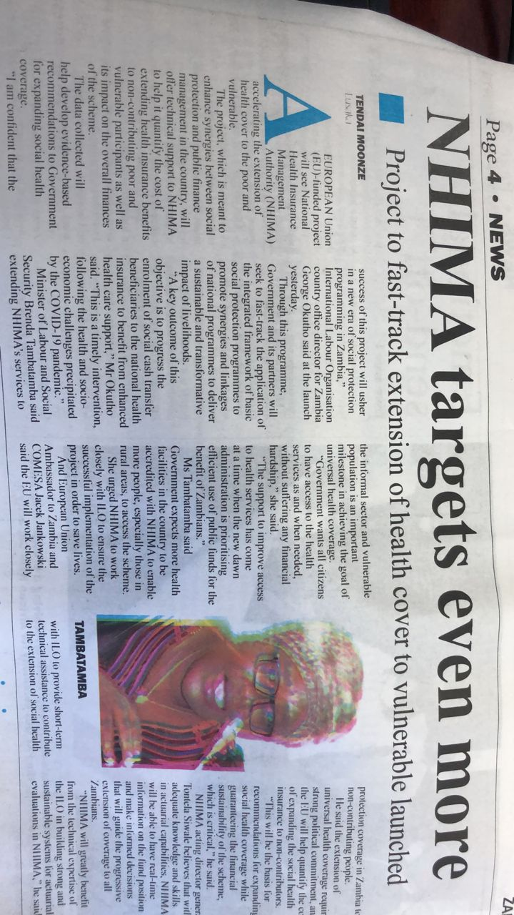

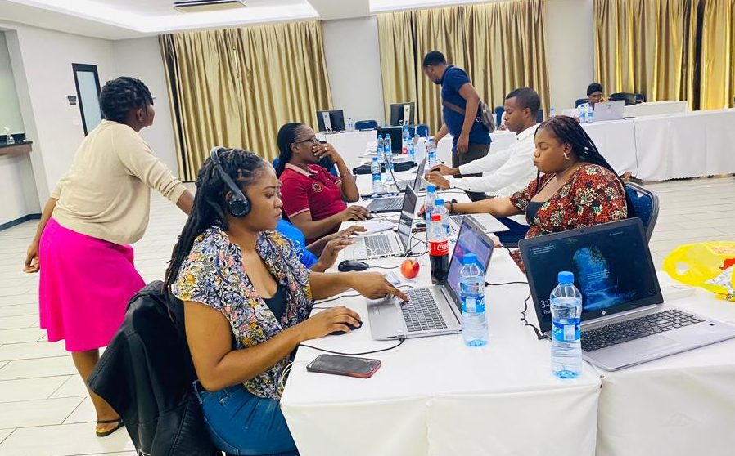
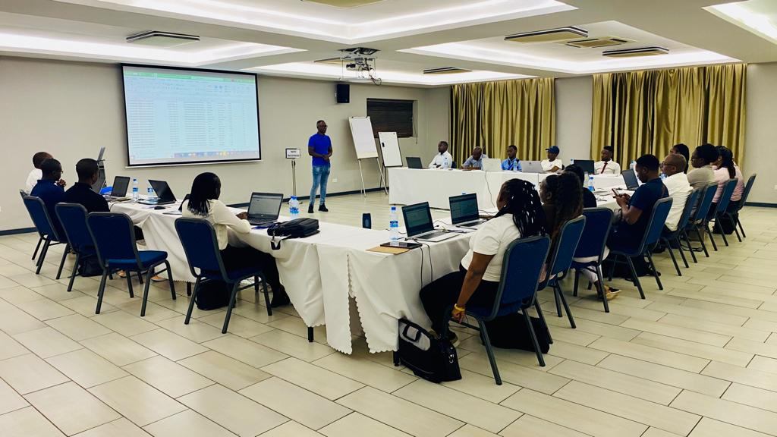
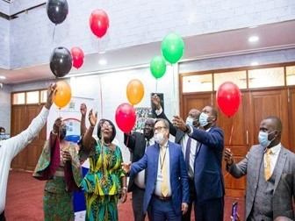
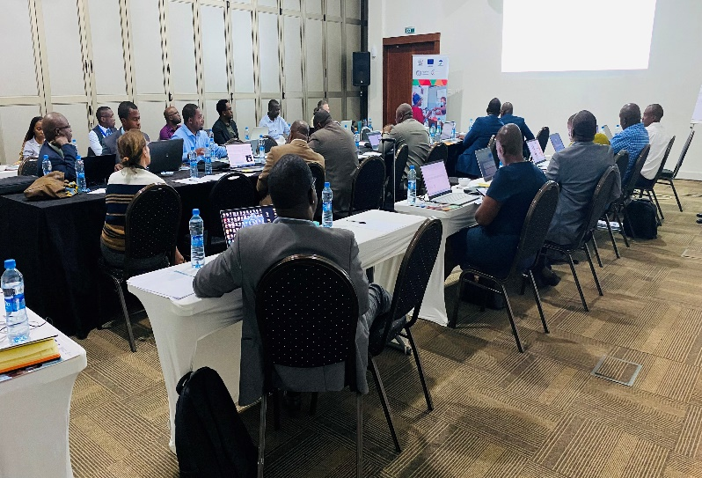
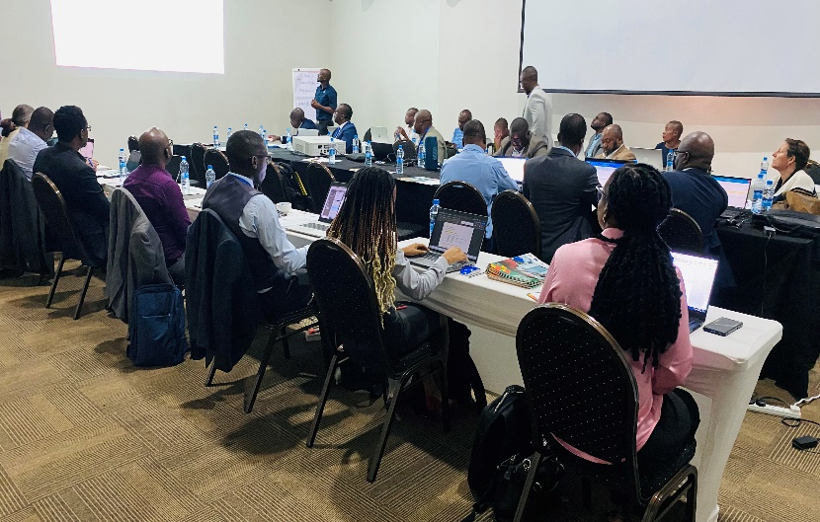
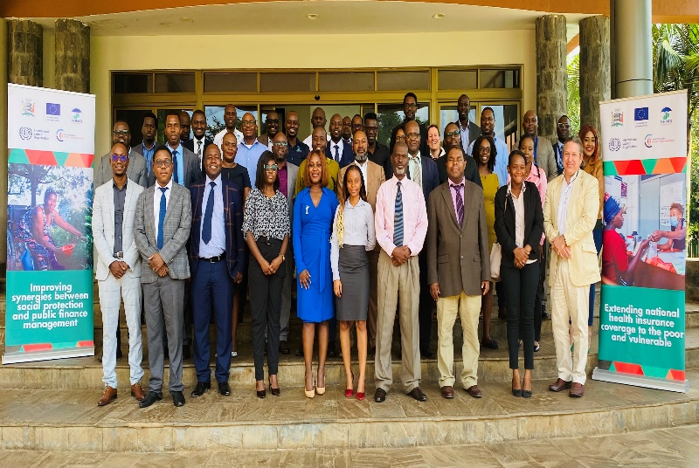
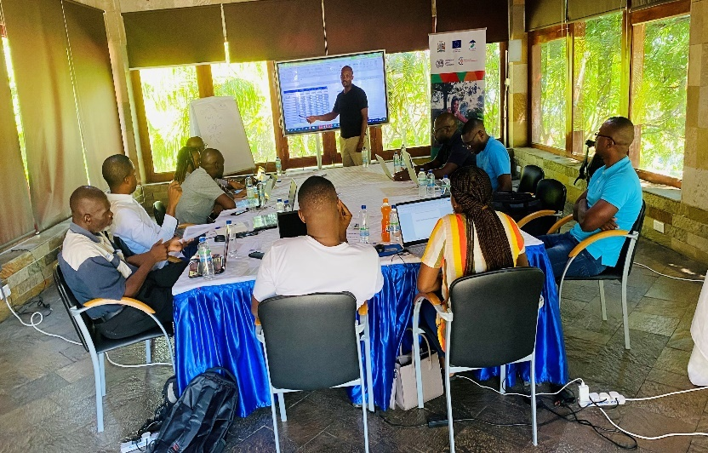
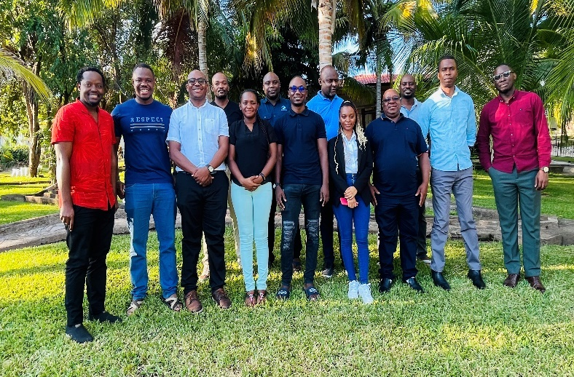
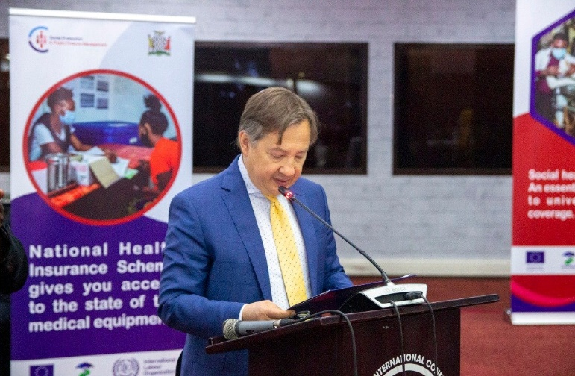
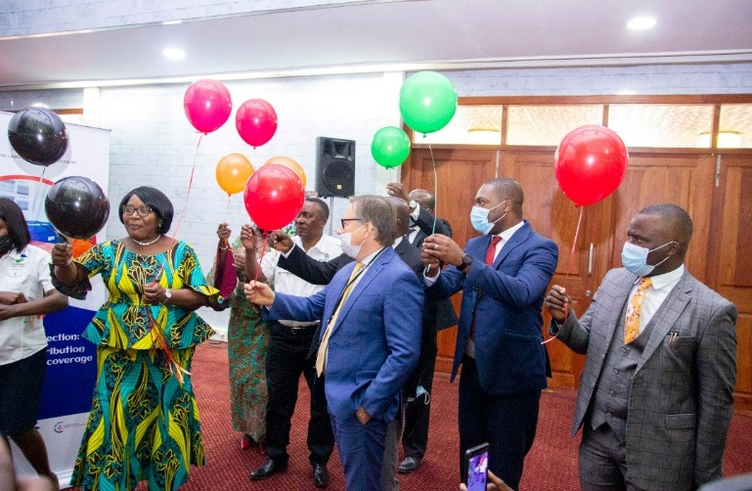
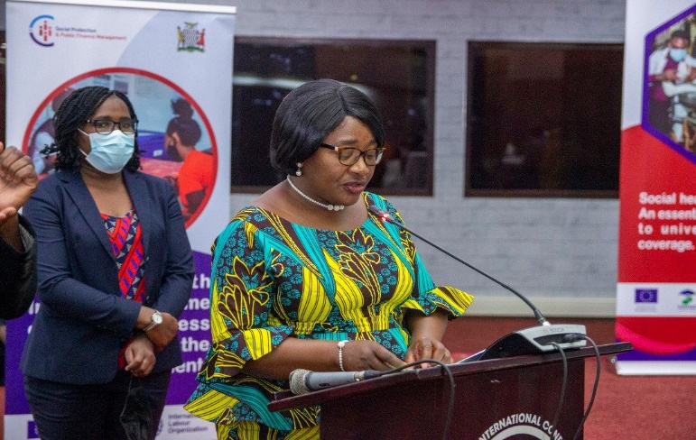
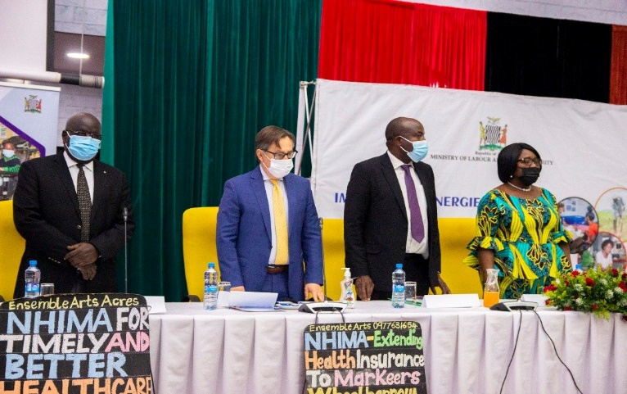
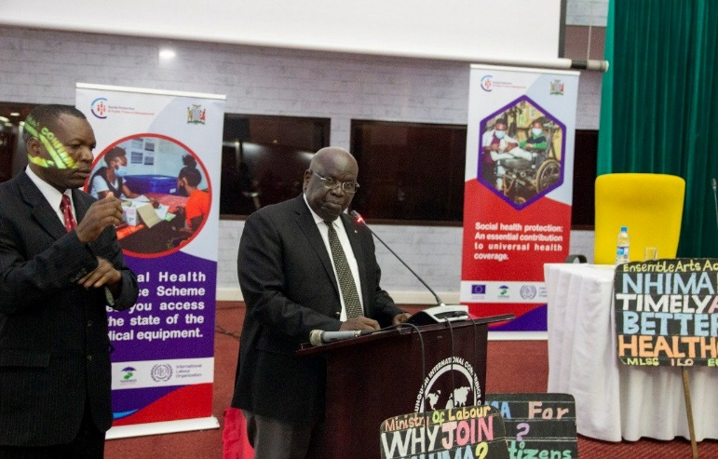
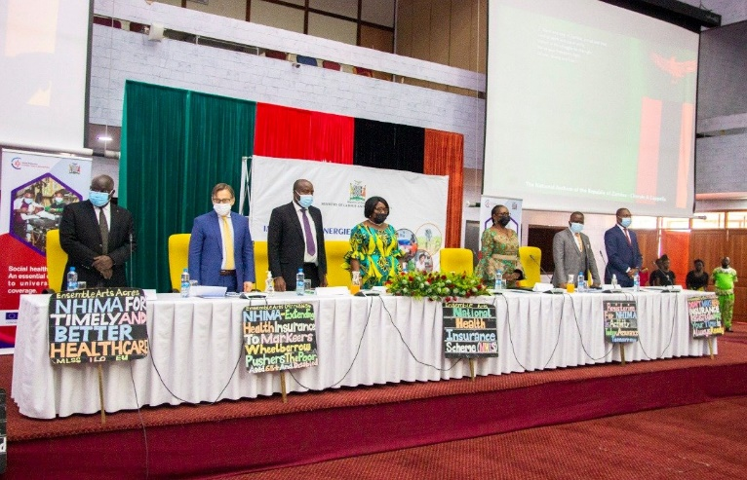
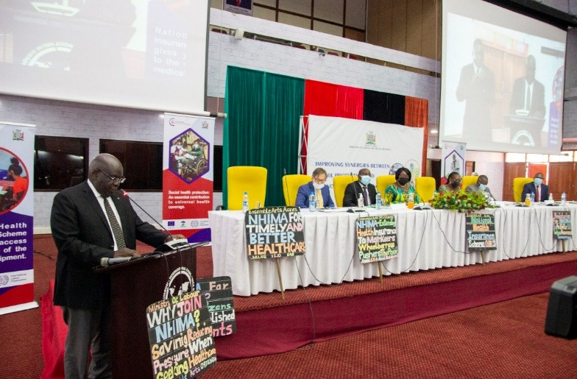
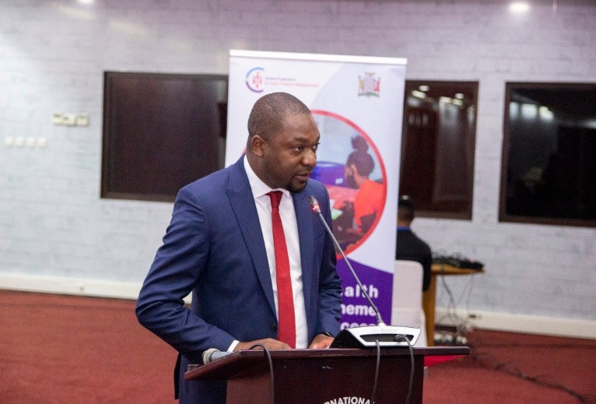

Annex 4: Emerging good practice

Country | ZAMBIA
Title of the practice | Prioritizing scheme data for actuarial modelling
Summary – Briefly describe the good practice, including results and the support provided by the SP&PFM Programme (1 paragraph) | The application of the ILO Health model demands robust data on Scheme membership, collections, and healthcare utilisation through health claims. At the beginning of the project NHIMA did not have this data in the right style and format to be able to run the actuarial model. There was a risk that the project would not be completed successfully in the absence of this data. However, NHIMA was able to mobilise internally by employing a Data Specialist with the support of USAID in Zambia who coordinated the production, cleaning, and integration of data internally. The SP&PFM project then provided funding support for the offsite data cleaning exercises that took place over a period of 3 months. With this intervention data was mobilised and made available for the successful running of the ILO – HEALTH Model. Therefore, the main objectives of the project were achieved while the project built new partnerships and collaboration with USAID that will outlive the project timelines.
Context - Describe relevant elements of the context and the preconditions of practice (the starting point) | At the beginning of the project the main challenge faced was that of data quality gaps. To run the actuarial model and be able to produce extension estimates that are robust, NHIS data ought to be availed in the appropriate format, and to be of good quality.  The main data concerns can be summarized as follows:  - There was a lack of alignment of Membership Register in eNHIMA and Health Information Platform (HIP) Databases. During its inception member registration phase, the NHIS used information available from the participating employer databases to undertake a bulk registration exercise. This approach has resulted in the non-capture of some of key participant variables, as well as significant deficits related to the member’s primary dependents who are also eligible to cover from the NHIS.  - Furthermore, NHIMA’s Health Information Platforms have been continuously evolving from paper-based systems to electronic systems, resulting in the inconsistent recording of claims and contribution details over the Scheme’s three-year operating period.  - Further, the NHIS has allocated differing unique membership numbers across the differing databases (membership, contributions, claims) and time-periods resulting in an inability to develop a consistent scheme profile.  - At the beginning of the project there was a lack of classification of Databases into specific cohorts. The NHIMA database was not consistently classified member and employer databases into the various NHIMA portfolios including Informal Sector, Pensioners, and Private as well as public sector. As a result, portfolio analysis of the performance of the different portfolios with respect to the contributions and claim, to support the formulation of actuarial valuation assumptions was constrained.  - Additionally, new employer IDs had not been generated for nearly 60% of registered employers. There was a risk that this could result in data inconsistences due to overlap of contributing member information. This issue was resolved by ensuring that a complete employer register with new employer ID and portfolio classification was updated.  - Lack of alignment of Contributions Data: Nearly 40% of contribution records did not contain a unique NHIS number of the primary member. As a result, a timeline of the contribution history for these members could not be developed, and transition probabilities formulated for input into the ILO/HEALTH model. Additional deficiencies were observed with respect to member salaries (which were in some cases abnormally low / high), and ambiguous contribution payment status (FAILED vs PENDING).
Good practice – Present the practice/experience, explaining the actors involved, the innovative methods/working methodology, the step-by-step to achieve the results | The good practice as outlined earlier is the ability of NHIMA to mobilize itself internally to ensure sufficient internal capacity to successfully process and manage critical data needed for the running of the actuarial valuation model.  Actors Involved:  - NHIMA: as the scheme, NHIMA is the primary custodian of scheme data which should make the same available to the ILO actuaries for modelling. This would be impossible for NHIMA does not have clear understanding of its own data to be able to determine whether it is suitable for modelling of this nature. For this project, NHIMA ensure there was a competent expert to generate all the data that was asked for by the actuaries. This determined the success of the project given that the process of actuarial valuation demands a lot of data whose absence would stall the project.  - ILO/SP&PFM: the ILO and SP&PFM team led the actuarial valuation process. Together with NHIMA, the actuarial team was able to quickly provide a long and clear list of data requirements for the running of the model. The clear and timely communication of the data needs is an important success factor in this process.  - USAID: the USAID is one of Zambia’s key funders of health interventions in TB, Malaria and HIV to contribute to Zambia’s attainment of Universal Health Coverage. The USAID agreed to fund the costs of a data expert who was situated in NHIMA and was responsible for data processing and management. With USAID support, the data manager was able to exclusively focus on ensuring the scheme data was cleaned and extracted for the purpose of the actuarial valuation.  Innovative methods  To ensure appropriate scheme data was made available for the running of the ILO-HEALTH actuarial model, NHIMA and the ILO designed an activity to undertake data cleaning. This data cleaning exercise was conducted over three separate sessions away from the usual office environment. A team of staff from different departments of NHIMA such as claims, investments, actuarial services was put together which spent significant time cleaning and arranging the data appropriately for use in the modelling. Guided by the Data Expert and the data request from the actuaries, the team spend several weeks cleaning the data and reconciling various reports to develop a coherent outlook of the scheme from different perspectives.  The outcome of this activity is not only clean data for the running of actuarial model. The process also culminated into capacity building for NHIMA staff who now comprehend scheme data and are able to observe trends of various variables to offer correction and alignment if necessary.
Main results – Briefly describe the results already achieved | Through the above process, the SP&PFM Project has made the possible the following results:  - Creation of Real-Time NHIS Indicator Reporting Dashboards: The extensive data cleaning exercise created an opportunity to generate and report the performance of the Scheme through real-time interconnection to membership, contribution, and claims data.  - Fraud Detection and Elimination in Claims: the NHIS was able to identify, and isolate outliers based on the analysis of Levels, Trends and Patterns of Claims that pointed to potential fraud, particularly Supplier Induced Demand in Optical Services. This resulted in supporting the introduction of new operational rules, the Gate Keeping Rules aimed at eliminating fraud related behaviours among Healthcare Providers and reducing wastage. These rules have resulted in significant reduction in claims, thus enhancing the solvency of the Fund.  NHIMA management’s appreciation of data and evidence has increased, alongside increasing the data culture for successful implementation of the NHIS. NHIMA has now rolled-out the Power BI Data Analytics system which was part of the ILO-HEALTH Model Data Clean-Up and Validation Process and integrated it into all Scheme operations. This has made management and government reporting on Scheme operations more efficient and responsive.
Success factors – List the factors that contributed to the success of the practice (bullet points) | - Internal capacity: NHIMA was able to mobilize internal capacity especially in scheme data management which made it possible to internally sort out the data requirements and fix gaps that could have hindered progression to the model valuation.  - Inter-agency collaboration and partnerships: NHIMA proactively reached out to the USAID, an important Cooperating Partner in Zambia’s health sector who agreed to meet the costs of a Data Expert for the period of the project. Thus, the project created new partnerships for NHIMA that will outlive the project.  - Communication: NHIMA was clear in communicating all the data gaps at the very beginning of the project making it relatively easy to design an approach to find a solution within the time frame of the project.
Challenges – List the main existing challenges (bullet points) | - Limited registration of dependents: to date NHIMA’s data challenges are compounded by limited registration of dependents per principal beneficiary
Lessons learned – Indicate up to 3 lessons learned from this experience that could be useful for other countries (more general than success factors) | - Presence of internal capacity, especially regarding collection, processing and management scheme data proved foundational to running successful actuarial valuation model. The scheme Authority should understand its own data very well to be able to detect anomalies and avoid obtaining misleading results.  - Social health protection institutions should team up with other institutions that are also providing health support from different perspectives. This is good for short term activities such as running of an actuarial model but can also prove useful for future collaborations in the attainment of universal health coverage objectives.  - There should be clear communication between the ILO project team and the scheme Authority to ensure all needs are identified as early as possible. This is important to ensure all gaps are filled within the project timeline.
Next steps | - NHIMA has now made periodical cleaning of scheme data a priority for frequent scheme performance monitoring. Keeping the data clean and comprehensive has become necessary for senior management to be able to follow important trends and be able to make policy and program adjustments in the provision of insurance services. This is an activity that outlives the SP& PFM project.

Based on the Implementation Plan
This is a self-assessment
Based on the M&E plan
Compare achievement against planned target as per indicator.
Conclusions should synthesize the main findings into statements of merit and worth. As such, judgments need to be fair, impartial, and consistent with the findings
Recommendations should follow from conclusions; link to lessons learned; and describe a time-frame (short-, medium-, long-term), the degree of priority (high, medium, low), who is called upon to act and acknowledge whether there are any resource implications.
Use the existing project risk register for filling in this table
Outline any additional mitigating measures or any change in the planned mitigating strategy and provide a rationale
The change column summarizes any change in the identified risk as a result of the corrective/mitigating measures
Outline the impact on project objectives once the mitigating measures were put in place

