Terms of Reference of the Advisory Board of the Global Action “Improving synergies between social protection and Public Finance Management” (DCI-HUM/2018/041-579, GLO/19/53/EUR)

The Global Action

Through the Global Action programme “Improving synergies between social protection and Public Finance Management” (hereafter SP&PFM programme), the European Commission has entrusted the ILO, together with UNICEF and the Global coalition for social protection floors (GCSPF), to improve the design and financing of social protection systems in countries in support of their efforts towards achievement of the SDGs 1.3, 3.8, 5.4, 8.5 and 10.4. The SP&PFM programme supports countries in designing, implementing and monitoring effective gender-sensitive and disability-inclusive social protection systems and programmes for all while ensuring financial sustainability and macroeconomic stability; and developing shock-responsive social protection programmes and systems adapted to the needs of those affected by protracted fragility and crises, including socio-economic shocks such as the current COVID-19 crisis.

The SP&PFM programme is composed of the following two approaches to deliver its technical support to countries:

Under approach 1, implemented jointly by the ILO, UNICEF and the GCSPF, the SP&PFM programme provides medium-term technical assistance and conducts capacity and knowledge development activities focused on eight pre-identified countries: Angola, Burkina Faso, Cambodia, Ethiopia, Nepal, Paraguay, Senegal and Uganda.

Under approach 2, implemented by ILO, an additional 15 to 20 countries receive on-demand specific technical advisory services to strengthen their social protection systems, in particular through better public finance management and improved implementation of social protection systems. The following 10 countries were selected through the first call for proposals with a thematic focus on social protection responses to COVID-19: Bangladesh, Cabo Verde, Cote d’Ivoire, Ecuador, Malawi, Myanmar, Nigeria, Peru, Sri Lanka, and Togo.

In addition, the SP&PFM programme implements cross-country training and research activities aimed at reinforcing exchange of knowledge and learning.

In each country receiving support from the SP&PFM programme either through Approach 1 or Approach 2, the country project teams will support the establishment of a country steering committee (either through a new entity or the extension of an existing body), in which workers and employers’ organisations shall be adequately represented. A Steering Committee at the global level (hereafter global Steering Committee), composed of representatives from the EC, ILO, UNICEF, an EU member States and the GCSPF provides strategic guidance to the programme and approves key planning documents for the overall programme and the country projects such as project documents, annual workplans, progress reports, among other documents.

The figure below visualizes the management and governance structure of the SP&PFM programme.

Figure 1: Management and governance structure
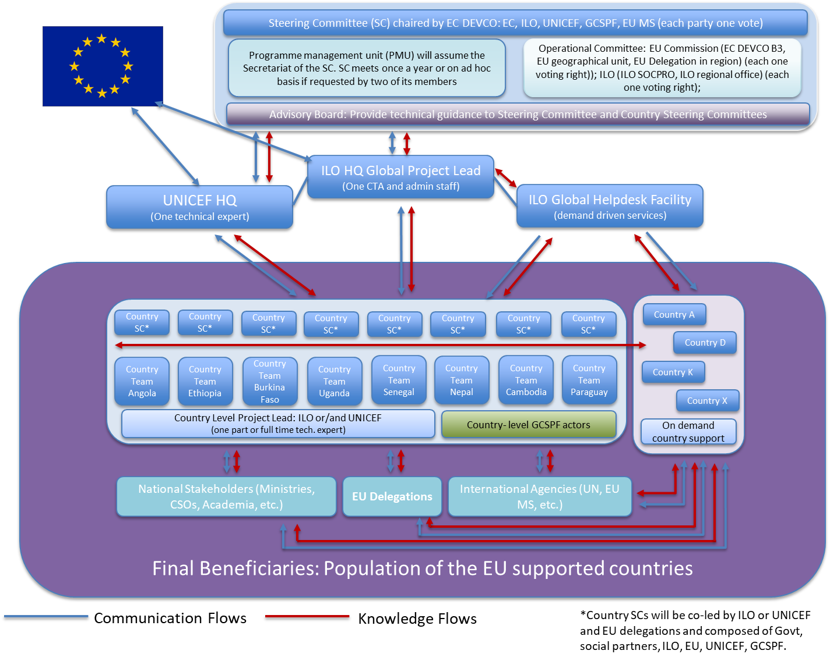

Role of the Advisory Board

The present terms of reference are for the Advisory Board. It has a strategic position, acts as an experts’ group and shall provide technical inputs and guidance to the Programme Management Unit and the global Steering Committee, as well as support for advocacy, for improving the global outcome and results of the SP&PFM programme. The technical advice-giving role of the Advisory Board will be particularly crucial in providing comments and inputs to the global research, products, handbooks and tools developed by the programme. The advocacy role of the Advisory Board will aim at supporting the SP&PFM programme’s efforts in promoting more and better financing for social protection among the experts’ networks and actions. The Programme Management Unit will relay the technical recommendations and inputs to the country steering committees to ensure that the key outputs produced by the countries under Approaches 1 and 2 best contribute to the objectives of the programme and promote the international principles and practices related to social protection, its financing, and PFM, as stipulated in the Action document.
The Advisory Board shall consider questions brought before it by the Programme Management Unit or other issues which the Steering Committee considers important to receive advice on for the further enhancement of the SP&PFM programme. In providing such advice to the Programme Management Unit or the Steering Committee, the Advisory Board may address issues that its members consider relevant to the effectiveness, impact and quality of the SP&PFM programme’s operations and technical outputs at country or global level.
The role of the Advisory Board is to:
- Provide comments and technical inputs for the development of the global knowledge and research products, handbooks and tools, as well as country analytical work when relevant;
- Discuss and propose linking emerging social protection and PFM issues to the SP&PFM programme and its interventions, including in the context of the COVID-19 crisis;
- Provide strategic feedback and technical advice for strengthening the vision, strategy and priorities of the SP&PFM programme, in particular in improving the synergies between social protection and public finance management, and in research to assess whether and how investments in social protection systems contribute to macroeconomic stability and improved measures of inclusive economic growth, social inclusion, equality, employment and formalization;
- Provide technical advice to ensure that the SP&PFM programme effectively promotes and applies international principles related to social protection, contributes to gender-equality and is inclusive of people with special needs such as people with disability, workers in the informal economy, migrant workers among others ;
- Provide guidance and support advocacy among a larger audience and network for more robust and sustainable financing of social protection that also promotes national and international solidarity;
- Offer technical advice and guidance for enhancing the strategy for building social protection systems that are more resilient to crisis and shocks.

Composition of the Advisory Board
Experts will be invited to play the role of chair the Advisory Board, assisted by the Programme Management Unit and one DEVCO B3 official as ex-officio members.

The Advisory Board shall consist of nominated experts as follows:

- Two representatives each of the social partners, nominated either by the International Trade Union Confederation (ITUC) and the International Organization of Employers (IOE) and/or by the designated national representative organizations of workers and employers;
- Three representatives of organizations representing the SP&PFM programme’s beneficiaries, namely at least one entity advocating for gender-equality, one for the rights of persons with disabilities, and one for the rights of people from the informal sector. The GCSPF could support the identification of key representatives as part of civil society, with a focus for representatives from development countries;
- Eight academics, experts and researchers in the area of social protection and/or PFM; participation of experts from developing countries is highly encouraged;
- Two representatives of the International Financial Institutions and other development partners working on PFM and social protection;
- Two representatives of bilateral development partners of the EU Member States, preferably EU member state or their development agency that are collaborating in the partner countries.

Technical staff of the EU, ILO, UNICEF or GCSPF may be called on for their specific expertise (workers and employers’ activities, social dialogue, gender equality and non-discrimination, employment, transition to the formal economy, shock-responsive interventions, labour migration, child protection, public finance, among others) and as relevant for each agenda of the Advisory Board meetings.

Meetings Protocol

The Advisory Board shall meet virtually at least once a year to share feedback on the programme’s information and key outputs. The meetings will be organized in English, with interpretation in French and Spanish, when needed.

The Advisory Board shall be consulted on the draft agenda for the meeting which will be circulated at least three weeks in advance of the meeting. The final agenda will be circulated one week before the meeting. The information to be discussed shall be shared two weeks prior to the meeting.

Meeting minutes shall be circulated by email, fourteen days after the meeting.

On ad-hoc basis, the Advisory Board may be consulted via emails to provide guidance and advice for the development of the terms of reference of the global products and events, provide technical inputs to global research products and publications developed by the SP&PFM programme.

